|  |
| --- |
| Image Web server |
| IWS viewer |

#### Introduction

As of late March 2023, the DEECA’s Image Web Server (IWS) will move to cloud based hosting. Existing users will need to update their connection url.

The IWS Viewer (https://iws.maps.vic.gov.au/erdas-iws/viewer/) allows easy viewing of IWS images in a web browser. The resolution of each image is improved and optimised with each zoom level. It is ideal for browsing the range of images that cover an area of interest and for viewing the coverage of each image.

Only authorised users can access the IWS.

To register as an authorised user of the IWS please refer to the User Registration section.

#### Accessing the IWS Viewer

1. Ensure your browser version is up-to-date (we recommend Chrome). **The IWS Viewer will not work in an “Edge” browser.**
2. Go to https://iws.maps.vic.gov.au/erdas-iws/viewer/  
     
   Make sure your connection is secure (by including https://), otherwise you will not be able to view any imagery.
3. 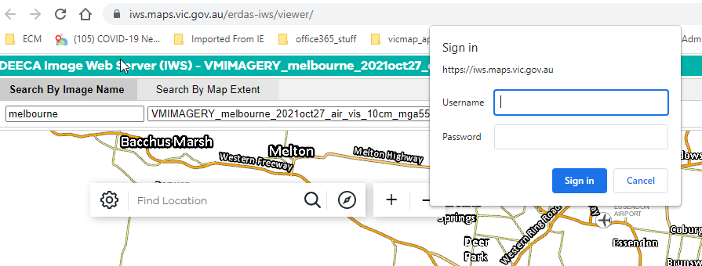You will be prompted to enter your IWS username and password after selecting an image. Note: if you enter your password incorrectly, you will need to close and re-open your browser window before re-attempting.

#### Searching for an image by name

Note: The IWS Viewer uses the IWS image footprints spatial dataset for its search. If an image is not appearing when searched for, it is likely due to an issue with this dataset. Contact GIS.Helpdesk@delwp.vic.gov.au for assistance.

a. Click on the Search By Image Name tab at the top of the application.

b. Enter the image name (or a part of it) as it appears in the filename for the image. **NOTE:** Even though an image is listed, you may not have permission to view that image.

c. Select an image from the drop-down list. This list will automatically populate as you type in the image name.

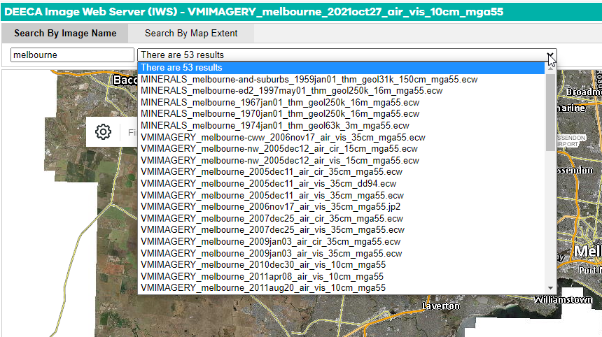d. The selected image will now appear on the map.

#### Searching for an image by map extent

1. Click on the Search By Map Extent tab at the top of the application.
2. Using the base map as a reference, zoom in (using the mouse wheel or by using the **+/-** buttons) to your area of interest.
3. As you zoom in, the drop-down list of images will be populated by those that cover all or part of the current extent of the map.
4. 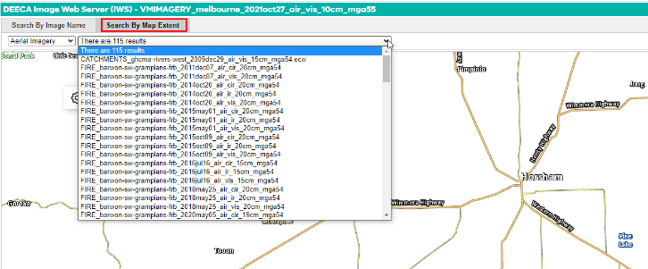View an image by selecting it from the drop-down list. You can use the second drop-down list to the left to switch between aerial, ground-based, merged, satellite or thematic imagery.

#### Search for an image using address or locality

1. You can search for imagery using an address or locality name by using the search bar on the map.
2. Entering an address/locality will centre the map at that location. You can also select the compass icon to the right of the search bar to automatically centre the map at your current location (if you give the site permission).
3. 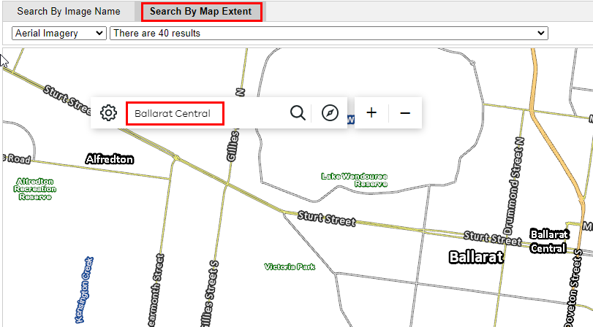You can then select imagery that covers that particular address/locality by using the **Search By Map Extent** tab.

#### User Registration

Approved customers need an account in the identity management system (idam), to access the IWS.

##### DEECA staff

If you have previously created a DataShare account then you will already have an account in the identity management system. You will be able to log into the Image Web Server using your “corporate email address” and your single sign on password.

DEECA staff without an account in the identity management system (eg you don’t have an existing DataShare account (<https://datashare.maps.vic.gov.au/>)) need to create one via the DataShare login option

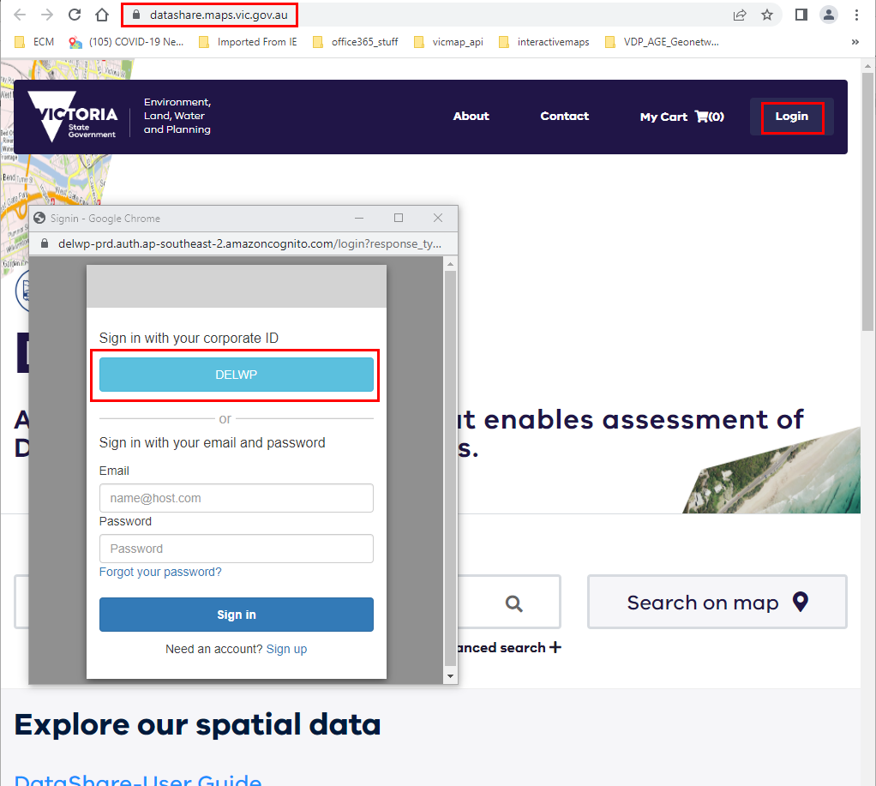

NOTE: once complete you can log out of DataShare

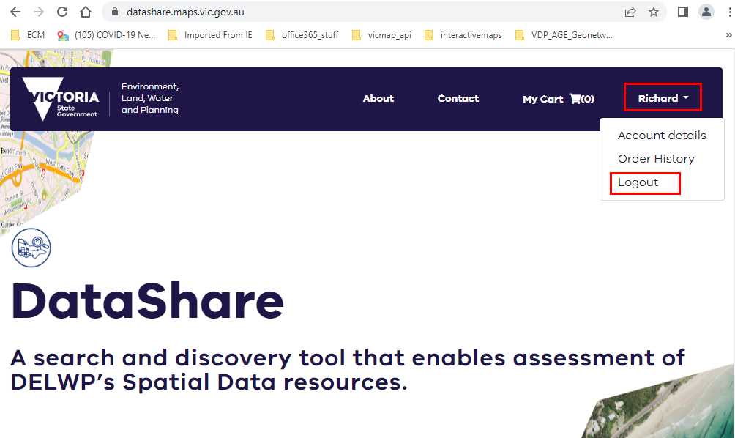

You can now log into the Image Web Server using your “corporate email address” and your single sign on password.

##### Non DEECA staff

If you have previously created a DataShare account (created using your corporate email address) then you will already have an account in the identity management system. You will be able to log into the Image Web Server using your “corporate email address” and your Datashare password.

Non DEECA staff without an account in the identity management system (eg you don’t have an existing DataShare account (<https://datashare.maps.vic.gov.au/>)) need to create one via the DataShare login option. Use your corporate email address.

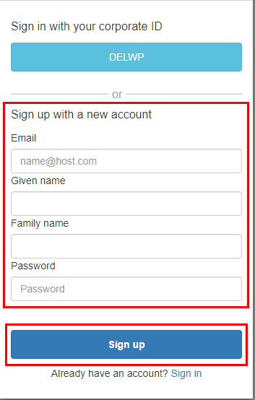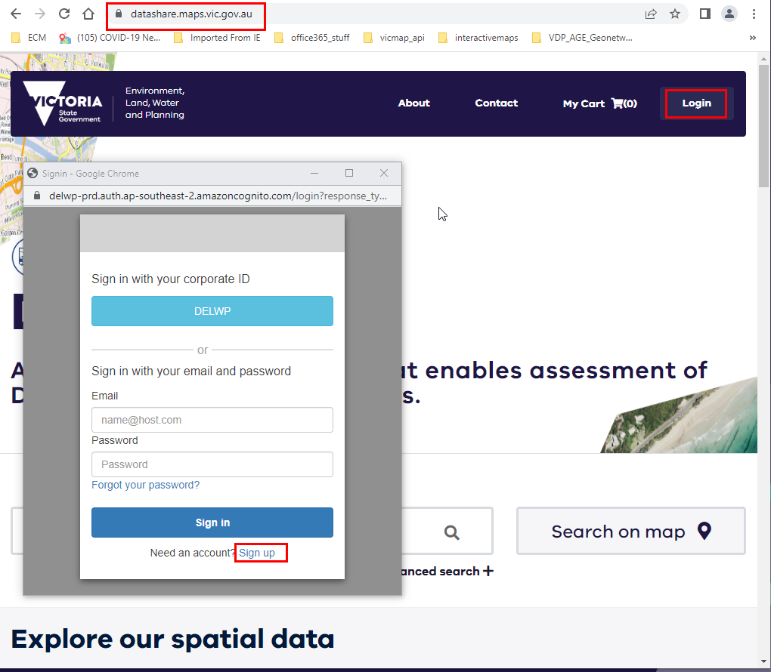

NOTE: once complete you can log out of DataShare



You can now log into the Image Web Server using your “corporate email address” and your DataShare password.

#### Coming Soon

The ability to view and save a list of Image Web Server imagery, so that you can differentiate between all the imagery on the image web server and those that you have access to is currently being developed and will be available soon.

#### Image Web Server Contact Details

The Information Services Division (DEECA) manages the IWS. Please address any feedback or queries to [GIS.Helpdesk@delwp.vic.gov.au](mailto:GIS.Helpdesk@delwp.vic.gov.au)

|  |  |
| --- | --- |
| © The State of Victoria Department of Energy, Environment and Climate Action 2023  Creative Commons BYThis work is licensed under a Creative Commons Attribution 4.0 International licence. You are free to re-use the work under that licence, on the condition that you credit the State of Victoria as author. The licence does not apply to any images, photographs or branding, including the Victorian Coat of Arms, the Victorian Government logo and the Department of Energy, Environment and Climate Change (DEECA) logo. To view a copy of this licence, visit http://creativecommons.org/licenses/by/4.0/  Disclaimer  This publication may be of assistance to you, but the State of Victoria and its employees do not guarantee that the publication is without flaw of any kind or is wholly appropriate for your particular purposes and therefore disclaims all liability for any error, loss or other consequence which may arise from you relying on any information in this publication. | Accessibility  If you would like to receive this publication in an alternative format, please telephone the DEECA Customer Service Centre on 136186, email [customer.service@delwp.vic.gov.au](mailto:customer.service@delwp.vic.gov.au) or via the National Relay Service on 133 677 [www.relayservice.com.au](http://www.relayservice.com.au). This document is also available on the internet at [www.deeca.vic.gov.au](http://www.deeca.vic.gov.au). |

.