|  |
| --- |
| Vicmap™ Product Development |
| Change Notice # 229 Advisory Notice |

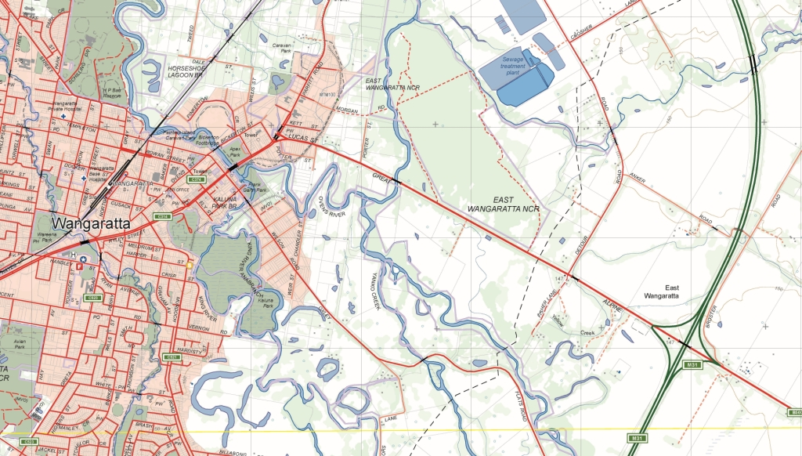

Vicmap Crown Land Tenure 20 December 2017

## What is happening

A table that links the Crown Land Tenure table to the Vicmap Property parcel table is being re-introduced to the Vicmap Crown Land Tenure data models. This table identifies what parcels fall within a crown land tenure and vice-versa.

The structure of the CL_TENURE_PARCEL table is:

|  |  |  |  |
| --- | --- | --- | --- |
| **Table_Attribute** | **Explanation** | **Field Type / Size** | **Example** |
| *UFI* | The Unique Feature Identifier (UFI) is updated each time the associated crown land tenure or parcel is created or updated. | NUMBER(10) | 84155081 |
| *CL_TENURE_PFI* | The Persistent Feature Identifier (PFI) of the associated crown land tenure identified in the CL_TENURE table. | VARCHAR2(10) | 52612200 |
| *PARCEL_PFI* | The Persistent Feature Identifier (PFI) of the associated parcel identified in the VMPROP.PARCEL table. | VARCHAR2(10) | 101316410 |
| *UFI_CREATED* | The date the Unique Feature Identifier (UFI) was created | DATE | 17/08/2016 7:59:08 AM |

## Why this change is occurring

This change is responding to customer requirements seeking improved interoperability between the different Vicmap Data sets, especially where there is a direct link between the products.

The link between Crown Land Tenure and Parcel tables can be determined using a spatial query. However, this query may be complex, computationally costly and time consuming. So, to improve product ease-of-use, an “out-of-the-box” join table is provided.

The introduction of the join table will simplify the validation of Crown land tenures only existing on parcels with a crown status of C, M or V.

## Who will it affect

This change will affect all users of Vicmap Crown Land Tenure and Crown Land Tenure Simplified

## When the change will occur

The change will be implemented on the **15/01/2018.**

|  |  |
| --- | --- |
| © The State of Victoria Department of Environment, Land, Water and Planning 2017  LogoThis work is licensed under a Creative Commons Attribution 4.0 International licence. You are free to re-use the work under that licence, on the condition that you credit the State of Victoria as author. The licence does not apply to any images, photographs or branding, including the Victorian Coat of Arms, the Victorian Government logo and the Department of Environment, Land, Water and Planning (DELWP) logo. To view a copy of this licence, visit http://creativecommons.org/licenses/by/4.0/  Disclaimer  This publication may be of assistance to you but the State of Victoria and its employees do not guarantee that the publication is without flaw of any kind or is wholly appropriate for your particular purposes and therefore disclaims all liability for any error, loss or other consequence which may arise from you relying on any information in this publication. | Accessibility  If you would like to receive this publication in an alternative format, please telephone the DELWP Customer Service Centre on 136186, email [customer.service@delwp.vic.gov.au](mailto:customer.service@delwp.vic.gov.au), or via the National Relay Service on 133 677 [www.relayservice.com.au](http://www.relayservice.com.au). This document is also available on the internet at [www.delwp.vic.gov.au](http://www.delwp.vic.gov.au). |

## For further information

You can contact Vicmap Help by emailing [vicmap.help@delwp.vic.gov.au](mailto:vicmap.help@delwp.vic.gov.au) or refer to our website

<https://www2.delwp.vic.gov.au/maps>