|  |
| --- |
| Vicmap™ Product Development |
| Change Notice # 262 Advisory Notice |

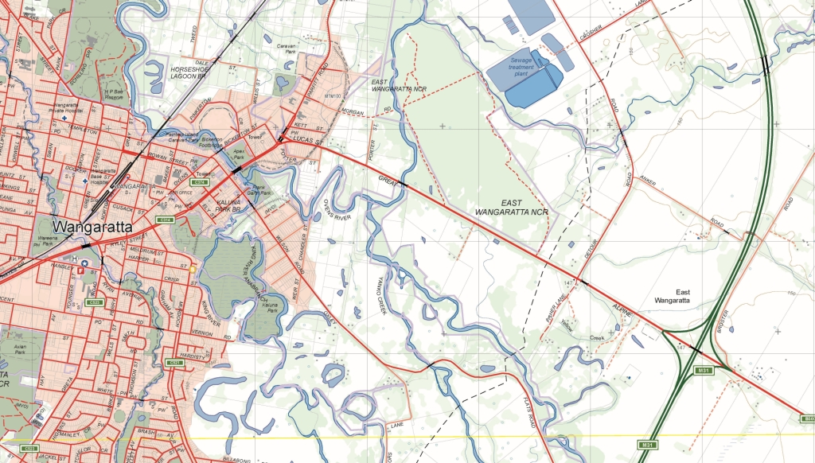

Vicmap Elevation - new relief features table

## What is happening

A new table ‘EL_RELIEF_AREA’ will be added to Vicmap Elevation containing polygons depicting relief features, such as, islands and island groups.

These features may be named or unnamed and names linked to VICNAMES.

Currently coastal islands are located within Vicmap Framework as ‘islands’ and inland islands are located within Vicmap Hydro as ‘voids’. Named island_marine and island _terrestrial features are in Vicmap Features of Interest GEO_AREA_HYDRO_LABEL table.

Inland islands will be derived from HY_WATER_AREA_POLYGON and will continue to be maintained as voids and vertically aligned with islands in EL_RELIEF_AREA.

Coastal islands will be derived from FR_FRAMEWORK_AREA_POLYGON and will continue to be maintained and vertically aligned with islands in EL_RELIEF_AREA.

The names for named island_marine and island _terrestrial features will be derived from GEO_AREA_HYDRO_LABEL.

This data will be replicated in the Geomark tables.

Data improvements include feature type modification, graphic alignments, new feature types.

For related tables, two name fields NAME and NAMED_FEATURE_ID in FR_FRAMEWORK_AREA_POLYGON will be removed.

Note: EL_RELIEF_AREA unlike Geomark will hold a scale_use_code.

Table 1 is the data structure for new table EL_RELIEF_AREA

|  |  |  |  |
| --- | --- | --- | --- |
| **Column Name** | **Data type** | **Mandatory** | |
| UFI | NUMBER (9) | Y | |
| PFI | NUMBER (9) | Y | |
| FEATURE_ID | NUMBER (9) | Y | |
| PARENT_FEATURE_ID | NUMBER (9) | N |  |
| FEATURE_TYPE | VARCHAR2 (30) | Y |  |
| FEATURE_SUBTYPE | VARCHAR2 (30) | Y |  |
| NAME | VARCHAR2 (100) | N |  |
| NAME_LABEL | VARCHAR2 (100) | N |  |
| PARENT_NAME | VARCHAR2 (100) | N |  |
| AUTH_ORG_CODE | VARCHAR2 (4) | N |  |
| AUTH_ORG_ID | VARCHAR2 (30) | N |  |
| AUTH_ORG_VERIFIED | DATE | N |  |
| VICNAMES_ID | NUMBER (9) | N |  |
| VICNAMES_STATUS_CODE | VARCHAR2 (2) | N |  |
| STATE | VARCHAR2 (3) | Y |  |
| SCALE_USE_CODE | VARCHAR2 (1) | N |  |
| CREATE_DATE_PFI | DATE | Y |  |
| SUPERCEDED_PFI | NUMBER (9) | Y |  |
| CREATE_DATE_UFI | DATE | Y |  |

**Table 1: Data structure for EL_RELIEF_AREA**

:

The Vicmap feature catalogue ‘VMREFTAB.FEATURE_CATALOGUE’ holds Vicmap’s feature terminology. Vicmap aims to align feature terminology with national feature terms where practical. The file can be downloaded from <http://services.land.vic.gov.au/reftab/>

|  |  |  |  |  |  |  |  |
| --- | --- | --- | --- | --- | --- | --- | --- |
| **Feature type** |  | | **What is happening** |  | | | **Reason** |
| island coastal | | NEW  term | records to be moved to ‘island coastal’ from ‘island’ | |  | Feature type is better described | |
| island inland | | NEW  term | records to be moved to ‘island inland’ from ‘island’ | |  | Feature type is better described | |
| island group | | NEW  term | records to be moved to ‘island group’ from ‘island’ | |  | Feature type is better described | |

**Table 2: Changes to Vicmap feature catalogue terminology.**

## Why this change is occurring

## Adding the EL_RELIEF_AREA to Vicmap Elevation will group like features enhancing maintenance and searchability within Vicmap.

## New feature terms have been created to better describe records.

## Who will it affect

## All Vicmap users, particularly those using: Vicmap Framework, Vicmap Elevation, Vicmap Features of Interest, VMREFTAB.FEATURE_CATALOGUE and/or Geomark.

## When the change will occur

## The EL_RELIEF_AREA table will be added to Vicmap Elevation from 12/08/2021.

## The data will be replicated in Geomark.

## The GEO_AREA_HYDRO_LABEL table will be withdrawn after 11/11/2021.

## Two fields NAME and NAMED_FEATURE_ID in FR_FRAMEWORK_AREA_POLYGON will be retired after 11/11/2021

## How to provide feedback

This is a data processing activity and this notice has been provided to customers to make them aware of the impending changes.

For Vicmap Product change notices and updates, visit [Vicmap change notices](https://www.land.vic.gov.au/maps-and-spatial/spatial-data/updates-to-vicmap/vicmap-change-notices%0d).

For further information & feedback please email [vicmap.help@delwp.vic.gov.au](mailto:vicmap.help@delwp.vic.gov.au)

If you would like to subscribe to change notices ongoing please forward your contact details including your email to [vicmap@delwp.vic.gov.au](mailto:vicmap@delwp.vic.gov.au)

|  |  |
| --- | --- |
| © The State of Victoria Department of Environment, Land, Water and Planning 2021  LogoThis work is licensed under a Creative Commons Attribution 4.0 International licence. You are free to re-use the work under that licence, on the condition that you credit the State of Victoria as author. The licence does not apply to any images, photographs or branding, including the Victorian Coat of Arms, the Victorian Government logo and the Department of Environment, Land, Water and Planning (DELWP) logo. To view a copy of this licence, visit http://creativecommons.org/licenses/by/4.0/  Disclaimer  This publication may be of assistance to you but the State of Victoria and its employees do not guarantee that the publication is without flaw of any kind or is wholly appropriate for your particular purposes and therefore disclaims all liability for any error, loss or other consequence which may arise from you relying on any information in this publication.  **DELWP spatial disclaimer**  The State of Victoria:   1. does not give any representation or warranty as to the accuracy or completeness of DELWP spatial data, Vicmap data (including metadata) or Vicmap product specifications or the fitness of such data or products for any particular purpose; 2. disclaims all responsibility and liability whatsoever for any errors, faults, defects or omissions in such data or products.   Any person using or relying upon such data or products must make an independent assessment of them and their fitness for particular purposes and requirements. | Accessibility  If you would like to receive this publication in an alternative format, please telephone the DELWP Customer Service Centre on 136186, email [customer.service@delwp.vic.gov.au](mailto:customer.service@delwp.vic.gov.au), or via the National Relay Service on 133 677 [www.relayservice.com.au](http://www.relayservice.com.au). This document is also available on the internet at [www.delwp.vic.gov.au](http://www.delwp.vic.gov.au). |