|  |
| --- |
| Victoria’s complex site addressing program |
| For retirement villages, universities. shopping centres, sports facilities, tourist venues, caravan parks and residential parks |

**We need to put your site on the map**

The complex site addressing program aims to provide unique identification (i.e. an address) for each sub-address within large or complex sites such as retirement villages, universities, shopping centres, camping sites, sporting facilities, tourist venues, and caravan and residential parks.

By doing this, the program will improve the property addressing system in Victoria and support efficient and effective delivery of emergency and postal services, as well as a range of government activities.

The program seeks to improve the addressing system by defining the processes for capture, storage, maintenance, geocoding, access and distribution of Victorian address data from Vicmap, the state’s authoritative spatial data suite.

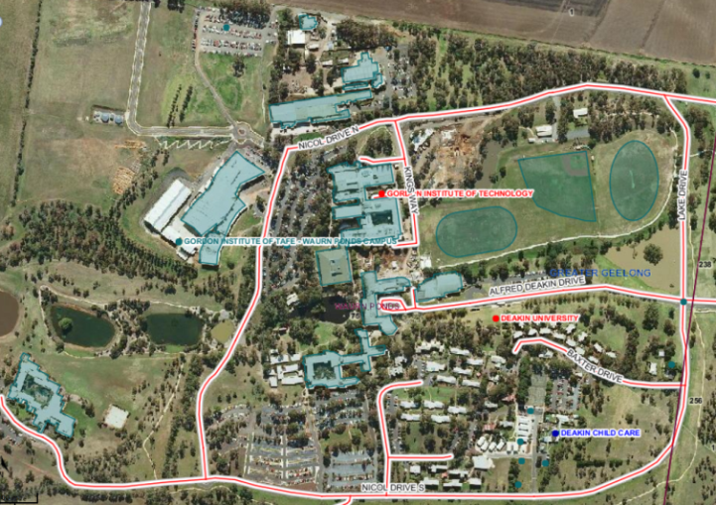

*Deakin University, a complex site*

What is complex site addressing?

The complex site addressing program will create a unique identification (address) for each sub-address within a large site. Each sub-address will then be identified, placed in its actual location on a map and included in Vicmap.

Information to achieve this should be provided by site management of each complex site to councils, who will submit this information to Vicmap.

For example, a retirement village could have 300 individual buildings within it and each road might already be named and each building already numbered; however, the site and its residents are only known by a single address, e.g. 81 Gallagher Street.

Another example might be a tourist venue, caravan or residential park that has named roads with many individual dwellings and sites within it; however, all dwellings and sites at the venue or park are only known by a single address, e.g. 46 Morrison Way.

The complex site addressing program aims to ensure all roads and relevant buildings on sites are individually identified by unique sub-addresses and that the addresses are recorded in Vicmap. When road names and building numbers have been assigned, appropriate signage should be installed so that emergency and other services can navigate to specific addresses.

For standard residential sites, addresses are assigned by the local council. A residence is typically associated with one land title, one property (for rating purposes) and one address. This information is typically already in Vicmap and available to emergency and other services.

How site managers can help

Many complex sites already have site plans that might show internal roads, dwellings and sites (including house/unit/cabin numbers, internal points of interest and community buildings e.g. camp kitchen, games rooms, laundry, kiosk, etc.). However, local councils require accurate site plans to be supplied with clearly marked road and building names, as well as unit/house numbers for each location. This ensures councils can capture correct address information for inclusion in Vicmap.

As site managers and site operators you have invaluable local knowledge. You can use an existing site plan and map (if all the address information is present) or add the necessary information to an existing plan and send it to your local council.

If you are unable to locate a site plan or have difficulty accurately identifying and marking address information on a plan, your local council can help. You should contact the local council and request a plan or aerial image of your site for you to identify and mark road names and address numbers.

By doing this you will improve service delivery within your site.

Local councils can also provide information about address identification, as well as correct addressing and road naming procedures that comply with the *Naming rules for places in Victoria*.

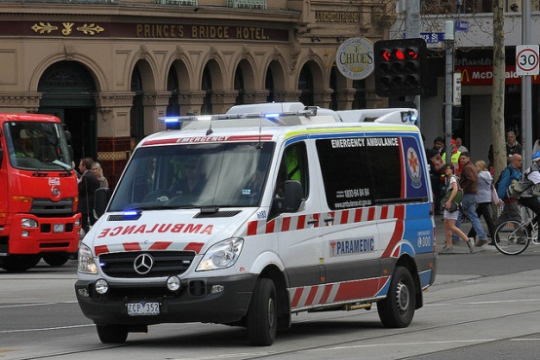

*Photo courtesy of Ambulance Victoria*

Things to consider when determining   
sub-addresses at complex sites

To ensure consistency in the way sub-addresses are applied and therefore make it easy to identify and locate individual sites or addresses, it is recommended that sub-addresses are consistent with AS/NZ 4819 Rural and Urban Addressing.

When allocating sub-addresses:

* use a consistent format and logical sequence for all sub-addresses within the site
* avoid using alphabetical prefixes.

More information

In the first instance, contact your local council. For additional information on this program, please contact the Vicmap Helpdesk on T: (03) 5336 6770 or   
E: [vicmap.help@delwp.vic.gov.au](mailto:vicmap.help@delwp.vic.gov.au)

This program has the support of the following organisations

 



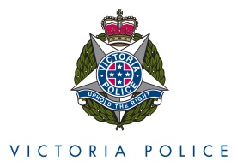



|  |  |  |  |  |  |  |  |  |  |  |  |  |  |
| --- | --- | --- | --- | --- | --- | --- | --- | --- | --- | --- | --- | --- | --- |
| |  |  | | --- | --- | | © The State of Victoria Department of Environment, Land, Water and  Planning 2020  byThis work is licensed under a [Creative Commons Attribution 4.0 International licence](http://creativecommons.org/licenses/by/4.0/). You are free to re-use the work under that licence, on the condition that you credit the State of Victoria as author. The licence does not apply to any images, photographs or branding, including the Victorian Coat of Arms, the Victorian Government logo and the Department of Environment, Land, Water and Planning (DELWP) logo. To view a copy of this licence, visit <http://creativecommons.org/licenses/by/4.0/>  **Disclaimer** This publication may be of assistance to you but the State of Victoria and its employees do not guarantee that the publication is without flaw of any kind or is wholly appropriate for your particular purposes and therefore disclaims all liability for any error, loss or other consequence which may arise from you relying on any information in this publication. | **Accessibility**  If you would like to receive this publication in an alternative format, please telephone DELWP Customer Service Centre on 136 186 or email [customer.service@delwp.vic.gov.au](mailto:customer.service@delwp.vic.gov.au). Alternatively, telephone the National Relay Service on 133 677 ([www.relayservice.com.au)](http://www.relayservice.com.au). This document is also available on the internet at [www.delwp.vic.gov.au](http://www.delwp.vic.gov.au). | | |  | |  | |  | |  | |  | |
|  | |  | |  | |  | | © The State of Victoria Department of Environment, Land, Water and  Planning 2016  byThis work is licensed under a [Creative Commons Attribution 4.0 International licence](http://creativecommons.org/licenses/by/4.0/). You are free to re-use the work under that licence, on the condition that you credit the State of Victoria as author. The licence does not apply to any images, photographs or branding, including the Victorian Coat of Arms, the Victorian Government logo and the Department of Environment, Land, Water and Planning (DELWP) logo. To view a copy of this licence, visit <http://creativecommons.org/licenses/by/4.0/>  **Disclaimer** This publication may be of assistance to you but the State of Victoria and its employees do not guarantee that the publication is without flaw of any kind or is wholly appropriate for your particular purposes and therefore disclaims all liability for any error, loss or other consequence which may arise from you relying on any information in this publication. | | **Accessibility**  If you would like to receive this publication in an alternative format, please telephone DELWP Customer Service Centre on 136 186 or email [customer.service@delwp.vic.gov.au](mailto:customer.service@delwp.vic.gov.au). Alternatively, telephone the National Relay Service on 133 677 ([www.relayservice.com.au)](http://www.relayservice.com.au). This document is also available on the internet at [www.delwp.vic.gov.au](http://www.delwp.vic.gov.au). | |