For retirement and lifestyle villages, universities, shopping centres, sports facilities, tourist venues, caravan parks and residential parks.

## We need to put your site on the map

**The complex site addressing program’s goal is to record unique identification, i.e. an address, in Vicmap for each sub-address within large or complex sites.**

**It is important that dwellings and infrastructure are addressed and associated to the street that provides direct access to the site.**

These sites can include retirement and lifestyle villages, caravan and residential parks, universities, shopping centres, camping sites, sporting facilities and tourist venues.

By doing this, the program is improving the property addressing system in Victoria and supporting efficient and effective delivery of emergency and postal services as well as a range of government activities.

The program is defining the processes for capturing, storing, maintaining, geocoding, accessing and distributing Victorian address data from [Vicmap](https://www.land.vic.gov.au/maps-and-spatial/spatial-data/vicmap-catalogue/about-vicmap), the state’s authoritative spatial data suite.

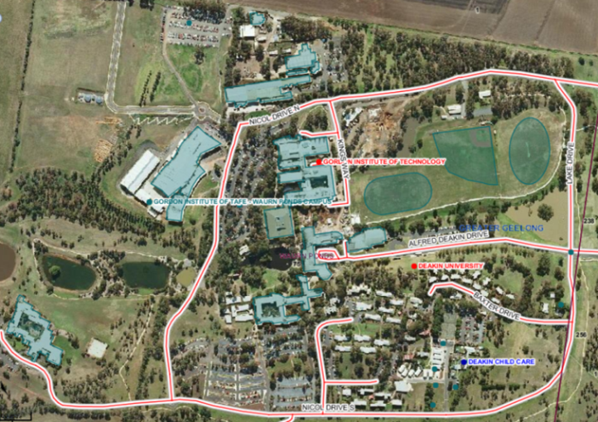

Deakin University, a complex site

## Why do we need complex site addressing?

Need more information?

Find out more about the government’s initiatives at [dtp.vic.gov.au](https://www.dtp.vic.gov.au/)



Large and complex sites like retirement villages can often be made up of hundreds of buildings, along with pre-existing building and road names, but often these sites are only known by a single address, e.g. Gallagher Street.

Unique and accurate place naming reduces the change of delaying service providers such as emergency services when they need to quickly and easily find and access a particular location.

Another example might be a tourist venue, caravan or residential park that is known by a single address, e.g. 46 Morrison Way, but has named roads with many individual dwellings and sites within it.

To help solve this, the complex site addressing program will create a unique identification (address) for each sub-address within a large site. Each sub-address will then be identified, placed in its actual location on a map, and added to Vicmap.

When road names and building numbers have been assigned, appropriate signage should be installed so that emergency and other services can navigate to specific addresses.

For standard residential sites, addresses are assigned by the local council. A residence is typically associated with one land title, one property (for rating purposes) and one address. This information is typically already in Vicmap and available to emergency and other services.

## How site managers can help

Many complex sites already have site plans that might show internal roads, dwellings and sites. This might include:

* road names
* house/unit/cabin numbers
* internal points of interest
* community buildings such as camp kitchens, games rooms, laundries and kiosk etc.

Local councils require accurate site plans to be supplied with all of these features clearly marked. This ensures councils can capture correct address information to be included in Vicmap.

As site managers and site operators, you have invaluable local knowledge. You can use an existing site plan and map (if all the address information is present) or add the necessary information to an existing plan and send it to your local council.

If you are unable to locate a site plan or have difficulty accurately identifying and marking address information on a plan, your local council can help. You should contact your local council and request a plan or aerial image of your site to identify and mark down all relevant features.

By doing this you will improve service delivery to and within your site.

Local councils can also provide you information about address identification, as well as correct addressing and road naming procedures that comply with the [Naming rules for places in Victoria](https://www.land.vic.gov.au/place-naming/understand-the-naming-process/the-naming-rules).



Photo courtesy of Ambulance Victoria

## Things to consider when determining sub-addresses at complex sites

It is recommended that sub-addresses are consistent with AS/NZ 4819 Rural and Urban Addressing. This will ensure consistency in the way sub-addresses are applied and make it easy to identify and locate individual sites or addresses.

When allocating sub-addresses:

* use a consistent format and logical sequence for all sub-addresses within the site
* avoid using alphabetical prefixes.

## More information

In the first instance, contact your local council. For additional information on this program, please contact the Vicmap Helpdesk by calling (03) 5336 6770 or emailing [Vicmap.help@transport.vic.gov.au](mailto:Vicmap.help@transport.vic.gov.au)

## This program has the support of the following organisations:













