

Guide to leader / follower dealings involving plan based dealings

Lodging across the Electronic Lodgment Networks (ELNs)
Version 1

Contents
Introduction 2
What are leader/follower dealings? 2
Leader dealing 2
Follower dealing 2
Case 2
Standalone dealing 2
Processes for submitting leader/followers in ELNs 3
Generic Residual Document (GRD) Transfer of Land Act - Section 104 3
SPEAR ELN: Submit for Pre-Lodgement Check 3
Common leader/follower examples 4
Transfer of Land for land acquired by agreement in a plan under section 35 of the Subdivision Act 1988 4
Plan of subdivision/consolidation and Transfer(s) to resolve NICO proprietorship 5
Multiple SPEAR applications affecting the same folio(s) 6
Plans under section 32A of the Subdivision Act and subsequent transactions 6
Roads discontinued under the Local Government Act 1989 and subsequent transactions 6
Changing the order of registration for leader/follower dealings 7

Introduction
Many electronic instruments are registered or recorded very soon after lodgment. These include:
- transfers
- mortgages
- discharge of mortgage
- caveats
- withdrawals of caveats
- transmission applications
- survivorship applications
Nearly all remaining instrument types are electronically lodged as a residual document or through SPEAR. Paper instruments that can’t be lodged electronically are submitted in a Generic Residual Document (GRD) Transfer of Land Act - Section 104.
Most transaction types require manual examination after they have been lodged at Land Use Victoria (LUV). These instruments which are examined after lodgment have the status ‘unregistered’ on the folio’s activity statement until they are registered.
What are leader/follower dealings?
Leader/follower dealings occur when multiple transactions are lodged against the same folio(s) before the first transaction is registered or recorded.

Leader dealing
A ‘leader dealing’ is the first plan/instrument lodged against a folio when multiple dealings are lodged.

Follower dealing
‘Follower dealing’ is the term used for subsequent plan/instrument(s) lodged against the same folio before the first plan/instrument is registered.

Case
A group of leader/follower dealings affecting the same folio and lodged together is referred to as a ‘case’. The ability to deal with plans/instruments as a case will depend on the combination and type of transactions.
Transactions lodged across different ELNs are not automatically linked as a case, therefore the order in which instruments/plans affecting the same folio(s) are submitted in the ELNs is important to avoid complications.

Standalone dealing
‘Standalone dealing’ means a single plan/instrument lodged against a folio. There are no other dealings expected against the folio before or after its registration.

Subsequent transactions may still be considered ‘standalone’ when they cannot be submitted in an ELN until after an earlier transaction is registered (e.g. transfer of land after the creation of new folios). Such transactions must be lodged and registered independently i.e. they cannot be lodged as a leader/follower ‘case’.
When a leader dealing results in the cancellation of folio(s), follower dealings may need to be withdrawn so that the instrument is lodged correctly against the current ‘live’ child folio(s). Full fees are payable upon re-lodgment.

Processes for submitting leader/followers in ELNs

Generic Residual Document (GRD) Transfer of Land Act - Section 104
Only paper instruments that are exempt from electronic lodgment can be submitted in a Generic Residual Document (GRD) Transfer of Land Act - Section 104. This is currently only available via PEXA ELN.
Acceptable reasons are set out in the paper instrument acceptance form.
A covering letter must be supplied with paper instrument(s) contained in a GRD that relate to another plan/instrument being lodged against the same folio (e.g. leader/follower dealings). The letter must list the associated transactions by SPEAR reference(s) and/or dealing numbers and include the desired order of registration.

SPEAR ELN: Submit for Pre-Lodgement Check
When the SPEAR lodgment contains a plan/instrument relating to another plan/instrument (leader/follower dealings), you must use the field ‘Please list any leader or follower dealings you intend to submit with this application’ when submitting for pre-lodgement check in SPEAR. Specify the plan/instrument e.g. GRD dealing number (e.g. AZ123457A) or SPEAR references to assist in timely lodgments.
Figure 1: Submit for Pre-Lodgement Check screen in SPEAR: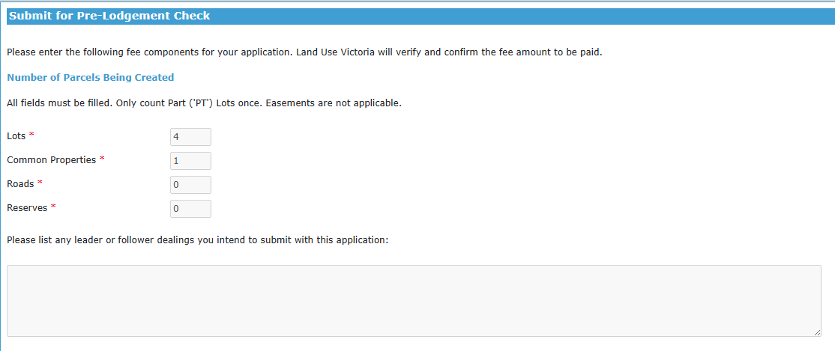
Once LUV accepts the pre-lodgement check, the lodging party must complete ‘pay and lodge’ for the plan/instrument to be ‘Lodged at Land Use Victoria’.

Common leader/follower examples
With most transactions now lodged electronically, leader/follower dealings may be lodged across different ELNs.
The varied processing times across the different ELNs affects the order in which transactions should be submitted. Therefore, the order of submission in an ELN is not always the order of registration (see common leader/follower examples that follow).
It is important to note that if a plan/instrument results in folio(s) being cancelled, any subsequent dealings mandated for electronic lodgment through an ELN (e.g. discharge of mortgage or mortgage) should not be lodged until after the plan/instrument is registered and new folio(s) issued. This avoids the need to withdraw instrument(s) and re-lodge over the correct new folio(s).
The following outlines common leader/follower examples that require lodgment across different ELNs.

Transfer of Land for land acquired by agreement in a plan under section 35 of the Subdivision Act 1988
Regulation 22 of the Subdivision (Registrar's Requirements) 2021 requires the relevant vesting transfer(s) and Certificates of Title to be supplied at lodgment of the plan of subdivision under section 35 of the Subdivision Act.
The plan of subdivision and transfer(s) for the acquired land are lodged through different ELN platforms:
- plan of subdivision electronically via SPEAR and
- transfer(s) for the land acquired by agreement, paper instrument supplied through PEXA Generic Residual Document (GRD) Transfer of Land Act - Section 104.
Before submitting the plan of subdivision for pre-lodgement check in SPEAR, lodging parties must ensure:
- the Certificate of Title(s) have been nominated by the eCT controlling party, or are in the eCT Control of the lodging party, and
- the relevant transfer(s) have been assessed for duty by the SRO.
First, in PEXA, submit the paper transfer instrument in a Generic Residual Document (GRD) Transfer of Land Act - Section 104 to receive a dealing number. In the GRD include a covering letter that references the SPEAR application/plan of subdivision that requires the transfer to be lodged.
Then, in SPEAR, when performing the ‘Submit for pre-lodgement check’ for the plan of subdivision, add the GRD dealing number (e.g. AZ123457A) in the field ‘Please list any leader or follower dealings you intend to submit with this application’ (see figure 1, page 3).
Plans under section 35 of the Subdivision Act 1988 where the land is acquired by agreement will be refused by LUV if the relevant GRD dealing number containing the paper transfer instrument has not been referenced in the ‘Submit for pre-lodgement check’.
New folios created as a result of the above issue eCT Control in accordance with the business rules for determining eCT Control after a transaction. For more information see Guide to Certificate of Title and Administrative Notices.

Plan of subdivision/consolidation and Transfer(s) to resolve NICO proprietorship
A plan of subdivision that includes two or more folios held in different ownership, may result in folios with NICO proprietorship and encumbrances ‘as to part’ depending on the new boundaries for parcels created in the plan. Plans of consolidation that include two or more folios held in different proprietorship will always result in NICO.
The timing of lodgment for subsequent transactions is dependent on the type of instrument and the ELN it is submitted through.
Transfers to resolve NICO proprietorship have not been mandated for electronic lodgment in an ELN and instead, a paper instrument must be submitted through PEXA Generic Residual Document (GRD) Transfer of Land Act - Section 104.
It is recommended these paper transfers are lodged before the plan is registered.
This leader/follower example requires three separate lodgments through the ELNs:
- plan of subdivision lodged through SPEAR (leader dealing)
- paper transfer instrument to resolve NICO proprietorship submitted through PEXA GRD (follower dealing)
- electronic discharge of mortgage and mortgage in an ELN (standalone dealings)
Step 1: The GRD containing the paper transfer instrument to resolve NICO proprietorship should be submitted to receive a dealing number (e.g. AZ123456A). A covering letter must be included that specifies there are multiple transactions anticipated against the folio(s). Please include the SPEAR reference and/or the plan number and the expected order of registration.
Step 2: Then the plan of subdivision can be submitted through SPEAR for pre-lodgement check ensuring the GRD dealing number (e.g. AZ123456A) is referenced under ‘Please list any leader or follower dealings you intend to submit with this application’ (see figure 1, page 3).
New folios created as a result of the above issue eCT Control in accordance with the business rules for determining eCT Control after a transaction. For more information see Guide to Certificate of Title and Administrative Notices.
Step 3: Once the new folios have issued from the plan of subdivision and the transfer instruments are registered, any subsequent dealings (e.g. discharge of mortgage and mortgage) can be lodged electronically over the new folios in the appropriate ELN.
For more information on NICO, please see Guide to NICO.

Multiple SPEAR applications affecting the same folio(s)
When multiple SPEAR applications affecting the same folio(s) are to be lodged as a leader/follower ‘case’, the pre-lodgement check must be accepted by LUV for all applications to enable these plans/instruments to be dealt with as a leader/follower ‘case’.
When submitting for pre-lodgement check ensure the plan or SPEAR reference for leader/followers are entered under ‘Please list any leader or follower dealings you intend to submit with this application’ (see figure 1, page 3).
Plans/instruments are not ‘Lodged at Land Use Victoria’ until the lodging party completes ‘pay and lodge’. ‘Pay and lodge’ must be completed in the order in which the plan/instrument(s) are to be registered.
Once lodged at LUV, the plan/instruments are linked by the volume and folio reference(s).
New folios created as a result of the above issue eCT Control in accordance with the business rules for determining eCT Control after a transaction. For more information see Guide to Certificate of Title and Administrative Notices.

Plans under section 32A of the Subdivision Act and subsequent transactions
The effects of registration for a plan under section 32A of the Subdivision Act 1988 are outlined in section 32A(3) of the Act.
As the land affected by previous owners corporation(s) is freed from any mortgage, new folios issue in the eCT Control of the lodging party in accordance with the business rules for determining eCT Control after a transaction. For more information see Guide to Certificate of Title and Administrative Notices.
It is the responsibility of the lodging party of the plan to ensure parties with a registered interest such as mortgagees that the land is freed from are notified.
All transactions after the section 32A plan are standalone transactions mandated for electronic lodgement in an ELN and include:
- transfers to resolve resultant tenants in common proprietorship that may be required if the land was owned by more than one lot owner and
- those parties who wish to reinstate their interests on the new folio(s) must take the appropriate steps to lodge the subsequent transactions (e.g. caveat, mortgage, charge, lease, sub-lease).
It is crucial these transactions are not submitted in an ELN until after the plan is registered and the new folio(s) issued as this will result in the need to withdraw these instruments and additional fees being paid upon resubmission.

Roads discontinued under the Local Government Act 1989 and subsequent transactions
If a road or part of a road is discontinued pursuant to section 206 schedule 10 clause 3 of the Local Government Act 1989 (LGA) and vested pursuant to Section 207B of the LGA in a council after publication of the required notice in a Government Gazette, council can make an application under section 207D of the LGA through SPEAR.
Once lodged at LUV and examined, new folio(s) will issue in the name of council for the parcel(s) of the discontinued road or part of a road upon registration of the application.
If adjoining land owner(s) purchase the discontinued road or part of a road, any subsequent transfer(s) for the newly created folio(s) from council to adjoining land owner(s) are standalone transactions mandated for electronic lodgement in an ELN.
It is crucial that subsequent transactions are not submitted in an ELN until after the application under section 207D is registered and the new folio(s) issued as this will result in the need to withdraw these instruments and additional fees being paid upon resubmission.
If the adjoining land owner is also lodging a plan of consolidation (or subdivision) of their folio and the purchased discontinued road or part of a road, this must not be submitted for pre-lodgement check in SPEAR until after the standalone electronic transfer has been registered in an ELN.

These processes may also apply for scenario(s) where council vest and/or remove reserve status in a plan under section 24A of the Subdivision Act 1988 and there are subsequent electronic transfer(s) in an ELN to an adjoining land owner followed by a plan of consolidation (or subdivision) of the parcels by the adjoining land owner.

Changing the order of registration for leader/follower dealings
Plans/instruments are typically registered in the order in which they are lodged (with the above examples being the exception).
If plans/instruments are to be registered out of lodgment order, all parties of each individual transaction must supply their written consent to the new order of registration.

