|  |
| --- |
| GDA2020 transformation in Victoria |
| Technical guidance for the transformation of spatial information between GDA94 and GDA2020 | | |

## Introduction

The transition to the new Geocentric Datum of Australia 2020 (GDA2020) from the old Geocentric Datum of Australia 1994 (GDA94) will see horizontal coordinates shift by approximately 1.5m - 1.6m in a north-easterly direction across Victoria. This fact sheet provides technical guidance for those involved in the collection, management and distribution of spatial information in Victoria, who will manage the transformation between GDA94 and GDA2020.

## Transformation products

To support the transformation of spatial data between GDA94 and GDA2020, the Intergovernmental Committee on Surveying and Mapping (ICSM) developed three transformation products that are, efficient, unique, rigorous in application and simple to apply. These include:

Table 1: GDA94 to GDA2020 transformation products

|  |  |  |  |
| --- | --- | --- | --- |
| Transformation product | EPSG code | Format | Description |
| 7-parameter (conformal) | 8048 | Parameters | **Recommended for the transformation of spatial information in Victoria.** Accounts for the tectonic plate motion from 1994 to 2020 and the update of the underlying reference frame. Although designed for three-dimensional data, this transformation approach is applied to two-dimensional data in some desktop software as the technique with least uncertainty and this is deemed suitable. |
| Conformal only grid | 8446 | NTv2 grid | **Recommended for the transformation of two-dimensional spatial information in Victoria.** This grid is consistent in application, replicates the behaviour of the 7-parameter conformal transformation and maintains the shape of spatial information being transformed. |
| Conformal + distortion grid | 8447 | NTv2 grid | This grid was designed to extend upon the conformal only grid and account for modelled distortion between adjusted GDA94 and GDA2020 survey control mark coordinates. Across Victoria the grid closely matches the conformal only grid with distortion only modelled around the state borders. Also, due to ongoing revision of survey control mark information, the modelled distortion within this grid is gradually becoming outdated. **Only consider this grid in Victoria if transforming data that extends across the state borders and was derived directly from the survey control mark network.** |

## Selection of transformation approach

The accuracy and origin of spatial information are important considerations when selecting the appropriate transformation approach. This includes the option to not transform data if it is considered GDA2020 compatible, such as data with a horizontal accuracy exceeding 3m. **Either of the conformal transformation options (7-parameter or conformal only grid) are recommended for the transformation of spatial data in Victoria.** Figure 1 supports the selection of the appropriate transformation option based on horizontal accuracy.

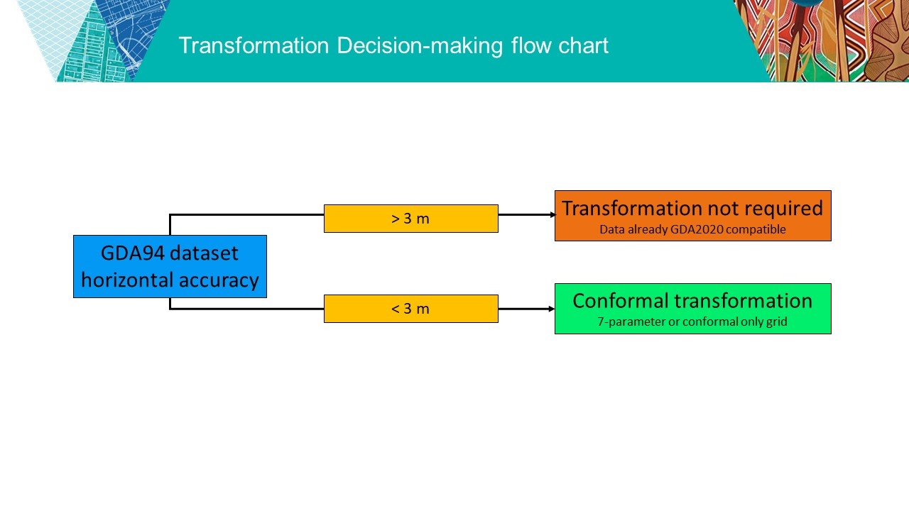

**Figure 1: Victoria spatial data transformation decision support diagram**

## WGS84 transformation

Careful consideration and caution must be applied if combining datasets and interacting with WGS84. This is due to the difficulty tracking the various, time-dependent realisations of WGS84 as well as the ‘WGS84 / Web Mercator’ projection (EPSG: 3857). This projection is considered an ‘ensemble’ of WGS84 realisations and commonly used in web mapping applications being suitable for low-accuracy (metre-level) applications. There is potential for 1.5-1.6m misalignment when attempting to combine GDA94 and GDA2020 data in WGS84 web-mapping applications due to the adoption of a null-transformation between WGS84 and both GDA94 and GDA2020.

## Useful resources

The ICSM GDA2020 website, www.icsm.gov.au/gda2020, is the authoritative online reference for GDA2020 and transformation information. The website includes background information as well as links to the GDA2020 Technical Manual, transformation grids, transformation software and other technical products.

## Support contact

In Victoria, the Surveyor-General Victoria (SGV) Geodesy section has led the technical development of GDA2020 and is actively encouraging and supporting organisations in the transition of their spatial information and applications to the new national datum. Please contact SGV Geodesy for support with the transition to the new GDA2020.

Phone: 03 9194 0770

Email: smes.support@delwp.vic.gov.au

|  |  |
| --- | --- |
| © The State of Victoria Department of Environment, Land, Water and Planning 2021  LogoThis work is licensed under a Creative Commons Attribution 4.0 International licence. You are free to re-use the work under that licence, on the condition that you credit the State of Victoria as author. The licence does not apply to any images, photographs or branding, including the Victorian Coat of Arms, the Victorian Government logo and the Department of Environment, Land, Water and Planning (DELWP) logo. To view a copy of this licence, visit http://creativecommons.org/licenses/by/4.0/  Disclaimer  This publication may be of assistance to you but the State of Victoria and its employees do not guarantee that the publication is without flaw of any kind or is wholly appropriate for your particular purposes and therefore disclaims all liability for any error, loss or other consequence which may arise from you relying on any information in this publication. | Accessibility  If you would like to receive this publication in an alternative format, please telephone the DELWP Customer Service Centre on 136186, email [customer.service@delwp.vic.gov.au](mailto:customer.service@delwp.vic.gov.au), or via the National Relay Service on 133 677 [www.relayservice.com.au](http://www.relayservice.com.au). This document is also available on the internet at [www.delwp.vic.gov.au](http://www.delwp.vic.gov.au). |