Factsheet

Airborne gravity surveys in Victoria

Airborne gravity surveys are being conducted to improve the vertical accuracy of GPS and better understand Victoria’s geology.
The airborne gravity surveys are being conducted across Victoria in 2023. Stakeholders and the general public are being advised of the surveys before they occur across specific areas.

Introduction
Surveyor-General Victoria, part of the Department of Transport and Planning (DTP), and the Geological Survey of Victoria, part of the Department of Energy, Environment and Climate Action (DEECA), are collaborating with Geoscience Australia (GA) to capture airborne gravity data over targeted regions of Victoria.
The objective is to collect consistent and evenly distributed gravity measurements. The new survey data will significantly improve Victoria’s gravity model and the accuracy of real-world heights from GPS. The data will also be used by geoscientists to further their understanding of southeast Australia’s geological ‘architecture’ and how it has evolved over time.
The surveys will be performed by an experienced contractor, Sander Geophysics Limited. The aircraft will fly in public airspace at 150 metres over rural areas, increasing to 300 metres over built-up areas. DTP, DEECA and GA are notifying stakeholders about the surveys before they are performed across regions.

Planned survey areas
Airborne gravity data is being collected over large regions including the central coast, Melbourne, the Australian Alps and eastern Victoria (see Figure 1). The surveys require flights over diverse land types including urban and rural areas, mountainous and coastal terrain and national and state parks and reserves. There is no ground disturbance.

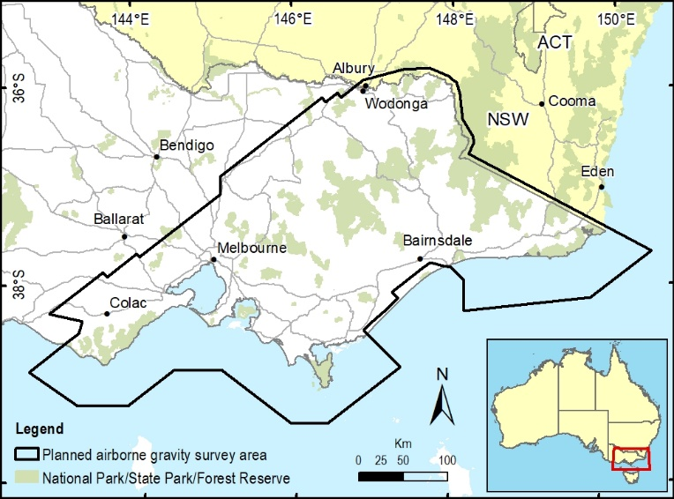
Figure 1 Airborne gravity survey area

Gravity surveys in Victoria
Victoria has some of the best coverage of ground gravity data in Australia, but some areas such as the alpine and coastal regions are difficult to access. This limits gravity data coverage, with corresponding local uncertainty in the gravity model.
Airborne gravity surveys fill these gaps by capturing consistent and evenly distributed gravity measurements across large areas with minimal disturbance to land users and the environment.

Flight operations
The surveys are being conducted throughout 2023 and will take several months to complete. The flight schedule is weather dependent and subject to change. Stakeholders and the general public will be notified at least two weeks before airborne surveys start.
The survey operations will be conducted by Sander Geophysics Limited, an airborne gravity survey specialist contractor. Experienced pilots operating a DHC-6 Twin Otter fixed wing aircraft will fly along a planned route with flight lines spaced 500 metres to 1 km apart. The aircraft will fly in public airspace at a nominated ground clearance of 150 metres, increasing to 300 metres over built-up areas.
An independent air safety audit has been conducted on the aircraft and flight plans. Flying will only occur in favourable weather conditions.
Figure 2 DHC-6 Twin Otter fixed wing aircraft

Impact on the environment
The DHC-6 Twin Otter is a standard aircraft with scientific instruments on board. Noise levels on the ground will be transient and less than the sound of a motorbike.
Specialised gravity-sensing instrumentation will be used to measure extremely small variations in the Earth’s natural gravitational pull. The gravity instruments are passive and do not emit any signals or impact people, animals or infrastructure in any way.

Survey benefits
The data and gravity model will improve height determination from GPS positioning to an accuracy of a few centimetres. The changes will support productive and effective land management and technological innovation and meet community expectations of reliable GPS positioning in Victoria.
The new data will also advance the geoscience that assists the Victorian Government to manage its earth resources, infrastructure and natural hazards. It will also assist the state’s resources sector, which contributes to regional jobs and economic growth.

Data availability
The survey data needs to be processed and quality checked before being released for use. Data will be freely available through the Victorian Government’s open data platforms and licensed for public use. The data will also be included in the national geoscience database and data portals managed by GA.

For more information
DTP, DEECA and GA are notifying stakeholders and the general public of the surveys at least two weeks before starting airborne operations across regions. This includes local newspaper advertisements, webpage updates and direct notification to people or organisations who have registered interest. If you or your organisation would like more information, please contact DTP:
Phone: 03 9194 0770
Email: smes.support@delwp.vic.gov.au
Web: www.land,vic.gov.au/surveying/geodesy/airborne-gravity-survey

Need more information?
Find out more about the government’s
initiatives at dtp.vic.gov.au

