|  |
| --- |
| Vicmap™ Product Development |
| Change Notice # VT55 Advisory Notice |

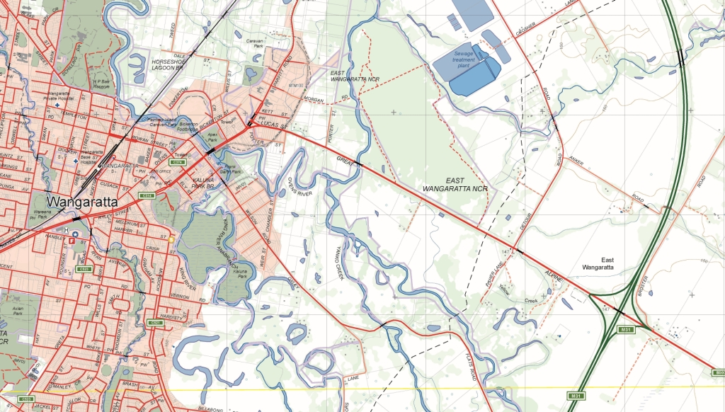

Vicmap Transport 10 July 2019

## What is happening

New columns will be added to the data schema for Vicmap Transport to enable capture of additional information.

GAZETTAL_DATE - Date (10) eg DD/MM/YYYY

GAZETTAL_REGISTRATION - Varchar2(15) eg G012 1995 p742

ROAD_NAME_THEME - Varchar2(1) eg ‘ANZAC’, ‘ABORIGINAL’, ‘OTHER’

GAZETTAL_URL - Varchar2(200) eg <http://www.gazette.vic.gov.au/gazette/Gazettes2019/GG2019G009.pdf#page=40>

This enhancement will enable users to ascertain when a road name was gazetted, its gazette reference, road name theme and provide a link to the gazette URL.

Users will no longer need to locate the electronic gazette notice via a web search, but will have all the information on hand. The addition of the road name theme will enable reporting on which roads are for example Aboriginal in origin.

## Why this change is occurring

VICNAMES – The Register of Geographic Names requires amendments to Vicmap Transport to enable display of gazette information within VICNAMES. It is a requirement of the ***Geographic Place Names Act 1998*** that the Registrar of Geographic Names establishes a Register of Geographic Names.

The Vicmap Transport layer known as TR_ROAD_LOCALITY will be the layer to be updated.

## Who will it affect

This will affect all users of Vicmap Transport.

## When the change will occur | How to provide feedback |

The change will be implemented **on the 31/07/2019.**

For Vicmap Product change notices and bulletins, go to the [News and Bulletins](http://www.delwp.vic.gov.au/parks-forests-and-crown-land/spatial-data-and-resources/news-and-bulletins) page.

For further information & feedback please email [vicmap.help@delwp.vic.gov.au](mailto:vicmap.help@delwp.vic.gov.au).

|  |  |
| --- | --- |
| © The State of Victoria Department of Environment, Land, Water and Planning 2019  LogoThis work is licensed under a Creative Commons Attribution 4.0 International licence. You are free to re-use the work under that licence, on the condition that you credit the State of Victoria as author. The licence does not apply to any images, photographs or branding, including the Victorian Coat of Arms, the Victorian Government logo and the Department of Environment, Land, Water and Planning (DELWP) logo. To view a copy of this licence, visit http://creativecommons.org/licenses/by/4.0/  Disclaimer  This publication may be of assistance to you but the State of Victoria and its employees do not guarantee that the publication is without flaw of any kind or is wholly appropriate for your particular purposes and therefore disclaims all liability for any error, loss or other consequence which may arise from you relying on any information in this publication. | Accessibility  If you would like to receive this publication in an alternative format, please telephone the DELWP Customer Service Centre on 136186, email [customer.service@delwp.vic.gov.au](mailto:customer.service@delwp.vic.gov.au), or via the National Relay Service on 133 677 [www.relayservice.com.au](http://www.relayservice.com.au). This document is also available on the internet at [www.delwp.vic.gov.au](http://www.delwp.vic.gov.au). |

Keep all content above this instruction text line. Delete only when document formatting is complete.