|  |
| --- |
| Vicmap Product Development |
| Change Notice # 252 |

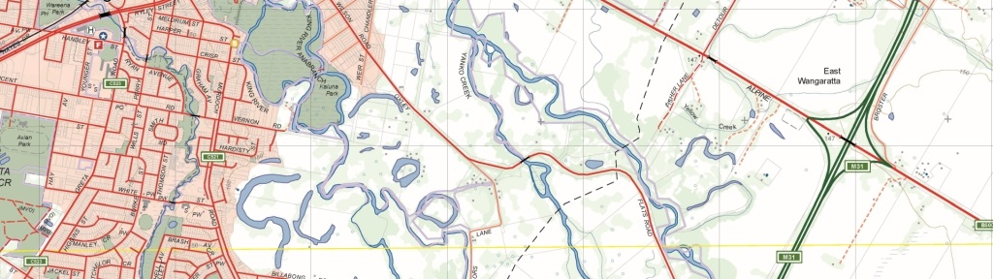

Vicmap Admin – Ward boundaries

## What is happening

From 10 August 2020, WARD_2020 is being added to Vicmap Admin.

From 4 January 2021, WARD_2017 will be removed from Vicmap Admin.

## Why this change is occurring

The WARD_2017 boundaries will become out of date as of the Council elections (in October 2020) and will be superseded by WARD_2020.

## Who it will affect

This change will affect all users of Vicmap Admin. Incremental Update Format (IUF) customers will not be affected as part of this change.

Anyone who uses ward boundary data from the Vicmap Administration product needs to be aware that there will be two ward datasets in Vicmap Admin (WARD_2017 and WARD_2020) until the 4th January 2021.

## When the change will occur

WARD_2020 will be added to Vicmap Admin on 10 August 2020 and WARD_2017 will be removed from Vicmap Admin on 4 January 2021.

## Background

The WARD_2020 dataset of Victorian local government ward boundaries was created by the Victorian Electoral Commission on behalf of Local Government Victoria (as part of the Electoral Representation Review process). New extracts are triggered by changed ward boundaries from Electoral Representation Reviews or Subdivision Reviews. The WARD_2020 boundaries will be used for all the Councils holding elections in October 2020.

## General Notes

WARD_2017 will remain in the Vicmap Admin product until after the council elections in October 2020. WARD_2017 will be removed from the product but will be accessible as an individual dataset from DataSearch Victoria.

## How to provide feedback

For Vicmap Product change notices and bulletins, go to the [News and Bulletins](http://www.delwp.vic.gov.au/parks-forests-and-crown-land/spatial-data-and-resources/news-and-bulletins) page.

For further information & feedback please email [vicmap.help@delwp.vic.gov.au](mailto:vicmap.help@delwp.vic.gov.au)

|  |  |
| --- | --- |
| © The State of Victoria Department of Environment, Land, Water and Planning 2020  LogoThis work is licensed under a Creative Commons Attribution 4.0 International licence. You are free to re-use the work under that licence, on the condition that you credit the State of Victoria as author. The licence does not apply to any images, photographs or branding, including the Victorian Coat of Arms, the Victorian Government logo and the Department of Environment, Land, Water and Planning (DELWP) logo. To view a copy of this licence, visit http://creativecommons.org/licenses/by/4.0/  Disclaimer  This publication may be of assistance to you but the State of Victoria and its employees do not guarantee that the publication is without flaw of any kind or is wholly appropriate for your particular purposes and therefore disclaims all liability for any error, loss or other consequence which may arise from you relying on any information in this publication. | Accessibility  If you would like to receive this publication in an alternative format, please telephone the DELWP Customer Service Centre on 136186, email [customer.service@delwp.vic.gov.au](mailto:customer.service@delwp.vic.gov.au), or via the National Relay Service on 133 677 [www.relayservice.com.au](http://www.relayservice.com.au). This document is also available on the internet at [www.delwp.vic.gov.au](http://www.delwp.vic.gov.au). |

Keep all content above this instruction text line. Delete only when document formatting is complete.