delwp.vic.gov.au

|  |
| --- |
| EDM Calibration Handbook  Edition 17 |
|  |
| December 2020 |

|  |  |
| --- | --- |
|  |  |

|  |  |  |  |
| --- | --- | --- | --- |
|  |  |  |  |
|  |  |  |  |

|  |
| --- |
| Acknowledgment  We acknowledge and respect Victorian Traditional Owners as the original custodians of Victoria's land and waters, their unique ability to care for Country and deep spiritual connection to it. We honour Elders past and present whose knowledge and wisdom has ensured the continuation of culture and traditional practices.  We are committed to genuinely partner, and meaningfully engage, with Victoria's Traditional Owners and Aboriginal communities to support the protection of Country, the maintenance of spiritual and cultural practices and their broader aspirations in the 21st century and beyond. |
| © The State of Victoria Department of Environment, Land, Water and Planning 2020  LogoThis work is licensed under a Creative Commons Attribution 4.0 International licence. You are free to re-use the work under that licence, on the condition that you credit the State of Victoria as author. The licence does not apply to any images, photographs or branding, including the Victorian Coat of Arms, the Victorian Government logo and the Department of Environment, Land, Water and Planning (DELWP) logo. To view a copy of this licence, visit <http://creativecommons.org/licenses/by/4.0/>  Disclaimer  This publication may be of assistance to you but the State of Victoria and its employees do not guarantee that the publication is without flaw of any kind or is wholly appropriate for your particular purposes and therefore disclaims all liability for any error, loss or other consequence which may arise from you relying on any information in this publication.  Accessibility  If you would like to receive this publication in an alternative format, please telephone the DELWP Customer Service Centre on 136186, email [customer.service@delwp.vic.gov.au](mailto:customer.service@delwp.vic.gov.au), or via the National Relay Service on 133 677 [www.relayservice.com.au](http://www.relayservice.com.au). This document is also available on the internet at [www.delwp.vic.gov.au](http://www.delwp.vic.gov.au). |

|  |
| --- |
| EDM Calibration Handbook  Edition 17 |

|  |
| --- |
| Surveyor-General Victoria |

|  |
| --- |
| Report produced by:  Surveyor-General Victoria  Land Use Victoria  Department of Environment, Land, Water and Planning  2 Lonsdale Street  Melbourne, Victoria 3000  Phone (03) 9194 0770  Website: https://www.land.vic.gov.au/surveying/services/equipment-calibration-services |

|  |  |  |  |
| --- | --- | --- | --- |
|  |  |  |  |

Contents

Preface iii

1. Introduction 1

2. Legal traceability of length measurements 2

2.1 Background 2

2.2 Victorian Cadastral Surveys Practice Derivatives – July 2018 3

2.3 Surveying (Cadastral Surveys) Regulations 2015 3

2.4 Survey Co-ordination Regulations 2014 4

3. The theory of EDM calibration 5

3.1 Instrument errors 5

3.1.1 Additive constant (correction for zero index error) 5

3.1.2 Scale error 5

3.1.3 Cyclic error (short periodic error) 5

3.2 Baseline design 5

3.3 Pillars 6

4. Recommended observing procedure 7

4.1 General procedures 7

4.1.1 Booking sheets 7

4.1.2 Set up and shade 7

4.1.3 Atmospheric correction 7

4.1.4 Operations 7

4.1.5 Power 7

4.1.6 Height of instrument 7

4.1.7 Reflector mountings 8

4.1.8 Levelling of equipment 8

4.1.9 Conditions 8

4.1.10 Meteorological observations 8

4.1.11 Calibration measurements 8

4.2 Measurement sequence (excluding Bendigo and Geelong baselines) 8

4.2.1 EDM with a 10m unit length 8

4.2.2 EDM with unit lengths other than 10m 8

4.3 Measurement sequence - Bendigo and Geelong baselines only 9

4.3.1 EDM with a 10m unit length 9

4.3.2 EDM with unit lengths other than 10m 9

5. Location of baselines 10

6. EDM instrument parameters 18

6.1 Pulsed instruments and instruments with a unit length of zero 18

7. Reduction and interpretation 18

8. References 19

Appendices – sample booking sheets 20

Preface

In relation to land surveying, the professional surveyor is intent not only on measuring accurately, but on ensuring measurement integrity. Electronic Distance Meter (EDM) calibration baselines are essential for verifying the accuracy of EDM equipment against the national standard for length.

The Surveyor-General of Victoria sets standards for property surveys under the Surveying (Cadastral Surveys) Regulations 2015, including requirements for the calibration and standardisation of survey equipment. To help licensed surveyors meet these standards, Surveyor-General Victoria (SGV) issues practical implementation advice and provides certified calibration facilities.

The [Victorian Cadastral Surveys Practice Directives, July 2018](https://www.land.vic.gov.au/surveying/cadastral-survey/practice-directives) outlines requirements for the calibration of EDM instruments. It states that EDM instruments must be calibrated over a certified baseline at intervals not exceeding 12 months, or more frequently if conditions warrant it. It also states that a licensed surveyor’s report must detail calibration information about the EDM used in the survey, including; make and model, serial number, EDM calibration site and date of calibration.

This EDM calibration handbook provides the specification and practice direction for achieving EDM calibration at each of the six baselines across Victoria. SGV is a verifying authority for length (up to 1160 metres) and is responsible for the annual re-certification of the baselines as subsidiary standards of length.

The SGV Geodesy section provides the continued certification of the baselines and the periodic updates of the handbook, and we also acknowledge the assistance of Land Use Victoria staff throughout the state.

Surveyor-General Victoria acknowledges the co-operation and support provided by Brayley & Hayes Pty. Ltd., Nacha Moore Land Surveyors Pty. Ltd., SMEC Australia Pty. Ltd. (Gippsland) and St. Quentin Consulting Pty. Ltd. for their assistance with the Hamilton, Mitcham, Cowwarr and Geelong baselines, respectively.

Craig L Sandy

Surveyor-General of Victoria

December 2020

# Introduction

This handbook outlines the calibration and standardisation of Electronic Distance Meters (EDM) in Victoria.

There are six EDM calibration baselines in the state that are maintained as subsidiary standards of length and as such are suitable for the calibration and standardisation of EDM instruments. All baselines are designed to accommodate a number of different EDM unit lengths. In particular, Mitcham and Hamilton are of Sprent/Zwart (Hobart) design; Bendigo and Geelong are a modified Schwendener design; and Braeside and Cowwarr are custom designed to support the mass of EDM unit lengths available in the modern market.

The calibration of EDM is concerned with the determination of instrument errors; whereas, standardisation refers to the comparison of the instrument to a standard of length traceable to the national standard. Instruments must be calibrated within a prescribed level of precision in order to be standardised. Chapter 3 discusses the legal background of standardisation.

The theory of EDM calibration is summarised in Chapter 4 along with an explanation of the instrument errors that are determined.

The observing procedures outlined in Chapter 5 are based on the instructions on the ‘Verification of Electro-optical Short-Range Distance Meters on Subsidiary Standards of Length in the Form of EDM Calibration Baselines’ proposed by Dr. J.M. Rueger (1984).

EDM instrument operators who wish to perform calibrations need to book the use of baselines in advance using the online booking facility available through the Survey Marks Enquiry Service (SMES). Chapter 6 summarises the baselines and controlling offices that support EDM calibration operations.

Surveyor-General Victoria has adopted the EDM instrument calibration software known as Baseline, version 6.0.0.5. This software has been developed by the Western Australia Land Information Authority (Landgate) for the calibration of EDM instruments against standard baselines.

Legal traceability of length measurements

## Background

In accordance with Regulation 73 of the National Measurement Regulations 1999, Surveyor-General Victoria (SGV) is appointed as a Verifying Authority with respect to length. This enables certification of subsidiary standards of length to a certain precision pursuant to Regulation 13 of the National Measurement Regulations 1999.

Although not common, the validity of length measurement may be challenged in a court of law. The validity will be strengthened if traceability to the national standard can be proved.

In 1983 the National Standards Commission (NSC), now incorporated into the National Measurement Institute (NMI), formed a working party on the Calibration of Electromagnetic Distance Measuring (EDM) Equipment. Following both the recommendations of this working party and research by the NSC, it was established that monumented baselines could be certified as subsidiary standards of length under Regulation 13 of the National Measurement Regulations 1999 to provide legal traceability for EDM measurements.

The standard of length was transferred to baselines through use of standard tapes or EDM as prescribed by the NSC. The Kern Mekometer and the Comrad Geomensor were the only EDM prescribed by the NSC. These instruments needed to be compared with the national frequency standard and certified as reference standards prior to their use for baseline certification.

The Kern Mekometer ME3000 owned by Melbourne Water/WBCM Surveys Pty Ltd was used to certify the Victorian baselines in the past. When this instrument ceased operating in 1994, the Kern Mekometer ME5000 owned by Hydro Tasmania was used. From 2006 to 2018 a Leica TCA2003 total station, routinely certified by NMI, was used to certify the EDM baselines. In 2019, SGV purchased a Leica TS60 total station which will continue to be used to certify the six EDM calibration baselines in Victoria

An EDM is considered to measure distances traceable to the national standard of length if:

(a) it is calibrated on a certified baseline,

(b) it is calibrated in accordance with the procedures laid down herein,

(c) the current inter-pillar distances (as determined from re-verification measurements) are used to compute the calibration and

(d) the instrument correction has been computed to a prescribed level of precision.

Recommendations of specific interest from the working party of the NMI (formerly NSC) on the calibration of EDM Equipment of 1 February 1983, include:

**No.2** To be certified as a subsidiary standard a baseline must be capable of being calibrated with an uncertainty of ± (1.5 + 20 10-3 L) mm at the 95% confidence level, where L is the interval length in metres.

**No.8** It is recommended that, in general, the minimum standard for the uncertainty of calibration of an EDM is $±$ (4.00 + 20 10-3 L) mm at the 95% confidence level, where L is the interval length in metres.

Six Victorian calibration baselines are certified annually in accordance with Recommendation No.2. The calibration procedures outlined in this handbook and the analysis techniques contained in Baseline are capable of meeting the requirement of Recommendation No.8.

## Victorian Cadastral Surveys Practice Derivatives – July 2018

Surveyor-General of Victoria sets standards for surveying title boundaries through the Surveying Act 2004, Surveying (Cadastral Surveys) Regulations 2015, and standards of measurement under the Survey Co-ordination Regulations 2014.

These standards include calibration and standardisation of survey equipment, record keeping and reporting, specifications for units of measurement and levels of precision achievable.

SGV issues practice directives to aid licensed surveyors in the interpretation of regulations and inform them of changes to the requirements of either the Surveyors Registration Board of Victoria and/or SGV.

The [Victorian Cadastral Surveys Practice Directives, July 2018](https://www.land.vic.gov.au/surveying/cadastral-survey/practice-directives), address SGV’s requirements regarding calibration of EDM instruments.

**SGV has determined that an adequate survey equipment comparison process requires the calibration of EDM surveying instruments over a certified baseline at intervals not exceeding 12 months.**

Where adverse conditions of use warrant it, more frequent EDM calibration may be required, including after every repair to all or part of such equipment.

Where an EDM surveying instrument is used in a cadastral survey, SGV requires the following information to be included in the surveyor's report:

* make and model of instrument
* serial number
* EDM calibration site
* date of calibration.

## Surveying (Cadastral Surveys) Regulations 2015

Regulations 6(1)(a)&(b) require a licensed surveyor to use survey equipment which has been compared to a standard of measurement and ensure that the process and basis of comparison are adequate to obtain the accuracy required under the Surveying (Cadastral Surveys) Regulations 2015.

Regulation 6(2) requires licensed surveyors to retain records of comparisons and make them available for inspection upon request by the Surveyor-General.

Regulation 15(2)(b) stipulates that a licensed surveyor’s report must provide details on the date of calibration of measuring equipment used in the cadastral survey.

## Survey Co-ordination Regulations 2014

Regulation 13 of the Survey Co-ordination Regulations 2014 requires surveyors to use and maintain survey equipment that has been compared to a standard of measurement. The units of measurement are specified in Regulation 12(a)(i) and levels of precision to be achieved are set out in Regulation 12(b).

It is considered that the requirements of the Surveying (Cadastral Surveys) Regulations 2015 and the Survey Co-ordination Regulations 2014 are satisfied for EDM if points (a) to (d) in section 2.7 are performed.

The theory of EDM calibration

EDM calibration is performed to determine the instrument errors. The instrument errors can be used to monitor the performance of the EDM over time and if significant, should be applied to measurements taken subsequent to the calibration.

If the calibration is performed over a certified baseline to a prescribed level of precision, the EDM is considered to be standardised.

## Instrument errors

### Additive constant (correction for zero index error)

All distances measured by a particular EDM/reflector combination are subject to a constant error. It is caused by three factors:

(a) electrical delays, geometric detours, and eccentricities in the EDM,

(b) differences between the electronic centre and the mechanical centre of the EDM,

(c) differences between the optical and mechanical centres of the reflector.

The additive constant or zero/index correction is added to measured distances to correct for these differences.

Note: that this error may vary with changes of reflector, after jolts, with different instrument mountings and after service.

### Scale error

The scale error describes errors that are linearly proportional to the length of line measured. These can arise from:

(a) variations in the modulation frequency of the EDM,

(b) non-homogeneous emission/reception patterns from the emitting and receiving diodes (phase inhomogeneities),

(c) unmodelled variations in atmospheric conditions which affect the velocity of propagation

(d) errors in the collection and use of atmospheric data. This includes the use of uncalibrated thermometers/barometers, not taking atmospheric measurements in the shade and the incorrect entry of the atmospheric correction into the EDM.

### Cyclic error (short periodic error)

Cyclic error is a function of the internal phase measurement of an EDM. Error in the internal phase measurement is caused by unwanted feed through the transmitted signal onto the received signal.

Cyclic error is usually sinusoidal in nature with a wavelength equal to the unit length of the EDM. The unit length is the scale on which the EDM measures the distance and is derived from the fine measuring frequency. Unit length is equal to one half of the modulation wavelength of an EDM (Rueger 1980).

As cyclic error repeats itself for every unit length contained within a measured distance, its sign and magnitude varies depending on the length measured. The magnitude of the error could be in the order of 5mm to 10mm; however, in modern EDM it is usually less than 2mm (negligible). Cyclic error can increase in magnitude as the components of an EDM age.

## Baseline design

EDM instruments can be calibrated by measuring a combination of distances on a baseline. An important feature of baseline design is to enable the determination of all instrument errors to an appropriate level of precision. Three types of baselines are used in Australia. The difference between their designs lies in the associated methodology used to determine cyclic error, and the observation procedures applicable to each one.

In general, calibration measurements over short distances assist in the determination of the additive constant while longer distances help determine scale error. One objective of the design is to ensure that the additive constant and scale error are determined independently of any cyclic error contributions. However, it is not possible to solve for a scale error unless the inter-pillar distances for the baseline are known. Only prescribed EDM are used to determine these distances and hence control scale.

The certified baselines in Victoria consist of Sprent/Zwart (Hobart) baseline design, Schwendener design and custom designs intended to accommodate the mass of EDM unit lengths in use. The Bendigo baseline has been modified to include an additional pillar at a chainage of 5m. This enables the Sprent/Zwart method of calibration to be employed at this baseline.

The original Sprent/Zwart design has been altered in Victoria by slightly changing the pillar locations so that the additive constant is determined with greater precision., Calibrations using this design are marginally less precise than other baseline designs. The great advantage of the Sprent/Zwart method is its ease of use, and this unquestionably offsets the slightly lower precision.

The additive constant and scale error can be determined independent of cyclic error on Sprent/Zwart baselines because their design has the effect of cancelling out cyclic error. If pairs of measurements are taken from pillars separated by half the unit length of the EDM, the cyclic error affecting each pair will be equal in magnitude and opposite in sign. An analysis, which treats the measurements as pairs, can eliminate the effect of cyclic error.

All but two of the certified baselines in Victoria have instrument pillars at chainages of 0m, 5m and 10m, enabling the Sprent/Zwart method of calibration to be used for EDM with unit lengths of 10m and 20m. The Bendigo and Geelong baselines are the exception with instrument pillars at chainages of 0m and 5m, making it suitable for EDM with a unit length of 10m.

A list of common EDM and their associated unit length are provided on the Surveyor-General Victoria [Equipment calibration services (land.vic.gov.au)](https://www.land.vic.gov.au/surveying/services/equipment-calibration-services) website. The lists show that in addition to 10m and 20m, there are EDM with unit lengths of 2m, 3m, 5m, 30m and 33m. Due to the difficulties with computing cyclic error, a slightly different calibration procedure is recommended for EDM with unit lengths other than 10m or 20m, details of which are given in Chapter 4.

The procedures recommended in this handbook are designed to specifically meet the requirements of legal surveys, and Rueger (1985) shows that the Sprent/Zwart method of taking measurements from 2 pillars separated by half the unit length is easily capable of satisfying Recommendation No. 8 of the NMI (formally NSC).

Calibrations of a higher precision can be achieved by occupying all pillars and measuring all combinations of distances on a baseline.

## Pillars

The baselines available for calibration and standardisation in Victoria have specially constructed pillars for the stations. The reasons for this are that:

(a) forced centring is essential to eliminate setting-up errors

(b) the speed and ease of the calibration procedure is enhanced

(c) a precision EDM is able to be used to its full capacity

(d) constant instrument heights are obtained.

Calibration techniques assume that there is no pillar movement between the time when the baseline is certified and when the user calibrates the EDM. Unfortunately, pillars do demonstrate seasonal movement; although, in most cases the movement is too small to have any significant effect.

Baseline stability is closely monitored to ensure that calibrations can be performed to the required precision. If it is suspected that pillar movement has occurred, it should be reported to the Geodesy section within Surveyor-General Victoria for immediate action and resolution.

Recommended observing procedure

Surveyor-General Victoria as a verifying authority has the responsibility for having certain pillared baselines measured by an EDM prescribed by the NMI. This means SGV is able to issue Regulation 13 certificates for these baselines, certifying them as subsidiary standards of length.

Each baseline is associated with a controlling office, which host support equipment including umbrellas, pillar-cap key and standard thermometer and barometer required for the calibration. Note that all baseline pillars are fitted with 5/8" BSW threads for mounting purposes.

Baseline locations, access details and pillar layouts, together with addresses and telephone numbers of the controlling offices, can be found later in this chapter.

## General procedures

### Booking sheets

Calibration data may only be recorded on official booking sheets provided by Land Use Victoria. All details must be recorded and booking sheets must be signed and dated. Measurements shall be recorded in units of metres (distance), degrees Celsius (temperature) and millibars (pressure). Controlling offices may have small quantities of booking sheets available, however it is preferred that baseline users have their own copies for use. Sample booking sheets are included in the Appendices. In addition, the booking sheet may be downloaded from the [Equipment calibration services (land.vic.gov.au)](https://www.land.vic.gov.au/surveying/services/equipment-calibration-services) website.

### Set up and shade

Initially, set up the EDM on pillar 1. The instrument must be shaded by an umbrella at all times during the calibration. At no time should it be put in its box or left in the sun. It must be switched on and allowed to run, in the shade, for at least 15 minutes before measurements commence.

### Atmospheric correction

The atmospheric correction for the EDM must be set to zero (ppm) for all the calibration measurements. This function is usually performed by one of the following methods:

(a) an atmospheric correction knob/dial

(b) direct input using the EDM keypad

(c) entry of the temperature and pressure for which the EDM is standardised. In this case the temperature and pressure corresponding to zero ppm should be entered, not the ambient conditions of the calibration.

Note: for instruments with a unit length of zero and pulsed instruments, the meteorological observations must be entered into the instrument at the time of the calibration.

### Operations

The measurements must be taken with the attenuator or aperture setting as prescribed by the instrument manufacturer's instructions.

### Power

If sufficient power is available, the EDM should be left switched on for the whole calibration (instruments with oven-controlled oscillators must remain switched on). All instruments must remain switched on while the minimum number of measurements (four, refer to 4.1.11) are taken.

### Height of instrument

The height of the mounted EDM above the base of the tribrach (pillar plate) must be accurately measured and recorded on the booking sheet. This should be done with the foot screws in mid-setting.

### Reflector mountings

The same reflector, reflector mounting, and tribrach should be used for all measurements. The height of the reflector must be measured and recorded in the same manner as for the EDM. The reflector must have a unique identification (serial number), which must be entered on the booking sheet.

### Levelling of equipment

All equipment should be levelled with care and any spot bubbles used for this purpose must be checked before the calibration.

### Conditions

All calibration measurements must be taken either fully in daytime or fully at night. A mixture of conditions is not acceptable. EDM that are typically used in daytime should be calibrated in daytime.

### Meteorological observations

Surveyor-General Victoria maintains a ‘transfer standard’ temperature and pressure gauge. The transfer standard is calibrated against the national standards for temperature and pressure on a biennial basis. During the annual baseline recertification surveys, each of the baseline standard thermometer and barometer devices is compared against the transfer standard. These comparisons are undertaken to monitor and record the offset of the baseline standard thermometer and barometer.

To ensure that values derived from thermometers and barometers used in instrument calibration are comparable to the national standards for temperature and pressure, the recorded offset for the baseline standard to transfer standard must be applied as a correction. These corrections are listed on the [Equipment calibration services (land.vic.gov.au)](https://www.land.vic.gov.au/surveying/services/equipment-calibration-services) website and must be included on the instrument calibration booking sheet.

Field thermometers and barometers must be compared with the baseline’s standard thermometer and barometer both prior to and at the conclusion of the calibration measurements. There is provision on the booking sheets to record these comparisons. The baseline standard thermometer and barometer shall remain in the controlling office at all times, and under no circumstances should they be used on the baseline.

Temperature and pressure must be measured in the shade at the instrument pillar. Temperature and pressure can be measured at the height of the instrument. These measurements are to be taken and recorded on the booking sheet (in the space provided) every time the prism has moved.

### Calibration measurements

On each line, four separate distance measurements should be taken as a minimum, with re-pointing after each measurement. Pointing can be optically or electronically performed as prescribed by the manufacturers.

## Measurement sequence (excluding Bendigo and Geelong baselines)

The recommended measurement sequence is dependent on the unit length of the EDM being calibrated. A list of EDM and their associated unit lengths are provided on the Surveyor-General Victoria [Equipment calibration services (land.vic.gov.au)](https://www.land.vic.gov.au/surveying/services/equipment-calibration-services) website.

### EDM with a 10m unit length

1. Set up the EDM on pillar 1 and measure to pillars 4,5,6,7 and 8 in turn. If the baseline has additional pillars located beyond pillar 8, they should be measured to also.

2. Move the EDM to pillar 2 and repeat the measurements taken above in the reverse order.

This sequence requires the reflector to be moved up and down the baseline only once.

1 → 4, 5, 6, 7, 8

2 → 8, 7, 6, 5, 4

### EDM with unit lengths other than 10m

The Victorian baselines were designed and constructed at a time when the majority of EDM in use had either 10m or 20m unit lengths. The baselines, in conjunction with the measurement sequences described above, enable the satisfactory determination of errors for these EDM.

The modern trend in EDM, however, is smaller unit lengths, with 2m, 3m and 5m instruments becoming more common. There are also EDM in use with unit lengths of 30m and 33m. As the baselines were not designed to efficiently cater for the calibration of these EDM, a different measuring sequence is required.

It is recommended for instruments with unit lengths other than 10m that additional measurements to the normal sequence outlined above be taken. For example, measurements from pillars 1, 2 and 4 to the other pillars can be observed. The instrument correction determined from these measurements would still satisfy the requirement of the NMI.

1 → 4, 5, 6, 7, 8

2 → 8, 7, 6, 5, 4

4 → 5, 6, 7, 8

If a more precise determination of the instrument corrections is required, then all combinations of measurements on a baseline can be observed. For an 8 pillar baseline the sequence would be:

1 → 4, 5, 6, 7, 8

2 → 8, 7, 6, 5, 4

4 → 5, 6, 7, 8

5 → 8, 7, 6

6 → 7, 8

7 → 8

Generally, the precision of the computed instrument correction is increased as more measurements are taken on a baseline.

## Measurement sequence - Bendigo and Geelong baselines only

Refer to the list of EDM and their associated unit lengths on the Surveyor-General Victoria [Equipment calibration services (land.vic.gov.au)](https://www.land.vic.gov.au/surveying/services/equipment-calibration-services) website.

### EDM with a 10m unit length

1. Set up the EDM on pillar 1 and measure to pillars 3, 4, 5, 6, 7 and 8 in turn. For the Bendigo baseline, completely ignore the old pillar at 20m chainage; pillar 3 is located approximately 60m from pillar 1.

2. Move the instrument to pillar 2 at chainage 5m and repeat the measurements taken above in the reverse order.

1 → 3, 4, 5, 6, 7, 8

2 → 8, 7, 6, 5, 4, 3

### EDM with unit lengths other than 10m

It is recommended for these instruments that measurements in addition to those outlined above be taken. As a minimum, measurements from pillar 3 to pillars 4, 5, 6, 7 and 8 should also be observed.

1 → 3, 4, 5, 6, 7, 8

2 → 8, 7, 6, 5, 4, 3

3 → 4, 5, 6, 7, 8

If the EDM is required to be calibrated to the highest precision possible on this baseline, then all combinations of measurements should be observed. This involves occupying pillars 1 to 7 (inclusive) with the instrument.

Location of baselines

**Baseline/Location Controlling Office Telephone**

BENDIGO DELWP Office (03) 5430 4444

McDowells Road, adjacent to 7 Taylor St

Bendigo Aerodrome Bendigo 3551

Note. The ancillary equipment for the Bendigo baseline is stored in a large umbrella box near “Pillar 2”.

BRAESIDE (Melway 88 D10) Land Use Victoria (03) 9194 0770

Braeside Park Level 11, 2 Lonsdale Street

Lower Dandenong Road Melbourne 3000

Braeside 3195

Note. The ancillary equipment for the Braeside baseline is stored in a cabinet adjacent to the Braeside Park rangers office.

GEELONG (Melway 452 H10) St Quentin Consulting Pty. Ltd. (03) 5229 2011

Bellarine rail trail 51 Little Fyans Street

Boundary Road South Geelong 3220

Newcomb

Note. The ancillary equipment for the Geelong baseline is stored in a large umbrella box, installed at McGilvray Place at the back of St. Quentin Consulting.

HAMILTON Brayley & Hayes Pty. Ltd. (03) 5571 9171

Balkins Road 85 Kennedy Street

2km West of Fairburn Road Hamilton 3300

Hamilton 3300

COWWARR SMEC Australia Pty. Ltd. (03) 5173 0100

Foxs Road West (Traralgon Gippsland)

Cowwarr Level 1/1 Franklin Street

Traralgon 3844

Note. The ancillary equipment for the Cowwarr baseline is stored in a large umbrella box near “Pillar 1”.

MITCHAM (Melway 48 F12) Nacha Moore Land Surveyors Pty. Ltd. (03) 9872 5512

Menin Road 226 Mitcham Road

Mitcham 3132 Mitcham 3132

1. Bookings to use the baselines are to be made in advance using the online facility. Go to: [Equipment calibration services (land.vic.gov.au)](https://www.land.vic.gov.au/surveying/services/equipment-calibration-services)
2. Controlling offices are open between 8.30am and 4.30pm, Monday to Friday.
3. Baselines are available for use on weekdays only.
4. Users are required to have their own copies of official booking sheets.
5. No rubbish is to be left behind.
6. All gates must be left in their original position.
7. Pillar caps are to be re-fitted upon completion.
8. When using non-standard prisms, sighting difficulties may be experienced between pillars. The same prism must be used for the observations to achieve a valid calibration.

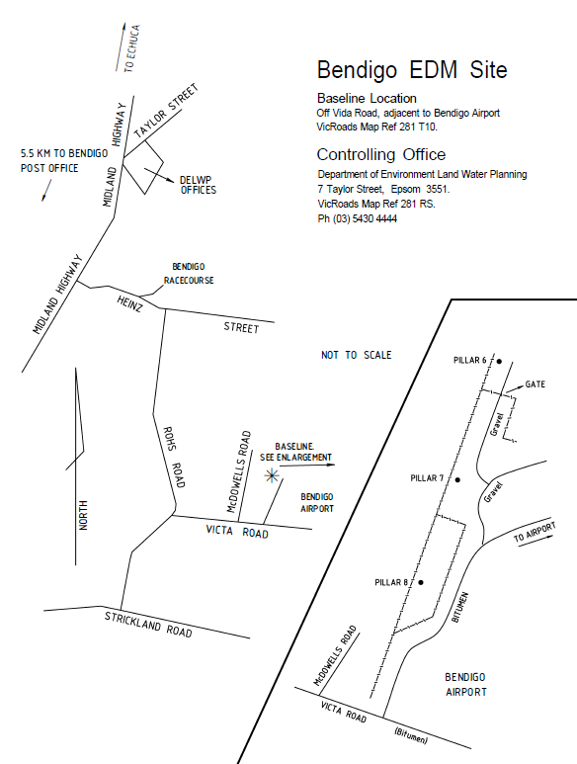

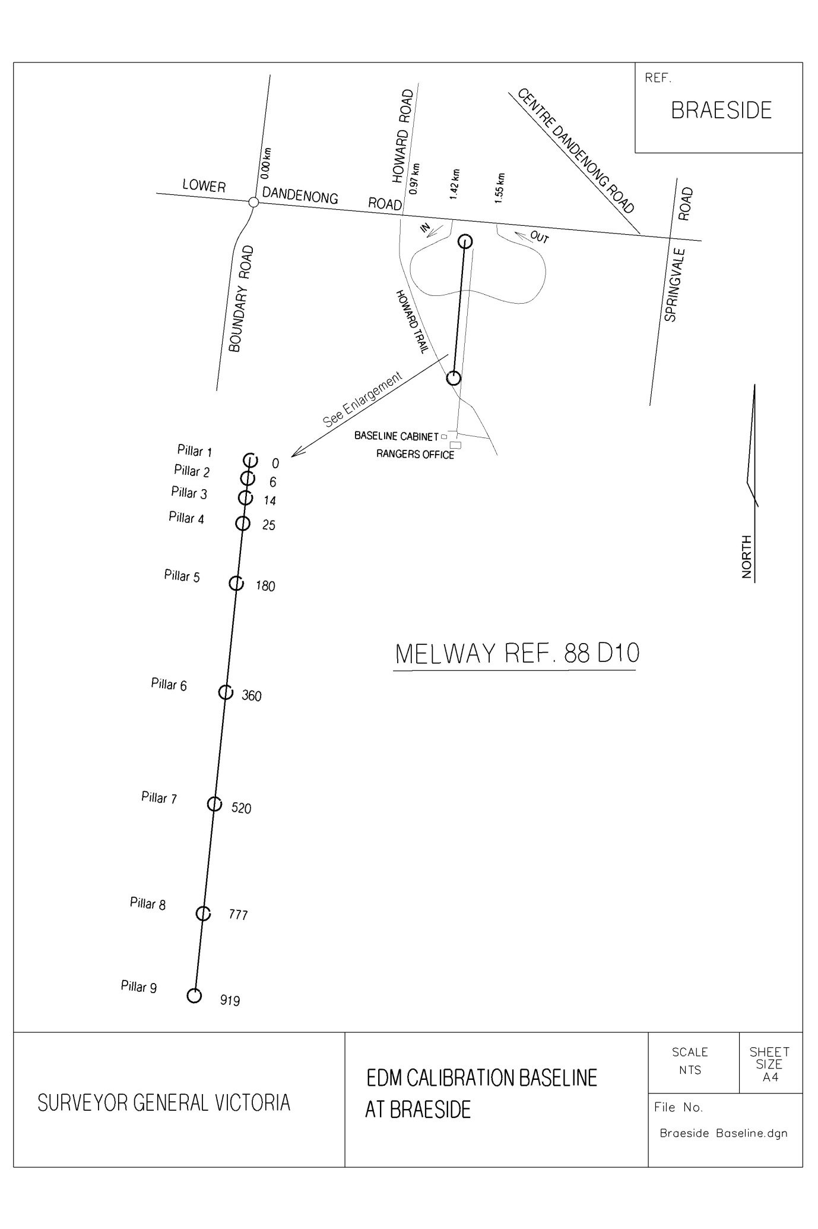

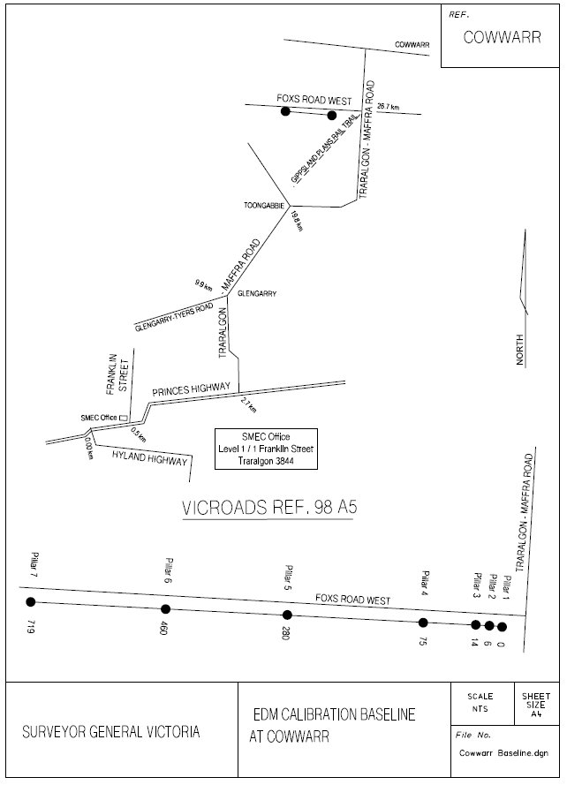



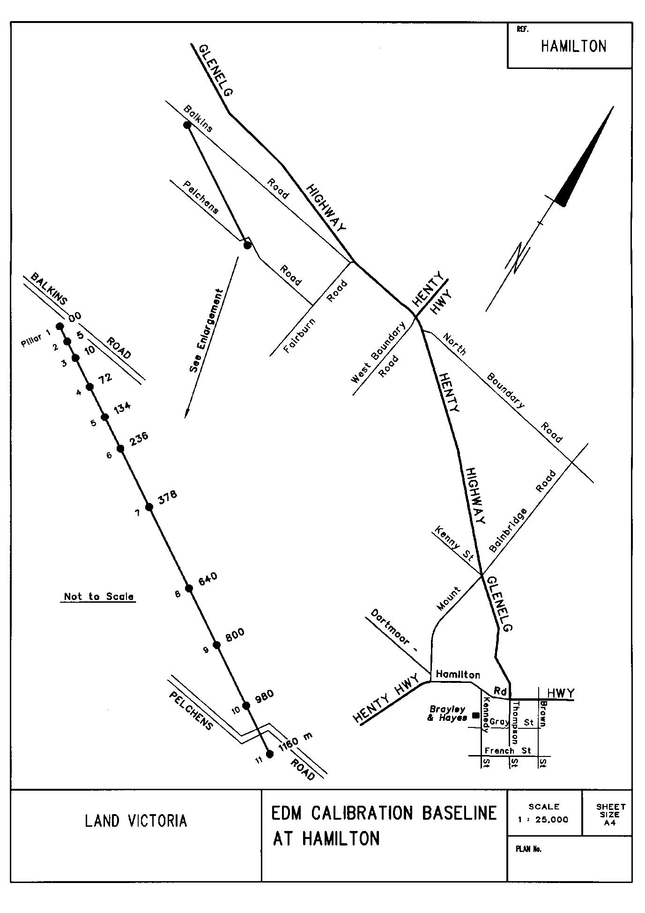

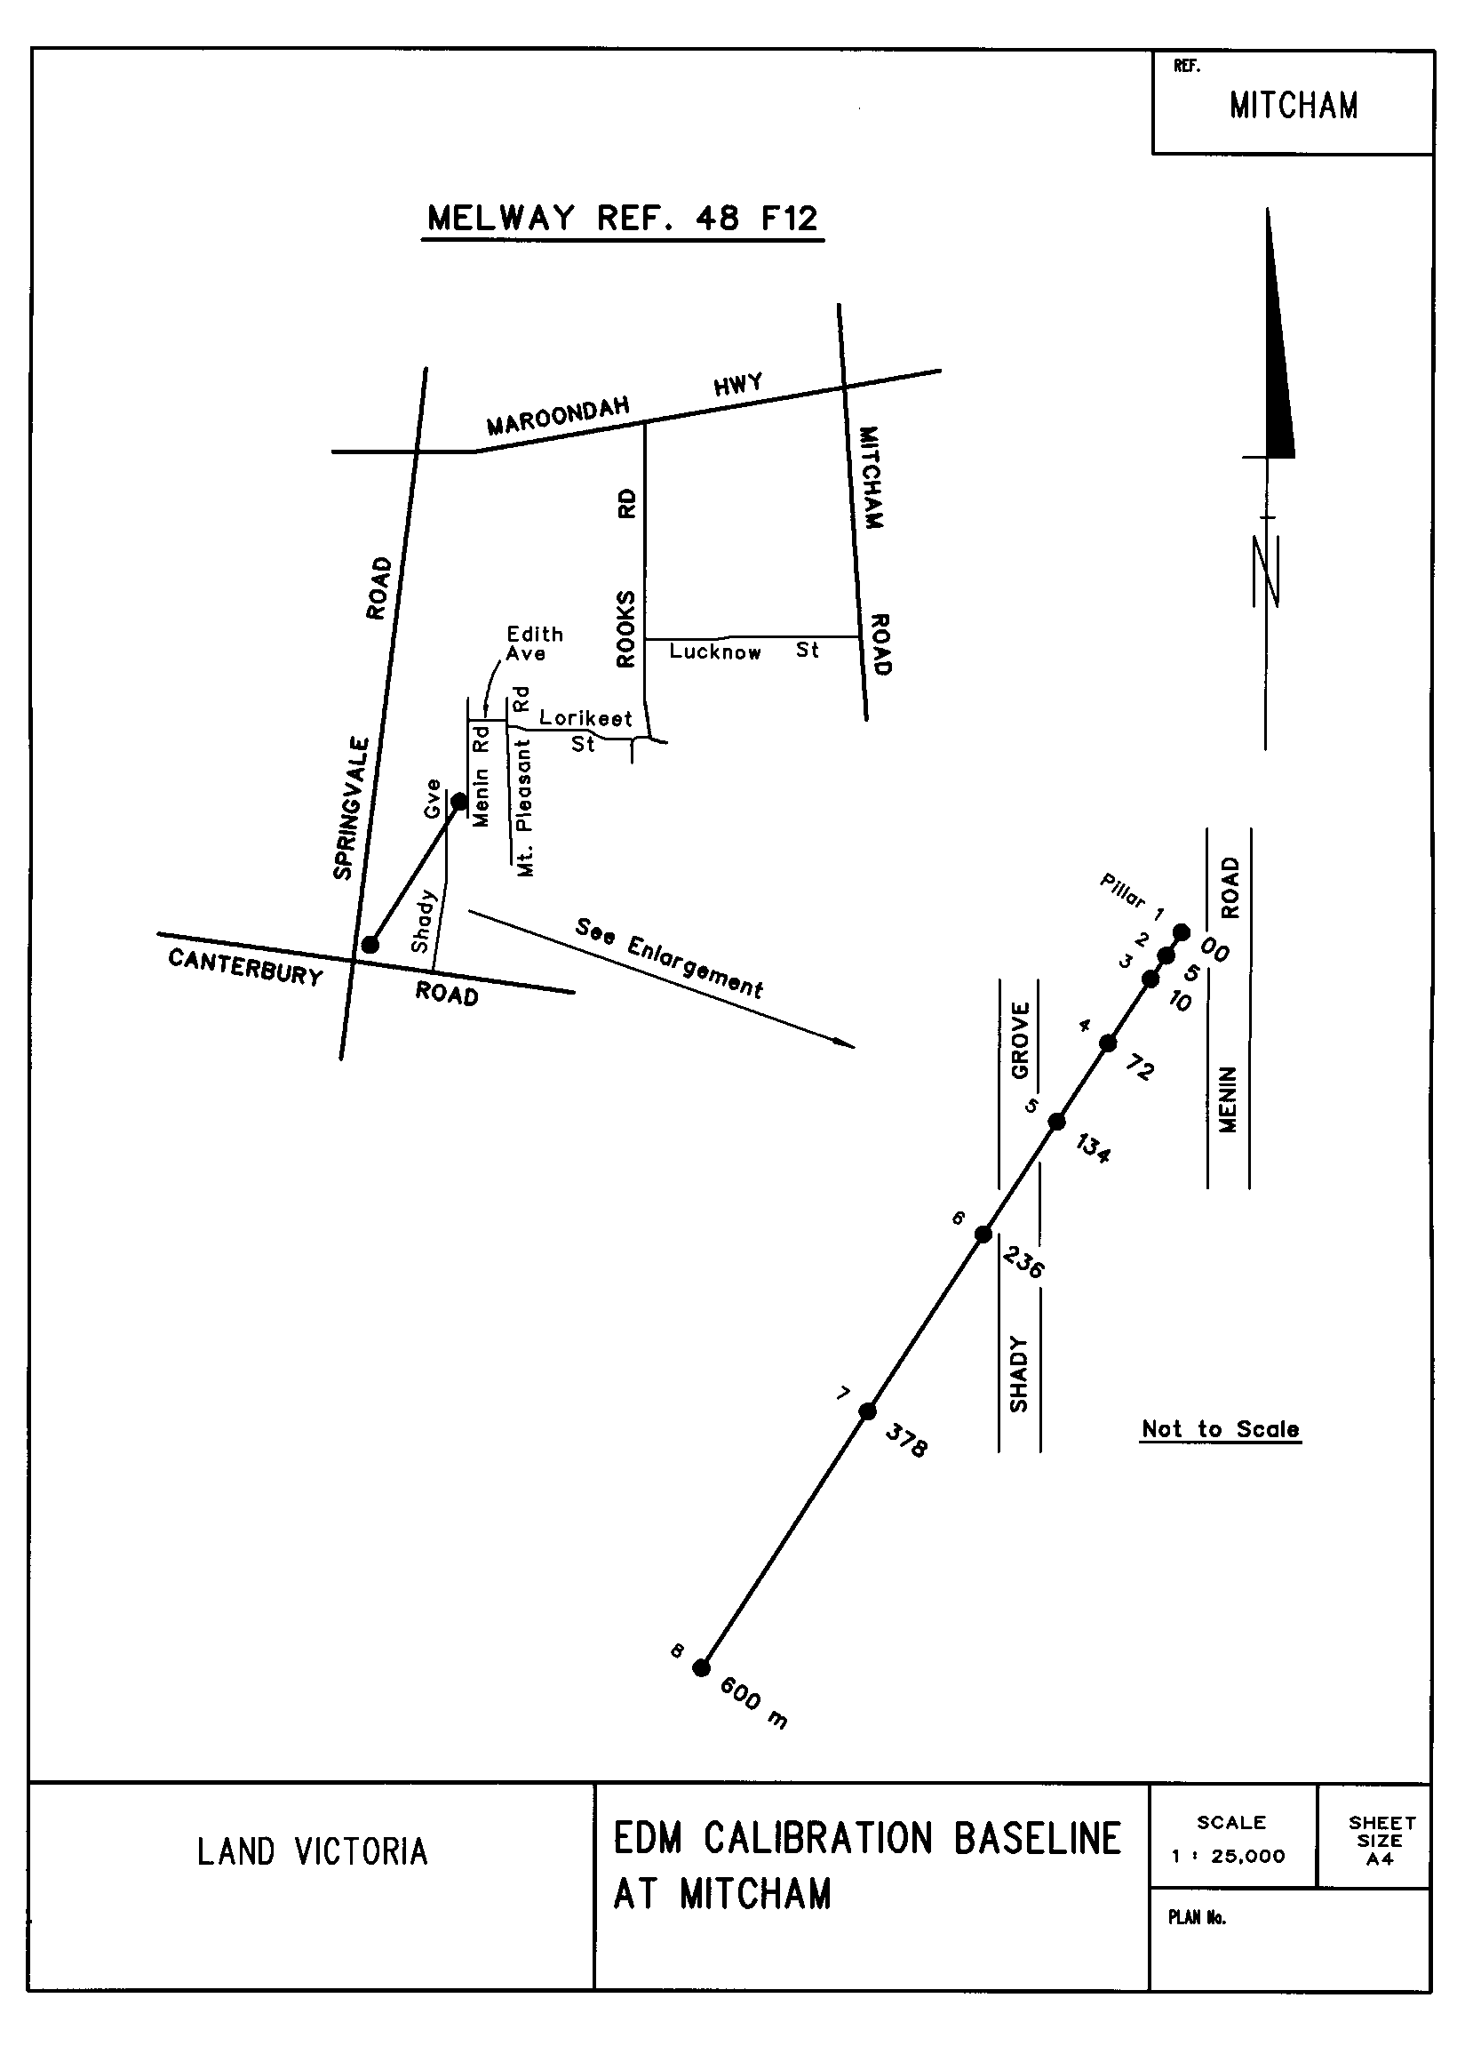

# EDM instrument parameters

EDM instrument parameters, such as unit length, frequency, carrier wavelength and manufacturer estimates of EDM standard deviation constant and parts per million, are supplied for most instruments within the Baseline software.

Detailed listings of instrument parameters are supplied in the instrument parameter sheets on the [Equipment calibration services (land.vic.gov.au)](https://www.land.vic.gov.au/surveying/services/equipment-calibration-services) website.

## Pulsed instruments and instruments with a unit length of zero

For instruments with a unit length of zero and pulsed instruments, the meteorological observations must be entered into the instrument at the time of the calibration.

The unit length, frequency and carrier wavelength are used in the calculation of the meteorological corrections and cyclic errors within the Baseline software. Surveyors can enter the instrument into the register and leave all the details blank and the software will still process the data correctly.

# Reduction and interpretation

Surveyor-General Victoria has adopted the EDM calibration computer program known as Baseline, version 6.0.0.5 (July 2012), developed by the Western Australia Land Information Authority (Landgate) for the calibration of EDM instruments against standard baselines. The calibration of EDM instruments is carried out to determine the instrument corrections to be applied to measurements and to ensure its reliability. Online help provides the user with the instructions necessary to run this software application. Software download is also freely available from the [Equipment calibration services (land.vic.gov.au)](https://www.land.vic.gov.au/surveying/services/equipment-calibration-services) website.

The Braeside, Bendigo, Geelong, Hamilton, Cowwarr and Mitcham baseline inter-pillar distances resulting from the annual re-verification surveys (performed in November) are included in the software database. All inter-pillar distances are updated on an annual basis. A selection of EDM instruments and reflector makes and models are also included. For EDM makes and models which are not included in the list, Baseline will accept the entry of new instruments although it requires the input of the unit length and the modulation frequency of the instrument by the operator.

The instrument details, measured distances and observed meteorological details (un-tick the ‘Mets Dial Set’ box to enter the meteorological data) are entered interactively by the operator. After the observed data is reduced to obtain horizontal distances and their associated variances, a least square adjustment is performed. The adjustment is made as suggested by Dr J.M Rueger (Rueger 1984) for modelling systematic errors in EDM measurements.

The program produces several reports for analysing an EDM instrument calibration and for analysing a calibration of a baseline. A certificate which summarises the results of an EDM instrument calibration is also produced.

As a Verifying Authority, Surveyor-General Victoria can issue Regulation 13 certificates for EDM, certifying them as reference standards of measurement. Normally this is reserved for precise EDM that are intended to be used to transfer the standard of length. For a Regulation 13 certificate to be issued, the entire calibration procedure can only be performed by Geodetic Survey within Surveyor-General Victoria, and a fee is applicable for this service.

The minimum standards for the uncertainty of calibration are described in terms of Recommendation No. 8 of the working party of the National Measurement Institute (formerly NSC) on the calibration of EDM Equipment of 1 February 1983. All uncertainties are specified at the 95% confidence level.

# References

Deaking, R. (1983). “A Guide to EDM Calibration”. Department of Surveying, Royal Melbourne Institute of Technology.

International Federation of Surveyors (FIG) (1994). “Recommended Procedures for Routine Checks of Electro-Optical Distance Meters”. Technical Monograph No.9 1994, 17 pages.

Murnane, A.B. (1983). “The Calibration of EDM Equipment for Monitoring Surveys”. In: Rivett. L (Ed), Proceedings, Symposium on the Surveillance of Engineering Structures. Department of Surveying, University of Melbourne. November 1983, 9 pages.

Norton, T. (1986). “Analysis of EDM Calibration Measurements - Program CALORY”. *The Australian Surveyor*. Vol 33 No. 1 March 1986 pp. 44-45.

Rueger, J.M. (1980). “Introduction to Electronic Distance Measurement” Monograph No. 7. School of Surveying, University of New South Wales, 127 pages.

Rueger, J.M. (1984). “Instructions on the Verification of Electro-optical Short-Range Distance Meters on Subsidiary Standards of Length in the form of EDM Calibration Baselines”. Recommendations to the National Standards Commission, School of Surveying, University of New South Wales, August 1984, 63 pages.

Rueger, J.M. (985). “Traceability of Electronic Distance Measurement to National Standards”. Proceedings 27th Australian Survey Congress, Alice Springs 1985. pp. 149-160.

Rueger, J.M. (1990). “Electronic Distance Measurement - An Introduction”. Third Totally Revised Edition - Springer-Verlag - Berlin 1990.

Sprent, A & Zwart P.R. (1978). “EDM Calibration - A Scenario”. *The Australian Surveyor* Vol 29 No. 3 September 1978 pp. 157-169.

Appendices – sample booking sheets

