|  |
| --- |
| Vicmap Product Development |
| Change Notice # 267 |

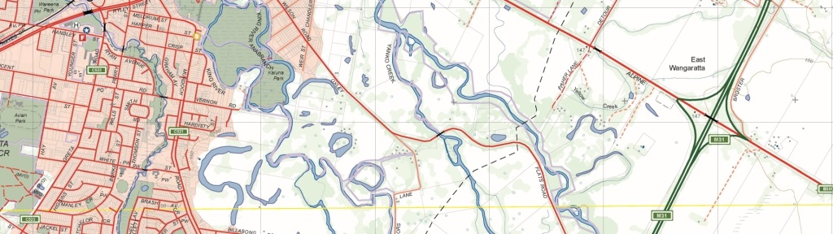

Vicmap Admin – renaming of Fire Rescue Victoria (FRV) dataset

## What is happening

From 2 August 2021, the dataset “FRV_LEGISLATED_BOUNDARY” within the Vicmap Admin product will be renamed to “FRV_RESPONSE_AREA”.

## Why this change is occurring

In consultation with FRV, the decision to rename has been made to better reflect the operational aspect of the dataset and ensure no confusion with the legislated FRV boundaries defined on Landata, which can be found at: <https://www.landata.vic.gov.au/>

## Who it will affect

This change will affect all users of Vicmap Admin that use the dataset. Incremental Update Format (IUF) customers will not be affected as part of this change.

## When the change will occur

The dataset name will be changed from 2 August 2021.

## How to provide feedback

For Vicmap Product change notices and bulletins, go to the [News and Bulletins](http://www.delwp.vic.gov.au/parks-forests-and-crown-land/spatial-data-and-resources/news-and-bulletins) page.

For further information & feedback please email [vicmap.help@delwp.vic.gov.au](mailto:vicmap.help@delwp.vic.gov.au)

|  |  |
| --- | --- |
| © The State of Victoria Department of Environment, Land, Water and Planning 2021  LogoThis work is licensed under a Creative Commons Attribution 4.0 International licence. You are free to re-use the work under that licence, on the condition that you credit the State of Victoria as author. The licence does not apply to any images, photographs or branding, including the Victorian Coat of Arms, the Victorian Government logo and the Department of Environment, Land, Water and Planning (DELWP) logo. To view a copy of this licence, visit http://creativecommons.org/licenses/by/4.0/  Disclaimer  This publication may be of assistance to you but the State of Victoria and its employees do not guarantee that the publication is without flaw of any kind or is wholly appropriate for your particular purposes and therefore disclaims all liability for any error, loss or other consequence which may arise from you relying on any information in this publication.  **Vicmap Disclaimer**  The State of Victoria:  a. does not give any representation or warranty as to the accuracy or completeness of DELWP spatial data, Vicmap data (including metadata) or Vicmap product specifications or the fitness of such data or products for any particular purpose;  b. disclaims all responsibility and liability whatsoever for any errors, faults, defects or omissions in such data or products.    Any person using or relying upon such data or products must make an independent assessment of them and their fitness for particular purposes and requirements. | Accessibility  If you would like to receive this publication in an alternative format, please telephone the DELWP Customer Service Centre on 136186, email [customer.service@delwp.vic.gov.au](mailto:customer.service@delwp.vic.gov.au), or via the National Relay Service on 133 677 [www.relayservice.com.au](http://www.relayservice.com.au). This document is also available on the internet at [www.delwp.vic.gov.au](http://www.delwp.vic.gov.au). |

Keep all content above this instruction text line. Delete only when document formatting is complete.