Surveying and Planning through Electronic Applications and Referrals (SPEAR) is the system used to process planning permits and subdivision applications online.
SPEAR now collects more information about new road names in plans of subdivisions, helping to improve Victoria’s geographic place naming data. This guide explains what information to provide, when to provide it, and how to build this step into your local workflow.
Collecting road name themes, commemorative naming details and a short statement about the history of the name helps councils meet their obligations under the Naming Rules for Places in Victoria 2022 (the naming rules) and the Gender Equality Act 2020.
This information is added to VICNAMES, the Register of Geographic Names, helping Land Use Victoria keep statewide records accurate and consistent.

In this guide
This guide sets out the essential steps for entering road name origin information in SPEAR:
- What information you need to provide
- When SPEAR prompts you to enter it
- Who is responsible for supplying it
- How councils should manage handovers with surveyors and developers
- What to do if information changes or an error occurs

At a glance: What you need to do
- Select ‘New road information to be entered into SPEAR’.
- Choose the road name theme from the drop-down list.
- If the name commemorates a person, record the gender.
- Add a clear and concise history or origin statement about the name.
- Submit the information.
- If you need to update details, edit the SPEAR record. If the application has already progressed, email the updated information to Geographic Names Victoria (GNV) at geo.names@transport.vic.gov.au so VICNAMES can be updated.

What are the new requirements?
From 30 January 2026, you’ll have the option to submit information about new road names registered in SPEAR. This information will be recorded and published on VICNAMES, Victoria’s Register of Geographic Names.
Submit this information by selecting:
- ‘New road information to be entered into SPEAR’.
If you cannot provide this information, you can select:
- ‘New road information cannot be entered into SPEAR for this application.’
From mid-2026, providing this information will be mandatory.
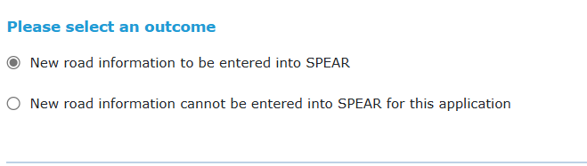
When you provide new road information, SPEAR will prompt you to answer the following questions.
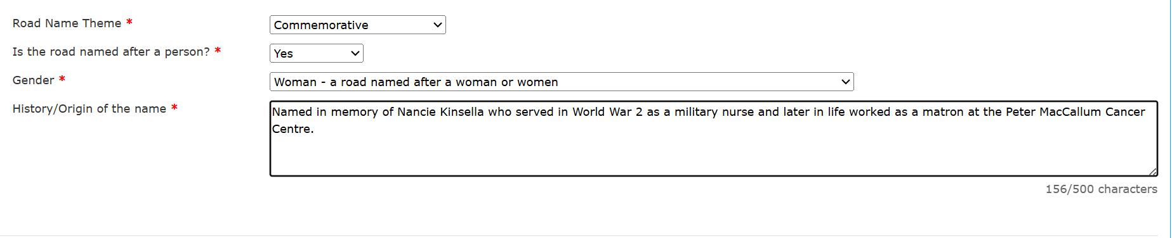

  - Road Name Theme
Road name themes are available from a drop-down menu. They include:
Table 1: Road name themes, meanings and examples
Road Theme | Meaning | Example
Aboriginal | Named using an Aboriginal language. | Tarnook Track. In Wadawurrung and other languages of the Kulin nation the word ‘tarnook’ is the wooden bowl or bucket that can contain water, food or hot coals and can be used during smoking ceremonies.
Aboriginal commemorative | A road that commemorates an Aboriginal person or an event of significance to Aboriginal people | Warrior Woman Lane. Named to commemorate the late Lisa Bellear, a broadcaster, photographer, poet, and a passionate advocate for First Peoples' rights.
Aboriginal fauna | Named using an Aboriginal language name for an animal. | Djinyap Lane. ‘Djinyap’ is the Dja Dja Wurrung word for the Sulphur Crested Cockatoo.
Aboriginal flora | Named using an Aboriginal language name for a plant. | Brungilo Boulevard. In Bunurong language ‘Brungilo’ means Stringybark, a type of eucalyptus that grows in the area.
Anzac | A road that commemorates something or someone associated with the Australian and New Zealand Army Corps (ANZAC). | Anzac Avenue, commemorates the 100th anniversary celebration of the ANZAC forces landing at Gallipoli.  Nancie Road, named after Nancie Kinsella who served as a nurse in World War II.
Commemorative | Named after a person or event. | Mirka Lane, named after the artist Mirka Mora.  Dardenelles Road, named after the Dardenelles Strait where the ANZACs landed.
Fauna | Named after an animal. | Angelfish Circuit, named after the angelfish, following the area’s marine naming theme.
Flora | Named after a plant. | Oak Street, named after the Oak tree.
Other | A road that does not fall under any of the above categories. | Jetty Track, named in reference to the Jetty which the track provides access to.

  - Is the road named after a person?
This field is used to identify any commemorative names. These names could fall under the themes of:
- Anzac
- Aboriginal commemorative
- Commemorative.
If you select ‘yes’, you will be asked to select the gender of the person the road is named after.
You can select one of the following options.
Table 2: Gender categories used for commemorative road names
Gender | Meaning
Woman | A road named after a woman or women
Man | A road named after a man or men
Self-described | A road named after a person who does not associate as either a man or a woman
Multi-gender | A road named after people of more than one gender e.g. a man and a woman

Collecting gender information helps Victoria track commemorative naming trends and meet gender equality commitments.
Gender information is stored securely and is only published once a name is formally approved in VICNAMES.
  - History / origin of the name
Every new road name needs a clear link to place. The origin statement should show how the person, event, plant, animal or theme connects to the local area.
By providing this information, we help future generations understand the history and meaning behind our place names.
If you have more historical information, email it to GNV so it can be added to the VICNAMES record and preserved for the future.

Frequently asked questions (FAQs)

What if I can’t provide this information?
From 30 January 2026, you will be able to choose whether to input this information. GNV is available to provide support with these new requirements throughout this transition period.
From mid‑2026 (exact date to be confirmed), entering this information will be mandatory to create a new road in SPEAR.

Who is required to enter this information and when?
Users with the Responsible Authority role (local councils) will be prompted to enter this information where there is a new road being created. This may be the same user who adds the New Street Address Allocations, or it may be someone else – each council will be different.
Users will be prompted to enter this information when the New Street Address Allocations have been added. It's up to local councils to decide when to add the street addressing - some do it as soon as the application is accepted, others wait until just before certification.
Local councils should make sure their internal workflows support collecting this information before street addressing is added.

How do I get this information?
The person submitting the road name needs to provide this information. This helps ensure compliance with the naming rules.
When road names are created by land surveyors and developers, the Responsible Authority should set up a process to make sure this information is submitted. GNV has developed a template to help Responsible Authorities collect this information.

How will checks be undertaken?
Providing this data will enhance GNV’s existing audit process to ensure compliance with the naming rules.
These audits are already undertaken monthly and involve a review of the road name, road type and extent. With this additional data, we will also be able to review the road theme, gender and history.

What happens if I make a mistake?
If a mistake is made when entering the information, take the following steps:
- If the SPEAR application is still active, then the information can be updated or re-entered.
- If the SPEAR application has progressed and is unable to be edited, you can supply the updated information directly to GNV.

Need more information?
If you have a question about SPEAR, raise it with the SPEAR Service Desk team at:
Email: spear.info@transport.vic.gov.au
Phone: (03) 9194 0612
If you have any questions about geographic place naming requirements, contact GNV at:
Email: geo.names@transport.vic.gov.au
Phone: (03) 8572 7991
If you would like to be added to our mailing list for upcoming GNV information sessions, please email geo.names@transport.vic.gov.au.

