|  |
| --- |
| Vicmap™ Product Development |
| Change Notice # 239 Advisory Notice |

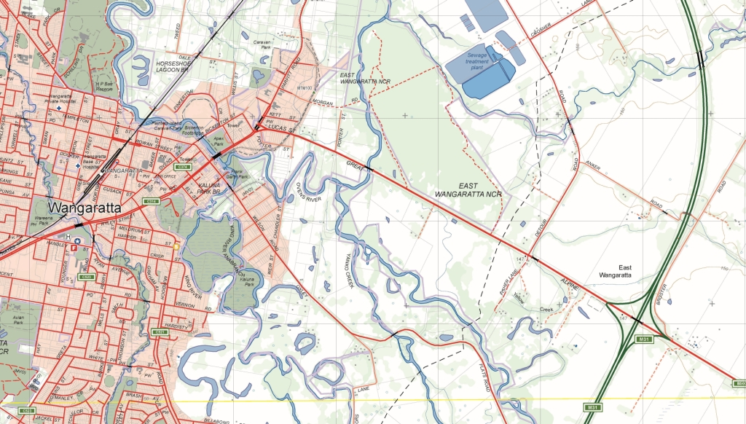

Vicmap Lite 12 February 2018

## What is happening

The LGA unique identifier, LGA_CODE, is being added to VMLITE.LGA.

The structure of the LGA dataset will now be:

|  |  |  |  |
| --- | --- | --- | --- |
| **Table_Attribute** | **Explanation** | **Field Type / Size** | **Example** |
| *UFI* | The Unique Feature Identifier (UFI) is updated each time the feature is edited. | NUMBER(14) | 84155081 |
| *FEATURE_TYPE_CODE* | Feature Type Code is always “lga”. | VARCHAR2(30) | lga |
| *LGA_CODE* | LGA Code | VARCHAR2(3) | 330 |
| *LGA_NAME* | LGA Name | VARCHAR2(50) | HINDMARSH |
| *STATE* | Australian State | VARCHAR2(7) | VIC |
| *SCALE_USE_CODE* | Scale Use Code helps control the level of detail displayed at different scales. | VARCHAR2(1) | 2 |
| *LABEL_USE_CODE* | Label Use Code helps control the level of labelling | VARCHAR2(1) | 1 |
| *UFI_CREATED* | The date the Unique Feature Identifier (UFI) was created | DATE | 17/08/2016 7:59:08 AM |

## Why this change is occurring

This change is responding to customer requirements seeking improved interoperability across Vicmap and business datasets.

LGA_CODE is a unique Vicmap local government area identifier that is applied to many Vicmap products and many business datasets.

The three character LGA_CODE is persistent and easily communicable.

## Who will it affect

This change will affect all users of Vicmap Lite.

## When the change will occur

The change will be implemented on the **26/02/2018.**

|  |  |
| --- | --- |
| © The State of Victoria Department of Environment, Land, Water and Planning 2018  LogoThis work is licensed under a Creative Commons Attribution 4.0 International licence. You are free to re-use the work under that licence, on the condition that you credit the State of Victoria as author. The licence does not apply to any images, photographs or branding, including the Victorian Coat of Arms, the Victorian Government logo and the Department of Environment, Land, Water and Planning (DELWP) logo. To view a copy of this licence, visit http://creativecommons.org/licenses/by/4.0/  Disclaimer  This publication may be of assistance to you but the State of Victoria and its employees do not guarantee that the publication is without flaw of any kind or is wholly appropriate for your particular purposes and therefore disclaims all liability for any error, loss or other consequence which may arise from you relying on any information in this publication. | Accessibility  If you would like to receive this publication in an alternative format, please telephone the DELWP Customer Service Centre on 136186, email [customer.service@delwp.vic.gov.au](mailto:customer.service@delwp.vic.gov.au), or via the National Relay Service on 133 677 [www.relayservice.com.au](http://www.relayservice.com.au). This document is also available on the internet at [www.delwp.vic.gov.au](http://www.delwp.vic.gov.au). |

## For further information

You can contact Vicmap Help by emailing [vicmap.help@delwp.vic.gov.au](mailto:vicmap.help@delwp.vic.gov.au) or refer to our website

<https://www2.delwp.vic.gov.au/maps>