|  |
| --- |
| Vicmap™ Product Development |
| Change Notice # VT-56 Advisory Notice |

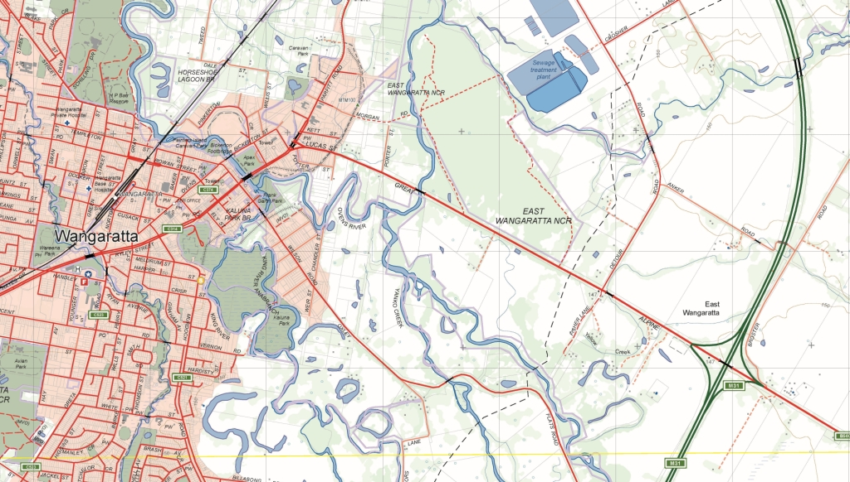

Vicmap Planning 17/07/19

## What is happening

Addition of two new date fields and the removal of the GAZ_END_DATE in the following tables in the VMPLAN schema:

PLAN_ZONE_HISTORY and

PLAN_OVERLAY_HISTORY

The new fields are:

START_DATE

END_DATE

The new fields will replace GAZ_END_DATE and consequently be removed.

For complete proposed structure refer to revised data model in attached vmplan_diagram_v3_3.pdf

## Why this change is occurring

To provide date information as to when features were added and retired from the PLAN_ZONE and PLAN_OVERLAY tables. This will enable users to obtain an accurate history of the Planning Scheme spatial data at any point in time since 30/07/2017.

## Who will it affect

This change will affect all users of Vicmap VMPLAN history tables.

## When the change will occur | How to provide feedback |

The change to include additional fields will be implemented on **05/08/2019.**

The change to remove GAZ_END_DATE field will be implemented **after 16/09/2019.**

For Vicmap Product change notices and bulletins, go to the [News and Bulletins](http://www.delwp.vic.gov.au/parks-forests-and-crown-land/spatial-data-and-resources/news-and-bulletins) page.

|  |  |
| --- | --- |
| © The State of Victoria Department of Environment, Land, Water and Planning 2019  LogoThis work is licensed under a Creative Commons Attribution 4.0 International licence. You are free to re-use the work under that licence, on the condition that you credit the State of Victoria as author. The licence does not apply to any images, photographs or branding, including the Victorian Coat of Arms, the Victorian Government logo and the Department of Environment, Land, Water and Planning (DELWP) logo. To view a copy of this licence, visit http://creativecommons.org/licenses/by/4.0/  Disclaimer  This publication may be of assistance to you but the State of Victoria and its employees do not guarantee that the publication is without flaw of any kind or is wholly appropriate for your particular purposes and therefore disclaims all liability for any error, loss or other consequence which may arise from you relying on any information in this publication. | Accessibility  If you would like to receive this publication in an alternative format, please telephone the DELWP Customer Service Centre on 136186, email [customer.service@delwp.vic.gov.au](mailto:customer.service@delwp.vic.gov.au), or via the National Relay Service on 133 677 [www.relayservice.com.au](http://www.relayservice.com.au). This document is also available on the internet at [www.delwp.vic.gov.au](http://www.delwp.vic.gov.au). |

For further information & feedback please email [Vicmap.help@delwp.vic.gov.au](mailto:Vicmap.help@delwp.vic.gov.au)

Keep all content above this instruction text line. Delete only when document formatting is complete.