Product data specification

Vicmap™ Elevation DEM 10m

www.delwp.vic.gov.au

|  |
| --- |
|  |

Version 3.0 October 2020

Applies to data model 4.0 December 2019

|  |  |
| --- | --- |
|  |  |

AS/NZS ISO 19131:2008 compliant

|  |
| --- |
| © The State of Victoria Department of Environment, Land, Water and Planning 2020  Logo  This work is licensed under a Creative Commons Attribution 4.0 International licence. You are free to re-use the work under that licence, on the condition that you credit the State of Victoria as author. The licence does not apply to any images, photographs or branding, including the Victorian Coat of Arms, the Victorian Government logo and the Department of Environment, Land, Water and Planning (DELWP) logo. To view a copy of this licence, visit <http://creativecommons.org/licenses/by/4.0/>  Disclaimer  This publication may be of assistance to you but the State of Victoria and its employees do not guarantee that the publication is without flaw of any kind or is wholly appropriate for your particular purposes and therefore disclaims all liability for any error, loss or other consequence which may arise from you relying on any information in this publication.  Accessibility  If you would like to receive this publication in an alternative format, please telephone the DELWP Customer Service Centre on 136186, email [customer.service@delwp.vic.gov.au](mailto:customer.service@delwp.vic.gov.au) or via the National Relay Service on 133 677 [www.relayservice.com.au](http://www.relayservice.com.au). This document is also available on the internet at [www.delwp.vic.gov.au](http://www.delwp.vic.gov.au). |

# Document history

|  |  |  |
| --- | --- | --- |
| Version | Date | Note |
| 1.0 | January 2003 | New template  Split vector statewide contours from raster digital elevation model |
| 1.0 | February 2003 | Checked by Custodial Officer |
| 1.1 | August 2003 | Added Data Model Version 2 reference |
| 1.2 | August 2005 | Added Data Model Version 2.2 reference |
| 1.3 | November 2015 | Added Data Model 3.4, reformatted to Vicmap Product Description_TEMPLATE v4.docx, update ground service point, ground type point sections |
| 2.0 | June 2017 | Updated to new product description template. |
| 2.1 | July 2018 | Updated product description following QA |
| 2.2 | July 2020 | Updated product description  Updated Project IDs with ANZLIC IDs |
| 3.0 | October 2020 | Changed dataset title from DTM 10M to DEM 10M, in line with Change Notice #253 Vicmap Elevation |

This document has been formatted and structured in compliance with AS/NZS ISO 19131:2008 Geographic Information – Data product specifications.

# Table of Contents

Document history 1

Publication Approval 1

Table of Contents 2

Overview 3

Specification scope 6

Data product identification 7

Data content and structure 7

Reference systems 11

Data quality 11

Data capture 12

Data maintenance 14

Data product delivery 14

Metadata 14

Appendix A: Data & object models 15

Appendix B: Data dictionary 15

# Overview

## Vicmap™

Vicmap™ is the foundation that underlies most spatial information in Victoria. This portfolio of spatial related authoritative data products, made up from individual datasets, is developed and managed by the Department of Environment, Land, Water & Planning (DELWP). The information provides the foundation to Victoria’s primary mapping and spatial information systems and is used for building business information and systems.

Vicmap is a registered trademark of the Victorian Government and is synonymous with authoritative statewide mapping since 1975.

The Vicmap portfolio includes:

|  |  |
| --- | --- |
| * + - Vicmap Address     - Vicmap Admin     - Vicmap Crown Land Tenure     - Vicmap Elevation     - Vicmap Features of Interest     - Vicmap Hydro     - Vicmap Imagery     - Vicmap Index | * + - Vicmap Lite     - Vicmap Planning     - Vicmap Position     - Vicmap Property     - Vicmap Topographic Mapping     - Vicmap Transport     - Vicmap Vegetation |

Further information can be found at <https://www2.delwp.vic.gov.au/maps>

## Data product specification title

Vicmap™ Elevation DEM 10m

## Responsible party

Department of Environment, Land, Water and Planning

PO Box 527, Melbourne VIC 3001 Australia

[vicmap.help@delwp.vic.gov.au](mailto:vicmap.help@delwp.vic.gov.au)

## Terms and definitions

For the purpose of this document, the following terms and definitions apply.

|  |  |
| --- | --- |
| **Term** | **Definition** |
| ANZLIC ID | A unique identifier enabling metadata records to be discovered and differentiated within a structured data library. |
| Attribute | A characteristic of a feature that may occur as a type or an instance. |
| Contours | Joins points of equal elevation (height) above a given level, such as mean sea level. |
| Custodian | The party that accepts accountability and responsibility for the data and ensures appropriate care and maintenance of the Dataset in accordance with ISO 19115-1:2014 Geographic information — Metadata — Part 1: Fundamentals. |
| Data type | Specification of a value domain with operations allowed on values in this domain.  Refer to AS/NZS ISO 19103 |
| Dataset | Identifiable collection of data. Maybe as small as a single feature or feature attribute contained within a larger dataset. A hardcopy map maybe considered a dataset.  Refer to AS/NZS ISO 19115 |
| DEM/DTM | Digital Elevation Model or Digital Terrain Model, an elevation surface representing the height of the earth. |
| Domain | A well-defined set both necessary and sufficient, as everything that satisfies the definition in the set and everything that does not satisfy the definition is necessarily outside the set.  Refer to ISO/TS 19103 |
| the Department | Meaning the Department of Environment, Land, Water & Planning (DELWP). |
| Entity | A unit of data that can be classified and have stated relationship with other entities. |
| Feature | An abstraction of real-world phenomena. A feature may occur as a type or an instance. Feature type or instance shall be used when only one is meant.  The feature structure of the feature-based data model can be summarised as:  feature instance = [spatial object + attribute object] |
| LiDAR | Light Detection and Ranging - a remote sensing method using light from a pulsed laser to measure distance and intensity. |
| Metadata | Metadata is ‘data about data’ and provides a synopsis about the data lineage, accuracy and details about access permissions.  Refer to ISO 19115 Geographic information ― Metadata |
| Persistent Feature Identifier (PFI) | The unique code provided at creation of the feature which remains until the feature is retired. |
| Product | Dataset or dataset series that conforms to a data product specification. |
| Quality | Totality of characteristics of a product that bear on its ability to satisfy stated and implied needs. Refer to:  ISO 19113 Geographic information ― Quality principles  ISO 19114 Geographic information ― Quality evaluation procedures |
| the State | Victoria |
| Thalweg | The deepest part of a water channel or valley |
| Unique Feature identifier (UFI) | Each feature is uniquely identified and renewed with each change. |

## Acronyms

For the purpose of this document, the following acronyms may apply.

|  |  |
| --- | --- |
| **Acronym** | **Definition** |
| DELWP | Department of Environment, Land, Water & Planning |
| DEM | Digital Elevation Model |
| DTM | Digital Terrain Model |
| GNSS | Global Navigation Satellite Systems |
| ICSM | Intergovernmental Committee on Surveying & Mapping |
| LGA | Local Government Area |
| LUV | Land Use Victoria |
| SDM | Spatial DataMart |
| VES | Vicmap Edit Service |
| VGDD | Victorian Government Data Directory |

## Informal description of the data product

Vicmap Elevation is a suite of datasets which assists with terrain analysis and land assessment by providing contour and relief data. This product can be combined with other data to enable more efficient and effective planning and analysis of urban and natural landscapes, including catchment modelling and habitat suitability.

The Vicmap Elevation is comprised of the following:

* **Statewide 10-20m contours & relief:** represents Victoria’s elevations in the form of contours, spot heights and surface features including cliffs, embankments and rock outcrops.
* **Digital Elevation Model (DEM):** represents a hydrologically enforced raster model of Victoria’s ground surface at 10m grid resolution.
* **Multi-resolution:** Compilation of project data primarily from Digital Elevation Models (DEM’s), contours, and LiDAR point clouds at various resolutions covering project areas across the state, including the coast and major flood plains.
* **Vicmap Coastal DEM:** high resolution raster representation of Victoria’s natural relief features along the coast.

Vicmap Elevation data is integrated from projects managed by the Coordinated Imagery Program in DELWP and from authoritative Custodians via the *LUV Custodianship Program.* Datasets may be supplemented and/or verified with information supplied by:

* **Federal, State & Local Government**
  + DELWP (Forests, Fire Management, Geographic Names & Land Registry)
* **Government agencies & authorities**
  + Parks Victoria
  + VicRoads
* **Emergency & Essential Services** 
  + Country Fire Authority
* **Asset Information Management**
* **Melbourne Water**
* **Licensed surveyors**
* **Water authorities**
* **Melway**

Vicmap Elevation is updated with new project data on an ad-hoc basis.

# Specification scope

This product description focuses on the statewide Vicmap Elevation DEM 10m raster dataset of Vicmap Elevation, which is freely available to users and incorporated into the Vicmap Topographic Mapping products.

### Level

Dataset.

### Extent & coverage

Vicmap Elevation DEM 10m covers the State of Victoria.

Cross border data for select Vicmap Products is provided to DELWP under an arrangement with New South Wales and South Australia with coverage extending up to 100 kilometres into New South Wales and a 1 x 1:100,000 tile into South Australia. Selected Vicmap Elevation data is maintained over the border. Refer to the metadata section of this document for more details.

# Data product identification

### Title

Vicmap Elevation DEM 10m

### Alternative title

VMELEV

Vicmap Elevation

Vicmap Elevation DEM10m

Vicmap Elevation Digital Elevation Model 10m

### Abstract

Vicmap Elevation DEM 10m is a product which is a raster representation of Victoria's elevation. DEM 10m has a spatial resolution of 10 metres with respective horizontal and vertical accuracy of 12.5m and 5m or better. The DEM is constructed from source data of various resolutions, accuracies and ages to produce an improved DEM containing increased detail in localised areas. The DEMs are hydrologically enforced and correctly defines the natural surface drainage and hydrological flow. This product has been quality assured by DELWP and additional third-party consultants.

Vicmap Elevation provides an accurate representation of natural relief features across Victoria. It is used in a variety of applications, particularly in emergency services, natural resource management, planning and development, and digital map publication.

### Topic category

Elevation.

# Data content and structure

### Data content

Vicmap Elevation statewide DEM contains the following dataset:

|  |  |  |  |
| --- | --- | --- | --- |
| **ANZLIC ID** | **Dataset name** | **Description** | **Feature type** |
| ANZVI0803003582 | VICMAP_ELEV_DEM_10M | Digital Elevation Model | Raster |

Table1: Dataset that comprise Vicmap Elevation DEM 10m.

*\*Parent metadata record for VMELEV. Parent metadata records act as a cover note for a product that contains a dataset series for search, discovery & delivery purposes. Refer to the data model in Appendix A.*

The VICMAP_ELEV_DEM_10M is produced based on the aggregation of data prepared for various basins in Victoria. The spatial distribution of these basins is presented in the following map. Edge matching has been applied to these products and sufficient overlap has been considered between basins. The numbered polygons in Figure 1 represent the boundaries of basins.

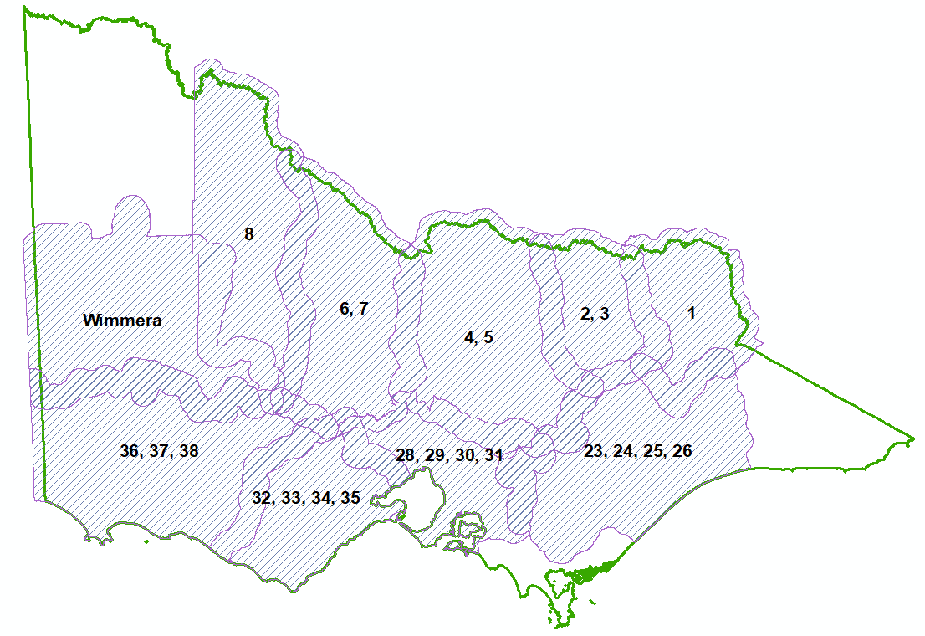

Figure 1: Boundaries of Victoria’s basins.

In 2016, the 10m DEM was improved and updated using recent high-resolution LiDAR surveys.

Figure 2 illustrates the extents and project names for these sources.

|  |  |  |
| --- | --- | --- |
|  |  |  |

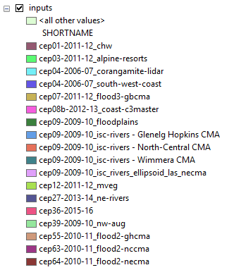

Figure 2: LiDAR projects used to improve Vicmap Elevation.

Table 2 below details the project information for the LiDAR data illustrated in Figure 2 that was used to improve Vicmap Elevation.

| **Project Name** | **ANZLIC ID** | **Project Description** |
| --- | --- | --- |
| cep01-2011-12_chw | ANZVI0008101978 | ± 60cm vertical accuracy with a point density of 1.69 points/m2 LiDAR survey project classified into ICSM Level 2 standard in Central Highlands Water Management Area including Hepburn and Moorabool Shire townships. |
| cep03-2011-12_alpine-resorts | ANZVI0008102846 | ± 20cm vertical accuracy with a point density of 2 points/m2 LiDAR survey project classified into ICSM Level 2 standard in Fall’s Creek, Mt. Buller/Stirling, Mt. Baw Baw, Lake Mountain and Mt. Hotham for bushfire risk assessment and planning of new developments. |
| cep04-2006-07_corangamite-lidar  cep04-2006-07_south-west-coast | ANZVI0008100225 | ± 50cm vertical accuracy with a point density of 2 points/m2 LiDAR survey project in Surf Coast, Colac Otway, Corangamite, Moyne, Golden Plains, Ballarat and Moorabool local council areas. |
| cep07-2011-12_flood3-gbcma | ANZVI0008101926 | ± 10cm vertical accuracy LiDAR survey project classified into ICSM Level 2 standard in the Goulburn Broken Catchment Management Area for land use planning and flood modelling. |
| cep08b-2012-13_coast-c3 | ANZVI0008102868  ANZVI0008102867  ANZVI0008102869  ANZVI0008102870  ANZVI0008102913  ANZVI0008102881 | ± 10cm vertical accuracy with a point density of 1.56 points/m2 coastal LiDAR survey project classified into ICSM Level 3 standard in Ninety Mile Beach, French Island, Phillip Island, Western Port, Gippsland, Wonthaggi, Greater Melbourne, Bunyip River and South West Victoria for coastal hazard assessment. |
| cep09-2009-10_floodplains | ANZVI0008102863  ANZVI0008102752  ANZVI0008102784  ANZVI0008102895  ANZVI0008102839  ANZVI0008102800  ANZVI0008102831  ANZVI0008102838  ANZVI0008102836  ANZVI0008102837 | ± 10cm vertical accuracy with a point density of 2 points/m2 LiDAR survey project in the floodplains areas of Goulburn Broken, North East, North Central, Corrangamite, Mallee, Glenelg Hopkins Catchment Management Areas. |
| cip09-2009-10_rivers | ANZVI0008102764  ANZVI0008102797  ANZVI0008102905  ANZVI0008102786  ANZVI0008102914  ANZVI0008102792  ANZVI0008103014  ANZVI0008102795  ANZVI0008102788  ANZVI0008102798 | ± 20cm vertical accuracy with a point density of 4 points/m2 LiDAR survey project in the riparian zone of rivers within the Mallee, North East, North Central, West Gippsland, East Gippsland, Mallee, Wimmera, Goulburn Broken, Glenelg Hopkins, Port Phillip and Western Port Catchment Management Areas. |
| cep12-2011-12_mveg | ANZVI0008102901  ANZVI0008102856  ANZVI0008102857  ANZVI0008102862  ANZVI0008102855  ANZVI0008103038  ANZVI0008102866  ANZVI0008102823  ANZVI0008102861  ANZVI0008102824  ANZVI0008102825  ANZVI0008103039 | ± 20cm vertical accuracy with a point density of 4 points/m2 forest LiDAR survey project classified to ICSM Level 2 standard in Melbourne fringe regions including Geelong, Surf Coast and Mornington Peninsula. |
| cep27-2013-14_ne-rivers | ANZVI0008102970  ANZVI0008102972  ANZVI0008102974  ANZVI0008102976  ANZVI0008102977 | ± 20cm vertical accuracy with a point density of 1 points/m2 LiDAR survey project classified into ICSM Level 2 standard in the Victoria’s North East region focusing on Corrying-Nariel Creek, Cudgewa Creek, Fifteen Mile Creek, Hodgson Creek, Upper King River and Black Range Creek for geomorphological erosion analysis. |
| cep36-2015-16_graniteck | ANZVI0008102376  ANZVI0008102505 | ± 10cm vertical accuracy with a point density of 0.7 points/m2 LiDAR survey project classified into ICSM Level 2 standard in the Granite Creek – Goulburn River, Numurkah and Wodonga areas for flood and sewerage planning analysis. |
| cep39-2009-10_nw-aug | ANZVI0008101837  ANZVI0008101838  ANZVI0008102126 | ± 10cm vertical accuracy with a point density of 4 points/m2 LiDAR survey project classified into ICSM Level 2 standard in the Wombat State Forest area. |
| cep55-2010-11_flood2-ghcma | ANZVI0008102782  ANZVI0008102782  ANZVI0008102782  ANZVI0008102842  ANZVI0008102842  ANZVI0008102842  ANZVI0008102842  ANZVI0008102842  ANZVI0008102842  ANZVI0008102842  ANZVI0008102842 | ± 10cm vertical accuracy with a point density of 3.08 points/m2 LiDAR survey project classified into ICSM Level 2 standard in the Glenelg Hopkins Catchment Management Area for land use planning and flood modelling. |
| cep63-2010-11_flood2-nccma | ANZVI0008102819 | ± 10cm vertical accuracy with a point density of 1.72 points/m2 LiDAR survey project classified to ICSM Level 2 standard in the North Central Catchment Management Area for land use planning and flood modelling. |
| cep64-2010-11_flood2-necma | ANZVI0008102822 | ± 10cm vertical accuracy with a point density of 3.1 points/m2 LiDAR survey project classified to ICSM Level 2 standard in the North East Catchment Management Area for land use planning and flood modelling. |

Table 2: Details of the LiDAR projects used to improve Vicmap Elevation.

### Data models

See Appendix A.

The Vicmap Elevation product data model is published on the Department’s website <https://www2.delwp.vic.gov.au/maps/maps-and-spatial-data>.

### Data dictionary

N/A

See Appendix B for reference tables.

### Data structure

The DEM is a raster dataset with a known pixel size where each pixel has a value representing elevation. The native format is stored as an ESRI Grid.

Cross border data is not subject to the same data structures or accuracy as the content within Victoria. This is due to the differences in the data models between the States.

# Reference systems

Vicmap Elevation is mapped to the Geocentric Datum of Australia (GDA) and the Australian Height Datum (AHD). Data is held in geographic latitude and longitude computed in terms of the GDA at 01 January 1994 (GDA94). The temporal reference system for Vicmap is the Gregorian calendar.

# Data quality

## Accuracy

### Spatial accuracy

The spatial accuracy for Vicmap Elevation DEM 10m is inherited from the spatial accuracies of its many source datasets. The most consistently used underlying product to create the Vicmap DEM and therefore the base for positional accuracy is the Vicmap Elevation 10-20 Contours & Relief, therefore the positional accuracy for Vicmap Elevation DEM 10m is 12.5m horizontally and 5m vertically or better.

This accuracy has been checked through a formal quality assurance process.

### Attribute accuracy and reliability

The vertical accuracy associated with the DEMs is +/-5m or better. The overall vertical accuracy of the product is calculated to be 2.96m. Beware that reprojecting, changing format or resampling causes changes to the height values in the DEM.

### Spatial data integrity

Vicmap Elevation DEM 10m is correct when used in its native projection and formats.

The DEM is hydrologically enforced where water bodies are flattened and, for water bodies of larger size, thalweg has been considered to ensure the flow of water. Where necessary, interpolation was used, and the outputs were checked to ensure the data has no gaps or interpolation artefacts.

As per previous versions of the dataset, the ANUDEM analysis utility from the Australian National University (ANU) was extensively used for updates to the dataset. “ANUDEM is a program that calculates regular grid digital elevation models (DEMs) with sensible shape and drainage structure from arbitrarily large topographic datasets” (ANU 2011).

In order to achieve hydrological enforcement, an analysis tool using a technique developed by the Centre for Research in Water Resources, the University of Texas at Austin (Jackson S., 2013) was adopted in this update. The Optimized Pit Removal tool used a combination of cut and fills techniques to hydrologically enforce the terrain model while modifying the minimum number of pixels necessary and retains more of the terrain detail defined by the LiDAR.

The different parts of the DEM (from the projects and basins) were properly edge-matched to remove any inconsistencies or any other artefacts.

## Completeness

The dataset is complete, in the correct formats and files are free of corruption.

## Logical Consistency

The DEM values across initial basin tiles have been constructed to ensure smooth consistent elevation values are achieved.

# Data capture

Vicmap Elevation integrates data from Vicmap Imagery with other point cloud and imagery data made available to Vicmap. Additionally, Vicmap is reliant on agreements and MoU’s signed with authoritative Custodians, through the *LUV Custodianship Program*. Examples of Custodians and/or those that may supplement verified data are listed below:

* Federal, State and Local Government
* Government agencies and authorities (e.g. Parks Victoria, Melbourne Water, VicRoads)
* Registrar of Geographic Names – DELWP
* Crown Land Management – DELWP
* Fire Management - DELWP
* Emergency & Essential Services
* Utility companies

Cross border data is maintained to a limited extent into New South Wales and South Australia, primarily to assist emergency and essential service activities. A cross boarder agreement between the State Government departments manages the relationship and distribution of this data. Data is updated on an ad hoc basis subject to funding allocation. The data made available to Vicmap is subject to the maintenance regime of the relevant jurisdiction and their respective quality, accuracy and completeness specifications and may differ to Vicmap.

## Production methods

Vicmap Elevation DEM 10m is a derived product.

Content had been supplemented and/or verified with information supplied by: Local Government Authorities, Water Authorities, Catchment Management Authorities, private industry, and State Government.

The process of production of the DEM 10m is described in Table 3 and illustrated in Figure 3. A number of assumptions have been made with respect to the various technical elements of the DEM build process:

|  |  |  |
| --- | --- | --- |
| **No.** | **Area** | **Decision** |
| 1 | Handling of lakes | * Enforce drainage into selected “terminal lakes”. * Thalwegs defined for flowing lakes. * Where present, LiDAR was used to define boundaries rather than vector data. |
| 2 | River Health stream alignments | Where present, the reviewed River Health alignments were adopted. |
| 3 | Vicmap editing | There were a number of cases where edits to Vicmap data were necessary to support the DEM development. Not all of these were incorporated into Vicmap Topographic. Edits required were as follows:   * Edits undertaken on the underlying Vicmap Topographic data relates to:   + Edits of the watercourse network for connectivity and directions   + Reviewed / edited version of River Health   + Streams used to correct Vicmap alignment. * There were a number of edits undertaken on Vicmap Hydro data to satisfy DEM stream flow requirements that were not replaced back into the Vicmap master dataset. * Spot heights that are inconsistent with Vicmap contours and ready to be corrected without detailed investigation will be retired from the Vicmap Elevation dataset. |

Table 3: Vicmap Elevation DEM 10m process of production.

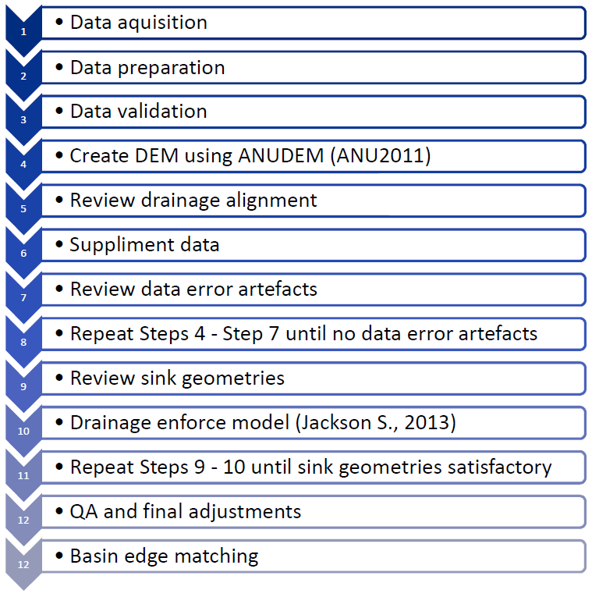

Figure 3: Vicmap Elevation DEM 10m process of production.

# Data maintenance

The DEM 10m is updated from project data on an ad-hoc basis.

# Data product delivery

## Access & licensing

Vicmap Elevation is freely available through the Victorian Government Data Directory (VGDD) at [www.data.vic.gov.au](http://www.data.vic.gov.au) under a Creative Commons Attribution 4.0 Australia license.

The Victorian Government Data Directory also provides details such as:

* Timetable for release
* Usage and availability restrictions
* License restrictions and conditions
* Access constraints
* Exclusion of liability
* Supply and media formats
* Projections

# Metadata

The metadata, abstract, and preview for the datasets within Vicmap products can be viewed at Spatial DataMart (SDM) located at <http://services.land.vic.gov.au/SpatialDatamart/> by searching for the ANZLIC ID.

# Appendix A: Data & object models

Vicmap Elevation data model can be found at [www2.delwp.vic.gov.au/maps/maps-and-spatial-data](https://www2.delwp.vic.gov.au/maps/maps-and-spatial-data)

# Appendix B: Data dictionary

## Accuracy attributes

N/A

## Data Source Code

The lookup table for data Custodian.

|  |  |
| --- | --- |
| Source | Source Description |
| 1 | MMBW |
| 10 | MELWAYS/UBD |
| 20 | VICROADS |
| 21 | VICROADS - DESIGN |
| 30 | DELWP |
| 31 | DELWP - TOPOGRAPHIC |
| 32 | DELWP - PROPERTY |
| 40 | LOCAL GOVERNMENT AUTHORITIES |
| 50 | EMERGENCY SERVICES/BEST |
| 60 | WATER AUTHORITIES |
| 70 | FIELD DATA CAPTURE |
| 80 | SATELLITE IMAGERY |
| 81 | AERIAL PHOTOGRAPHY |
| 90 | NSW – LAND INFORMATION CENTRE |
| 999 | UNKNOWN |

## Derivation of Planimetric Accuracy

N/A

## Data Source Class Attributes

N/A

# 

Table 14 – add_access_type

|  |  |
| --- | --- |
| Code | Description |
| L | An address that is accessed from a road |
| W | An address that is accessed from a water way |
| I | An address that is located on an island that cannot be accessed from the mainland by road. |

delwp.vic.gov.au