delwp.vic.gov.au

Land Use Victoria

|  |
| --- |
| Land Registry Services Business Activity Report  2020-2021 Financial Year |

|  |  |
| --- | --- |
|  |  |

|  |
| --- |
| Acknowledgment  We acknowledge and respect Victorian Traditional Owners as the original custodians of Victoria's land and waters, their unique ability to care for Country and deep spiritual connection to it. We honour Elders past and present whose knowledge and wisdom has ensured the continuation of culture and traditional practices.  We are committed to genuinely partner, and meaningfully engage, with Victoria's Traditional Owners and Aboriginal communities to support the protection of Country, the maintenance of spiritual and cultural practices and their broader aspirations in the 21st century and beyond. |
| © The State of Victoria Department of Environment, Land, Water and Planning 2021  LogoThis work is licensed under a Creative Commons Attribution 4.0 International licence. You are free to re-use the work under that licence, on the condition that you credit the State of Victoria as author. The licence does not apply to any images, photographs or branding, including the Victorian Coat of Arms, the Victorian Government logo and the Department of Environment, Land, Water and Planning (DELWP) logo. To view a copy of this licence, visit <http://creativecommons.org/licenses/by/4.0/>  Disclaimer  This publication may be of assistance to you but the State of Victoria and its employees do not guarantee that the publication is without flaw of any kind or is wholly appropriate for your particular purposes and therefore disclaims all liability for any error, loss or other consequence which may arise from you relying on any information in this publication.  Accessibility  If you would like to receive this publication in an alternative format, please telephone the DELWP Customer Service Centre on 136186, email [customer.service@delwp.vic.gov.au](mailto:customer.service@delwp.vic.gov.au) or via the National Relay Service on 133 677 [www.relayservice.com.au](http://www.relayservice.com.au). This document is also available on the internet at [www.delwp.vic.gov.au](http://www.delwp.vic.gov.au). |

Contents

Land Registry Services 2

Business activity report 2020-2021 financial year 2

Lodgments 2

Number of dealings lodged 2

Yearly lodgments (1945-2021) 3

Monthly lodgments 3

Average daily lodgments (with trend line) 4

Financial year lodgments from 2012-2013 to 2020-2021 (by month) 4

Search 5

Title searches 5

Financial year title searches (by month) 6

Planning certificates 6

Instrument searches 7

Property certificates 7

Land Index searches 8

Lodgment and Support Services 1 (LSS1) 9

Landata statistics with trend lines 9

Water share transactions 11

Lodgment by specific dealing types 12

Discharges of mortgage 12

Transfers of land 12

Mortgages 13

Differences in lodging levels and percentages of discharges, transfers and mortgages 13

Number of plans of subdivision lodged 16

Number of new parcels created from plans of subdivision 17

General law conversion 17

Top 40 dealings types, by number lodged 18

Other measures of Land Registry Services activity 20

Registrations 20

Number of dealings registered 20

Percentage of dealings registered within five days 20

Number of plans registered 20

Number of dealings refused 20

Number of dealings waiting to be processed 20

Electronic transactions processing 21

Electronic Conveyancing 21

Percentage of transactions lodged electronically 22

Land Registry Services

## Business activity report 2020-2021 financial year

This report provides statistics for land registration and property information services conducted at the Land Registry Services area of Land Use Victoria.

As well as figures for the 2020-2021 financial year, statistics are also provided for previous years.

# Lodgments

## Number of dealings lodged

The number of dealings lodged for the financial year was 896,843. This is a 5.11 per cent increase on the 2019-2020 financial year.

Recent financial years’ lodgments have been:

|  |  |
| --- | --- |
| Year | Total |
| 2020-2021 | 896,843 |
| 2019-2020 | 853,227 |
| 2018-2019 | 885,058 |
| 2017-2018 | 917,385 |
| 2016-2017 | 876,482 |
| 2015-2016 | 857,497 |
| 2014-2015 | 792,335 |
| 2013–2014 | 747,598 |
| 2012–2013 | 669,214 |
| 2011–2012 | 677,708 |
| 2010–2011 | 720,649 |
| 2009–2010 | 743,389 |
| 2008–2009 | 675,640 |
| 2007–2008 | 777,542 |
| 2006–2007 | 727,464 |
| 2005–2006 | 748,647 |
| 2004–2005 | 780,329 |
| 2003–2004 | 797,231 |
| 2002–2003 | 798,686 |
| 2001–2002 | 792,336 |
| 2000–2001 | 670,865 |

## Yearly lodgments (1945-2021)

This graph represents the yearly lodgments for each year since 1945.

A trend line has also been incorporated to give an indication of the growth in lodgments over time.

Since 1945, the trend line shows a 4.0 per cent increase per annum.

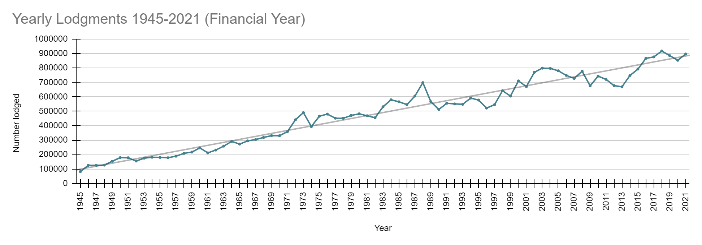

## Monthly lodgments

This graph shows the number of lodgments received for each month of the financial year.

In the 2020-2021 financial year, the average number of lodgments was 74,736 per month.

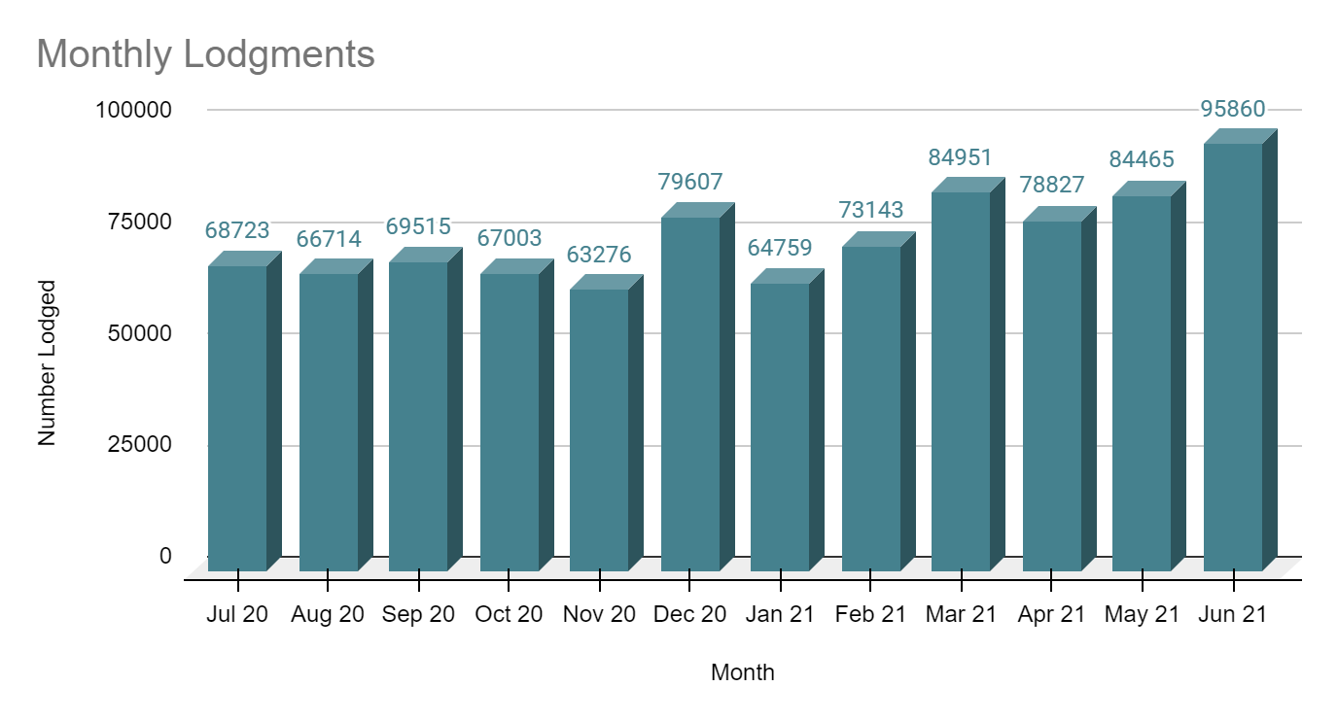

## Average daily lodgments (with trend line)

This graph shows the daily average lodgments for each week of the 2020-2021 financial year.

The average daily lodgment throughout the financial year was 3,374 per day.

The average daily lodgment is monitored on a daily basis (along with moving averages).

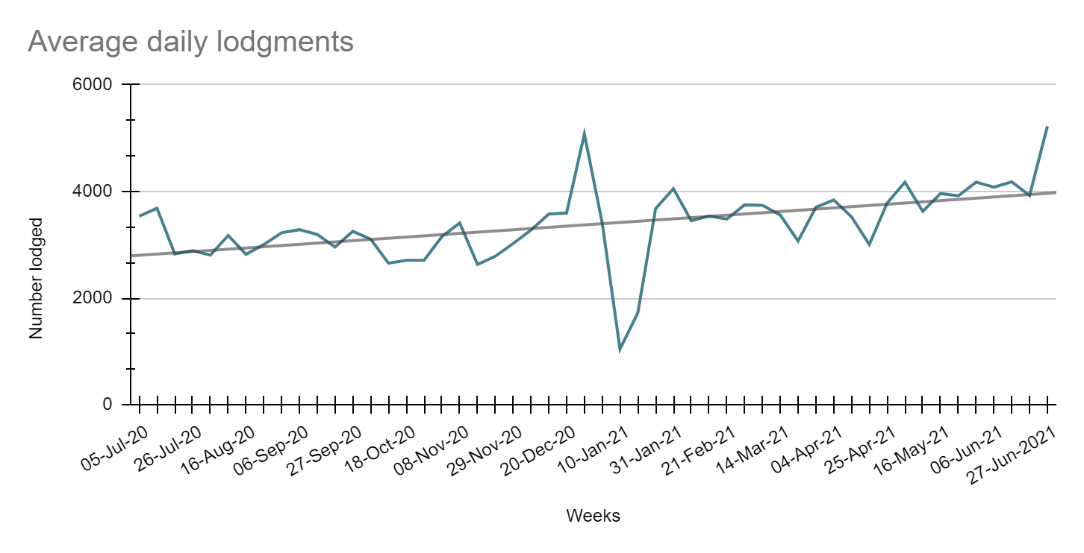

## Financial year lodgments from 2012-2013 to 2020-2021 (by month)

This graph compares monthly lodgments since the 2012-2013 financial year.

# Search

There are a number of search categories listed below, together with historical data to show trends.

## Title searches

Title searches increased by 10.14 per cent in the 2020-2021 financial year

|  |  |
| --- | --- |
| Year | Quantity |
| 2020-2021 | 2,797,895 |
| 2019-2020 | 2,540,297 |
| 2018-2019 | 2,483,433 |
| 2017-2018 | 2,866,297 |
| 2016-2017 | 2,463,249 |
| 2015-2016 | 2,232,051 |
| 2014-2015 | 2,242,562 |
| 2013–2014 | 2,205,947 |
| 2012–2013 | 2,169,973 |
| 2011–2012 | 2,192,819 |
| 2010–2011 | 2,218,043 |
| 2009–2010 | 2,200,297 |
| 2008–2009 | 2,023,852 |
| 2007–2008 | 2,169,427 |
| 2006–2007 | 2,050,786 |
| 2005–2006 | 1,906,169 |
| 2004–2005 | 1,731,553 |

## Financial year title searches (by month)

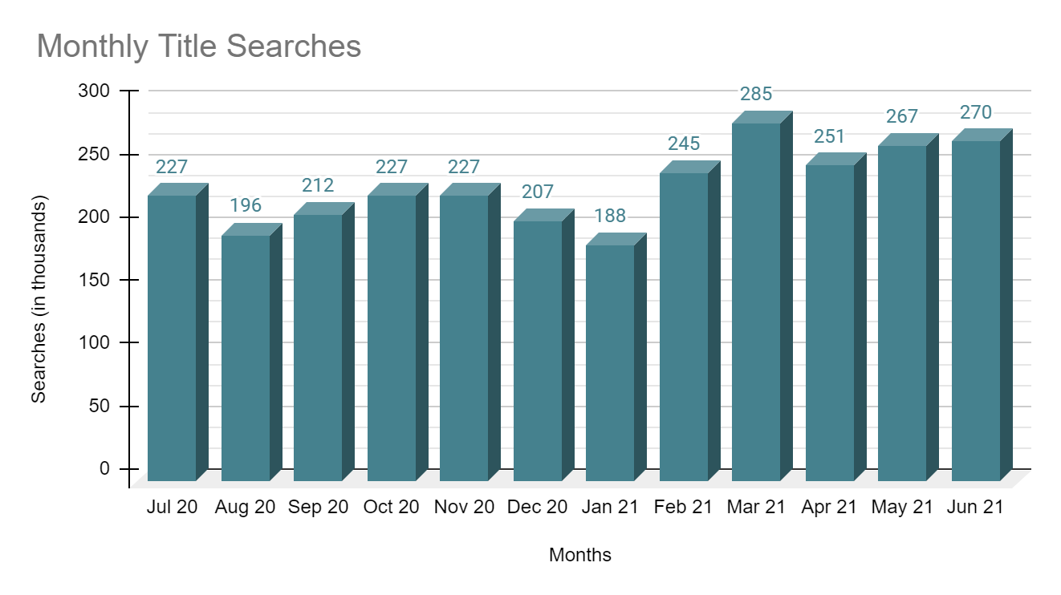

## Planning certificates

Planning certificate searches increased by 19.08 per cent in the 2020-2021 financial year.

|  |  |
| --- | --- |
| Year | Quantity |
| 2020-2021 | 90,139 |
| 2019-2020 | 75,695 |
| 2018-2019 | 67,658 |
| 2017-2018 | 71,771 |
| 2016-2017 | 63,161 |
| 2015-2016 | 57,078 |
| 2014-2015 | 55,461 |
| 2013–2014 | 50,090 |
| 2012–2013 | 42,018 |
| 2011–2012 | 38,196 |
| 2010–2011 | 37,131 |
| 2009–2010 | 37,695 |
| 2008–2009 | 32,893 |
| 2007–2008 | 40,716 |
| 2006–2007 | 33,259 |
| 2005–2006 | 37,301 |

## Instrument searches

Instrument searches increased by 29.43 per cent in the 2020-2021 financial year.

| Year | Quantity |
| --- | --- |
| 2020-2021 | 604,336 |
| 2019-2020 | 466,912 |
| 2018-2019 | 582,125 |
| 2017-2018 | 677,407 |
| 2016-2017 | 673,628 |
| 2015-2016 | 667,018 |
| 2014-2015 | 667,648 |
| 2013–2014 | 682,478 |
| 2012–2013 | 683,604 |
| 2011–2012 | 668,858 |
| 2010–2011 | 721,380 |
| 2009–2010 | 757,195 |
| 2008–2009 | 618,854 |
| 2007–2008 | 613,296 |
| 2006–2007 | 587,682 |

## Property certificates

Property certificate searches increased by 22.99 per cent in the 2020-2021 financial year.

| Year | Total searches |
| --- | --- |
| 2020-2021 | 815,614 |
| 2019-2020 | 663,119 |
| 2018-2019 | 622,465 |
| 2017-2018 | 630,885 |
| 2016-2017 | 619,212 |
| 2015-2016 | 541,176 |
| 2014-2015 | 521,891 |
| 2013–2014 | 367,172 |
| 2012–2013 | 271,449 |
| 2011–2012 | 213,692 |
| 2010–2011 | 243,917 |
| 2009–2010 | 188,155 |
| 2008–2009 | 126,380 |
| 2007–2008 | 134,288 |
| 2006–2007 | 109,355 |

## 

## Land Index searches

Land Index searches increased by 6.49 per cent in the 2020-2021 financial year.

| Year | Total searches |
| --- | --- |
| 2020-2021 | 1,440,211 |
| 2019-2020 | 1,352,415 |
| 2018-2019 | 1,319,785 |
| 2017-2018 | 1,374,961 |
| 2016-2017 | 1,345,345 |
| 2015-2016 | 1,153,439 |
| 2014-2015 | 1,070,323 |
| 2013–2014 | 998,803 |
| 2012–2013 | 1,056,131 |
| 2011–2012 | 1,053,140 |
| 2010–2011 | 1,103,887 |
| 2009–2010 | 1,137,876 |
| 2008–2009 | 1,278,727 |
| 2007–2008 | 1,488,230 |
| 2006–2007 | 1,466,544 |

## Lodgment and Support Services 1 (LSS1)

This statistic refers to services provided to Electronic Lodgment Networks (ELN) on the creation of a workspace, consisting of pre-population of title data, title activity checks and lodgment verification. As LSS1 is required on the creation of a workspace in an ELN, this statistic is a measure of the number of such workspaces created.

|  |  |
| --- | --- |
| Year | Total LSS1 |
| 2020-2021 | 528,675 |
| 2019-2020 | 476,167 |

# 

# Landata statistics with trend lines

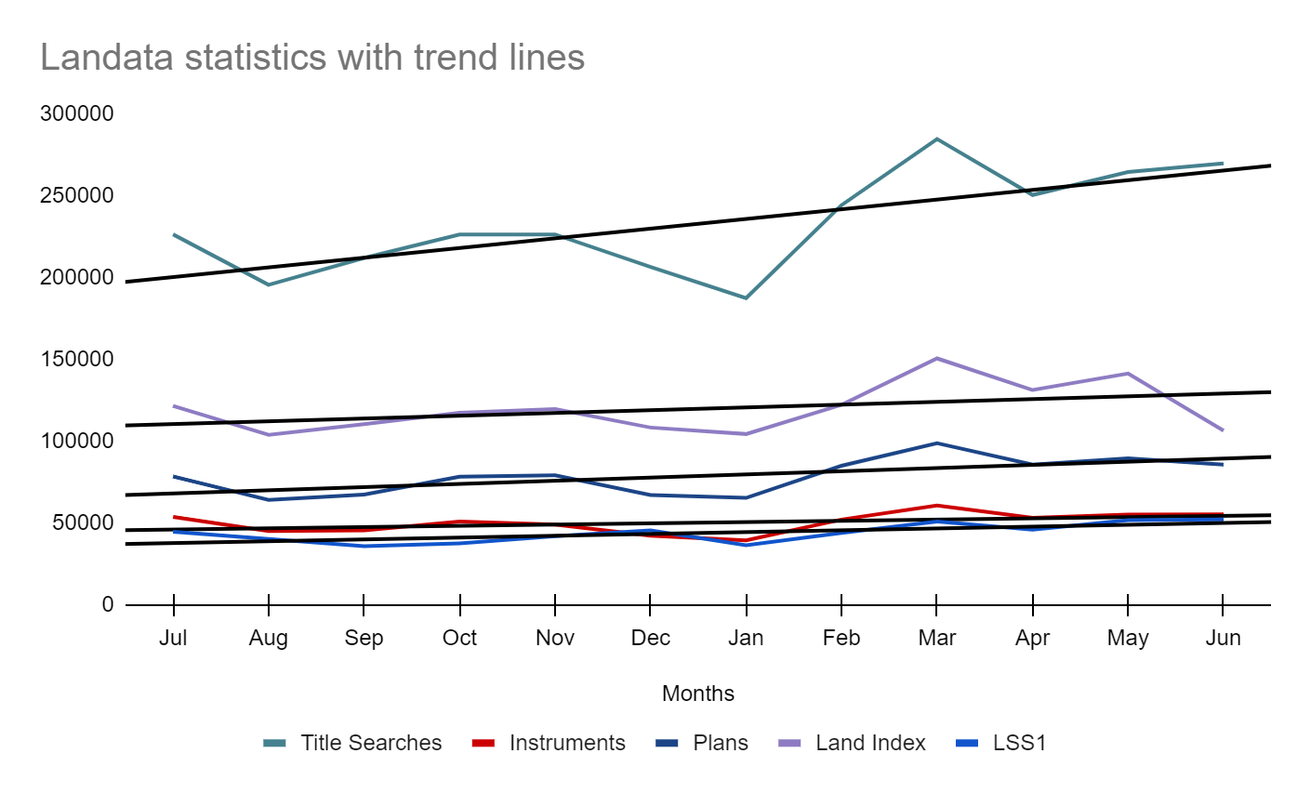

**Water Register**

Water share record searches decreased by 5.44 per cent in the 2020-2021 financial year.

| Year | Quantity |
| --- | --- |
| 2020-2021 | 7,083 |
| 2019-2020 | 7,491 |
| 2018-2019 | 11,876 |
| 2017-2018 | 9,648 |
| 2016-2017 | 6,162 |
| 2015-2016 | 7,013 |
| 2014-2015 | 7,670 |
| 2013–2014 | 7,529 |
| 2012–2013 | 8,800 |
| 2011–2012 | 9,871 |
| 2010–2011 | 9,990 |
| 2009–2010 | 10,983 |
| 2008–2009 | 13,391 |
| 2007–2008 | 5,259 |

## Water share transactions

There are a number of water share transactions recorded each year. The total numbers in each category are shown below.

**Type of Transaction Number Lodged**

#### Transfers

Transfer within authority (including limited term transfers) 2,262

Transfer between authority (including limited term transfers) 111

#### Total Transfers 2,373

#### Party amendments

Address amendment 3,555

Name and address amendment 42

Party merge 0

#### Total party amendments 3,597

#### Mortgages

Mortgages created 262

Mortgages discharged 608

Mortgages varied 0

Mortgage amendment 5

Mortgage priority 0

Create MCP 0

#### Total Mortgages 875

#### Survivorships

Recording of LPR 126

Recording of survivorship 101

Recording of trustee in bankruptcy 4

#### Total survivorships 231

#### Registrar notification on water share

Create notification 0

Remove notification 7

#### Total notifications 7

# Lodgment by specific dealing types

## Discharges of mortgage

For the 2020-2021 financial year, discharges of mortgage were 33.35 per cent of all dealings lodged

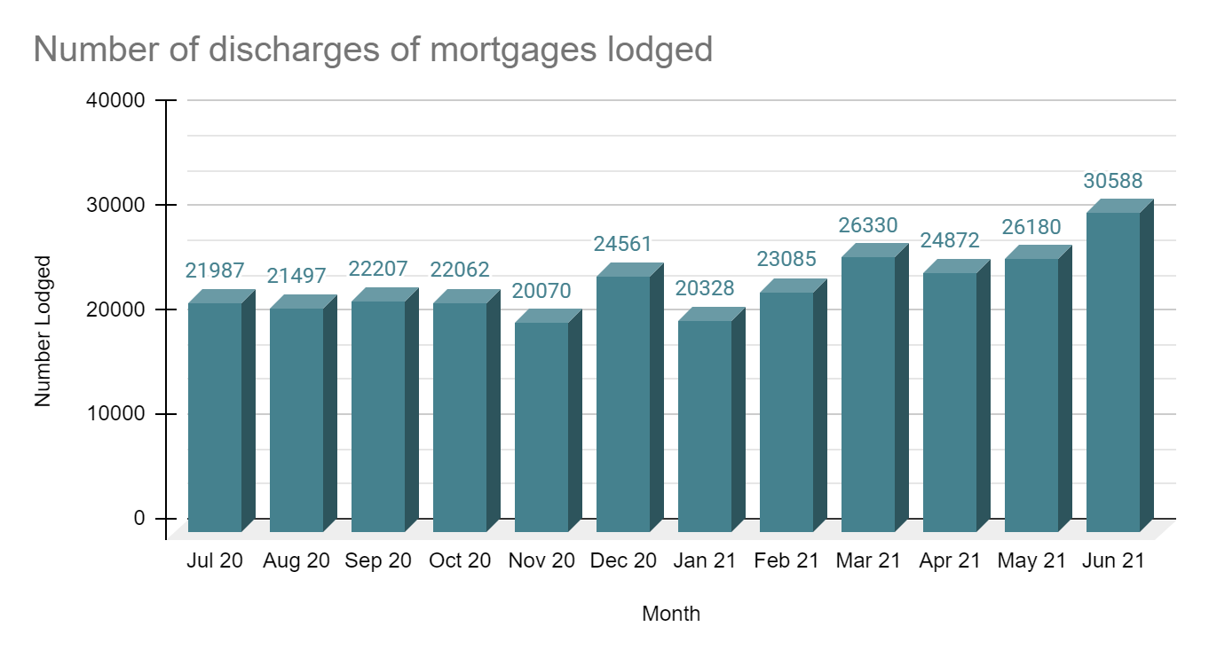

## Transfers of land

For the 2020-2021 financial year, transfers (45 and 45NM) were 25.75 per cent of all dealings lodged

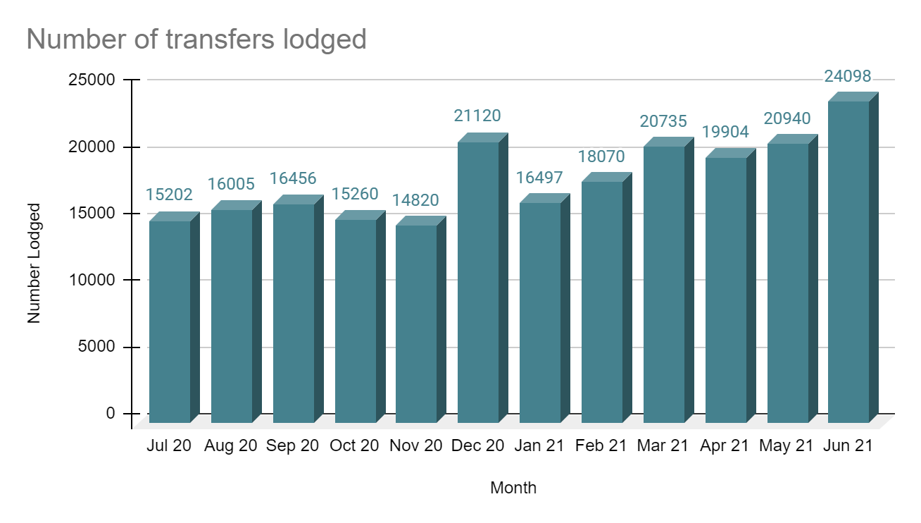

## Mortgages

For the 2020-2021 financial year, mortgages (includes 74 and 74D) were 33.25 per cent of all dealings lodged.

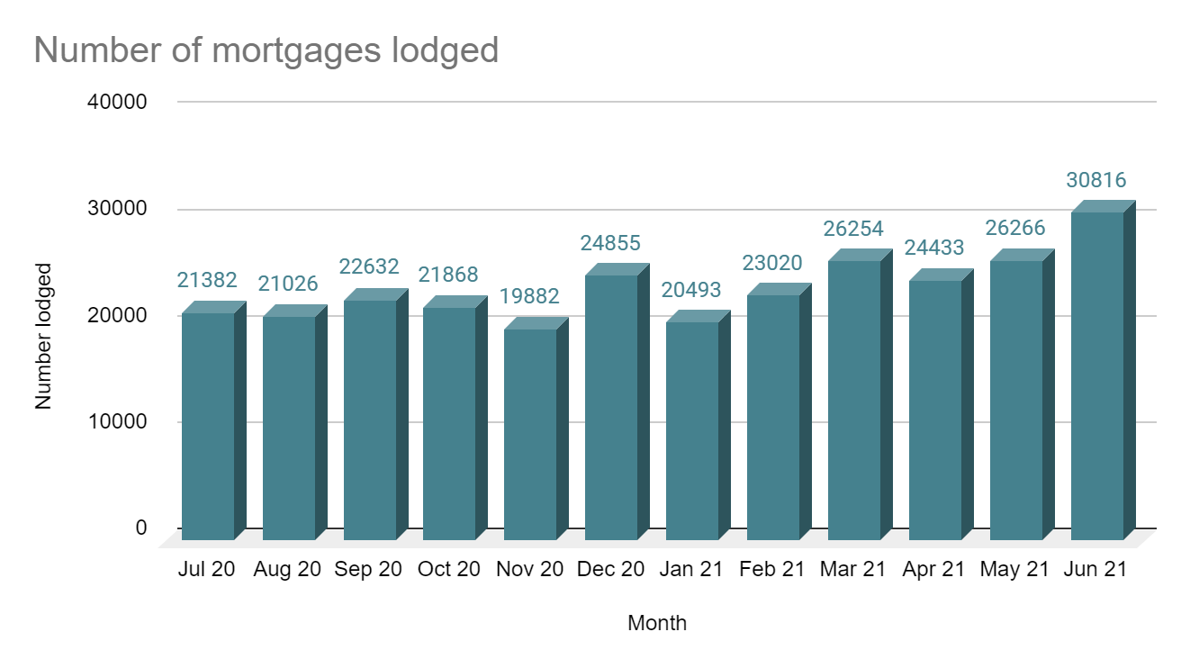

## Differences in lodging levels and percentages of discharges, transfers and mortgages

Over time, the number and relative percentages in the lodgment levels of the three most common transactions vary.

These variations are shown below.

The average for each of the dealing types for this financial year is as follows:

|  |  |
| --- | --- |
| Dealing type | Percentage |
| Transfers | 25.75 |
| Discharges | 33.35 |
| Mortgages | 33.25 |

The three main dealing types as a percentage of all dealings lodged since 1997-1998 is shown below.

|  |  |  |  |
| --- | --- | --- | --- |
|  | Transfers (%) | Discharges (%) | Mortgages (%) |
| 2020-21 | 25.75 | 33.35 | 33.25 |
| 2019-20 | 23.72 | 31.98 | 30.80 |
| 2018-19 | 23.03 | 29.22 | 27.72 |
| 2017-18 | 25.90 | 30.57 | 28.66 |
| 2016-17 | 28.05 | 30.60 | 28.69 |
| 2015-16 | 23.90 | 29.90 | 29.20 |
| 2014-15 | 25.44 | 29.15 | 28.25 |
| 2013-14 | 25.76 | 28.54 | 27.74 |
| 2012-13 | 25.04 | 28.15 | 27.80 |
| 2011-12 | 25.24 | 28.28 | 28.05 |
| 2010-11 | 26.22 | 27.20 | 27.68 |
| 2009-10 | 26.87 | 27.16 | 28.62 |
| 2008-09 | 25.95 | 27.21 | 28.42 |
| 2007-08 | 26.27 | 27.59 | 29.19 |
| 2006-07 | 25.87 | 28.13 | 29.85 |
| 2005-06 | 25.49 | 28.36 | 30.51 |
| 2004-05 | 25.05 | 29.53 | 26.75 |
| 2003-04 | 27.15 | 30.63 | 27.79 |
| 2002-03 | 27.93 | 30.33 | 27.29 |
| 2001-02 | 28.42 | 29.41 | 26.30 |
| 2000-01 | 28.81 | 29.74 | 26.14 |
| 1999-00 | 30.79 | 25.91 | 29.63 |
| 1998-99 | 30.46 | 25.50 | 29.20 |
| 1997-98 | 30.66 | 27.30 | 30.57 |

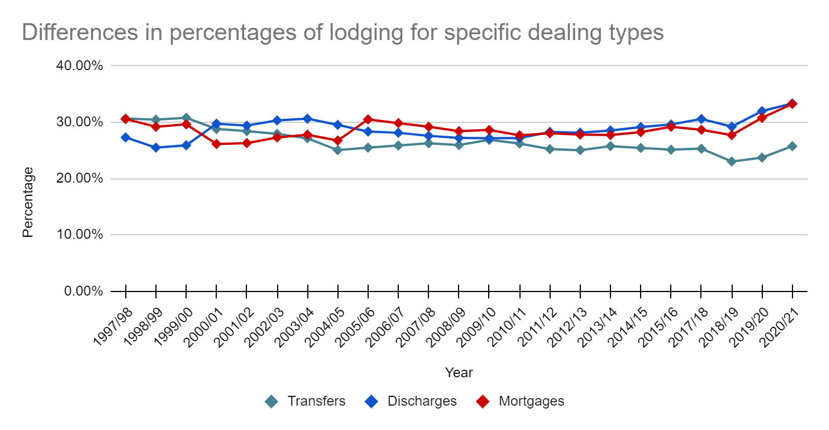Plans of subdivisions

There were 8,220 plans of subdivision lodged in the 2020-2021 financial year, representing 0.86 per cent of all dealings lodged. These plans of subdivision are captured in the Victorian Online Titles System (VOTS) as ‘PS’ transaction types.

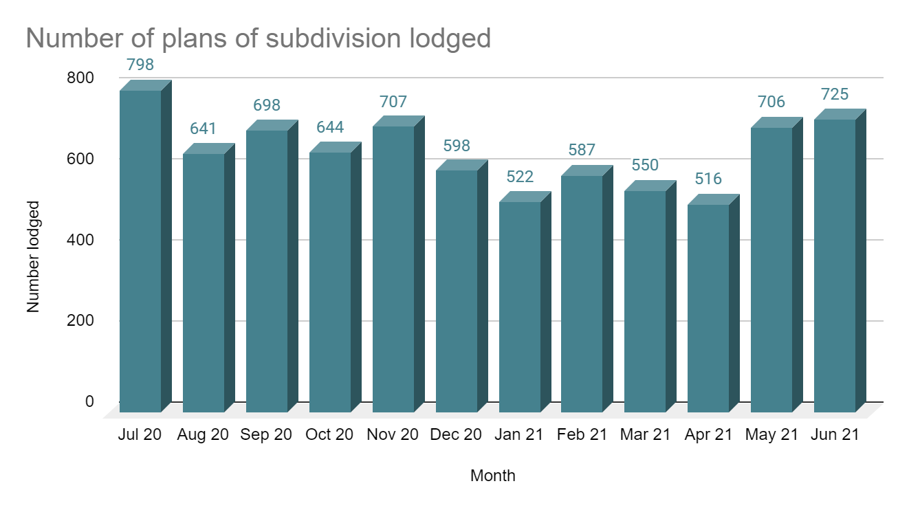

Another plan type of transaction is captured as a ‘PS35’. In the 2020-2021 financial year there were 138 of this transaction lodged, a decrease of 39.5 per cent from 2019-2020 financial year when 228 of this transaction were lodged. These are for compulsory acquisitions of property to assist with, for example, the building of major roads.

A further plan type of transaction is a ‘SA32PS’. This plan type transaction occurs typically in the redevelopment of a plan with an owners corporation. In the 2020-2021 financial year there were 207 of this transaction lodged, an increase of 4.4 per cent from 2019-2020 financial year, when 198 of this transaction were lodged.

## 

## Number of plans of subdivision lodged

The number of plans of subdivision lodged for the 2020–2021 financial year was 8,220

Recent financial year’s lodgments have been:

|  |  |
| --- | --- |
| Year | Quantity |
| 2020-2021 | 8,220 |
| 2019-2020 | 8,541 |
| 2018-2019 | 8,249 |
| 2017-2018 | 8,340 |
| 2016-2017 | 8,376 |
| 2015-2016 | 8,970 |
| 2014-2015 | 8,252 |
| 2013–2014 | 8,001 |
| 2012–2013 | 7,896 |
| 2011–2012 | 8,088 |
| 2010–2011 | 7,699 |
| 2009–2010 | 7,988 |
| 2008–2009 | 7,719 |
| 2007–2008 | 8,048 |
| 2006–2007 | 8,304 |
| 2005–2006 | 8,547 |
| 2004–2005 | 8,349 |
| 2003–2004 | 8,052 |
| 2002–2003 | 7,962 |
| 2001–2002 | 8,477 |
| 2000–2001 | 8,126 |

## 

## Number of new parcels created from plans of subdivision

1. The number of parcels created from plans of subdivision for the 2020–2021 financial year was 74,352. This compares to previous financial years as follows:

|  |  |
| --- | --- |
| Year | Quantity |
| 2020-2021 | 74,352 |
| 2019-2020 | 82,898 |
| 2018-2019 | 77,602 |
| 2017-2018 | 77,014 |
| 2016-2017 | 79,034 |
| 2015-2016 | 75,351 |
| 2014-2015 | 61,669 |

## 

## General law conversion

The number of parcels created from General law conversions for the 2020–2021 financial year was 482. This compares to previous financial years as follows:

|  |  |
| --- | --- |
| Year | Quantity |
| 2020-2021 | 482 |
| 2019-2020 | 1,468 |
| 2018-2019 | 1,575 |
| 2017-2018 | 1,922 |
| 2016-2017 | 3,228 |
| 2015-2016 | 2,868 |
| 2014-2015 | 2,018 |
| 2013–2014 | 3,774 |
| 2012–2013 | 1,997 |
| 2011–2012 | 1,303 |
| 2010–2011 | 2,559 |
| 2009–2010 | 1,559 |
| 2008–2009 | 1,023 |
| 2007–2008 | 1,238 |
| 2006–2007 | 1,309 |
| 2005–2006 | 1,490 |
| 2004–2005 | 1,750 |
| 2003–2004 | 1,996 |
| 2002–2003 | 2,357 |

## Top 40 dealings types, by number lodged

Shown below are the top 40 dealing types lodged in Land Registry Services for the financial year.

| Dealing type | Description | Lodged |
| --- | --- | --- |
| 84M | Discharge of mortgage | 283,768 |
| 74 | Mortgage | 273,980 |
| 45 | Transfer | 198,250 |
| 89 | Caveat | 30,038 |
| 45NM | Transfer without monetary consideration | 20,887 |
| 89W | Withdrawal of Caveat | 16,559 |
| 49 | Transmission Application | 13,161 |
| 50 | Survivorship Application | 9,171 |
| 74D | Mortgage with name change | 8,947 |
| PS | Plan of Subdivision | 7,755 |
| 173 | Planning Agreement | 2,695 |
| 31 | Application to replace lost Certificate of Title | 2,241 |
| PN | Priority Notice | 1,571 |
| MCP | Memorandum of Common Provisions | 1,177 |
| 32-2 | Application for a new folio of the Register | 968 |
| LTD | Discharge of land tax charge | 882 |
| LACA | Notice | 789 |
| LTC | Statutory Charge | 746 |
| 89A | Removal of caveat | 729 |
| 45N | Transfer requiring new folio | 651 |
| PC | Plan of consolidation | 550 |
| 106C | Removal of encumbrance | 513 |
| 77 | Transfer by Mortgagee | 489 |
| 45E | Creation of easement | 478 |
| 113A | Amendment of address on folio | 435 |
| 52-2 | Warrant | 358 |
| 45M | Transfer of Mortgage | 343 |
| 183W | Removal of Planning Agreement | 333 |
| OCR | Owners Corporation rules | 315 |
| 106AR | Registrar’s caveat | 293 |
| 47MSA | Removal of encumbrance | 254 |
| 14 | General law conversion – non-survey | 225 |
| 32-1 | Application for a new folio of the Register | 219 |
| SA32PS | Plan of Subdivision - Section 32 | 207 |
| SACA | Change of address of owners corporation | 162 |
| 60 | Adverse Possession | 158 |
| XEN | Expiry of encumbrance | 154 |
| 23 | Application TLA | 152 |
| 23RE | Plan for removal of easement | 151 |
| 23VR | Variation of restriction | 140 |

# Other measures of Land Registry Services activity

## Registrations

### Number of dealings registered

The number of transactions registered in the 2020–2021 financial year was 891,409

### Percentage of dealings registered within 5 days

The average percentages achieved were greater than 99 per cent for the whole of the financial year.

### Number of plans registered

The number of plans registered in the 2020–2021 financial year was 8,098. The average percentage of plans registered within 15 business days was 84.57 per cent for the whole of the financial year.

### Number of dealings refused

The number of dealings refused in the 2020–2021 financial year was 7,849. This represents 0.87 per cent of total dealings presented for acceptance at Land Registry Services for the financial year.

In the 2019–2020 financial year the figure was 9,248. This represents 1.0 per cent of total dealings presented for acceptance at Land Registry Services.

### Number of dealings waiting to be processed

The number of dealings waiting to be processed in in the 2020–2021 financial year has remained fairly stable. The ‘holding level’ at the commencement of the financial year was 2,872. For the majority of this year that figure has been less than 2,900. The majority, if not all of these dealings, will be in a processing state that requires attention from customers, or cannot be processed until a statutory period has elapsed. As of 1 July 2021 the figure was 3,107.

# Electronic transactions processing

## Electronic Conveyancing

The number of transactions lodged electronically in the 2020–2021 financial year was 860,843, up from 806,643 in 2019–2020. Transactions lodged electronically in 2020-2021 financial year accounted for 97 per cent of all lodgments.

This is made up of the following:

|  |  |
| --- | --- |
| Transaction Type | Quantity |
| Discharge of mortgage | 281,893 |
| Mortgage | 281,880 |
| Transfer of land | 216,563 |
| Caveat | 29,599 |
| Withdrawal of caveat | 16,361 |
| Transmission | 12,662 |
| Other | 9,198 |
| Survivorship | 8,819 |
| Priority notice | 1,571 |
| Discharge of land tax charge | 814 |
| Transfer by mortgagee | 483 |
| Land tax charge | 478 |
| Transfer of mortgage | 335 |
| Withdraw priority notice | 133 |
| Discharge of charge | 27 |
| Statutory charge | 27 |

## Percentage of transactions lodged electronically

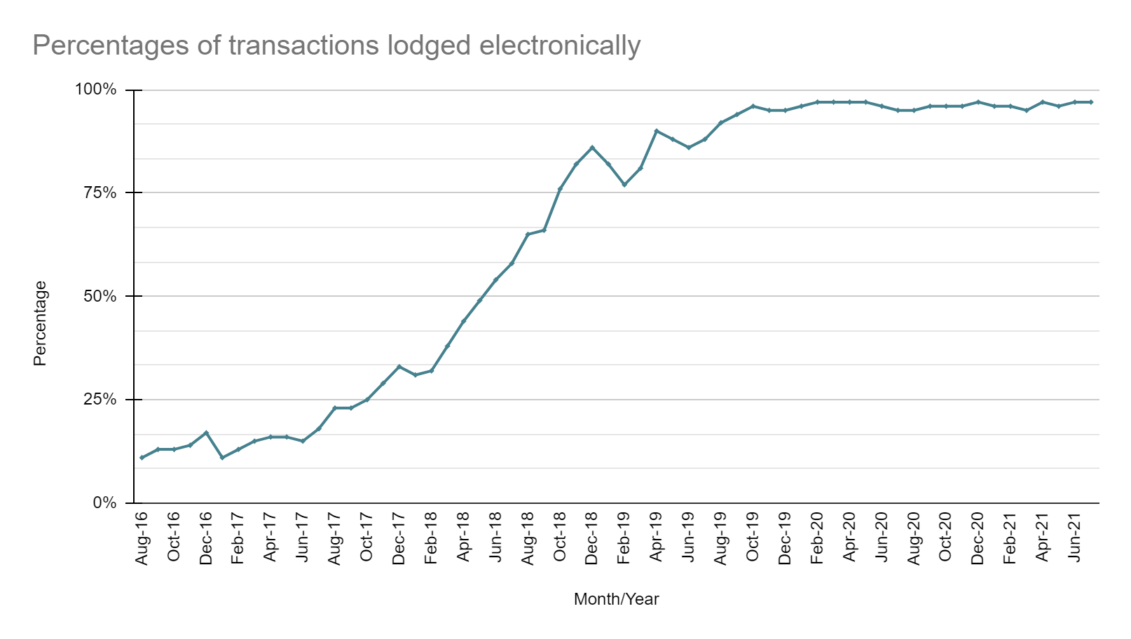

delwp.vic.gov.au