Victoria StateView 1.5m

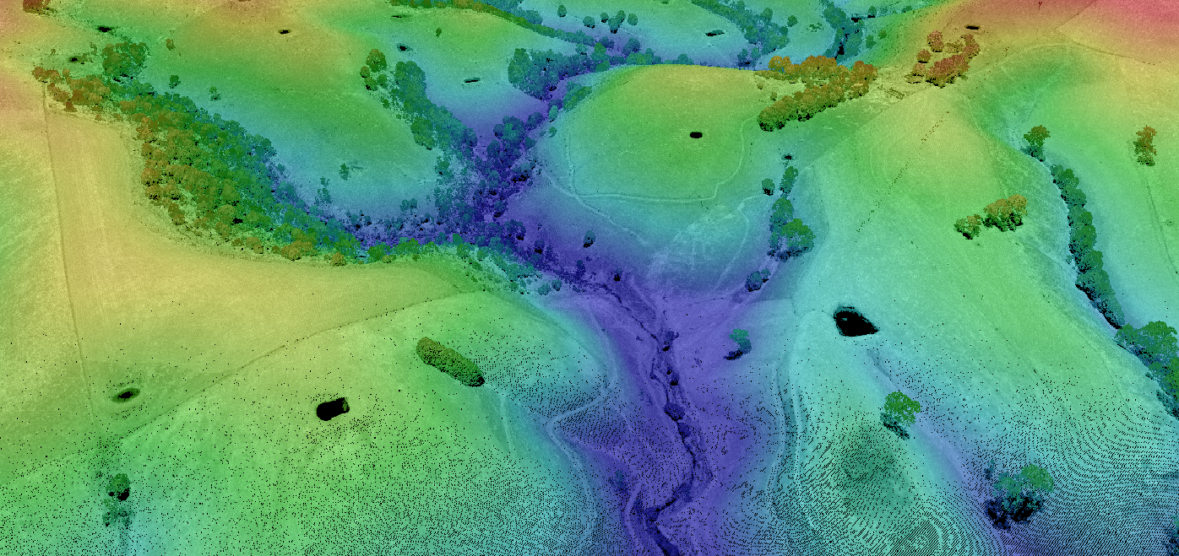

Data product specification



ISO 19131:2022 compliant

Version 1.0 APR 2024

Applies to data model Version 0.0 31 AUG 2023

Contents

About the data product specification 4

Data Product Specification – Victoria StateView 1.5m 4

English 4

Identification and purpose of the data product 5

Title 5

Alternative title 5

Abstract 5

Purpose 5

Use cases 5

Disclaimer 6

Data content and structure 7

Data content 7

Reference systems 9

Data quality 10

Coverage Accuracy 10

Pixel smearing and distortion 10

Logical consistency along Seamlines 10

Data capture and production 10

Data Voids 10

Ground sampling distance 10

Control and Check points 11

Footprints 11

Data maintenance 11

Data delivery methods 11

Access & licensing 11

Metadata 12

Filename 12

# About the data product specification

**Table 1:** About the data product specification.

|  |  |
| --- | --- |
| Element | Comment |
| Title | Data Product Specification – Victoria StateView 1.5m |
| Language | English |
| Contact | Department of Transport and Planning  PO Box 527, Melbourne VIC 3001 Australia  [coordinated.imagery@delwp.vic.gov.au](mailto:coordinated.imagery@delwp.vic.gov.au)  [vicmap@delwp.vic.gov.au](mailto:vicmap@delwp.vic.gov.au) |
| Web location | <https://www.land.vic.gov.au/maps-and-spatial/imagery/satellite-imagery/victoria-stateview-1.5m> |
| Maintenance | The data product specification is updated in accordance with changes to the product and reviewed periodically. Collaboration, and review process in accordance with the Departments Change Management Framework. |
| Terms and definitions | Refer to Vicmap Terms and Definitions repository at web location. |
| Overview of the data product specification | **Change History**   |  |  |  | | --- | --- | --- | | Version | Date | Note | | 0.1 | Nov 2023 | First draft – adapted from older template | | 0.2 | Jan 2024 | Revised | | 0.3 | Mar 2024 | Revised | | 1.0 | Apr 2024 | Approved |   **Conformance**  This data product specification conforms to ISO 19131: 2022 |

# Identification and purpose of the data product

## Title

Victoria StateView 1.5m

### Alternative title

Stateview 1.5m

Stateview - SATELLITE

## Abstract

1. Victoria StateView 1.5m is a set of high-resolution orthorectified satellite images derived from AIRBUS SPOT imagery (for more details about SPOT, visit [SPOT 6/7 (intelligence-airbusds.com)](https://www.intelligence-airbusds.com/en/8693-spot-67)). Datasets derived include: 3-band (Red, Green, Blue) orthorectified mosaic, 4-band (Blue, Green, Red and Near-Infrared) orthorectified mosaic, 4-band uncompressed orthorectified swaths for three consecutive epochs, 2021/22, 2022/23, and 2023/24.
2. The high-resolution at consistent and consecutive summer epochs allows customers to comprehensively explore Victoria’s landmass and accurately analyse changes over time.
3. Victoria StateView 1.5m is subject to cloud cover, atmospheric conditions, and seasonal changes, which may affect the quality and accuracy of the images.

Each mosaic has gone through rigorous quality assurance and quality control (QA and QC) validation processes. Included are confirmation of horizontal geospatial accuracy and visual checks for seemliness. Images are orthorectified to 10cm using aerial photography as ground control.

1. Additional datasets may be captured at varying resolutions and accuracies depending on the use of the imagery and requirements of the products in consultation with customers.

Victoria StateView 1.5m is maintained through the Vicmap Coordinated Imagery Program maintenance lifecycle for a period of three years beginning 2021/22.

## Purpose

Victoria StateView 1.5m is primarily derived to function as a base map, offering a seamless and comprehensive background for the entire Victoria region year over a three-year period starting from the summer of 2021/22. Carefully curated the product may be used for state-level research, with particular attention given to precise capture windows for each epoch to mitigate variations such as seasonal changes. Additionally, this collection provides a diverse array of formats, band combinations, and projections.

### Use cases

* Basemap search and discovery
* Change detection and year on year analysis
* Land use monitoring and forestry management

Further details about the identification and purpose of the data product:

Table 2: Identification and purpose of the data product details.

|  |  |
| --- | --- |
| Element | Comment |
| Topic category | environment, imagery base maps Earth cover |
| Keywords | Satellite, mosaic, base map, high-res, SPOT, multi spectral imagery |
| Spatial representation | Raster |
| Spatial resolution | 1.5m High-resolution remote sensing images |
| Supplemental information | The information contained in this document (the specification) is different from that contained in metadata, which provides information about particular datasets. Metadata describes how the data is and the specification describes how it should be. |
| Restrictions | Restricted for use by Victorian state government agencies and local governments. Disclaimer The State of Victoria:   1. does not give any representation or warranty as to 2. the accuracy or completeness of DTP spatial products (including data and metadata), Vicmap products or Vicmap product specifications; or 3. the fitness of such data or products or of DTP spatial services (including APIs and web services) for any particular purpose; 4. disclaims all responsibility and liability whatsoever for any errors, faults, defects or omissions in such data or products and services.   Any person using or relying upon such products and services must make an independent assessment of them and their fitness for particular purposes and requirements. |
| Extent | Victoria StateView 1.5m is state-wide extending coverage conformance to Vicmap Index 1:100,000 title map index[1]. Refer to **Figure 1** and **Figure 2**. |

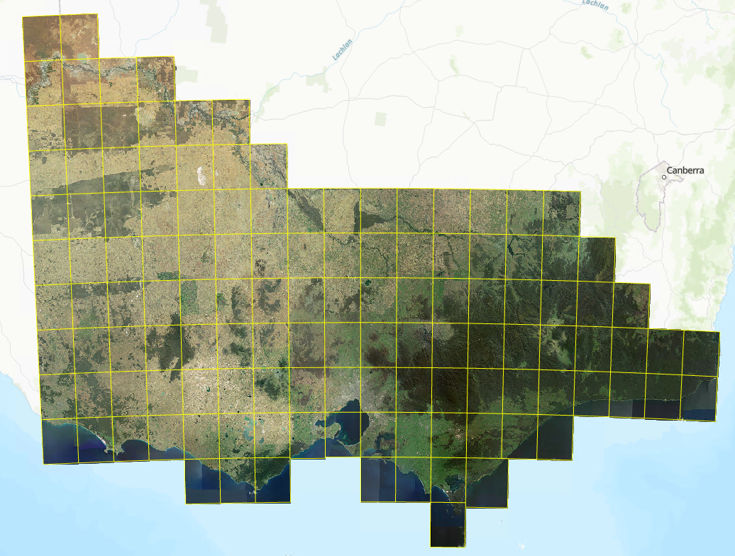  
Figure 1: Victoria StateView 1.5m product coverage.

# Data content and structure

### Data content

The coverage datasets that comprise Victoria StateView 1.5m are listed in **Table 3**. Further details (e.g. Narrative description and coverage description) are provided in the linked metadata records for each dataset.

Table 3: Victoria StateView 1.5m datasets.

|  |  |  |  |  |
| --- | --- | --- | --- | --- |
| **UUID** | **Dataset name** | **Description** | **Coverage type** | |
| bcc0f740-281d-4f4b-a2c6-f12ace5ce03c | [MetaShare PROD (maps.vic.gov.au)](https://metashare.maps.vic.gov.au/geonetwork/srv/eng/catalog.search#/metadata/bcc0f740-281d-4f4b-a2c6-f12ace5ce03c)   1. Victoria StateView 2021/22 1.5m Natural 2. Victoria StateView 2021/22 1.5m Infrared | Victoria in summer 2021/2022 (Epoch 1) in RGB and NIR.  Mosaic and footprint | Grid Coverage |
| e76adbde-dcaf-4c60-a1ad-4da05c860966 | [MetaShare PROD (maps.vic.gov.au)](https://metashare.maps.vic.gov.au/geonetwork/srv/eng/catalog.search#/metadata/e76adbde-dcaf-4c60-a1ad-4da05c860966)  Victoria StateView 2022/23 1.5m Natural  Victoria StateView 2022/23 1.5m Infrared | Victoria in summer 2022/2023 (Epoch 2) in RGB and NIR.  Mosaic and footprint | Grid Coverage |
| 8f651702-eb22-4d38-a7cf-b2965552fc4a (In progress) | 1. VictoriaStateView 2023/24 1.5m Natural 2. Victoria StateView 2023/24 1.5m Infrared   [MetaShare PROD (maps.vic.gov.au)](https://metashare.maps.vic.gov.au/geonetwork/srv/eng/catalog.search#/metadata/8f651702-eb22-4d38-a7cf-b2965552fc4a) | Victoria in summer 2023/2024 (Epoch 3) in RGB and NIR.  Mosaic and footprint | Grid Coverage |

2. Victoria StateView 1.5m covers the entire State of Victoria. Each epoch includes multiple datasets varying in projection and file format. Refer to **Table 4** for a summary of the Victoria StateView 1.5m collection.
3. Table 4: Victoria StateView 1.5m content summary.

|  |  |
| --- | --- |
| Source | Satellite imagery (AIRBUS SPOT 6/7) |
| Resolution | 1.5m – pansharpened (4 bands)  6m – multispectral (4 bands)  1.5m – panchromatic (1 band) |
| Currency | Epoch 1: June 2021 – August 2022  Epoch 2: December 2022 – May 2023  Epoch 3: December 2023 – April 2024 |
| Accuracy | CE90 of 5m |
| Datum | Ortho swath: GDA2020  Mosaic tile: GDA2020 and WGS84 |
| Projection | Ortho swath: MGA Zone 54 /55  Mosaic tile: Web Mercator and VicGrid 2020 |
| Data Format | ECW; GeoTIFF; and Cloud Optimised GeoTIFF |
| Coverage | 100% of the State of Victoria |
| Image processing level | Level 0: raw strips (not included in this collection)  Level 1: ortho swath (orthorectified to 10cm aerial photography, please see **Figure 2a**)  Level 2: mosaic tile (cloud masked, colour balanced, mosaicked, and tiled, please see **Figure 2b**) |

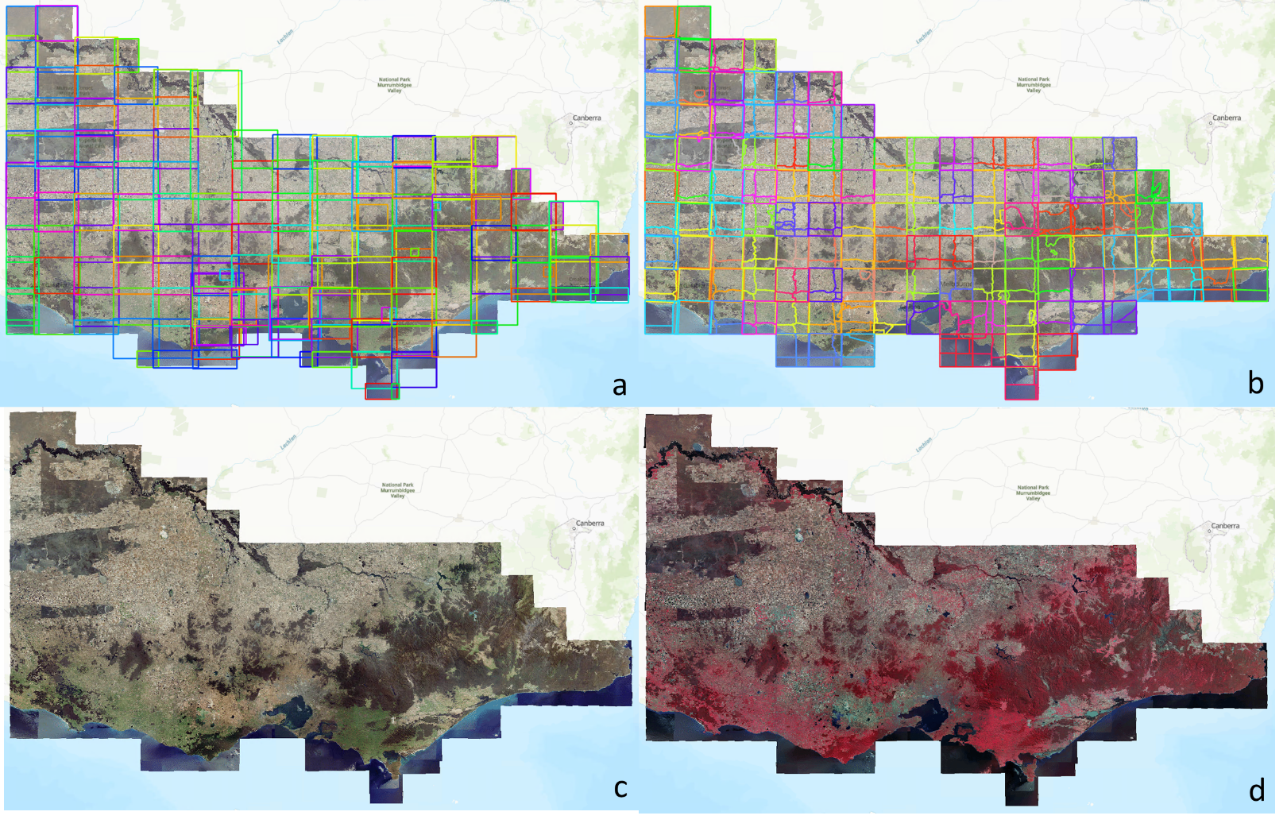

Figure 2: Epoch 2 of Victoria StateView 1.5m as example: a) extent of ortho swaths used; b) extent of mosaic tiles; c) final epoch 2 mosaic in natural colour (RGB); and d) final epoch 2 mosaic in false colour (CIR).

# Reference systems

1. Table 5: Reference system description.

|  |  |
| --- | --- |
| **Element** | **Description** |
| Horizontal Datum | 1. GDA2020 |
| Vertical Datum  (Ellipsoidal) | Ellipsoidal heights are delivered in terms of the GDA2020 reference frame |
| Projection | MGA Zone 54 /55 |
| Geoid | AUSGeoid2020 |
| Metadata | ANZLIC Metadata Profile Version 1.1 |
| File formats | ECW and GeoTIFF |

While COGs are aligned to World Geodetic System 1984 ensemble (WGS84).

Customers are able to obtain data in a variety of datums and projections.

# Data quality

## Coverage Accuracy

The horizontal accuracy of imagery products is assessed by comparing the known coordinates of a surveyed ground check point against the location of the same point in the image. Check points are typically marked by either a target placed on the ground or an easily identifiable ground feature.

The two main aspects of data quality for the Victoria StateView 1.5m collection are visual check for seamlessness and geospatial accuracy which depend largely on cloud cover and capture Off-Nadir Angle of the raw strips captured.

After orthorectification, the geospatial accuracy is at 5m of CE90 (circular error at 90th percentile).

## Pixel smearing and distortion

The production of orthorectified imagery requires a Digital Surface Model (DSM), therefore pixel smearing, or distortions of ground features may occur when the DSM does not adequately correlate to the imagery: Most commonly seen along cliff lines and raised features such as bridges and large buildings.

Victoria StateView 1.5m mosaics have undergone further orthorectification to increase spatial accuracy using 10cm aerial photography as control.

## Logical consistency along Seamlines

Otho swaths are mosaicked together using seamlines that are placed along features in the imagery so visible signs of the join are minimised. Inconsistencies may occur between separate ortho swaths in the final seamless mosaics (**Figure2c & d**) exist along the seamlines. Inconsistencies may include differing shadow directions, seasons, elevated features such as bridges not joining or opposing lean directions on buildings or trees.

Manual placement of seamlines to improve logical consistency.

Pixel feathering is also used along the seamlines to minimise the visible differences at the join. Feathering may create the appearance of pixels being fuzzy or ghosted directly either side of a seamline.

# Data capture and production

Victoria StateView 1.5m collection is mosaicked using AIRBUS SPOT6/7 imagery at 1.5m acquired by the Vicmap Spatial Services Coordinated Imagery Program (CIP) Satellite Tasking and Statewide Mosaic Services.

The raw strips are orthorectified to 20cm or 10cm resolution aerial photography which allows the geospatial accuracy to be CE90 of 5m. The orthorectified strips are one of the deliverables of this collection.

The orthorectified strips are then mosaicked and colour balanced to be seamless. The mosaic tiles are cut based on extent file provided: RFQ31202122_VIC_SatExtent_GDA20. Refer to **Figure 1**.

Manual intervention is undertaken with a focus only on essential areas within the mosaic such as urban centres, key infrastructure and significant natural features. It is to be expected that there will be distortions and artefacts caused by seamlines and the surface model evident within the imagery mosaic.

### Data Voids

1. “NODATA” value is set to be zero in all TIFF and COG files with no opacity layer included. ECW files have background colour as pure white (255 in all bands) with an opacity layer.

### Ground sampling distance

The spatial resolution of a digital image is described as its Ground Sampling Distance (GSD) and is the actual measured ‘on ground’ width of a pixel. This value is dependent upon the job type of the imagery and defines the level of detail that is visible in the image. Victoria SateView 1.5m covers the area of a VIC 1:100,000 scale mapping block, are captured at a resolution of 1.5m GSD.

### Control and Check points

Ground control and check points are surveyed by connection to the local Survey Control with ellipsoidal heights. Where relevant, orthometric heights using the local Australian Height Datum (AHD) are also provided. Control Points are typically located near the corners and centre of the imagery capture area whilst check points are distributed throughout the geographic extent of the area. The ground control points are used in the triangulation of the imagery to accurately locate the imagery to the ground. Control points were obtained by the utilisation of high-resolution aerial photography at a resolution of 20cm and 10cm. The input aerial photography had a horizontal accuracy of +/- 2 pixels at 1 sigma (68%).

### Footprints

The footprints associate with this product are maintained in Vicmap Index (VMINDEX), details as below:

1. Table 6: Victoria StateView 1.5m footprints and descriptions.

|  |  |
| --- | --- |
| **Layer name** | **Description** |
| Victoria.stateview_<year>_sat_ortho_150cm | Footprint of orthorectified swaths, with attributes:   * swath name * image size |
| Victoria_stateview_<year>_sat_footprint_150cm | Footprint of mosaic tiles, with attributes:   * capture date and time * satellite * off-nadir angle * original orthorectified swath * mosaic tile name |

# Data maintenance

Victoria StateView 1.5m collection contains three epochs of mosaics covering the entire State of Victoria. The deliverables and any derivatives derived will be managed by the Coordinated Imagery Program (CIP) team.

There will be no maintenance made by CIP to Victoria StateView 1.5m Epoch 1 - 3 once supplied. CIP is open to understand the need of future epoch from customers/partners. Please contact [coordinated.imagery@delwp.vic.gov.au](mailto:coordinated.imagery@delwp.vic.gov.au) to express your interest.

# Data delivery methods

## Access & licensing

1. Victoria StateView 1.5m collection is subject to licensed use. [AIRBUS-standard-background-layer-licence-agreement](https://delwpvicgovau.sharepoint.com/sites/ecm_400/Procurement/Statewide%20DTV%20Satellite/Licensing/EULAs/1_Airbus_EULAs/8-standard-background-layer-licence-agreement-25102021.pdf) are used to provide the terms and conditions of use, including license fees determined by the coverage and extent of the data purchased.
2. Table 7: Access points for Victoria StateView 1.5m collection.

|  |  |
| --- | --- |
| **Discover Data** | |
| [Vicmap Imagery & Elevation Coverage](https://enterprise.mapshare.vic.gov.au/portal/apps/webappviewer/index.html?id=b9e60777274f427ab29c7c33ba402fb1) | Victoria StateView 1.5m collection can be discovered on the Vicmap Imagery & Elevation Coverage map. |
| [DataShare](https://datashare.maps.vic.gov.au/) | DataShare is a DEECA hosted website for text searching both licensed and open spatial data resources held by participating State agencies. Metadata on available datasets can be discovered. |
| [Digital Twin Victoria (DTV)](https://vic.digitaltwin.terria.io/) | Victoria StateView 1.5m collection can be viewed on Digital Twin Victoria as basemap. |

# Metadata

The metadata, abstract, and preview for the datasets is finable and discoverable via DataShare and maybe replicated to other data discovery services and applications.

Metedata is compliant with AS/NZS ISO 19115.1:2015 Metadata.

Paired with each dataset description are dual spatial metadata or “footprint” records that represent 1) extent all of the ortho swaths used in an epoch and 2) the internal data tiling schema for each dataset. Associated with each mosaic tile footprint is a summary of key dataset specific data attributed (please refer to **Table 6**).

The mosaic tile footprints with metadata can be found in [Victoria StateView 1.5m Source Map (mapshare.vic.gov.au)](https://enterprise.mapshare.vic.gov.au/portal/home/item.html?id=14a0b7244cfb417e84b2abde033b4fe6) or <https://vic.digitaltwin.terria.io/#share=s-ykNGUPek3XUULC5crUzyNh3EMFX> to view them on DTV.

# Filename

Victoria StateView conforms to the following naming convention for coverages.

**<location/eastingnothing>_<epoch_year/start_date_of_collection>_<platform>_<sensor/product_type>_<resolution(units)>_<epsg>.<extension>**

Table 8: file name examples.

|  |  |
| --- | --- |
| Orthorectified swath | e704n5714_2023feb10_sat_ panms-rgbi_150cm_ epsg7854.ecw |
| Mosaic tiles | ararat-7423_2022dec20_sat_panms-rgbi_150cm_epsg3857.ecw |
| Full mosaic for Victoria | victoria_2021jun21_sat_ panms-irg_150cm_epsg7899.ecw |

1. Vicmap Topographic Index dataset, [vicmap_mapindex_100d](https://datashare.maps.vic.gov.au/search?q=uuid%3Db4910ad9-6ff9-541a-b4e0-9ddd975d5da6).