|  |
| --- |
| Vicmap™ Product Development |
| Change Notice #238 Advisory Notice |

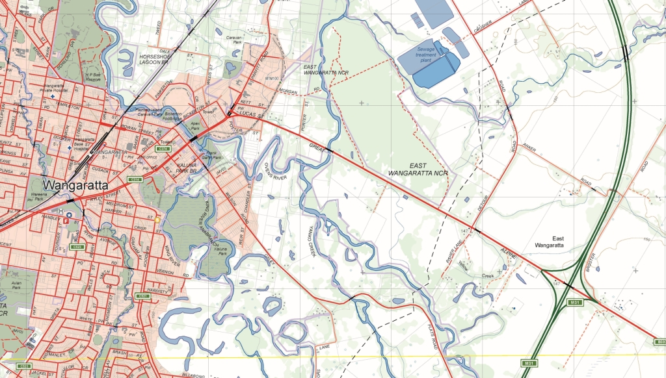

Vicmap Planning 16 February 2018

## What is happening

The ZONE_CODE_GROUP, ZONE_CODE_GROUP_LABEL is being added to VMPLAN.PLAN_CODELIST.

The structure of the PLAN_CODELIST dataset will now be:

|  |  |  |  |
| --- | --- | --- | --- |
| **Table_Attribute** | **Explanation** | **Field Type / Size** | **Example** |
| *PFI* | The Permanent Feature Identifier (PFI). | NUMBER(11) | 84155081 |
| *ZONE_NUM* | A unique number used by DELWP for automatic issuing of planning certificates. | NUMBER(6) | 11691 |
| *CODE_PARENT* | Parent Code | VARCHAR2 (10) | MUZ, RDZ, DDO, HO |
| *CODE_NUMBER* | Code Number | Long Int | 123 |
| *CODE_SCHEDULE* | Code Schedule Number | Long Int | 56 |
| *CODE_PART* | Code Part | VARCHAR2 (10) | A1 |
| *ZONE_CODE* | A unique code that links map data to the written part of the Planning Scheme. | VARCHAR2 (12) | MUZ1, RDZ2, DDO56-A1, HO123 |
| *ZONE_DESCRIPTION* | Description of Zone Type | VARCHAR2 (100) | MIXED USE ZONE - SCHEDULE 1 |
| *ZONE_GROUP* | Grouping of Zone | VARCHAR2 (30) | RESIDENTIAL, INDUSTRIAL, SPECIAL USE |
| *RED* | Red value of the RGB colour value for display fill | Small int | 204 |
| *GREEN* | Green value of the RGB colour value for display fill | Small int | 102 |
| *BLUE* | Blue value of the RGB colour value for display fill | Small int | 153 |
| *ZONE_CODE_GROUP* | A grouping value used to symbolize the zones and overlays in the Planning Schemes | VARCHAR2 (10) | B3Z |
| *ZONE_CODE_GROUP_LABEL* | The label to be used for the symbology groups for the zones and overlays in the Planning Schemes | VARCHAR2 (100) | B3Z-Business 3 Zone |
| *ACTIVE* | The value used to determine if the code value is currently active | CHAR(1) | Y |
| *PFI_CREATED* | The date the Persistent Feature Identifier (PFI) was created | DATE | 17/08/2016 7:59:08 AM |
| *UFI* | The Unique Feature Identifier (UFI) is updated each time the feature is edited | NUMBER(14) | 84155081 |
| *UFI_CREATED* | The date the Unique Feature Identifier (UFI) was created | DATE | 17/08/2016 7:59:08 AM |

## Why this change is occurring

This change is responding to customer requirements seeking improved ability to symbolise planning zones and overlays.

ZONE_CODE_GROUP is a grouping value used to symbolise the zones and overlays in the Planning Schemes.

ZONE_CODE_GROUP_LABEL is the label used for the symbology groups for the zones and overlays in the Planning Schemes.

## Who will it affect

This change will affect all users of Vicmap Planning.

## When the change will occur

The change will be implemented on the **05/03/2018**

|  |  |
| --- | --- |
| © The State of Victoria Department of Environment, Land, Water and Planning 2018  LogoThis work is licensed under a Creative Commons Attribution 4.0 International licence. You are free to re-use the work under that licence, on the condition that you credit the State of Victoria as author. The licence does not apply to any images, photographs or branding, including the Victorian Coat of Arms, the Victorian Government logo and the Department of Environment, Land, Water and Planning (DELWP) logo. To view a copy of this licence, visit http://creativecommons.org/licenses/by/4.0/  Disclaimer  This publication may be of assistance to you but the State of Victoria and its employees do not guarantee that the publication is without flaw of any kind or is wholly appropriate for your particular purposes and therefore disclaims all liability for any error, loss or other consequence which may arise from you relying on any information in this publication. | Accessibility  If you would like to receive this publication in an alternative format, please telephone the DELWP Customer Service Centre on 136186, email [customer.service@delwp.vic.gov.au](mailto:customer.service@delwp.vic.gov.au), or via the National Relay Service on 133 677 [www.relayservice.com.au](http://www.relayservice.com.au). This document is also available on the internet at [www.delwp.vic.gov.au](http://www.delwp.vic.gov.au). |

## For further information

You can contact Vicmap Help by emailing [vicmap.help@delwp.vic.gov.au](mailto:vicmap.help@delwp.vic.gov.au) or refer to our website

<https://www2.delwp.vic.gov.au/maps>