Change Notice # 247 Advisory Notice

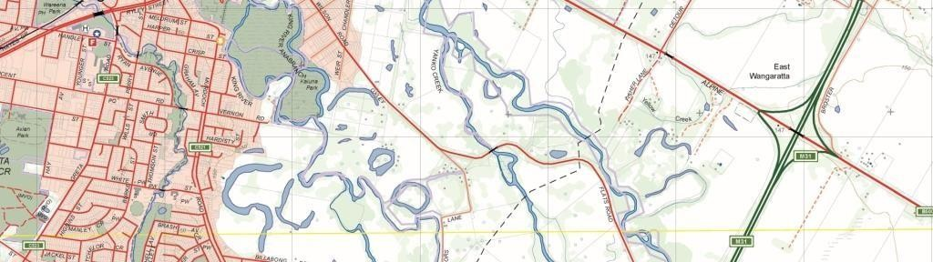
Vicmap Hydro

What is happening
A table HY_WATER_AREA_FUZZY is to be added to Vicmap Hydro.
The table will hold polygons depicting indicative extents of the area of the hydro feature.
The table has previously been located within the Vicmap Features of Interest Product as Geo_Area_Hydro_Label. This data will be replicated in the Geomark tables.
The Geo_area_hydro table will be retired.
Data improvements include feature type modification, graphic alignments, new feature types.

Note
HY_WATER_AREA_FUZZY is primarily used for the depiction and position of name labels for map display purposes. The table should not be used for spatial analysis such as area statements and unlike Geomark the HY_WATER_AREA_FUZZY table will hold a scale_use_code.

Data Structure

Column Name | Data type | Mandatory
UFI | NUMBER (9) | Y
PFI | NUMBER (9) | Y
FEATURE_ID | NUMBER (9) | Y

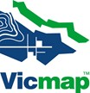

PARENT_FEATURE_ID | NUMBER (9) | N
FEATURE_TYPE | VARCHAR2 (30) | Y
FEATURE_SUBTYPE | VARCHAR2 (30) | Y
NAME | VARCHAR2 (100) | N
NAME_LABEL | VARCHAR2 (100) | N
PARENT_NAME | VARCHAR2 (100) | N
AUTH_ORG_CODE | VARCHAR2 (4) | N
AUTH_ORG_ID | VARCHAR2 (30) | N
AUTH_ORG_VERIFIED | DATE | N
VICNAMES_ID | NUMBER (9) | N
VICNAMES_STATUS_CODE | VARCHAR2 (2) | N
STATE | VARCHAR2 (3) | Y
SCALE_USE_CODE | VARCHAR2 (1) | N
CREATE_DATE_PFI | DATE | Y
SUPERCEDED_PFI | NUMBER (9) | Y
CREATE_DATE_UFI | DATE | Y

feature type |  | What is happening | Number of records | Reason
bay |  |  | 232
beach |  |  | 193
bend | NEW  term | records to be moved to ‘bend’ from ‘watercourse’ | 75 | Feature type is better described
entrance | NEW  term | records to be moved to ‘entrance’ from ‘marine_place’ | 2
inlet | NEW  term | records to be moved to ‘inlet’ from ‘watercourse’ or ‘waterbody’ | 73 | Feature type is better described.
Island group | NEW  term | records to be moved to VMINDEX.FRAMEWORK_AREA_POLYGON | 5 | Feature type is more relevant to the VMINDEX Product
passage | NEW  term | records to be moved to ‘passage’ from ‘marine_place’ | 18 | Feature type is better described
reach | NEW  term | records to be moved to ‘reach’ from ‘watercourse’ | 18 | Feature type is better described
sea |  |  | 3

The Vicmap feature catalogue (VMREFTAB.FEATURE_CATALOGUE) holds feature terminology utilised by Vicmap.
The feature terminology should align with national feature terms wherever practical. The file can be downloaded from http://services.land.vic.gov.au/reftab/

FEATURE | FEATURE  definition | included terms
BEND | A curve in the course of a STREAM | Meander, Loop
ENTRANCE | A passageway into enclosed waters
INLET | A small indentation in a waterline usually tapering towards its head | Arm
ISLAND GROUP | A group of Islands often with a common name which covers the group. The Islands may have their own individual names. The island group can any  combination of rocks, reefs, islets and islands names. | Archipelago
PASSAGE | A navigable route, specifically one through REEFS, ISLANDS, LANDS or shallow waters | Strait, Rip, Narrows
REACH | A straight portion of WATERCOURSE from one BEND to another

Why this change is occurring
Adding the HY_WATER_AREA_FUZZY to Vicmap Hydro will group it with like features enhancing maintenance and searchability within Vicmap.
New feature types have been created to better describe records.

Please note
A further Change Notice will be created to add a similar table EL_RELIEF_AREA_FUZZY to Vicmap Elevation. The table is currently located within the Vicmap Features of Interest Product as Geo_Area_Hydro_Label.

Who will it affect?
All Vicmap users, particularly those using: Vicmap Hydro, Vicmap Features of Interest, Vicmap Index, VMREFTAB.FEATURE_CATALOGUE and/or Geomark.

When the change will occur
The HY_WATER_AREA_FUZZY table is created and populated.

The data is replicated in Geomark.
The Geo_area_hydro table will be retired after 05/05/2020.

For Vicmap Product change notices and bulletins, go to the News and Bulletins page. For further information & feedback please email Vicmap.help@delwp.vic.gov.au

© The State of Victoria Department of Environment, Land, Water and Planning 2019  This work is licensed under a Creative Commons Attribution 4.0 International licence. You are free to re-use the work under that licence, on the condition that you credit the State of Victoria as  author. The licence does not apply to any images, photographs or branding, including the Victorian Coat of Arms, the Victorian Government logo and the Department of Environment, Land, Water and Planning (DELWP) logo. To view a copy of this licence, visit http://creativecommons.org/licenses/by/4.0/  Disclaimer  This publication may be of assistance to you but the State of Victoria and its employees do not guarantee that the publication is without flaw of any kind or is wholly appropriate for your particular purposes and therefore disclaims all liability for any error, loss or other consequence which may arise from you relying on any information in this publication. | Accessibility  If you would like to receive this publication in an alternative format, please telephone the DELWP Customer Service Centre on 136186, email customer.service@delwp.vic.gov.au, or via the National Relay Service on 133 677 www.relayservice.com.au. This document is  also available on the internet at www.delwp.vic.gov.au.

