Vicmap Product Development
  - REVISED: Change Notice # 265.1
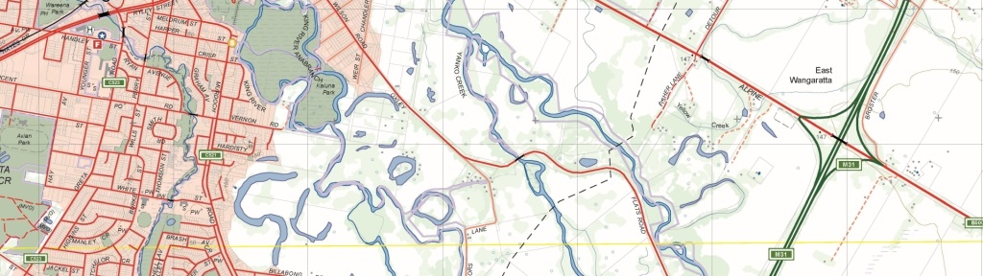
Vicmap Basemaps – Service changes
Document version control
Version Number | Author | Comment | Date
265 | A Densley | Initial notice | 12/02/2021
265.1 | A Densley | Revised schedule & scope | 16/06/2021

Amendment notes
This amendment explains the revision of Vicmap Change Notice #265 published [12/02/2021] following feedback received.
- Withdrawal of the addition of “Vicmap Basemaps - VicGrid 2020 – Cartographic” service to Vicmap Basemaps.
- Modified implementation schedule for the addition of “Vicmap Basemaps - Web Mercator - Cartographic (256 pixel tiles)” to Vicmap Basemaps.
- Modified implementation schedule for styling changes to the Vicmap Cartographic and Overlay services.
The revised Vicmap Change Notice #265.1 is provided below.

What is happening
Changes occurring to modernise the Vicmap Basemaps product are:
- A new service called “Vicmap Basemaps - Web Mercator - Cartographic (256 pixel tiles)” will be added to the Vicmap suite of Basemaps.
- Multiple styling changes (detailed below) will be applied to the Vicmap Cartographic and Overlay services.

Why this change is occurring
- The Vicmap Basemaps - Web Mercator - Cartographic (256px) service will be made to comply with the standards of the Web Mercator coordinate reference system (EPSG:3857) used in services such as Google Maps and OpenStreetMap (OSM). The change will see the tile resolution size change from 512 x 512 pixels to 256 x 256 pixels.
- Extensive stakeholder consultation on the styling of the Vicmap Cartographic and Overlay services has resulted in recommendations to implement multiple changes listed in Table 1:
No | Service | Item Class | Description | Scales affected | Implementation
1 | Carto | Road labels | Road labelling in regions is very sparse when zoomed. Users must drag the tiles a few times to learn what the road name is. | 10k to 1:800 | Increased the frequency of labels and ticked 'never remove' in some cases.
2 | Carto & Overlay | Address labels | Address Parcel labelling is too small and faint at the smaller scales. There are congestion issues in built up areas. | 800 - 2500 | Changed to a darker colour, increased halo and font size.
3 | Carto & Overlay | Address labels | In sparsely populated areas where parcels are very large it is difficult to see the numbers. They are only shown between 800 and 2500 which doesn’t work well in these areas. | 800-5k | Labelled rural numbers at 5000 using the rural flag.
4 | Carto | Hydro Watercourse | Creeks – blue colour is too faint. | 800 – 25k | Increased the thickness and darkened the colour.
5 | Carto & Overlay | Hydro Labels | Labelling of water features and parks are often duplicated. | All | Removed duplication
6 | Carto & Overlay | Hydro and Park area Labels | Too wide white text buffering | All | Reduced label halo
7 | Carto (Vicgrid only) | Hillshade | No hillshade in Vicgrid service like in the web mercator service. | All | Added hillshade
Table 1: Vicmap Cartographic and Overlay proposed changes.

Who will the change affect
This change will affect all users of the Vicmap Basemaps services in GIS desktop and web mapping applications.

When the change will occur
Testing of the new services is available now via:
https://dev-base.maps.vic.gov.au/service?SERVICE=WMTS&REQUEST=Getcapabilities
The identifiers for each service are:
- CARTO_WM_256 = Vicmap Basemaps - Web Mercator - Cartographic (256px)
- Unchanged for existing services with styling changes.
Styling changes to the Vicmap Basemaps Cartographic can be viewed here.
The new services will be added to the Vicmap Basemaps service from 30 July 2021.
Please note that the current Web Mercator service (512px) will continue to operate and be maintained in parallel with the Web Mercator service (256px) version for now but will be phased out following successful user migration.

How to provide feedback
For Vicmap Product change notices and updates, visit Vicmap change notices.
For further information & feedback please email vicmap.help@delwp.vic.gov.au
If you would like to subscribe to change notices ongoing please forward your contact details including your email to vicmap@delwp.vic.gov.au
© The State of Victoria Department of Environment, Land, Water and Planning 2021  This work is licensed under a Creative Commons Attribution 4.0 International licence. You are free to re-use the work under that licence, on the condition that you credit the State of Victoria as author. The licence does not apply to any images, photographs or branding, including the Victorian Coat of Arms, the Victorian Government logo and the Department of Environment, Land, Water and Planning (DELWP) logo. To view a copy of this licence, visit http://creativecommons.org/licenses/by/4.0/  Disclaimer  This publication may be of assistance to you but the State of Victoria and its employees do not guarantee that the publication is without flaw of any kind or is wholly appropriate for your particular purposes and therefore disclaims all liability for any error, loss or other consequence which may arise from you relying on any information in this publication.  DELWP spatial disclaimer  The State of Victoria:  - does not give any representation or warranty as to the accuracy or completeness of DELWP spatial data, Vicmap data (including metadata) or Vicmap product specifications or the fitness of such data or products for any particular purpose;  - disclaims all responsibility and liability whatsoever for any errors, faults, defects or omissions in such data or products.  Any person using or relying upon such data or products must make an independent assessment of them and their fitness for particular purposes and requirements. | Accessibility  If you would like to receive this publication in an alternative format, please telephone the DELWP Customer Service Centre on 136186, email customer.service@delwp.vic.gov.au, or via the National Relay Service on 133 677 www.relayservice.com.au. This document is also available on the internet at www.delwp.vic.gov.au.

