Product Data Specification

Vicmap™ Buildings

|  |
| --- |
|  |

Version 1.0 December 2022

Applies to data model Version 1.0 November 2022

AS/NZS ISO 19131:2008 compliant

|  |
| --- |
| © The State of Victoria Department of Environment, Land, Water and Planning 2022  Logo  This work is licensed under a Creative Commons Attribution 4.0 International licence. You are free to re-use the work under that licence, on the condition that you credit the State of Victoria as author. The licence does not apply to any images, photographs or branding, including the Victorian Coat of Arms, the Victorian Government logo and the Department of Environment, Land, Water and Planning (DELWP) logo. To view a copy of this licence, visit <http://creativecommons.org/licenses/by/4.0/>  Disclaimer  This publication may be of assistance to you but the State of Victoria and its employees do not guarantee that the publication is without flaw of any kind or is wholly appropriate for your particular purposes and therefore disclaims all liability for any error, loss or other consequence which may arise from you relying on any information in this publication.  DELWP spatial disclaimer  The State of Victoria:   1. does not give any representation or warranty as to the accuracy or completeness of DELWP spatial data, Vicmap data (including metadata) or Vicmap product specifications or the fitness of such data or products for any particular purpose; 2. disclaims all responsibility and liability whatsoever for any errors, faults, defects or omissions in such data or products.   Any person using or relying upon such data or products must make an independent assessment of them and their fitness for particular purposes and requirements.  Accessibility  If you would like to receive this publication in an alternative format, please telephone the DELWP Customer Service Centre on 136186, email [customer.service@delwp.vic.gov.au](mailto:customer.service@delwp.vic.gov.au) or via the National Relay Service on 133 677 [www.relayservice.com.au](http://www.relayservice.com.au). This document is also available on the internet at [www.delwp.vic.gov.au](http://www.delwp.vic.gov.au). |

# Document history

|  |  |  |
| --- | --- | --- |
| Version | Date | Note |
| 1.0 | December 2022 | Product data description created |

This document has been formatted and structured in compliance with AS/NZS ISO 19131:2008 Geographic Information – Data product specifications.

# Table of Contents

[Document history 1](#_Toc122433259)

[Table of Contents 2](#_Toc122433260)

[Overview 3](#_Toc122433261)

[Specification scope 5](#_Toc122433271)

[Data product identification 5](#_Toc122433272)

[Data content and structure 6](#_Toc122433279)

[Reference systems 10](#_Toc122433285)

[Data quality 10](#_Toc122433286)

[Data capture 15](#_Toc122433303)

[Data maintenance 16](#_Toc122433304)

[Data product delivery 16](#_Toc122433305)

[Metadata 17](#_Toc122433307)

[Appendix A: Data & object models 18](#_Toc122433308)

[Appendix B: Data dictionary 19](#_Toc122433309)

[Appendix C: Product Reference Tables 22](#_Toc122433310)

[Appendix D: Vicmap Reference Tables 25](#_Toc122433311)

[Appendix E: Supplementary Information 26](#_Toc122433313)

# Overview

## Vicmap™

Vicmap™ is the foundation that underlies most spatial information in Victoria. This portfolio of spatially related authoritative data products, comprising individual datasets, is developed, and managed by the Department of Environment, Land, Water and Planning. The information provides the foundation to Victoria’s primary mapping and spatial information systems and is used for building business information and systems.

Vicmap is a registered trademark of the Victorian Government and has been synonymous with authoritative statewide mapping since 1975.

The Vicmap data portfolio includes:

|  |  |
| --- | --- |
| Vicmap Address  Vicmap Admin  Vicmap Buildings  Vicmap Crown Land Tenure  Vicmap Elevation  Vicmap Features of Interest  Vicmap Hydro  Vicmap Imagery  Vicmap Index | Vicmap Infrastructure (proposed) Vicmap Lite  Vicmap Planning  Vicmap Position  Vicmap Property  Vicmap Survey (proposed)  Vicmap Topographic Mapping  Vicmap Transport  Vicmap Vegetation |

Vicmap is supported by:

* + 1. Vicmap Reference Tables: Reference tables used by and between products that list the full name, description and other attributes associated with a feature code or identifier. For example, the Feature catalogue that lists and describes feature types and feature subtypes.

Further information can be found at [Vicmap catalogue (land.vic.gov.au)](https://www.land.vic.gov.au/maps-and-spatial/spatial-data/vicmap-catalogue)

## Data product specification title

Vicmap™ Buildings

## Informal description of the data product

Vicmap Buildings aligns to [ANZLIC’s Foundational Spatial Data Framework](https://www.anzlic.gov.au/resources/foundation-spatial-data-framework/fsdf-themes-datasets) and the UN-GGIM’s Building and Settlements theme within [The Global Fundamental Geospatial Data Themes](https://ggim.un.org/documents/Fundamental%20Data%20Publication.pdf)[[1]](#footnote-2).

The information contained in this document (the **specificatio**n) is different from that contained in metadata, which provides information about datasets. Metadata describes how the data is and the specification describes how it should be.

This product should also be used in conjunction with Vicmap Reference Tables.

|  |  |
| --- | --- |
|  |  |

Figure 1: Example images of the Vicmap Buildings data.

### The content of the datasets

Vicmap Buildings was initially released in 2022 and contains topologically structured datasets depicting the built environment across the State of Victoria. Vicmap Buildings main specification, coverage over Greater Melbourne and Greater Geelong are sourced from imagery captured from January 2021 through to March 2022 and elevation data from 2017-18 with specification detailed in this document. The Vicmap Buildings product also includes additional data sources with varying specification, sourced from imagery and elevation data captured from January 2019 through to March 2022. This product is designed to provide a 2D and 3D digital representation of Victoria’s built environment using high confidence data.

Vicmap Buildings can be used in conjunction with the Vicmap Imagery to verify the spatial accuracy and provide further information about the features that are represented. Feature attributes may also be sourced from authoritative Custodians via the Departments Custodianship Program.

### The purpose

Vicmap Buildings is a product that provides high level context of the built environment targeting a variety of applications, particularly to improve decision-making in a range of planning, environmental assessments, asset and risk management, and other spatial analyses.

The UN-GGIM identified that a buildings product will help meet the three main [Sustainable Development Goals](https://www.earthwatch.org.au/global-impact?gclid=EAIaIQobChMIvN6Z4puw9AIVx5NmAh14NwuUEAAYASAAEgI96vD_BwE) (SDG)

* **9) Industry, Innovation and Infrastructure**: Build resilient infrastructure, promote sustainable industrialization and foster innovation
* **11) Sustainable Cities Communities:** Make cities and human settlements inclusive, safe, resilient and sustainable
* **12) Responsible Consumption and Production**: Ensure sustainable consumption and production patterns

### The product sources and data production processes

First published in 2022, The Building Outlines dataset is derived from Vicmap Imagery and Vicmap Elevation inputs using intuitive data integration methodologies (i.e. Machine Learned Feature Extraction (MLFEX) and Deep Learning) and human learning methods, and includes extensive human data analyst intervention to achieve target quality.

Vicmap Buildings consists of 2D polygon vector features and a height attribute to enable 3D visualisation and analysis in a seamless and topologically structured dataset series. It is comprised of a basic framework of linear features supplemented by value-add attributes for the features across the State. Attribute tables classify and describe the real-world features using code lists that can be used for search, discovery and analysis.

### Topic Category

Structure

## Responsible party

Department of Environment, Land, Water and Planning

PO Box 527, Melbourne VIC 3001 Australia

[vicmap@delwp.vic.gov.au](mailto:vicmap@delwp.vic.gov.au)

## Acroynms, Terms and definitions

Refer to Vicmap Terms and Definitions repository at [Vicmap catalogue (land.vic.gov.au)](https://www.land.vic.gov.au/maps-and-spatial/spatial-data/vicmap-catalogue)

# Specification scope

A formal definition for specification scope information in given in Appendix A which provides the UML model and corresponding data dictionary in Appendix B

|  |  |  |  |  |  |
| --- | --- | --- | --- | --- | --- |
| **Dataset name** | **Level** | **Level name** | **Level Description** | **Extent** | **Coverage** |
| VMBUILDING\_2D | 1 | Vicmap Foundational | Root level in the scope level hierarchy | See VMBUILDINGS\_EXTENT | State wide |

Table 1: Vicmap Buildings specifiction scope

# Data product identification

### Title

Vicmap™ Buildings

### Alternative Title

VMBuildings

VMBUILD

VMBuildingsSettlements

### Spatial representation type

Feature vector data

### Spatial resolution

The product is suitable for viewing at a spatial resolution of 1:1000.

### Supplementary Information – Spatial Data Integrity

#### Coincident features

There will be no coincident polygons, lines (whole or in part) or points of the same feature type in the data (also frequently known as double digitising). Differing features may be coincident, as may be the case where a building outline is represented by different levels of detail, (in these cases, the common data repeats for each feature type, and is appropriately tagged and supplied as part of each feature type)

#### Resolution of coordinates

Co-ordinates of all spatial objects will be quoted to the nearest 0.01 metres in line with the significant features of the source data’s spatial accuracy.

#### Unique Feature Identifier Attribute

Feature identification is managed through the use of two identifier attributes, the Persistent Feature identifier (PFI) and the Unique Feature Identifier (UFI).

The PFI is a sequential number allocated to new features at creation and remains with the feature throughout all editing actions. Over time the PFI itself will not be unique within the database as edit actions result in splitting and merging of features. Old PFI’s are retired after merge and split edits. A PFI does not change when edits are undertaken on attributes or modifications done to spatial representation of a feature.

A Unique Feature Identifier (UFI) will be an alphanumeric string attached to each feature instance as an attribute. The UFI will be unique on a State basis (depending on systems adopted by other States), and is expected to facilitate the efficient incremental update of Vicmap Transport features.

The UFI attribute will be assigned to new or edited features as maintenance occurs. The UFI attribute will always be unique.

Both PFI and UFI items are numeric by definition and will be managed with the same domain across all themes in Vicmap Digital.

### Main themes

The main themes associated with Vicmap Buildings are:

* *Buildings* - a building is any roofed structure permanently constructed or erected on its site for the protection of humans, animals, things, or the production of economic goods, as per the UN-GGIM Buildings and Settlements definition of a building
* *Building Outlines* – the perimeter of a building at its outer roof extents (Biljecki, et al., 2016a) as it appears in aerial imagery.

# Data content and structure

Vicmap Buildings contains the following datasets:

### Feature-based data

Vicmap Buildings contains the following feature-based datasets:

|  |  |  |  |
| --- | --- | --- | --- |
| **Product UUID** | **Dataset Name** | **Description** | **Feature type** |
| ANZVI0803009707 | Vicmap Buildings | Parent Record\* for Vicmap Buildings | N/A |
| ANZVI0803009708 | VMBUILDING\_2D | Vicmap Buildings | 2D polygon |
| ANZVI0803009709 | VMBUILDING\_2D\_EDIT | Internal version of Vicmap Buildings with additional restricted attributions | 2D polygon |

Table : Vicmap Buildings feature based datasets.

*\*Parent metadata record for Vicmap Buildings. Parent metadata records act as a cover note for a product that contains a dataset series for search, discovery & delivery purposes. Refer to the data model in Appendix A.*

The Vicmap Reference Tables associated with Vicmap Buildings are referred to in **Appendix D**.

### Source of feature data

The table below contains the lineage data used to populate the products described above.

| **AnzlicID** | **Dataset Source Name** | **Description** | **Feature type** | **Extent area km2** |
| --- | --- | --- | --- | --- |
| tbc | rfq23-2021-22 | Main project specification over greate Melbourne, Geelong LGA and growth towns, Buildings extractd using Machine Learing and manual mapping techniques |  | 8,091 |
|  | ararat\_2019sep09\_3dm-footprints\_v30\_h20\_ahd\_mga54 | LOD1 models derived from stereo mapped LOD2+ building models. cip17b-2019-30 |  | 0.84 |
| ID36869 | ballarat\_2019nov24\_3dm-footprints\_v30cm\_h20cm\_ahd\_mga54 | LOD1 models derived from stereo mapped LOD2+ building models. cip17b-2019-30 |  | 2.48 |
| ID36873 | swan-hill\_2019dec10\_3dm-footprints\_v30cm\_h20cm\_ahd\_mga54 | LOD1 models derived from stereo mapped LOD2+ building models over Swan Hill |  | 1.57 |
|  | castlemaine\_2019sep16\_3dm\_footprints\_v10cm\_h10cm\_ahd\_mga55 | LOD1 models derived from stereo mapped LOD2+ building models |  | 1.0 |
| ID36871 | echuca\_2019dec7\_3dm-footprints\_v30cm\_h20cm\_ahd\_mga55 | LOD1 models derived from stereo mapped LOD2+ building models |  | 1.87 |
| ID36872 | sale\_2019dec22\_3dm-footprints\_v30cm\_h20cm\_ahd\_mga55 | LOD1 models derived from stereo mapped LOD2+ building models |  | 1.2 |
| ID36874 | shepparton\_2019sep14\_3dm-footprints\_v45cm\_h30cm\_ahd\_mga55 | LOD1 models derived from stereo mapped LOD2+ building models |  | 2.13 |
| ID36875 | wangaratta\_2019oct09\_3dm-footprints\_v45cm\_h30cm\_ahd\_mga55 | LOD1 models derived from stereo mapped LOD2+ building models |  | 9.52 |
| tbc | wonthaggi\_2019dec17\_3dm\_footprints\_v50cm\_h20cm\_ahd\_mga55 | LOD1 models derived from stereo mapping  cip03-2019-20 |  | 6.76 |
| tbc | clayton\_2020jan4\_footprints\_v30cm\_h30cm\_ahd\_mga55 | cip54-2019-20\_3D-Infrastructure |  | 1.0 |
| tbc | doncaster\_2020jan4\_footprints\_v30cm\_h30cm\_ahd\_mga55 | cip54-2019-20\_3D-Infrastructure |  | 1.5 |
| tbc | fawkner\_2020jan4\_footprints\_v30cm\_h30cm\_ahd\_mga55 | cip54-2019-20\_3D-Infrastructure |  | 1.0 |
| tbc | glen\_waverley\_2020jan4\_footprints\_v30cm\_h30cm\_ahd\_mga55 | cip54-2019-20\_3D-Infrastructure |  | 1.0 |
| tbc | heidelberg\_2020jan4\_footprints\_v30cm\_h30cm\_ahd\_mga55 | cip54-2019-20\_3D-Infrastructure |  | 1.5 |
| tbc | melbourne\_airport\_2020jan4\_footprints\_v30cm\_h30cm\_ahd\_mg | cip54-2019-20\_3D-Infrastructure |  | 1.75 |
| tbc | monash\_2020jan4\_footprints\_v30cm\_h30cm\_ahd\_mga55 | cip54-2019-20\_3D-Infrastructure |  | 1.0 |
| tbc | reservoir\_2020jan4\_footprints\_v30cm\_h30cm\_ahd\_mga55 | cip54-2019-20\_3D-Infrastructure |  | 1.25 |
| tbc | box\_hill\_2020jan4\_footprints\_v30cm\_h30cm\_ahd\_mga | cip54-2019-20\_3D-Infrastructure |  | 0.75 |
| tbc | broadmeadows\_2020jan4\_footprints\_v30cm\_h30cm\_ahd\_mga55 | cip54-2019-20\_3D-Infrastructure |  | 1.0 |
| tbc | bundoora\_2020jan4\_footprints\_v30cm\_h30cm\_ahd\_mga55 | cip54-2019-20\_3D-Infrastructure |  | 1.0 |
| tbc | burwood\_2020jan4\_footprints\_v30cm\_h30cm\_ahd\_mga55 | cip54-2019-20\_3D-Infrastructure |  | 0.75 |
| tbc | yarra\_2021apr02\_footprints\_v50cm\_h20cm\_ahd-epsg7855 | cip54-2019-20\_3D-Infrastructure |  | 19.54 |
| tbc | ballarat\_2019oct25\_3dm\_footprints\_ahd\_mga54 | Machine Leaning LOD1  rfq43-2019-20-AutomaticBuildingFeatureExtraction |  | 290 |
| tbc | bendigo\_2020mar05\_3dm-footprints\_ahd\_mga55 | Machine Leaning LOD1  rfq43-2019-20-AutomaticBuildingFeatureExtraction |  | 723 |
| tbc | horsham\_2019sep11\_3dm-footprints\_ahd\_mga54 | Machine Leaning LOD1  rfq43-2019-20-AutomaticBuildingFeatureExtraction |  | 108 |
| tbc | kilmore\_2019sep14\_3dm-footprints\_ahd\_mga55 | Machine Leaning LOD1  rfq43-2019-20-AutomaticBuildingFeatureExtraction |  | 70 |
| tbc | latrobevalleycorridor\_2019oct29\_3dm-footprints\_ahd\_mga55 | Machine Leaning LOD1  rfq43-2019-20-AutomaticBuildingFeatureExtraction |  | 424 |
| tbc | mildura\_2019sep10\_3dm-footprints\_ahd\_mga54 | Machine Leaning LOD1  rfq43-2019-20-AutomaticBuildingFeatureExtraction |  | 80 |

Table : Feature-based datasets within Vicmap Buildings.

### Data structure

Rules and/or characteristics that apply to Vicmap Buildings:

* A Persistent Feature Identifier (PFI) is generated once for each feature at the point of creation and remains constant until a feature is retired. A PFI is unique to and cannot be reused within a particular table. However, you may have the same PFI number in different tables but does not relate to the same feature entity

A new PFI is assigned in the following instances:

Creation of a new feature, i.e. when a new object is added to the database.

When two or more existing features are merged, the final merged feature assumes a new PFI. The old PFIs of the features making up the merged feature are retired.

When a feature is split into two or more new features. Each of the new features is assigned a new PFI. The PFI of the original feature is retired.

PFIs do not change when a feature is edited in any other way. i.e. when the following edits are undertaken on features :-

Attributes of a feature are modified

Physical or spatial representation of a feature is modified.

* The Unique Feature Identifier (UFI) is generated for each feature at the point of creation and changes with each modification or version. This allows users to track the changes made to a feature over time

New UFIs are created on a feature whenever edits are undertaken on the feature.

* Create\_date\_UFI, The date that a UFI is created on a feature
* Retire\_date\_UFI, The date that a feature is retired. A feature is retired when any physical change, attribute change, or deletion of a feature occurs.
* Superceded\_UFI; This is the UFI of a feature prior to the last edit of the feature
* create\_date\_pfi, (format dd-mmm-yyyy hh:mm:ss) is the date/time stamped against each feature when it is originally created and remains with the feature through all editing actions to attributes or modification of feature spatial representation.
* ‘retire\_date\_pfi, (format dd-mmm-yyyy hh:mm:ss) is the date/time stamped against each feature when it is retired as a result of merge, split or deletion actions.
* Feature attribution to further describe or classify features e.g. building\_model\_height

Vicmap data is never deleted, only retired. All key features are tagged with the above attributes to enable an audit trail to be maintained and to facilitate incremental updating.

* lod and lod\_subtype attributes. Level of Detail (LOD) geometry detail description as defined by Refined Levels of Detail (Biljecki et al., 2016a) see Appendix D.

Further information regarding the structure of the product can be referred to Appendix C.

The structure includes:

* Topologically structured (vertical topology) with other Vicmap products
* Conforms to national data models (i.e. ICSM)
* Additional information about features contained in attribute tables (i.e. data quality, feature type).

### Data models

Refer to Appendix A for the data and object models.

Vicmap product data models are published on DELWP’s website

[Vicmap catalogue (land.vic.gov.au)](https://www.land.vic.gov.au/maps-and-spatial/spatial-data/vicmap-catalogue)

### Data dictionary

Refer to Appendix B for the data dictionary.

Refer to Appendix C for the reference tables.

# Reference systems

The native datum format of Vicmap Buildings is the Geocentric Datum of Australia (GDA2020) and the Australian Height Datum (AHD).

The native projection for Vicmap Infrastructure is held in geographic coordinates (latitude and longitude), computed in terms of GDA2020 at the 01 January 2020 epoch.

The temporal reference system for Vicmap is the Gregorian calendar.

Customers are able to obtain data in a variety of datums and projections.

# Data quality

The following procedures are undertaken as normal update/maintenance routines, to ensure conformity of the data to specification:

* Customised menus for data editing which provide on the fly logical consistency attribute checking as data is edited
* Automated data loading routines, reflecting business rules for data population, to ensure data accuracy
* Independent review of data upon loading including aspatial attributes, spatial extents and successful data load
* Validation of accepted types according to approved reference tables
* Validation of entity PFI/UFI tags for uniqueness.

Deficiencies within Vicmap data may have been inherited by the overlying data to ensure vertical alignment with other Vicmap datasets.

## Feature and attribute accuracy

### Completeness

Reliability figures indicating completeness of content between the data set and real world. Estimated completeness of content in Victoria for the main Vicmap Buildings datasets:

|  |  |
| --- | --- |
| **Dataset** | **Percentage of completeness** |
| Vicmap Buildings | 65% of Victoria’s buildings due to current dataset extent |

Table 4: Vicmap Buildings completeness 2022.

### Logical consistency

Logical consistency is a measure of the degree to which data complies with the technical specification.

This product is designed to provide a 2D and 3D digital representation of Victoria’s built environment using the high confidence data. This consist of three main source classes.

1. Vicmap Buildings Outlines – Machine Leaning and Manual Mapping (8,091km2)  
   Majority of Vicmap Buildings has been sourced from this dataset and is described in this document,  
   Spatial coverage of this source is defined by Greater Melbourne Urban Growth Boundary, Vicmap Greater Melbourne Imagery extent, Geelong LGA and the Vicmap Built Up Areas of Gisborne, Macedon, Woodend, and Kyneton. See Figure 2.
2. Vicmap Buildings Outlines – 3D Regional POC - – Machine Leaning and Manual Mapping (1,695km2)  
   These sources were the precursor to Vicmap Buildings main specification and differ in quality and accuracy slightly.   
   Spatial coverage of 5 Regional centres of Ballarat, Bendigo, Mildura, Horsham, Kilmore, and Latrobe Valley Corridor.
3. Vicmap Buildings Outline – LOD1 Model derived from higher LOD models (101km2)  
   Where available, LOD1 Models have been source from stereo mapped LOD2.0 models depicting an accurate horizontal position of buildings of between +/-0.10m>+/-0.50m RMSE. Speciation for these sources may include addition above ground features not aligned with this product’s definition of a Buildings.

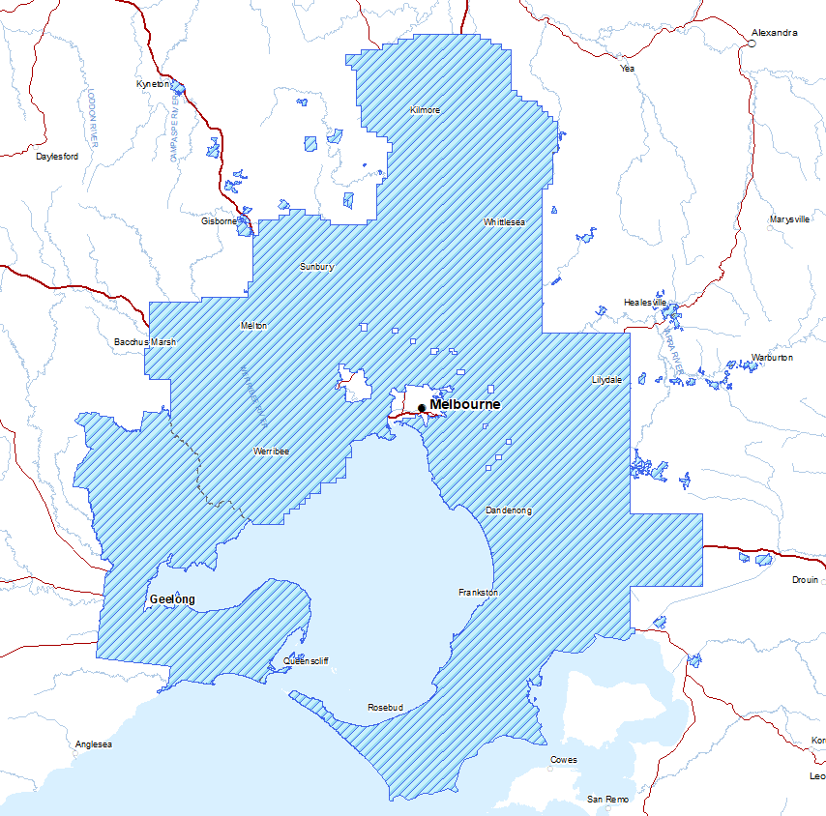

Figure 2: Coverage of Vicmap Building Outlines for Greater Melbourne and Geelong, derived from Machine Learning and Manual Mapping.

## Accuracy

Vicmap Buildings has been derived from and will be maintained using high-resolution Vicmap Imagery and Vicmap Elevation point cloud source datasets to ensure alignment across the Vicmap foundational spatial datasets. Therefore, the accuracy of the product will be dependent on the accuracy of the source imagery and elevation data and the feature extraction processing methodology.

The spatial accuracy of data within Vicmap Buildings is where possible better than 1:1,000 and retains vertical alignment with other Vicmap datasets.

### Positional accuracy

2D features have been extracted from 10cm imagery with 30cm horizontal accuracy for features on the ground. Building outlines are a depiction of the roof edges as they appear in the source imagery resulting in a maximum horizontal radial displacement (building lean) ratio of 2.5-1. A 20 metre high building with an extract Building Outline may be up to 8m offset from its true footprint location. Buildings with a height greater than 20m have had building lean manual corrected with various degrees of accuracy.

Vertical accuracy of the extracted building model height varies between 0.5m > 1.0m. Building model heights are a generalisation of the building eave or maximum height. Accuracy stated refer to the accuracy of that approximation. Additionally building model heights have been extracted using source elevation data of different epoch to that of the source horizontal spatial data resulting in some known inaccuracies.

## Level of Detail

Buildings are modelled to **a minimum** of LOD 1.2 H1 (where elevation data is available), Refined LOD (Refined Levels of Detail) (Biljecki et al., 2016a) See **Appendix E** Supplementary Information

### Building Model Base (z\_min)

The building base (z\_min) represents the minimum elevation of the building outline’s intersection with the source 1m LiDAR digital elevation model or Vicmap 10m digital elevation model.

### Building Model Top (z\_max)

The building height is defined as the best approximation of the building eave.

Where a building outline contains multiple eaves of different elevations, the building H1 (z\_max) will be determined by the eave with the largest roofprint area.

In areas of steep terrain the eave definition descriped above may result in a eave elevation below the highest terrain level of the buildng footprint. In these cases, the building model top will be the maximum elevation of the building.

Where no building elevation or LiDAR data is available (due to difference in horizontal and elevation source data epochs) the following rules have been used to allocate approximation/falsification heights.

* H1 Building eave height (z\_max) will be equal to the nearest neighbouring building if that building is within 5m.
* If there is no building within 5m, the buildings will be assumed to be one storey in height (4.0m) with the H1 building eave height (z\_max) being equal to 4.0m

## Geometry

### Outward Facing Normals

Multipatch features have outward facing normals.

### Minimal Vertices

Building Outlines have sufficient vertices to meet the specified spatial accuracy with no widespread redundant vertices along straight features.

### Circular building

Circular buildings and industrial silos have been represented as circles and not as square features.  
Features are presented with a best fit stroked circular feature.

### Donut Polygons

Buildings with enclosed courtyards at ground level are modelled as donut polygons (where the area of the courtyard is greater than 25m2.)

### Diagonals

Diagonals are modelled as straight lines and not stepped/square features.

### Building Outline Overlap

Where possible Building Outlines do not overlap or otherwise occupy the same space.

## Separation of Contiguous Buildings

Contiguous buildings have been separated using split lines, creating a co-planar edge between adjoining buildings follow the below rules.

Contiguous buildings spanning multiple property bases have been represented by individual polygons where a significant height difference (approximately 4m) exist at or near the property boundary, such as stratification between two adjoining buildings of different floor levels. Additional separation may occur where the height difference is not present at the property edge, for example is cases of two buildings with towers of different heights ontop of podiums with the same height.

Separation location of contiguous buildings uses Vicmap Property as a guide (not an absolute) with split line location using 3D roof geometry (LiDAR data) and/or 2d plan geometry.

Additional separation of large contiguous buildings structure, such as commercial, industrial, education or health precinct buildings, may be represented by individual polygons if significant height difference do not exist at the property boundary. These contiguous buildings have been separated guided by Vicmap Property, 2d plan geometry and roof material type.

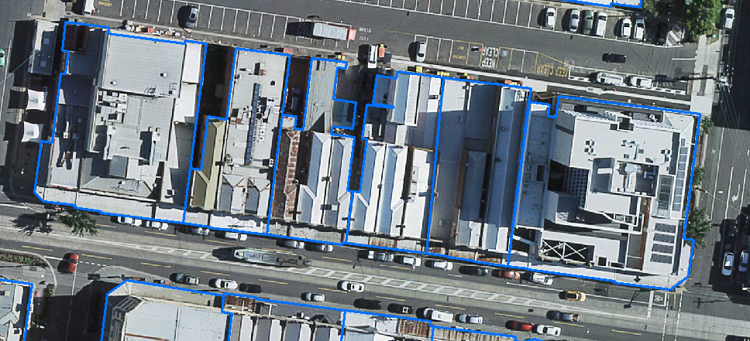

Figure 3: Example of separation of contiguous buildings in commercial areas. Building Lean Correction.

Ground features with Vicmap Imagery, from which Vicmap Buildings have been derived, have an absolute horizontal accuracy of +/0.20m @ 1 sigma. However due to that nature of radial displacement, criteria under which building lean correction has occurred if:

* The building maximum LiDAR height is greater than 20m.
* Two adjacent Building Outlines overlap each other (greate than 40%) due to radial displacement/building lean.
* There is less than 40% overlap between outlines derived from Imagery and LiDAR.  
  Specifically, automatic building outlines will be extracted from the existing Lidar dataset (Class-6: Building Class) and will be compared with the building outline which is detected/captured from the ortho imagery. Buildings with lesser than 40% overlap between the two outlines [Imagery and LiDAR] potentially due to the lean effect in the imagery have been shifted to their footprint.

|  |  |  |
| --- | --- | --- |
| Before building lean correction | After building lean correction | |
| A_Lean building.png | A_Lean building1.png |

Figure 4: Building lean correction.

# Data capture

Building Outlines varies in the level of detail (LOD) available for the 3D building models across the State according to the following classification:

* Population centres – Semi-detailed 3D building models (LOD1) over population centres including Greater Melbourne and Geelong comprising 2D building outlines and heights extruded to eave height to form block models, with a high level of positional accuracy. This data has been created using high-resolution Vicmap Imagery and Vicmap Elevation point cloud source datasets.
* Regional LOD 1 Models

As consumerisation of technology increases and data transferability is enhanced, Vicmap will increase value through interoperability and evolving data integration methodologies.

For example, Vicmap’s aerial imagery and LiDAR (Light Detection and Ranging) data libraries provide an opportunity to extract significant value from current, historic and forthcoming data captures to support the integration, accuracy and timeseries goals of Vicmap.

Vicmap may use various data integration methodologies, including:

1. Authoritative data integration: The integration of authoritative data from Custodians through the Departments Custodianship Program and the signing of data sharing agreements.
2. Non-Authoritative data integration: Used to fill the gap in authoritative data, where available, to ensure the Portfolio is useful by improving data completeness.
3. Intuitive data acquisition: The use of imagery with machine learning to assist with data gaps in the Vicmap portfolio.

Examples of Custodians and/or those that may supplement or verify data are listed below:

* Federal, State and Local Government;
* Government agencies and authorities (e.g. Parks Victoria, Melbourne Water, VicRoads);
* Registrar of Geographic Names – Department of Environment, Land, Water, and Planning;
* Crown Land Management – Department of Environment, Land, Water, and Planning;
* Fire Management – Department of Environment, Land, Water, and Planning;
* Emergency and Essential Services; and
* Asset and utility companies.

The provision of cross-border data is under investigation for a limited extent into New South Wales and South Australia to assist emergency and essential service activities.

# Data maintenance

Product updates are subject to the acquisition of imagery through the Vicmap maintenance lifecycle.

Vicmap products can change under one of the following terms:

* *Vicmap maintenance* - The incorporation of new data to an existing dataset via scheduled Custodial supply or updates created by the Department. Where changes made do not impact the object model, change management is not required. Once changes are made, they can be seen in the next update of Vicmap which occurs weekly.
* *Vicmap Improvements* – Changing existing data, example the moving of a feature or adding of attributes. Significant changes to a dataset that may see existing data over a large area replaced and/or may require the data model changed. Change management processes are applied.

Reported errors or omissions are verified where possible with authoritative Custodian before a change is made. Most notifications regarding anomalies are received via the Vicmap Editing Service (VES) and once verified will be incorporated into Vicmap. Feedback from users and stakeholders, including emergency services dispatch providers, ensures that the highest standards are maintained.

Data made available to DELWP are subject to the maintenance regime of the relevant custodian with respective quality, accuracy and completeness specifications.

# Data product delivery

## Access & licensing

Vicmap Buildings is available, under a DALA, to the Victorian public sector, Emergency Management sector and Local Government though a shared investment model via the Coordinated Imagery Program and can be found by searching the Victorian Government Data Directory.

The Victorian Government Data Directory also provides details such as:

* Timetable for release
* Usage and availability restrictions
* License restrictions and conditions
* Access constraints
* Exclusion of liability
* Supply and media formats
* Projections.

Non-government organisations will be able to access Vicmap Buildings through a network of resellers listed at: [Commercial licensing (land.vic.gov.au)](https://www.land.vic.gov.au/maps-and-spatial/imagery/aerial-imagery/commercial-licensing)

Vicmap Buildings may also be made available for public viewing within Victorian Government web platforms, where the 3D building models can easily be integrated with relevant information held across government, providing richer information and insights. Currently Vicmap Buildings is publicly available in the [Digital Twin Victoria Platform](https://vic.digitaltwin.terria.io).

Cross border data is not currently available for Vicmap Buildings.

# Metadata

The metadata, abstract, and preview for the datasets within Vicmap products is finable and discoverable via DataShare and maybe replicated to other data discovery services and applications.

Vicmap metadata is compliant with AS/NZS ISO 19115.1:2015 Metadata.

# Appendix A: Data & object models

Vicmap data models can be located at [www2.delwp.vic.gov.au/maps](http://www.delwp.vic.gov.au/vicmap)

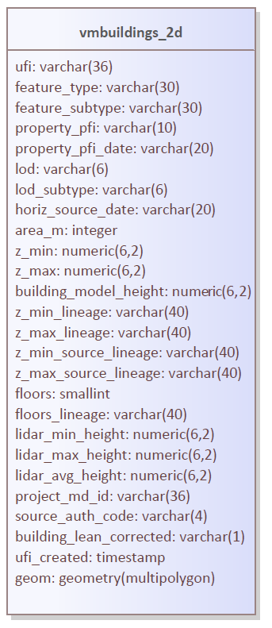

# Appendix B: Data dictionary

This section sets out the layers, entities, attribute tables, and fields within these tables that comprise the Vicmap Buildings product.

|  |  |  |  |  |  |
| --- | --- | --- | --- | --- | --- |
| **Vicmap Buildings**  **Attribute** | **Definition** | **Source Table** | **Explanation** | **Field Type/Size** | **Nullable** |
| ufi | Unique Feature Identifier |  | This unique identifier facilitates reporting quality or enhancement issues.  Currently, a new UFI will be generated each time the data is reloaded by the maintainer even if the polygon spatial or aspatial attributes have not changed. | varchar(36) | No |
| feature\_type | Feature Type | VMREF.FEATURE\_CATALOGUE | Type of feature. Valid values are:   * building | varchar(30) | No |
| feature\_subtype | Feature Subtype | VMREF.FEATURE\_TYPE | Type of feature subtype Valid values are:   * building outline | varchar(30) | No |
| property\_pfi | Property Persistent Feature Identifier |  | Static attribute populated using various methodologies. For the main project over greater Melbourne and Geelong; the object will be assigned the PFI of the largest intersecting property where the overlap area is greater than 40%. The building outline will not be associated with a property if the overlap is less than 40%. | varchar(10) | Yes |
| property\_pfi\_date | Property PFI date |  | Date from which property\_pfi was extracted/attributed | varchar(20) | Yes |
| lineage\_type | Lineage Type | lineage\_type | Summary of events or source data used in constructing the object.  Valid values are:   * undefined * remote sensing - stereo mapping * remote sensing – machine learning and manual digitisation * remote sensing - other | varchar(40) | No |
| lod | Generic Level of Detail | lod | Highest master level of detail (lod) geometry detail description as defined by Refined Levels of Detail (Biljecki et al., 2016a). | varchar(6) | No |
| lod\_subtype | Refined Level of Detail | lod\_subtype | Highest refined level of detail (lod) geometry detail description as defined by Refined Levels of Detail (Biljecki et al., 2016a). | varchar(6) | Yes |
| horiz\_source\_date | Horizontal Source Date |  | Earliest acquisition date of the horizontal spatial data source (tile or project) used to determine the horizontal representation. | varchar(20) | Yes |
| area\_m | Building Outlines Area in square metres |  | Calculated building outline area in meters squared. | integer | No |
| z\_min | Building Model Minimum Elevation in metres |  | Ahd elevation of the minimum bounding box of the building model | numeric(6.2) | Yes |
| z\_max | Building Model Maximum Elevation in metres |  | Ahd elevation of the maximum bounding box of the building model | numeric(6,2) | Yes |
| building\_model\_height | Building Model Height in metres |  | Calculated height of the building model by (z\_max - z\_min)  Conditional calculated where z\_max is not null, an empty string or 0 | numeric(6,2) | Yes |
| z\_min\_lineage | Building Model Elevation Lineage | z\_min\_lineage | Primary lineage and processing information used to determine the building model base elevation.  Valid values are:   * lidar | varchar(40) | Yes |
| z\_max\_lineage | Building Model Elevation Lineage | z\_max\_lineage | Primary lineage and processing information used to determine the building model top elevation.   Valid values are:   * maximum elevation * average elevation * eave estimation - other * eave estimation – nearest neighbour | varchar(40) | Yes |
| z\_min\_source\_lineage | Building Model Elevation Lineage | z\_min\_source\_lineage | Primary source used in the z\_min\_lineage processes to determine z\_min  Valid values are:   * lidar * vicmap 10m dem | varchar(40) | Yes |
| z\_max\_source\_lineage | Building Model Elevation Lineage | z\_max\_source\_lineage | Primary source used in the z\_max\_lineage processes to determine z\_max. Valid values are:   * lidar | varchar(40) | Yes |
| floors | Estimated Number of Floors |  | Estimation of the number of floors. | smallint | Yes |
| floors\_lineage | Floors Lineage | building\_floor\_lineage | Primary lineage source or processing information used to determine floors. | varchar(40) | Yes |
| lidar\_min\_height | LiDAR Minimum Elevation |  | Minimum LiDAR height derived from either source classified building points or non-classified points. | numeric(6,2) | Yes |
| lidar\_max\_height | LiDAR Minimum Elevation |  | Maximum LiDAR height derived from either source classified building points or non-classified points. | numeric(6,2) | Yes |
| lidar\_avg\_height | LiDAR Minimum Elevation |  | Average LiDAR height derived from either source classified building points or non-classified points. | numeric(6,2) | Yes |
| project\_md\_id | Feature Extraction Project ID |  | Anzlic\_ID/Geonetwork UUID of the feature extraction project; not that of the source spatial data. | varchar(36) | Yes |
| source\_auth\_code | Source author code | VMREF.FT\_AUTHORITATIVE\_ORGANISATION | The organisation code for the source of the building outline feature.  Current valid values   * 203 | varchar(4) | Yes |
| building\_lean\_corrected | Lineage information | building\_learn\_corrected | Denotes if building lean has been corrected.  Valid values   * 1 * 0 | varchar(1) | Yes |
| ufi\_created | UFI create date timestamp |  | Timestamp for the creation of the ufi | Timestamp | No |

# Appendix C: Product Reference Tables

This section sets out the tables reference by Vicmap Buildings data dictionary in **Appendix B**.

For a complete list of Vicmap Reference Tables utilised by Vicmap Building see **Appendix D.**

|  |  |
| --- | --- |
| **lineage\_type** | **Description** |
| undefined | Undefined |
| remote sensing - stereo mapping | Building model feature extraction from stereo oblique imagery, which removes building lean. |
| remote sensing – machine learning and manual digitisation | Building outline feature extraction using Machine Leaning and manual digitisation |
| remote sensing - other | Building outline feature extraction using alternative remote sensed methods such as extraction from aerial or ground-based LiDAR, imagery photomesh, traditional survey techniques or other methods. |

|  |  |
| --- | --- |
| **lod** | **Description** |
| lod0 | Highest master level of detail (lod) geometry detail description as defined by Refined Levels of Detail (Biljecki et al., 2016a) |
| lod1 | Highest master level of detail (lod) geometry detail description as defined by Refined Levels of Detail (Biljecki et al., 2016a) |
| lod2 | Highest master level of detail (lod) geometry detail description as defined by Refined Levels of Detail (Biljecki et al., 2016a) |
| lod3 | Highest master level of detail (lod) geometry detail description as defined by Refined Levels of Detail (Biljecki et al., 2016a) |

|  |  |
| --- | --- |
| **lod\_subtype** | **description** |
| lod0.0 | Highest level of detail (lod) geometry detail description as defined by *Refined Levels of Detail (Biljecki et al., 2016a)* |
| lod0.1 | Highest level of detail (lod) geometry detail description as defined by *Refined Levels of Detail (Biljecki et al., 2016a)* |
| lod0.2 | Highest level of detail (lod) geometry detail description as defined by *Refined Levels of Detail (Biljecki et al., 2016a)* |
| lod0.3 | Highest level of detail (lod) geometry detail description as defined by *Refined Levels of Detail (Biljecki et al., 2016a)* |
| lod1.0 | Highest level of detail (lod) geometry detail description as defined by *Refined Levels of Detail (Biljecki et al., 2016a)* |
| lod1.1 | Highest level of detail (lod) geometry detail description as defined by *Refined Levels of Detail (Biljecki et al., 2016a)* |
| lod1.2 | Highest level of detail (lod) geometry detail description as defined by *Refined Levels of Detail (Biljecki et al., 2016a)* |
| lod1.3 | Highest level of detail (lod) geometry detail description as defined by *Refined Levels of Detail (Biljecki et al., 2016a)* |
| lod2.0 | Highest level of detail (lod) geometry detail description as defined by *Refined Levels of Detail (Biljecki et al., 2016a)* |
| lod2.1 | Highest level of detail (lod) geometry detail description as defined by *Refined Levels of Detail (Biljecki et al., 2016a)* |
| lod2.2 | Highest level of detail (lod) geometry detail description as defined by *Refined Levels of Detail (Biljecki et al., 2016a)* |
| lod2.3 | Highest level of detail (lod) geometry detail description as defined by *Refined Levels of Detail (Biljecki et al., 2016a)* |
| lod3.0 | Highest level of detail (lod) geometry detail description as defined by *Refined Levels of Detail (Biljecki et al., 2016a)* |
| lod3.1 | Highest level of detail (lod) geometry detail description as defined by *Refined Levels of Detail (Biljecki et al., 2016a)* |
| lod3.2 | Highest level of detail (lod) geometry detail description as defined by *Refined Levels of Detail (Biljecki et al., 2016a)* |
| lod3.3 | Highest level of detail (lod) geometry detail description as defined by *Refined Levels of Detail (Biljecki et al., 2016a)* |

|  |  |
| --- | --- |
| **z\_min\_lineage** | **description** |
| lidar | z\_min represents the minimum elevation of the building outline’s intersection with the source LiDAR digital elevation model. Some anomalies may occur due to difference between the horiz\_source\_date and the vertical\_source\_date. See the metadata project\_md\_id for more information on the processing methodology. |
| vicmap 10m dem | z\_min represents the minimum elevation of the building outline’s intersection with the Vicmap 10m cell size digital elevation model.  See the metadata project\_md\_id for more information on the processing methodology. |

|  |  |
| --- | --- |
| **z\_min\_source\_lineage** | **description** |
| lidar | LiDAR data source for determining z\_min using z\_min\_lineage processing methodology |
| stereo mapping | Data source for determining z\_min, being using a combination of manual feature extraction from stereo image pairs (stereo mapping) and source LiDAR digital elevation model.  See the metadata project\_md\_id for more information on the data source. |

|  |  |
| --- | --- |
| **z\_max\_lineage** | **description** |
| eave elevation | z\_max represents the general eave elevation of the building feature. In cases where a LOD1 building model represents multiple contiguous building structures with different eave elevations, the z\_max represents the building structure eave with the largest area.  See the metadata project\_md\_id for more information on the processing methodology |
| maximum elevation | z\_max represents the maximum elevation of the building structure extracted from the z\_max\_source\_lineage: either using LiDAR pointcloud or from the maximum bounding box elevation of a higher lod building model.  See the metadata project\_md\_id for more information on the processing methodology |
| average elevation | z\_max represents the average elevation of the building roof structure extracted from the z\_max\_source\_lineage; either using LiDAR pointcloud or from the maximum bounding box elevation of a higher lod building model.  See the metadata project\_md\_id for more information on the processing methodology |
| eave estimation – nearest neighbour | z\_max represents an estimation/falsification of the building eave elevation using the processing methodology of apply the height of a neighbouring building to the z\_min, provided the neighbouring building is within 5m proximity.  eg: z\_max(A) = z\_min(A) + building\_model\_height(B)  See the metadata project\_md\_id for more information on the processing methodology |
| eave estimation - other | z\_max represents an estimation/falsification of the building eave elevation where an elevation source isn’t available and there is no neighbouring building within 5m proximity.  See the metadata project\_md\_id for more information on the processing methodology |

|  |  |
| --- | --- |
| **z\_max\_source\_Lineage** | **Description** |
| lidar | Data source for determining z\_max using z\_max\_lineage processing methodology. |
| stereo mapping | Data source for determining z\_max, being using manual feature extraction from stereo image pairs (stereo mapping) vertically adjusted to field survey control and/or a LiDAR digital elevation model.  See the metadata project\_md\_id for more information on the data source. |

|  |  |
| --- | --- |
| **building\_floor\_lineage** | **Description** |
| estimation from height | Foor number is estimated from building\_model\_height using a classification ruleset.  See the metadata project\_md\_id for more information |

|  |  |
| --- | --- |
| **lod\_multiple\_representation** | **Description** |
| 1 | LOD2.0 or greater representation exist for a given LOD1/LOD0 This does not denote if a BIM or ecomply model exist |
| 0 | LOD2.0 or greater representation does not exist for the given LOD1/LOD0  This does not denote if a BIM or ecomply model exist |

|  |  |
| --- | --- |
| **building\_lean\_corrected** | **Description** |
| 1 | Denotes that building lean has been corrected, either from manual offset, through stereo mapping or other methodologies |
| 0 | Denotes that the building outline has not had building lean corrected |

|  |  |
| --- | --- |
| **separated** | **Description** |
| 1 | Denotes that contiguous building structures have been represented as separated building outline features.  See the metadata project\_md\_id for more information |
| 0 | Denotes that contiguous building structures are represented as a single building outline feature. |

# Appendix D: Vicmap Reference Tables

This section sets out the tables reference by Vicmap Buildings data dictionary in **Appendix B**.

## Feature Quality Class Attributes

Refer to Vicmap Reference for the data dictionary for the tables listed below:

1 – VMREF.FEATURE\_CATALOGUE (feature\_type)

2 – VMREF.FEATURE\_TYPE (feature\_subtype)

3 – VMREF.FT\_AUTHORITATIVE\_ORGANISATION (auth\_org\_code)

**Class: feature\_quality**

***Definition:*** *Defines accuracy and other quality information pertaining to this spatial feature*

***Features:*** *Aspatial*

|  |  |  |  |  |  |
| --- | --- | --- | --- | --- | --- |
| **Name** | **Definition** | **Data Type** | **Code List** | **Key** | **Mandatory** |
| Id | Identifier for the feature quality record | number |  | yes | yes |
| feat\_reli\_date | reliability date for spatial features | date |  |  | yes |
| attr\_reli\_date | reliability date attribute | date |  |  | yes |
| plan\_accuracy | plan accuracy | real |  |  | yes |
| elevation\_accuracy | elevation accuracy | real |  |  | yes |
| data\_sour\_code | Source Code | number |  |  | yes |
| Scale | VICMAP Digital data scale indicating position accuracy | number |  |  | yes |
| create\_date | Date the record was created on | date |  |  | yes |

# Appendix E: Supplementary Information

## Building Definition

Vicmap Buildings aligns to the UN-GGIM Buildings and Settlements theme which defines a building as any roofed structure permanently constructed or erected on its site for the protection of humans, animals, things, or the production of economic goods. This definition has been further defined as any Building over 15m2 and refined with the below mandatory inclusions and exclusions.

## Required Structures

|  |  |
| --- | --- |
| Mandatory Inclusions | Mandatory Exclusions |
| **Inclusion 1:**  Residential dwellings (houses, apartments) and sheds greater that 15m2, including awnings, carports, or permanent annexes (see appendix for examples) | **Exclusion 1:**  Temporary objects, such as shipping containers (non-repurposed as residential), vehicles, boats, caravans, event marquees, circus tents, scaffolding and construction cranes. |
| **Inclusion 2:**  Commercial/industrial buildings | **Exclusion 2:**  Non covered balconies/decks/patios  Non-permanent annexes (see appendix for definition/examples) |
| **Inclusion 3:**  Public structures (public toilets, railway stations, utility buildings, shelters) | **Exclusion 3:**  Swimming pools, paved areas and driveways |
| **Inclusion 4:**  Circular buildings, including tanks and silos, shall be captured greater than 20m2 (approximate 5m diameter) | **Exclusion 4:**  Natural features |
| **Inclusion 5:**  Shade sails greater than 200m2 (such as at schools or shopping centres) | **Exclusion 5:**  Shade sails (less that 200m2), shade netting, large umbrellas |
| **Inclusion 6:**  Shipping containers repurposed as residential or commercial dwellings with a standard roof structure which meets housing code | **Exclusion 6:**  Pergolas, tanks/silos and rotundas (asset/small structures) less than 5m in diameter |
| **Inclusion 7:**  Large semi-permanent industrial/farm structures such as green houses | **Exclusion 7:**  Industrial/Farm material such as machinery, farm supplies, hay bales, tarped material, piles etc |
|  | **Exclusion 8:**  Street furniture, sculptures, public artwork |
|  | **Exclusion 9:**  Trampolines, playgrounds |
|  | **Exclusion 10:**  Bridges or roads |

## Refined LOD and Geometric Elements

Building Level of Detail (LOD) geometry description reference by CityGML2.0 Open Geospatial Consortium standards, and further refined according to the paper Biljecki, et al., 2016a, visually represented below

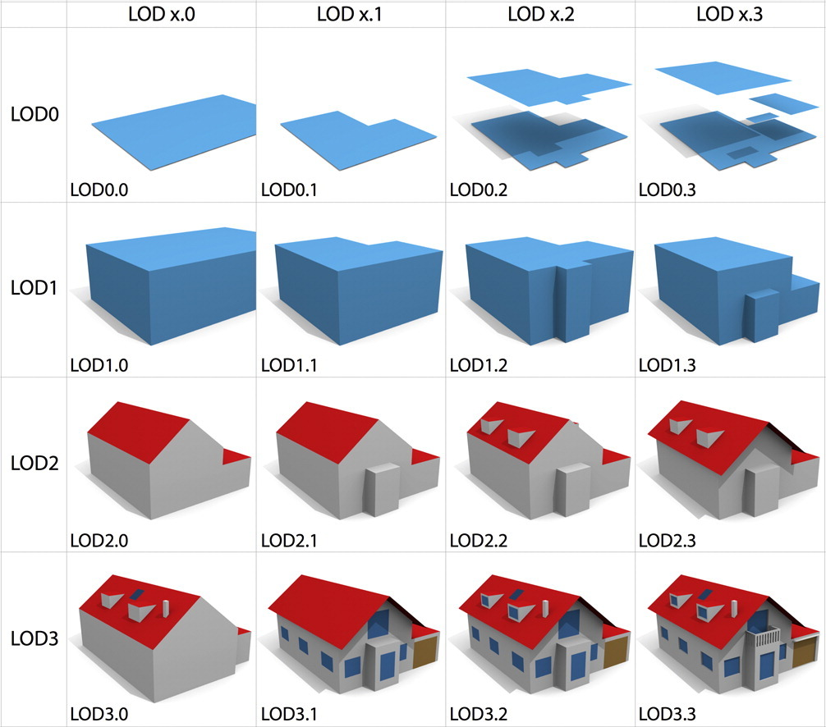

Refined Levels of Detail (Biljecki et al., 2016a)

|  |  |  |  |
| --- | --- | --- | --- |
| Code | Footprint at | INSPIRE Reference | Reference |
| F0 | Actual location | footprint | = |
| Fd | Roof edges offset by a fixed distance | n/a | offsetRoofEdge |
| F1 | Roof edges | roofedge | = |

Table : Horizontal geometric elements (Biljecki, et al, 2016b)

|  |  |  |  |
| --- | --- | --- | --- |
| Code | Height at | INSPIRE Reference | Reference |
| H0 | Roof edges | generalRoofEdge | = |
| H1 | Roof eaves | generalEave | = |
| H2 | One third of the roof height | generalRoof | oneThirdRoof |
| H3 | Half of the roof height | generalRoof | halfRoof |
| H4 | Two thirds of the roof height | generalRoof | twoThirdRoof |
| H5 | Top of the roof (i.e. ridge) | topOfConstruction | = |
| H6 | Highest point of the building | highestPoint | = |
| HL-avg | Average height of the point cloud | n/a | avgHeightLiDAR |
| HL-med | Median height of the point cloud | n/a | medHeightLiDAR |
| HL-max | Maximum height of the point cloud | n/a | maxHeightLiDAR |
| Hx | Varies | n/a | NonEleAtt |

Table : Vertical geometric elements (Biljecki, et al, 2016b)

## References

* [BILJECKI, F., LEDOUX, H., STOTER, J., 2016. An improved LOD specification for 3D building models. Computers, Environment, and Urban Systems, vol. 59, pp. 25-37.](http://filip.biljecki.com/)
* [BILJECKI, F., LEDOUX, H., STOTER, J., VOSSELMAN, G. 2016. The variants of an LOD of a 3D building model and their influence on spatial analyses, ISPRS Journal of Photogrammetry and Remote Sensing 116 (2016) pp. 42–54.](http://filip.biljecki.com/)

Both papers may also be accessed at:

<http://filip.biljecki.com/>

delwp.vic.gov.au

1. Developed by the United Nations Committee of Experts on Global Geospatial Information Management [↑](#footnote-ref-2)