22/12/2025

Vicmap Special Bulletin – Vicmap Satellite Tasking Service extended to June 2026

What is happening?
We are pleased to announce that the Vicmap Satellite Tasking Service has been extended to June 2026. This will ensure State and Local Government partners have continued access to timely satellite imagery to support projects and daily operations.
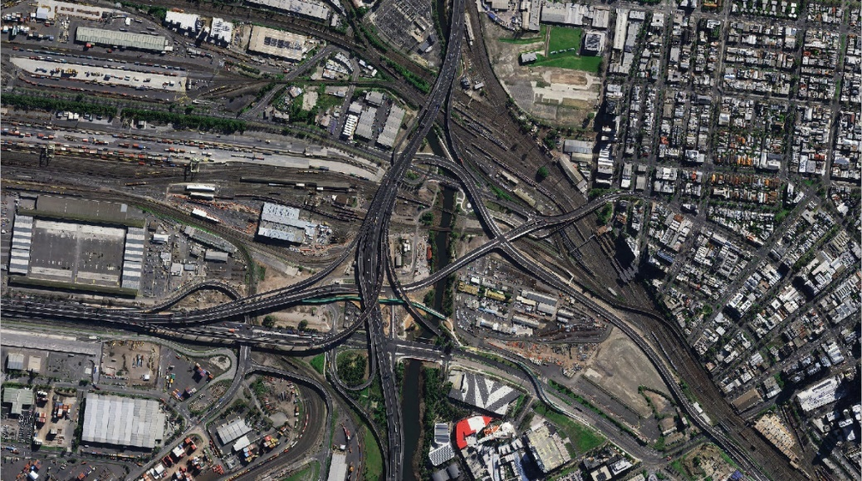e
Image caption: West Gate Tunnel on 19 Aug 2025, captured by Pleiades NEO (30cm) ©AIRBUS DS (2025).
About the service
Vicmap satellite imagery is available on-demand, with access to 54 satellites in orbit at various resolutions with constellations passing over Victoria.
The service offers near real-time delivery of high-quality imagery once captured. Imagery turnaround times are often between 2–12 hours post-capture. Previously captured satellite imagery can also be acquired at various resolutions.
Our satellite Tasking Service supports government agencies by allowing users to request satellite capture over areas of interest. Some of recent uses of the service include:
- Environmental monitoring: track vegetation change, land use, etc.
- Disaster response and recovery: obtain near-real-time imagery following events such as floods and bushfires.
- Urban planning and infrastructure: support event planning and construction monitoring in the city.
- Agriculture insights: predict pasture biomass in SmartFarms.
Want to learn more or request imagery?
Visit our Satellite Tasking Service website https://go.vic.gov.au/3WkVOxm
Satellite imagery is only available to state and local government agencies.
To access satellite imagery, please complete the Satellite Tasking Expression of Interest Form or email vicmap@transport.vic.gov.au
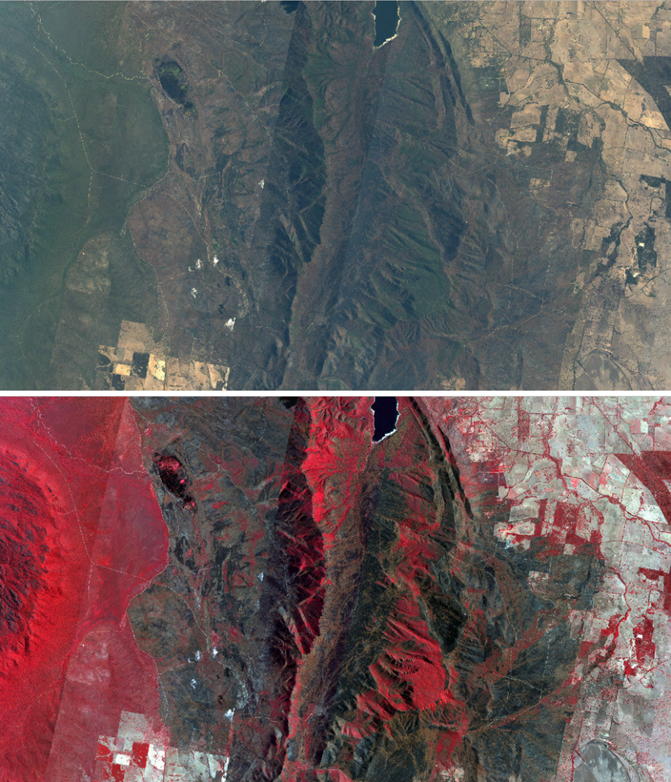
Image caption: The Grampians bushfires on 14 Jan 2025, captured by Skysat (50 cm) ©Planet. True colour (top) and false colour (bottom).

Get in touch with us
For further help, information or to join our Vicmap User Reference Group (VURG) please email vicmap@transport.vic.gov.au
For Vicmap change advisory notices and updates, visit updates to Vicmap.
To subscribe to Vicmap change notices, please contact vicmap@transport.vic.gov.au

© The State of Victoria Department of Transport and Planning 2025  This work is licensed under a Creative Commons Attribution 4.0 International licence. You are free to re-use the work under that licence, on the condition that you credit the State of Victoria as author. The licence does not apply to any images, photographs or branding, including the Victorian Coat of Arms, the Victorian Government logo and the Department of Transport and Planning (DTP) logo. To view a copy of this licence, visit http://creativecommons.org/licenses/by/4.0/ | Disclaimer  This publication may be of assistance to you but the State of Victoria and its employees do not guarantee that the publication is without flaw of any kind or is wholly appropriate for your particular purposes and therefore disclaims all liability for any error, loss or other consequence which may arise from you relying on any information in this publication.  Spatial disclaimer  The State of Victoria:  - does not give any representation or warranty as to  - the accuracy or completeness of State of Victoria spatial products (including data and metadata), Vicmap® products or Vicmap® product specifications; or  - the fitness of such data or products or of State of Victoria spatial services (including APIs and web services) for any particular purpose;  - disclaims all responsibility and liability whatsoever for any errors, faults, defects or omissions in such data or products and services.  Any person using or relying upon such products and services must make an independent assessment of them and their fitness for particular purposes and requirements.  Vicmap is registered trademark licensed to the State of Victoria

