Vicmap™ Product Development
Change Notice # 248 Advisory Notice
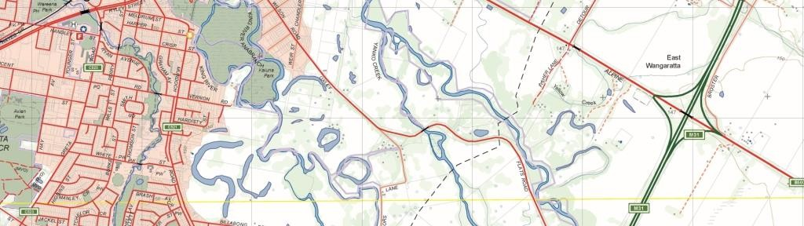

Vicmap Transport

What is happening
The following four new columns will be added to Vicmap Transport TR_ROAD_LOCALITY: Data Structure
Column Name | Data type | Mandatory
GAZETTAL_DATE | DATE | DD/MM/YYYY
GAZETTAL_REGISTRATION | VARCHAR2(15) | G012 1995 p742
GAZETTAL_URL | VARCHAR2(200) | http://www.gazette.vic.gov.au/gazette/Gazettes2019/GG2019G009.pdf #page=40
ROAD_NAME_THEME | VARCHAR2(10) | ‘ANZAC’, ‘ABORIGINAL’, or ‘OTHER’

This enhancement enables users to ascertain when a road name was gazetted, its gazette reference, road name theme and provides a link to the gazette URL.

Users will no longer need to locate the electronic gazette notice via the web.

The addition of the road name theme will enable reporting on which roads, for example, are Aboriginal in origin.

Vicmap™ Product Development

Why this change is occurring
VICNAMES – The Register of Geographic Names requires amendments to Vicmap Transport to enable display of gazette information within VICNAMES. It is a requirement of the Geographic Place Names Act 1998 that the Registrar of Geographic Names establishes a Register of Geographic Names.

Who will it affect?
This change will affect all users of Vicmap Transport.

When the change will occur | How to provide feedback |
The change will be implemented on the 12/11/2019.

For Vicmap Product change notices and bulletins, go to the News and Bulletins page. For further information & feedback please email vicmap.help@delwp.vic.gov.au.

© The State of Victoria Department of Environment, Land, Water and Planning 2019  This work is licensed under a Creative Commons Attribution 4.0 International licence. You are free to re-use the work under that licence, on the condition  that you credit the State of Victoria as author. The licence does not apply to any images, photographs or branding, including the Victorian Coat of Arms, the Victorian Government logo and the Department of Environment, Land, Water and Planning (DELWP) logo. To view a copy of this licence, visit http://creativecommons.org/licenses/by/4.0/  Disclaimer  This publication may be of assistance to you but the State of Victoria and its employees do not guarantee that the publication is without flaw of any kind or is wholly appropriate for your particular purposes and therefore disclaims all liability for any error, loss or other consequence which may arise from you relying on any  information in this publication. | Accessibility  If you would like to receive this publication in an alternative format, please telephone the DELWP Customer Service Centre on 136186, email customer.service@delwp.vic.gov.au, or via the National Relay Service on 133 677 www.relayservice.com.au. This document is also available on the internet at www.delwp.vic.gov.au.

