|  |
| --- |
| Requirements for  permanent marks in new estates |
| Permanent marks are required in new estates to support ongoing surveying of property boundaries, construction and mapping | |

Permanent marks are stable reference points in the ground with accurately measured coordinate and height information. In new estate developments it is important that clearly identifiable, permanent marks are installed, and information recorded to support ongoing surveying, construction and mapping activities.

## Importance of permanent marks

Permanent marks are valuable infrastructure that support surveying of property boundaries, development and construction activities, mapping and environmental monitoring. Permanent marks hold accurate coordinate and height information and provide a point of reference for surveying activities. It is important that they are accessible, stable and built of durable material to ensure the accuracy and reliability of the permanent mark information is preserved. Permanent marks enable surveyors to easily comply with legislation and project requirements, which improves the efficiency of surveying activities, reducing costs for industry and the community.

## Permanent mark materials

Permanent marks should be made of good quality, durable, corrosion resistant material and installed employing robust construction techniques. The most common permanent mark is a brass plaque set in concrete below ground level and enclosed by a protective surround with a cover/lid. Examples of permanent mark types are shown in [Schedule 1 of the Survey Co-ordination Regulations 2014](http://classic.austlii.edu.au/au/legis/vic/consol_reg/scr2014359/sch1.html).

Lower quality survey monuments such as nails, rivets and star iron pickets are not considered suitable as permanent marks. These types of materials are generally recorded as primary cadastral marks (PCMs).

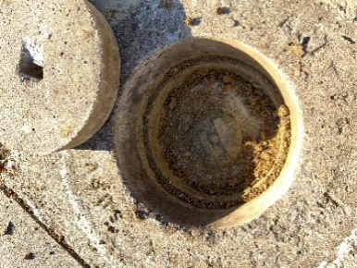 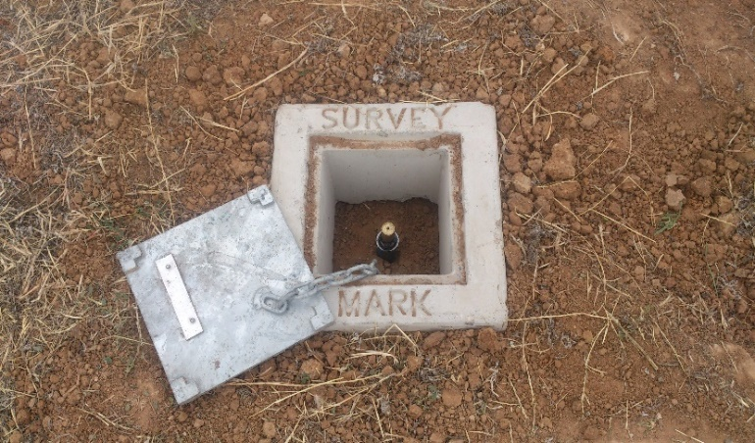

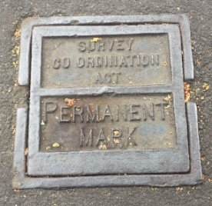 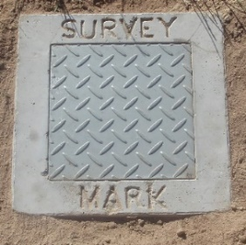

**Common permanent marks and covers**

## Council and engineering requirements

Local government authorities (LGAs) set requirements for the establishment of permanent marks in new estate developments. The number of permanent marks required is usually based on the number of lots in the new estate. Permanent marks are usually installed in footpaths at road intersections, as part of civil construction works. Engineers are encouraged to engage with the project cadastral surveying consultant to ensure permanent marks are placed to support ongoing accessibility and line of sight observations.

## Licensed surveyor responsibilities

Licensed surveyors are required to connect to permanent marks to align surveys with the national coordinate datum (GDA2020, AHD) and support ongoing surveying and mapping activities. In new estates, connections should be made to permanent marks as per Regulation 11 (3) of the Surveying (Cadastral Surveys) Regulations 2015. The number of permanent marks to be connected to depends on the number of lots and the layout of the new estate.

In addition, Regulations 6 and 7 of the Survey Co-ordination Regulations 2014 require licensed surveyors to submit survey mark information and sketch plans to the Survey Marks Enquiry Service (SMES) for new or unregistered permanent marks that are connected to in cadastral surveys.

## Survey Marks Enquiry Service

Information about all permanent marks in Victoria is available at no cost through the SMES interactive online application at [Survey Marks Enquiry Service (land.vic.gov.au)](https://www.land.vic.gov.au/surveying/services/survey-marks-enquiry-service).

The permanent marks in an area can be located through this online service. Coordinate and height information, mark type and sketch plans are available.

Registered users can log into SMES to reserve permanent mark numbers and update information about permanent marks as required by Regulations 6 and 7 of the Survey Co-ordination Regulations 2014.

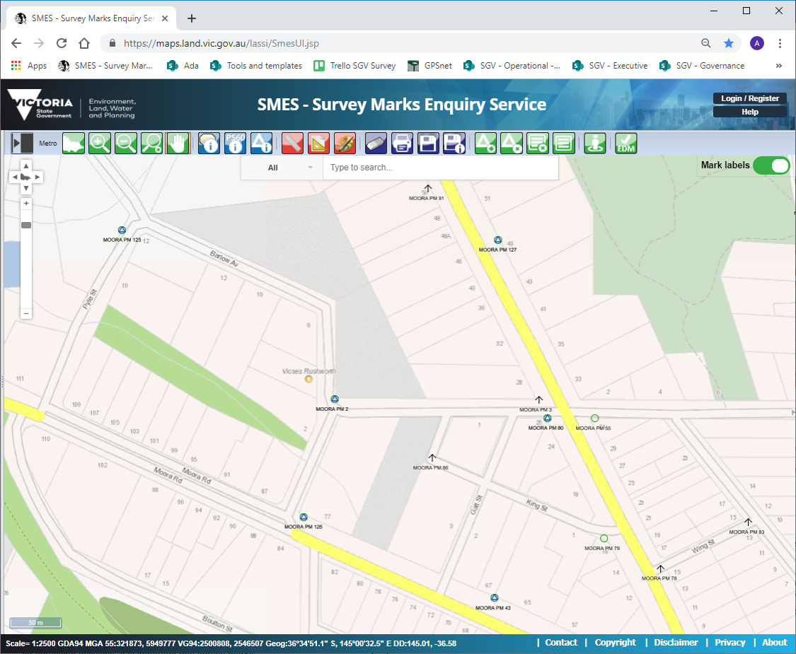

Survey Marks Enquiry Service (SMES)

## Reporting issues

It is important that permanent marks are not disturbed and that they remain stable and accessible*.* Councils and construction contractors should make every effort to preserve existing permanent marks. Sometimes interference with these permanent marks is unavoidable due to development and other works. In these instances, it is important to notify SMES Support:

Phone: 03 9194 0770

Email: smes.support@delwp.vic.gov.au

Potential damage or destruction of permanent marks may require them to be removed or replaced. SMES Support will advise the appropriate course of action and update the SMES database as required.

## Your assistance is appreciated

Surveyor-General Victoria (SGV) appreciates any assistance in the maintenance and enhancement of the Victorian survey control mark network. Collaboration by the surveying industry, local government and SGV will ensure the protection of this important and valuable infrastructure.

|  |  |
| --- | --- |
| © The State of Victoria Department of Environment, Land, Water and Planning 2021  LogoThis work is licensed under a Creative Commons Attribution 4.0 International licence. You are free to re-use the work under that licence, on the condition that you credit the State of Victoria as author. The licence does not apply to any images, photographs or branding, including the Victorian Coat of Arms, the Victorian Government logo and the Department of Environment, Land, Water and Planning (DELWP) logo. To view a copy of this licence, visit http://creativecommons.org/licenses/by/4.0/  Disclaimer  This publication may be of assistance to you but the State of Victoria and its employees do not guarantee that the publication is without flaw of any kind or is wholly appropriate for your particular purposes and therefore disclaims all liability for any error, loss or other consequence which may arise from you relying on any information in this publication. | Accessibility  If you would like to receive this publication in an alternative format, please telephone the DELWP Customer Service Centre on 136186, email [customer.service@delwp.vic.gov.au](mailto:customer.service@delwp.vic.gov.au), or via the National Relay Service on 133 677 [www.relayservice.com.au](http://www.relayservice.com.au). This document is also available on the internet at [www.delwp.vic.gov.au](http://www.delwp.vic.gov.au). |