Product Description

Vicmap Elevation
LiDAR Points Collection

Document History

Version | Date | Note
0.0 | November 2022 | First Draft – DEM description transferred from Vicmap Elevation Multi-resolution DEM and Contours.
1.0 | February 2023 | Content updated to reflect coverage status as of January 2023, MOG changes to DTP and clearer License and Access sections. First version ready for review and potential release. Mirroring updates made to Vicmap LiDAR DEMs Collection PD.
2.0 | March 2023 | Adopted DTP document template and badging
This document has been formatted and structured as an adaptation to AS/NZS ISO 19131:2008 Geographic Information – Data product specifications.

Table of Contents
Document History 1
Table of Contents 2
List of Figures 3
List of Tables 3
Overview 4
Vicmap™ 4
Data Product Specification Title 4
Informal Description of the Data Product 4
Related VicmapTM Elevation Products 4
Responsible Party 4
Internet Site for Information 4
Specification Scope 5
Level 5
Extent & Coverage 5
Data Product Identification 6
Title 6
Alternative Title 6
Spatial Representation Type 6
Point Density 6
Data Content and Structure 7
Data Content 7
Data Model 7
Data Type 9
Data Structure 9
Reference Systems 9
Horizontal Datum 9
Projection 9
Vertical Datum 9
Data Capture 10
Production Methods 10
Data Quality 13
Accuracy 13
Completeness 14
Logical Consistency 14
Data Maintenance 14
Data Product Delivery 14
Licensing 14
Access 15
Metadata 15
Follower pages 19

List of Figures
Figure 1: Vicmap LiDAR Points Collection coverage 5
Figure 2: LiDAR point attribution supported by LAS1.4 data format 8
Figure 3: LiDAR point classification for 2022 Wedderburn LiDAR dataset 12
Figure 4: Mosaic footprints - Kilmore LiDAR Points dataset 16

List of Tables
Table 1: Vicmap LiDAR Points content summary 7
Table 2: Modified ICSM LiDAR point classification schema 11
Table 3: Access to Vicmap LiDAR Points datasets 15
Table 4: Data file names - Kilmore LiDAR Points dataset 16

Overview

Vicmap™
Vicmap™ is the foundation that underlies most spatial information in Victoria. This portfolio of spatially related authoritative data products, comprising individual datasets, is developed, and managed by the Department of Transport and Planning. The information provides the foundation to Victoria’s primary mapping and spatial information systems and is used for building business information and systems.

Vicmap is a registered trademark of the Victorian Government and has been synonymous with authoritative state-wide mapping since 1975.

Vicmap Catalog

Data Product Specification Title
Vicmap™ LiDAR Points Collection

Topic Theme
Elevation

Topic Category
Elevation Point Cloud

Informal Description of the Data Product
Vicmap Elevation LiDAR Points is a collection of mass 3D point data sets sourced from LiDAR projects undertaken by the Coordinated Imagery Program (CIP) since the mid 2000’s. The Vicmap Elevation – LiDAR Points Collection is closely associated with the Vicmap Elevation – LiDAR DEMs Collection as each point cloud dataset has an associated DEM ground surface data set. By virtue of its collection history, the Point Cloud data sets vary in point density and vertical accuracy, with each of these generally improving in more recent years.

Related VicmapTM Elevation Products
VicmapTM Elevation – LiDAR DEMs Collection
VicmapTM Elevation – 1m DEM Web Services

Responsible Party
Vicmap Spatial Services Branch
Department of Transport and Planning
PO Box 527, Melbourne VIC 3001 Australia
vicmap.help@delwp.vic.gov.au

Internet Site for Information
Vicmap Elevation

Specification Scope
This specification describes the Vicmap Elevation LiDAR Points product, which is a collection of LiDAR derived point cloud datasets of varying currency, point density and accuracy collected by the State through the Coordinated Imagery Program (CIP). The information provided describes the nature of the collection as well as some of the fundamental and common characteristics of the point cloud datasets that constitute the collection.

Level
Product

Extent & Coverage
As of January 2023, the Vicmap LiDAR Point Clouds Collection covers approximately 60% of the States land area and achieves coverage of over 99% of the States populated areas. Data acquisition is driven by purchase partner investment through the Coordinated Imagery Program (CIP) and as such, some areas have remained unsurveyed by LiDAR. Conversely, some parts of the State have also been surveyed multiple times where investment funding has been driven by monitoring and change analysis requirements. The 40% not covered by LiDAR represents the unpopulated regions of the State including the National Parks and State Forests of the Great Dividing Range and the western plains desert and cropping country.

Figure 1: Vicmap LiDAR Points Collection coverage
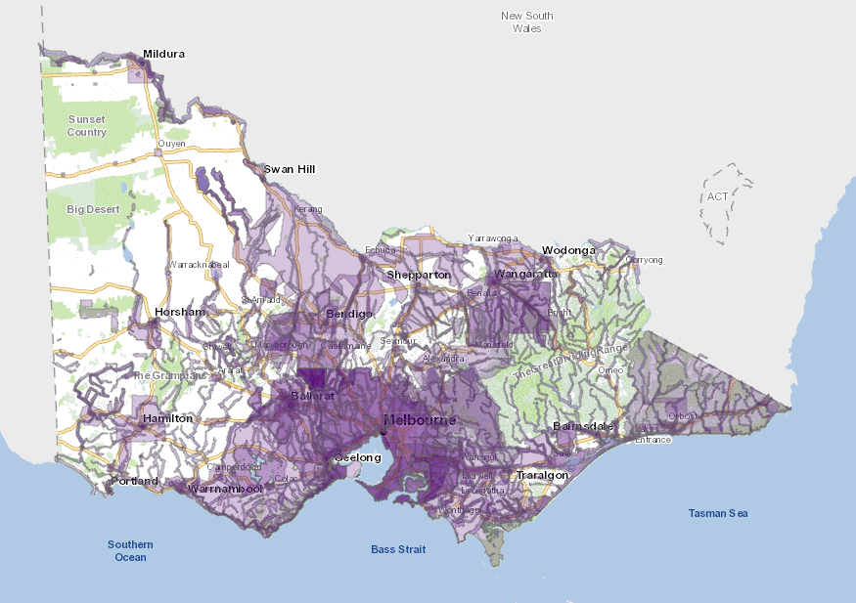
Vist the CIP website for current extent and coverage: Vicmap Imagery & Elevation Coverage

Data Product Identification

Title
Vicmap Elevation LiDAR Points Collection

Alternative Title
Vicmap LiDAR Points Collection
Vicmap LiDAR Points

Spatial Representation Type
Point Cloud (vector) data

Point Density
Ranging from 2pts/m² to 24pts/m²

Abstract
The Vicmap LiDAR Points collection is a compilation of point cloud data sets captured by aerial LiDAR surveys undertaken by the Coordinated Imagery Program since 2007. It represents the most comprehensive and extensive archive of LiDAR point clouds for the State of Victoria.
Typically, datasets within the collection vary in point density and accuracy but all adhere to evolving, standardised point cloud specifications that were reflective of the technical capability at the time of survey.
Supported by evolving LAS data file formats and advances in software capability, LiDAR point classification has improved over time with a wider range of classes being more accurately classified. Additionally, the use of bit flags to carry extra point attribution has allowed recent point datasets to be more comprehensively characterised than early LiDAR datasets.
Simultaneously acquired imagery has also been a common feature in later LiDAR surveys with the RGB and IR imagery values encoded with each recorded lidar point. This feature provides additional contextual and interpretative support not available with early LiDAR datasets.
Despite evolving point cloud standards, consistent throughout the collection has been vertical alignment to the Australian Height Datum (AHD) and the preservation of original ellipsoidal height datasets. Horizontal datum and data file formats have changed over time, but these have been, or can be transferred to newer standards as required.
Finally, each point cloud dataset has been verified against the designated standard of the time through rigorous QA/QC validation processes implemented within the CIP program. Included in the validation processes are confirmation of point cloud dataset vertical accuracy and vertical alignment between adjacent point clouds within their vertical accuracy tolerances.

Data Content and Structure

Data Content
As of January 2023, the LiDAR Points collection contains over 300 point cloud datasets, where each dataset represents a single, contiguous area. Depending on the original survey, multiple datasets may have come from the same sourcing project. For example, a 2019 regional towns LiDAR survey generated several point cloud datasets each representing a spatially explicit township coverage.
Importantly, the LiDAR Points collection continues to expand with each new LiDAR survey undertaken. New surveys may represent an extension of the existing available coverage, or they may represent repeat coverage of an area previously surveyed. In each case, the LiDAR Points collection will continue to expand and deepen in content.

Table 1: Vicmap LiDAR Points content summary
Source | Aerial LiDAR survey
Point Density | Ranging from 2pts/m² to 24pts/m²
Currency | Ranging from 2007 to present
Vertical Accuracy | Ranging from +/- 50cm RMSE to +/-10cm RMSE
Horizontal Datum | Ranging from GDA94 to GDA2020
Vertical Datum | Ellipsoidal and AHD
Format | Ranging from ASCII, LAS to LAZ
Coordinates | Ranging from GDA94 zone 54 and 55 to GDA2020 zone 54 and 55
Coverage | 60% of Victoria

Data Model
The Vicmap Elevation LiDAR Points collection comprises of 3-dimensional point cloud elevation data. The file format in which the points are stored determines the data model, and this has evolved over time according to available technology and prevailing data standards at the time of survey.
The format used for early datasets in the collection was simple ASCII with basic X and Y coordinates and Z elevation values. The development of more sophisticated, purpose designed point cloud formats like the American Society for Photogrammetry & Remote Sensing (ASPRS) LAS 1.4 has allowed more extensive point cloud detail and attribution to be stored and used. In addition to elevation values, points carry intensity values, RGB imagery and classification encoding, point source (capture swath) ID, scan angle and have a host of Bit Flag settings that can track whether points overlap with other swaths or are treated in specific ways during classification. Artificial points may even be inserted and flagged as Synthetic inclusions.

Figure 2: LiDAR point attribution supported by LAS1.4 data format
Classification | Intensity
Simultaneous RGB imagery encoding | Elevation

Additional formats that address transfer and streaming considerations such as LAZ and COPC are now also being used for datasets in the collection. No doubt, newer versions and alternative point cloud formats will be employed in the future as data formats continue to evolve.
Conformity has always been sought with existing ANZLIC and international standards and specifications. However, the nature and age profile of the collection means there are instances where the point cloud data format and attribution will vary across the Collection.

Data Type
Vicmap LiDAR Points are stored as 3-dimensional X,Y,Z tuplet with 2 decimal point precision.

Data Structure
Point cloud datasets are assembled and archived in pre-defined tile sets of either 500m, 1km or 2km units, with one data file per tile. Tile indices are created on MGA coordinates aligned to 100m or 1000m easting and northing intervals. File naming of each data file reflects the easting and northing dataset origin, as well as acquisition date and other key metadata elements for the file.

Data Voids
Data voids may be present within the point clouds where they have been caused by
- water bodies.
- areas of low near infra-red (NIR) reflectivity such asphalt or composition roofing.
- shadowing from buildings or other features

In all other cases, LiDAR survey specifications have required that gaps between lidar points should not exceed a measure of 4 times the point spacing.

Reference Systems

Horizontal Datum
Vicmap LiDAR Points are aligned to the Geocentric Datum of Australia (GDA) that was officially in use at the time of survey.

LiDAR Points generated up to and including 2019 are aligned to GDA94 and Points generated since 2020 are aligned to GDA2020.

Projection
LiDAR Points are projected to MGA zones 54 or 55 for both GDA datums.

Vertical Datum
Vicmap Elevation LiDAR Points are collected with respect to the GRS80 refence ellipsoid.
and are also modelled to the Australian Height Datum (AHD) using the Ausgeoid model officially in use at the time of survey.

Dataset specific Reference System details are recorded with each DEM data file.

Data Capture
Vicmap LiDAR Points are acquired via LiDAR survey projects undertaken through the States Coordinated Imagery Program (CIP). LiDAR surveys are conducted on behalf of the State by commercial aerial survey companies that have qualified for the relevant State services panels.
Acquisition planning is driven by purchase partner investment in the CIP program and is implemented in an on-demand basis. Aerial survey most often occurs as a single project achievable within one flying season by a single commercial supplier. As investment and funding allows, larger capture programs may occur that span multiple flying seasons and require multiple commercial suppliers to complete.
LiDAR survey within Victoria is achievable throughout the whole calendar year, however most data capture has been conducted during the spring, summer, and autumn seasons (November through to May).

Production Methods

Following airborne LiDAR survey, production methods for generation of point cloud datasets broadly follow a generic processing workflow, although the implementation of some of these stages may vary between commercial suppliers.

- GNSS/INS Trajectory Processing
- LiDAR strip alignment
- LiDAR adjustment to AHD
- LiDAR classification

The specification of vertical accuracy and level of point cloud classification may impact the production methods in which steps 3 and 4 are undertaken.
Point classes used in Vicmap LiDAR Points datasets are based on the Australian Intergovernmental Committee for Survey and Mapping (ICSM) LiDAR classification schema. These classes are described in Table 2. Not all classes in the schema have been equally applied across all datasets in the Collection. The designation of classes used in a dataset has always been subject to the specific project requirements of the LiDAR survey and these have not always been the same across projects from which the Collection derives. However, in general, it is true that early Vicmap LiDAR Points datasets will have a lower level of classification detail and thematic accuracy than later datasets.
The improvement in classification detail and accuracy in more recent datasets is governed by several interconnected factors. Sensor and positioning technologies have improved over time delivering higher point densities, improved positional representation of points and greater definition of landscape and built features. Improved feature representation allows automated classification algorithms to be more successfully applied across a broader range of classes, reducing the amount of manual editing required and reducing cost.

Table 2: Modified ICSM LiDAR point classification schema
Number | Point Class | Description
0 | Unclassified | Created, never classified  (Points that have been attempted to be classified and failed)
1 | Default | Unclassified  (Points that have not attempted to have been classified)
2 | Ground | Bare ground
3 | Low vegetation | 0 – 0.3m
4 | Medium vegetation | 0.3 – 2m
5 | High vegetation | 2m >
6 | Buildings, structures | Buildings, houses, sheds, silos etc.
7 | Low / high points | Spurious high/low point returns (noise)
8 | Reserved | Model Key Points
9 | Water | Any point in water
10 | Bridge | Any bridge or overpass  - No minimum size specified.  - All non-ground features such as the bridge deck, railing and piers should be classified as Bridge Class 10.  - Mineral earth embankments, even if faced with other materials, can be classified as Ground Class 2.
11 | Not Used | Reserved for future definition
12 | Reserved | Previously Flight line overlap points (not in current use)
13 | Non-building human Made Features  (Extension Class) | Human made objects that do not fit the building or bridge classes (hay bales, industrial plant and equipment, power lines, parked cars, shipwrecks, etc).  Supplier discretion can be exercised in discerning from class 6 buildings. This class introduced due to some human made non-building objects commonly being classified as vegetation.
14 | Culverts  (Extension Class) | Major Culverts only (>= 1m height)  Culverts can be defined as any kind of pipe or box structure overlaid with mineral earth for the purpose of allowing water to pass under a raised surface.
15-31 | Not Used | Reserved for future definition

Figure 3: LiDAR point classification for 2022 Wedderburn LiDAR dataset
2D representation of classified LiDAR points dataset with Ground class not shown
Simultaneous RGB imagery

Data Quality
The aspect of data quality for the LiDAR Points collection will vary according to the LiDAR survey specifications and to some extent, the age and date of the source LiDAR survey. In all cases, the LiDAR Point datasets have been verified as meeting the designated specifications for the survey.

Accuracy

Horizontal Accuracy
Greater than or equal to +/- 30cm RMSE

All LiDAR surveys from which the LiDAR Point datasets are derived are rated at +/-30cm RMSE horizontal accuracy. Greater horizontal accuracies are now achievable and have been demonstrated in the more recent LiDAR surveys that have contributed LiDAR Points datasets.

Vertical Accuracy
Ranging between +/- 10cm RMSE and +/- 50cm RMSE

Vertical accuracy has historically been a commonly varied LiDAR survey specification. Within the LiDAR Points collection, vertical accuracy ranges from +/-50cm RMSE for some of the older datasets to +/-10cm for later datasets. The increase in vertical accuracy is due to improved sensor technology as well as better positioning and aerial survey inertial management technology.

Spatial Data Integrity
Vicmap Elevation LiDAR Points are most correct when used in their native datums and projections. Transforming and reprojecting the data may alter and reduce the fidelity of the elevation values for the transformed or reprojected coordinate.

Edge Matching
Although not possible to guarantee, Point datasets in the collection should vertically align with adjacent and overlapping datasets within the degree of their respective vertical tolerances or accuracies. Older datasets are less likely to agree with newer datasets and this is due to the reasons described in the Vertical Accuracy section. Since the advent of GDA2020 and the Ausgeoid2020 model for AHD, the State has introduced the practise of supplying survey control to its commercial aerial survey contractors. This strategy allows the State to ensure consistently high accuracy, high-quality ground control data is used across all LiDAR surveys, and this has resulted in excellent vertical alignment across LiDAR surveys conducted by different contractors.

Completeness
The LiDAR Point datasets are complete for their respective project areas of interest, are in the correct formats and are free of file corruption.

Logical Consistency
The LiDAR DEM datasets are all consistent in their data representation of AHD. As described, variations exist in resolution and vertical accuracy. Additionally, there will be variation in the degree to which older datasets have been hydro flattened and bridges treated, as surface modelling improvements have evolved over time.

Data Maintenance
The Vicmap LiDAR Points collection is continuously growing with each successful airborne LiDAR survey undertaken by the Coordinated Imagery Program (CIP). Data maintenance will continue to be conducted in a manner that services the requirements of the investing purchase partners. For the near future, acquisition planning will be driven by those agencies that fund LiDAR surveys for their project purposes.

Data Product Delivery

Licensing
Vicmap Elevation LiDAR Points are subject to licensed use. Data Access License Agreements (DALA) are used to provide the terms and conditions of use, including license fee. License fees are determined by the coverage and extent of the data purchased.

Commercial use licenses may also be negotiated with businesses wishing to become a licensed Value-Added Reseller (VAR) or licensed Data Service Provider (DSP).

VARs and DSPs offer data ordering and sale services for Vicmap LIDAR DEM datasets.

Access
Table 3: Access to Vicmap LiDAR Points datasets
Discover Data
Vicmap Imagery & Elevation Coverage | The collection of Vicmap LiDAR Points datasets can be discovered on the Vicmap Imagery & Elevation Coverage map. This interactive web map supports spatial search and query of available Vicmap LiDAR Points as well as Vicmap LiDAR DEMs and Vicmap Imagery. Using search results, data can be ordered through the VAR & DSP network.
DataShare | DataShare is a DEECA hosted website for text searching both licensed and open spatial data resources held by participating State agencies. Metadata on available Vicmap LiDAR Points datasets can be discovered on this site, however data can only be ordered through the VAR & DSP network.
Order Data
VAR & DSP Network | Licensed value-added resellers and data service providers can provide data search and sale services for Vicmap LiDAR Points. Data access license agreements are provided with purchased data.
ELVIS | In exceptional cases, some project specific Vicmap LiDAR Points datasets are available under Creative Commons by Attribution 4.0 Australia license (CCB4). These can be discovered and downloaded directly from the ELVIS platform provided by Geoscience Australia.

Metadata
There are four levels of metadata available in relation to the Vicmap LiDAR DEMs Collection.
- Product description
This document describes the Vicmap LiDAR Points Collection as a collated archive of LiDAR datasets. This high-level summary identifies the range and variety of content in the collection.

- LiDAR Point dataset metadata
Metadata, based on an early version of the ISO 19115-2 schema for imagery and gridded data, is also described for each LiDAR Points dataset in the collection and can be accessed via DataShare or via the VAR & DSP Network.

- LiDAR Point dataset spatial footprints
Paired with each LiDAR Points dataset description are dual spatial metadata or “footprint” records that represent (1) the explicit external data boundary (also referred to as the mosaic footprint) and (2) the internal data tiling schema for each dataset. Associated with each mosaic footprint is a summary of key dataset specific data attributes. Dataset boundaries are used to support spatial search and discovery tools such as those on the Vicmap Imagery & Elevation Coverage web map.
Figure 4: Mosaic footprints - Kilmore LiDAR Points dataset
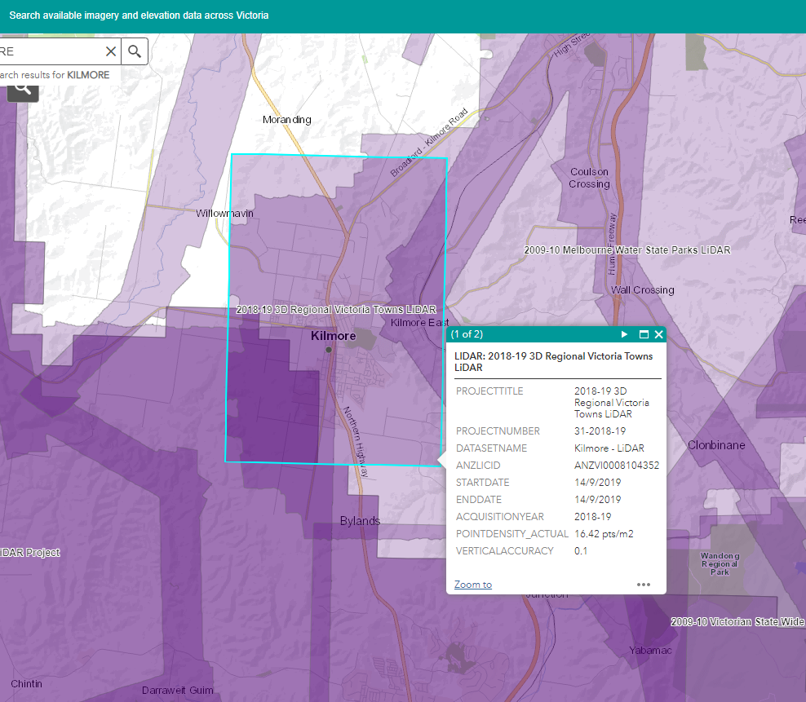

- LiDAR Points dataset filename

A standardised data file naming convention has been used to convey key metadata features for each LiDAR points data file.

<name>_<project>_<start date>_<product>_v<vertical accuracy>_<v-datum>_<h-rojection>.<extension>

Table 4: Data file names - Kilmore LiDAR Points dataset
Single tile data file - AHD | e315n5866_kilmore_2019sep14_mptsc2_v10cm_ahd_epsg7855.laz
Single tile data file - Ellipsoidal | e315n5866_kilmore_2019sep14_ mpts-c2_v10cm_ell_epsg7855.laz

[Click to add Section cover Title]
[Click to add Section cover Subtitle]

Follower pages
Enter copy using the type styles in the styles gallery for formatting.

