|  |
| --- |
| Vicmap Bulletin  27 February 2018 |
| Implementing GDA2020 in Vicmap™ |

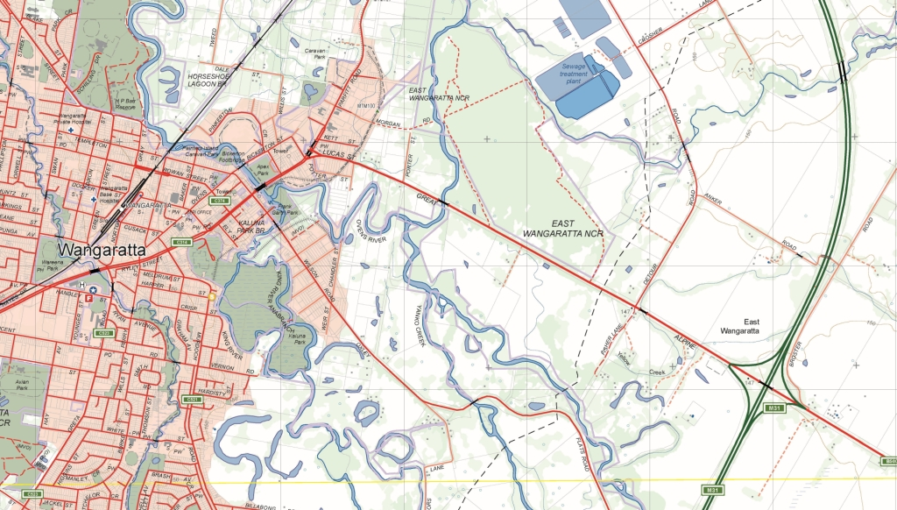

Australia's new national datum is called GDA2020. It replaces GDA94, which is now approximately 1.8 metres out of position in relation to satellite positioning systems due mainly to tectonic plate movement. The new datum will enable positioning technologies and location services to more accurately map and navigate.

# GDA2020 is here

Vicmap data is currently held in GDA94. The Department of Environment, Land, Water and Planning (DELWP) will migrate Vicmap to GDA2020 in three major stages over the next several years.

It should be noted that customers will still be able to receive data from Spatial Datamart in GDA94 format following the migration of data into GDA2020.

### Stage 1: 2018

The first stage focuses on enabling stakeholders to begin using GDA2020 as soon as possible by providing data in GDA2020, as well as other datum options (including GDA94). This means Vicmap* will be publicly available in GDA2020 by June 2018.

A help file for users will be available through the [Vicmap Helpdesk](https://www2.delwp.vic.gov.au/maps/help-and-resources/vicmap-helpdesk) at [www.delwp.vic.gov.au/maps](http://www.delwp.vic.gov.au/maps) >.

* Vicmap LAT Incremental Update Format will not be available in GDA2020 until the implementation of Stage 2 (see below).

### Stage 2: Estimated 2019 – 2020

This stage will be internal to DELWP, where Vicmap edit and storage databases will be migrated into GDA2020. It will be done in parallel with system capability improvements to support the new datum into the future.

### Stage 3: 2021

In the third and final stage, data improvement will take place through improving the spatial accuracy of Vicmap. This project has already begun but the accuracy improvements will be incorporated into Vicmap in stages, with an expected completion in 2022.

## Vicmap Topographic Mapping Program

The scales of Vicmap topographic maps are not sufficiently fine enough to show the difference between GDA2020 and GDA94 data in hardcopy and softcopy (.PDF) products. Hardcopy maps will be stamped ‘GDA2020 compatible’.

Following Stage 2 (above) of implementation, all new Vicmap Topographic Mapping products will be labelled as being derived from and consistent with GDA2020.

## Vicmap API

The Vicmap API is currently available in two datums – VicGrid94 and WGS84 (used by Google Earth). The API will also be available in GDA2020 later in 2018. The VicGrid94 option will be phased out as customer demand for it wanes over the following years.

## Vicmap Position

### Continuously Operating Reference Station network

GPSnet™ will start testing GDA2020 in early 2018 and proposes to move to a full Production Data Centre upgrade to GDA2020 in June 2018. This timeline depends upon a uniform decision by all operators of similar networks across Australia about when systems will uniformly adopt GDA2020.

Legacy support for GDA94 will continue for as long as it is deemed necessary.

### Survey Mark Enquiry Service (SMES)

SMES will continue to be held in GDA94 until the *Surveyor General Practice Directives* issue a requirement for cadastral surveys to be aligned to GDA2020. Survey mark coordinate information was made available in GDA2020 on 1 December 2017.

## Vicmap Imagery

Imagery and LiDAR is now capable of being captured in the GDA2020 datum; however, the decision to begin capturing in this datum is driven by Coordinated Imagery Program (CIP) purchase partner requirements. CIP currently requests data in different datums and GDA2020 will just be another option available to partners. It is expected that GDA2020 will become the primary datum for collection over the next several years.

While raster imagery is stored in its capture datum (and generally, transformations are avoided as they introduce errors), web services such as web map services available through the Image Web Server can re-project on-the-fly, delivering imagery to users in whichever is their preferred datum. The Image Web Server (IWS) is expected to deliver GDA2020 data to users by June 2018, subject to the results of internal testing of the application.

### Migrating LiDAR datasets to GDA2020

Unlike imagery data, historical LiDAR point cloud data will need to be transformed to GDA2020. This will involve transforming the X, Y, Z values to produce new LAS files and then rebuilding all the derivative products.

This is a significant undertaking and Victoria will not be done until the new AHD (Australian Height Datum) model has been released in 2020. In other words, the transformation will be undertaken for both horizontal and vertical shifts for all LiDAR data sometime after 2020.

# Further resources

A number of tools including fact sheets, transformation grids, technical resources, videos, and GDA2020 products are available to assist organisations from the ICSM/ANZLIC homepage at www.icsm.gov.au/gda2020. Additionally, an online forum at gda2020.invisionzone.com) has been set up for stakeholders to share information and ask questions. It is a peer-to-peer community moderated by authoritative experts from across Australia where you can get answers and share experiences.

## Sample marks to test conversion between GDA94 and GDA2020

DELWP, through the Office of the Surveyor-General Victoria, has produced a dataset of 48 marks with both GDA94 and GDA2020 coordinates to test conversion between the two datums. The dataset, named GDA94TOGDA2020_SAMPLE_DAT is available for download through Spatial Datamart at services.land.vic.gov.au/SpatialDatamart.

Finally, the [Victoria GDA2020 Newsletter](http://mailchi.mp/3f656a24e3bc/lfkf7pqmar?e=4b235add83) is produced up to three times per year, subscribe at www.gda2020.vic.gov.au.

|  |  |
| --- | --- |
| © The State of Victoria Department of Environment, Land, Water and Planning 2018  LogoThis work is licensed under a Creative Commons Attribution 4.0 International licence. You are free to re-use the work under that licence, on the condition that you credit the State of Victoria as author. The licence does not apply to any images, photographs or branding, including the Victorian Coat of Arms, the Victorian Government logo and the Department of Environment, Land, Water and Planning (DELWP) logo. To view a copy of this licence, visit http://creativecommons.org/licenses/by/4.0/  Disclaimer  This publication may be of assistance to you but the State of Victoria and its employees do not guarantee that the publication is without flaw of any kind or is wholly appropriate for your particular purposes and therefore disclaims all liability for any error, loss or other consequence which may arise from you relying on any information in this publication. | Accessibility  If you would like to receive this publication in an alternative format, please telephone the DELWP Customer Service Centre on 136186, email [customer.service@delwp.vic.gov.au](mailto:customer.service@delwp.vic.gov.au), or via the National Relay Service on 133 677 [www.relayservice.com.au](http://www.relayservice.com.au). This document is also available on the internet at [www.delwp.vic.gov.au](http://www.delwp.vic.gov.au). |