Vicmap™ Product Development
Change Notice # 249 Advisory Notice
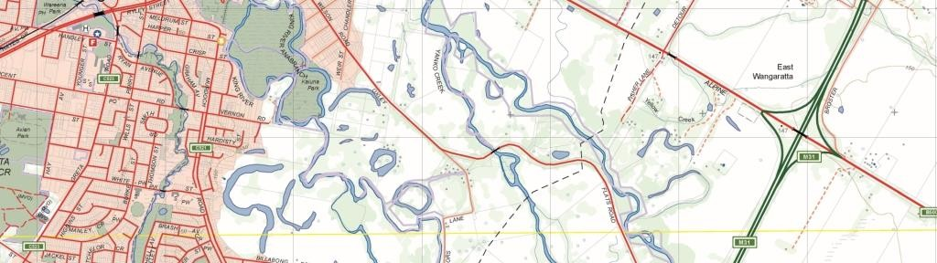

Vicmap Address

What is happening

A new attribute COMPLEX_SITE will be added to the Vicmap Address product. This attribute will identify addresses that are associated with complex sites ie retirement villages, caravan parks.
The valid attributes for these attributes are in the table below.

Attribute Name | Valid Attributes
COMPLEX_SITE | Y or N

Why this change is occurring
Vicmap Address - Complex Site
Not all complex sites are individually rated by Local Government and therefore these sites are assigned a single property and address. This has proven to be an issue for emergency dispatch. To satisfy the emergency service dispatch, individual complex site addresses have been captured through an internal project. Whilst this corrected the problem at a point in time no sustainable maintenance regime was put in place to keep it current.
Also, automation processes in the address maintenance process, have over written or retired these captured complex site addresses with the single LGA address information. Thus, undoing all the good work of the complex addressing project.
The addition of this attribute will enable the maintainer to flag that an address edit is trying to change a complex site address, instead of over writing the information. These flagged records will need to be verified as valid corrections prior to changes occurring.

Vicmap™ Product Development

Who will it affect?
This change will affect LGA’s as they will be required to verify that the complex address no longer exists and all users of Vicmap Address product will receive two extra attributes.

When the change will occur | How to provide feedback |

The change will be implemented into the full file supply of Vicmap Address on the 12/11/2019.
The change will be implemented into the Incremental Update format (IUF) file supply on the 14/02/2020 (to coincide with the IUF Seed file creation)

For Vicmap Product change notices and bulletins, go to the News and Bulletins page. For further information & feedback please email Vicmap.help@delwp.vic.gov.au

© The State of Victoria Department of Environment, Land, Water and Planning 2019  This work is licensed under a Creative Commons Attribution 4.0 International licence. You are free to re-use the work under that licence, on the condition that you credit the State of Victoria as  author. The licence does not apply to any images, photographs or branding, including the Victorian Coat of Arms, the Victorian Government logo and the Department of Environment, Land, Water and Planning (DELWP) logo. To view a copy of this licence, visit http://creativecommons.org/licenses/by/4.0/  Disclaimer  This publication may be of assistance to you but the State of Victoria and its employees do not guarantee that the publication is without flaw of any kind or is wholly appropriate for your particular purposes and therefore disclaims all liability for any error, loss or other consequence which may arise from you relying on any information in this publication. | Accessibility  If you would like to receive this publication in an alternative format, please telephone the DELWP Customer Service Centre on 136186, email customer.service@delwp.vic.gov.au, or via the National Relay Service on 133 677 www.relayservice.com.au. This document is also available on the internet at  www.delwp.vic.gov.au.

