|  |
| --- |
| Vicmap™ Product Development |
| Change Notice #253 Vicmap Elevation Advisory Notice |

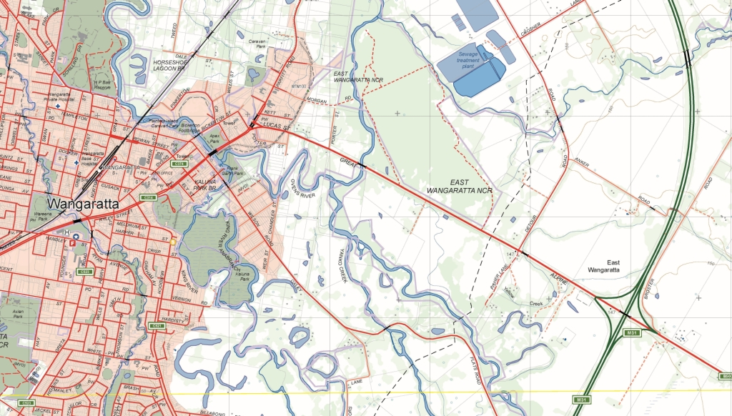

Vicmap Elevation

## What is happening

Several changes are occurring to modernise the Vicmap Elevation suite of products. There are:

* The Vicmap DTM 20M product is being retired, and
* The Vicmap DTM 10M has been significantly updated with new and revised content
* The Vicmap DTM 10M will be renamed Vicmap 10M DEM

## Why this change is occurring

The Vicmap DTM 20M is obsolete, and future maintenance and updating will only occur for the Vicmap DTM 10M dataset. The Vicmap DTM 20M will be archived and available on demand from Vicmap.

The Vicmap DTM 10M is updated at an ad-hoc basis with new content, as it becomes available.

The Vicmap DTM 10M is being renamed to Vicmap DEM 10M to align with more generic terminology used across other Australian jurisdictions, and to recognise that digital elevation models developed using the software product ANUDEM differ from digital terrain models (DTMs) due to their hydrologic enforcement.

## Who will it affect

This change will affect users of Vicmap Elevation.

## When the change will occur | How to provide feedback

The change will be implemented on the 01/10/2020.

For Vicmap Product change notices and bulletins, go to the [News and Bulletins](http://www.delwp.vic.gov.au/parks-forests-and-crown-land/spatial-data-and-resources/news-and-bulletins) page.

For further information & feedback please email [Vicmap.help@delwp.vic.gov.au](mailto:Vicmap.help@delwp.vic.gov.au)

|  |  |
| --- | --- |
| © The State of Victoria Department of Environment, Land, Water and Planning 2020  LogoThis work is licensed under a Creative Commons Attribution 4.0 International licence. You are free to re-use the work under that licence, on the condition that you credit the State of Victoria as author. The licence does not apply to any images, photographs or branding, including the Victorian Coat of Arms, the Victorian Government logo and the Department of Environment, Land, Water and Planning (DELWP) logo. To view a copy of this licence, visit http://creativecommons.org/licenses/by/4.0/  Disclaimer  This publication may be of assistance to you but the State of Victoria and its employees do not guarantee that the publication is without flaw of any kind or is wholly appropriate for your particular purposes and therefore disclaims all liability for any error, loss or other consequence which may arise from you relying on any information in this publication. | Accessibility  If you would like to receive this publication in an alternative format, please telephone the DELWP Customer Service Centre on 136186, email [customer.service@delwp.vic.gov.au](mailto:customer.service@delwp.vic.gov.au), or via the National Relay Service on 133 677 [www.relayservice.com.au](http://www.relayservice.com.au). This document is also available on the internet at [www.delwp.vic.gov.au](http://www.delwp.vic.gov.au). |

Keep all content above this instruction text line. Delete only when document formatting is complete.