Vicmap Elevation LiDAR DEMs Collection

Product Description

Document History
Version | Date | Note
0.0 | November 2022 | First Draft – DEM description transferred from Vicmap Elevation Multi-resolution DEM and Contours.
1.0 | February 2023 | Content updated to reflect coverage status as of January 2023, MOG changes to DTP and clearer License and Access sections. First version ready for review and potential release.
2.0 | March 2023 | Adoption of DTP template and badging.
This document has been formatted and structured as an adaptation to AS/NZS ISO 19131:2008 Geographic Information – Data product specifications.

Table of Contents
Document History 1
Table of Contents 2
List of Figures 3
List of Tables 3
Overview 4
Vicmap™ 4
Data Product Specification Title 4
Informal Description of the Data Product 4
Related VicmapTM Elevation Products 4
Responsible Party 4
Internet Site for Information 4
Specification Scope 5
Level 5
Extent & Coverage 5
Data Product Identification 6
Title 6
Alternative Title 6
Spatial Representation Type 6
Spatial Resolution 6
Data Content and Structure 7
Data Content 7
Data Model 7
Data Type 7
Data Structure 7
Reference Systems 8
Horizontal Datum 8
Projection 8
Vertical Datum 8
Data Capture 8
Production Methods 9
Data Quality 10
Accuracy 10
Completeness 11
Logical Consistency 11
Data Maintenance 12
Data Product Delivery 12
Licensing 12
Access 12
Metadata 13
Follower pages 16

List of Figures
Figure 1: Vicmap LiDAR DEMs Collection Coverage 5
Figure 2: Bridge exclusion from DEM surface 9
Figure 3: Hydro flattened rivers and water bodies 10
Figure 4: Mosaic footprints - Kilmore DEM dataset 13

List of Tables
Table 1: Vicmap LiDAR DEMs content summary 7
Table 2: Access points for Vicmap LiDAR DEMs datasets 12
Table 3: Data file names - Kilmore DEM dataset 14

Overview

Vicmap™
Vicmap™ is the foundation that underlies most spatial information in Victoria. This portfolio of spatially related authoritative data products, comprising individual datasets, is developed, and managed by the Department of Transport and Planning. The information provides the foundation to Victoria’s primary mapping and spatial information systems and is used for building business information and systems.

Vicmap is a registered trademark of the Victorian Government and has been synonymous with authoritative state-wide mapping since 1975.

Vicmap Catalog

Data Product Specification Title
Vicmap™ LiDAR DEMs Collection

Topic Theme
Elevation

Topic Category
Elevation Surface

Informal Description of the Data Product
Vicmap Elevation LiDAR DEMs is a collection of DEM data sets derived from LiDAR projects undertaken by the Coordinated Imagery Program (CIP) since the mid 2000’s. The Vicmap Elevation – LiDAR DEMs Collection is closely associated with the Vicmap Elevation – LiDAR Points Collection as each DEM is paired with a source point cloud data set. By virtue of its collection history, the DEM datasets vary in resolution and accuracy, with each of these generally improving in more recent years.

Related VicmapTM Elevation Products
VicmapTM Elevation – LiDAR Points Collection
VicmapTM Elevation – 1m DEM Web Services

Responsible Party
Vicmap Spatial Services Branch
Department of Transport and Planning
PO Box 527, Melbourne VIC 3001 Australia
vicmap.help@delwp.vic.gov.au

Internet Site for Information
Vicmap Elevation

Specification Scope
This specification describes the Vicmap Elevation LiDAR DEMs product, which is a collection of DEM datasets of varying currency, resolution and accuracy derived from LiDAR surveys undertaken by the State through the Coordinated Imagery Program (CIP). The information provided describes the nature of the collection as well as some of the fundamental and common characteristics of the DEM datasets that constitute the collection.

Level
Product

Extent & Coverage
As of January 2023, the Vicmap LiDAR DEMs Collection covers approximately 60% of the States land area and achieves coverage of over 99% of the States populated areas. Data acquisition is driven by purchase partner investment through the Coordinated Imagery Program (CIP) and as such, some areas have remained unsurveyed by LiDAR. Conversely, some parts of the State have also been surveyed multiple times where investment funding has been driven by monitoring and change analysis requirements. The 40% not covered by LiDAR survey represents the unpopulated regions of the State including the National Parks and State Forests of the Great Dividing Range and the western plains desert and cropping country.
Figure 1: Vicmap LiDAR DEMs Collection Coverage
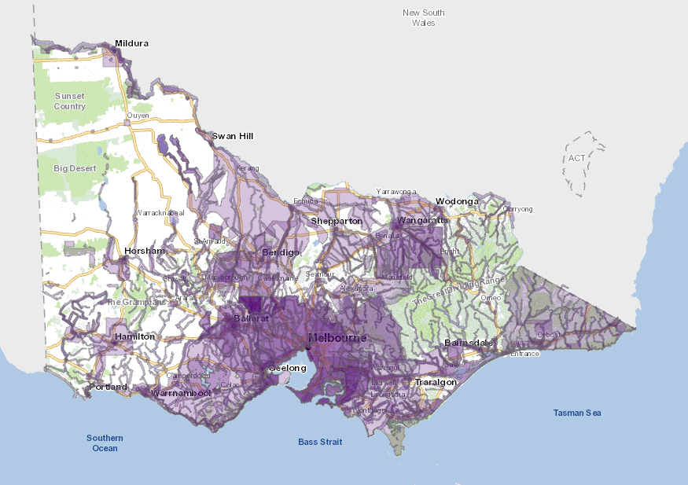
Vist the CIP website for current extent and coverage: Vicmap Imagery & Elevation Coverage

Data Product Identification

Title
Vicmap Elevation LiDAR DEMs Collection

Alternative Title
Vicmap LiDAR DEMs Collection
Vicmap LiDAR DEMs

Spatial Representation Type
Raster data

Spatial Resolution
Ranging from 50cm to 5m

Abstract
The Vicmap Elevation LiDAR DEMs Collection is a compilation of LiDAR derived ground surface models produced from purpose specific LiDAR surveys undertaken through the States Coordinated Imagery Program (CIP) since 2007. It represents the most comprehensive and extensive archive of LiDAR derived DEMs for the State of Victoria.
Typically, datasets within the collection vary in resolution and accuracy but all adhere to evolving, standardised DEM specifications that were reflective of the requirements and technical capability at the time of survey.
Consistent throughout the evolving DEM standard has been the AHD vertical datum and hydro flattening of water bodies and large rivers, as well as the exclusion of rail and road bridges from the DEM surface. Horizontal datum and data formats have changed over time, but these have been, or can be transferred to newer standards as required.
Each DEM dataset has been verified against the designated standard of the time through rigorous QA/QC validation processes implemented within the CIP program. Included in the validation processes are confirmation of individual DEM dataset vertical accuracy and vertical alignment between adjacent DEM surfaces within their vertical accuracy tolerances.
DEM datasets within the collection have not been hydro enforced. Although containing hydro flattened water bodies and rivers, the surfaces have not been edited to ensure that correct water drainage occurs within each DEM dataset, or across DEM datasets. Achieving this state would require specific hydro-enforcement treatment.

Data Content and Structure

Data Content
As of January 2023, the LiDAR DEMs collection contains over 300 DEM datasets, where each dataset represents a single, contiguous area. Depending on the original survey, multiple datasets may have come from the same sourcing project. For example, a 2019 regional towns LiDAR survey generated several DEM datasets each representing a spatially explicit township coverage.
Importantly, the LiDAR DEMs collection continues to expand as new LiDAR surveys continue to be undertaken. New surveys may represent an extension of the existing available coverage, or they may represent repeat coverage of an area previously surveyed. In each case, the LiDAR DEMs collection will continue to expand and deepen in content.

Table 1: Vicmap LiDAR DEMs content summary
Source | Aerial LiDAR survey
Resolution | Ranging from 50cm to 5m
Currency | Ranging from 2007 to present
Vertical Accuracy | Ranging from +/- 50cm RMSE to +/-10cm RMSE
Horizontal Datum | Ranging from GDA94 to GDA2020
Vertical Datum | AHD
Data Format | Ranging from ESRI Ascii GRID to Cloud Optimised GeoTIFF
Coordinates | Ranging from GDA94 zone 54 and 55 to GDA2020 zone 54 and 55
Coverage | 60% of Victoria

Data Model
The Vicmap Elevation LiDAR DEMs represent bare earth ground surface models as raster (or gridded) data. The file format in which the rasters are stored determines the data model, and this has evolved over time according to available technology and prevailing data standards at the time of survey.
The format used for early datasets in the collection was ESRI ASCII Grid whilst more recently acquired datasets are stored as Cloud Optimised GeoTIFF (COG).
Conformity has been sought with existing ANZLIC and international standards and specifications. However, the nature and age profile of the collection means there are instances where datasets exhibit variant surface model characteristics.

Data Type
32-bit gridded/raster floating point data with 2 decimal point precision.

Data Structure
DEM datasets are assembled and archived in pre-defined tile sets and are also mosaiced to form a single file version of the data.
Each dataset will be available in one of the following tile indices: 500m, 1km or 2km with one file per tile. Tile indices are created on MGA coordinates aligned to 100m or 1000m easting and northing intervals. As raster data, the origin cell of each DEM file neatly aligns with the tile index origin at these intervals. File naming of each data file reflects the easting and northing dataset origin, as well as acquisition date and other key metadata elements for the file.

Data Voids
Data voids are not present within the bounds of each DEM dataset. Any void areas outside of the DEM bounds but within the relevant tiling scheme are coded with a “NODATA” value of -9999. In general, older LiDAR surveys were captured to irregular project boundaries which did result in void areas of this type. More recent LiDAR surveys have been captured to tile-based projects leaving no void area within the LiDAR DEM tile.

Reference Systems

Horizontal Datum
Vicmap LiDAR DEMs are aligned to the Geocentric Datum of Australia (GDA) officially in use at the time of survey.

LiDAR DEMs generated up to and including 2019 are aligned to GDA94 and DEMs generated since 2020 are aligned to GDA2020.

Projection
LiDAR DEMs are projected to MGA zones 54 or 55 for both GDA datums.

Vertical Datum
Vicmap Elevation LiDAR DEMs are modelled to the Australian Height Datum (AHD) using the Ausgeoid model that was officially in use at the time of survey.

Dataset specific Reference System details are recorded with each DEM data file.

Data Capture
Vicmap LiDAR DEMs derive from LiDAR survey projects undertaken through the States Coordinated Imagery Program (CIP). LiDAR surveys are conducted on behalf of the State by commercial aerial survey companies that have qualified for the relevant State services panels.
Acquisition planning is driven by purchase partner investment in the CIP program and is implemented in an on-demand basis. Aerial survey most often occurs as a single project achievable within one flying season by a single commercial supplier. As investment and funding allows, larger capture programs may occur that span multiple flying seasons and require multiple commercial suppliers to complete.
LiDAR survey within Victoria is achievable throughout the whole calendar year, however most data capture has been conducted during the spring, summer, and autumn seasons (November through to May).

Production Methods

Vicmap LiDAR DEMs are constructed from LiDAR points classified as “ground”. The model defines a “bare earth” ground surface and is devoid of trees and human-made structures. In summary terms, the DEM generation approach employs a Point to TIN and TIN to Raster process with Natural Neighbour interpolation.

The surface models exclude road and rail bridges as well as major culverts. If these features were incorrectly classified as LiDAR ground points and automatically included in the DEM, they are subsequently edited out of the model in a manner that ensures the underlaying terrain is continuous and not left as a gap or void in the surface.

Figure 2: Bridge exclusion from DEM surface
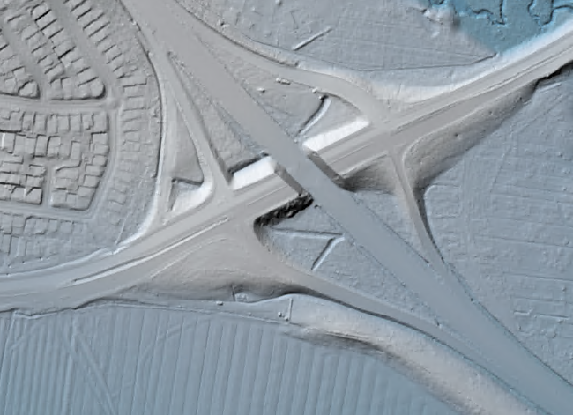
Non tidal water bodies with a surface area in excess of 625m² and major rivers with mean width greater than 30m are represented as flat surfaces within the DEM. Various approaches to hydro flattening have been employed, however all approaches have been based on using the lowest surrounding land elevation values to set the height of the flattened water surface. The result is that the entire water-surface edge is at, or below the immediately surrounding terrain.

Figure 3: Hydro flattened rivers and water bodies
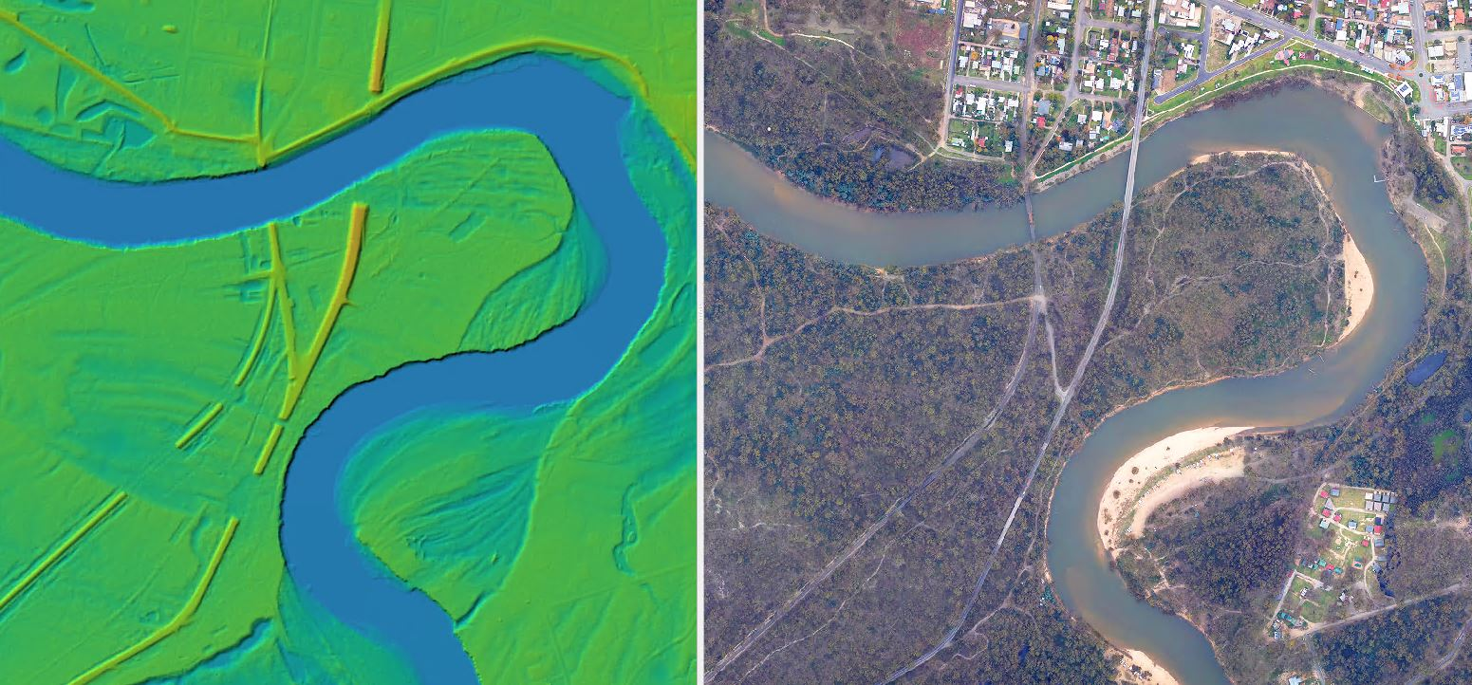

Data Quality
The aspect of data quality for the LiDAR DEMs collection will vary according to the LiDAR survey specifications and to some extent, the age and date of the source LiDAR survey. In all cases, the LiDAR Point and DEM data products have been verified as meeting the designated specifications for the survey.

Accuracy

Horizontal Accuracy
Greater than or equal to +/- 30cm RMSE

All LiDAR surveys from which the LiDAR DEM datasets are derived are rated at +/-30cm RMSE horizontal accuracy. Greater horizontal accuracies are now achievable and have been demonstrated in the more recent LiDAR surveys that have contributed LiDAR DEM datasets.

Vertical Accuracy
Ranging between +/- 10cm RMSE and +/- 50cm RMSE

Vertical accuracy has historically been a commonly varied LiDAR survey specification. Within the LiDAR DEMs collection, vertical accuracy ranges from +/-50cm RMSE for some of the older datasets to +/-10cm for later datasets. The increase in vertical accuracy is due to improved sensor technology as well as better positioning and aerial survey inertial management technology.

Spatial Data Integrity
Vicmap Elevation LiDAR DEMs are most correct when used in their native datums and projections. Transforming and reprojecting DEMs may alter and reduce the fidelity of the elevation values for the transformed or reprojected coordinate.

Geoid Models
The representation of DEM elevations on AHD is affected by the quality of the Geoid Model used to transform the original ellipsoidal elevation. Older DEM datasets in the collection have been modelled to AHD using different geoid model versions including Ausgeoid94, Ausgeoid09 and presently, Ausgeoid2020. For more recent LiDAR DEMs, gradual improvements in each of the new geoid models has resulted in better modelling to AHD.

Edge Matching
Although not possible to guarantee, DEM datasets in the collection should vertically align with adjacent and overlapping DEMs within the degree of their respective vertical tolerances or accuracies. Older DEMs are less likely to agree with newer DEMs and this is due to the reasons described in the Vertical Accuracy section. Since the advent of GDA2020 and the Ausgeoid2020 model for AHD, the State has introduced the practise of supplying survey control to its commercial aerial survey contractors. This strategy allows the State to ensure consistently high accuracy, high-quality ground control data is used across all LiDAR surveys, and this has resulted in excellent vertical alignment across LiDAR surveys conducted by different contractors.

Completeness
The LiDAR DEM datasets are complete for their respective project areas of interest, are in the correct formats and are free of file corruption.

Logical Consistency
The LiDAR DEM datasets are all consistent in their data representation of AHD. As described, variations exist in resolution and vertical accuracy. Additionally, there will be variation in the degree to which older datasets have been hydro flattened and bridges treated, as surface modelling improvements have evolved over time.

Data Maintenance
The Vicmap LiDAR DEMs collection is continuously growing with each successful airborne LiDAR survey undertaken by the Coordinated Imagery Program (CIP). Data maintenance will continue to be conducted in a manner that services the requirements of the investing purchase partners. For the near future, acquisition planning will be driven by those agencies that fund LiDAR surveys for their project purposes.

Data Product Delivery

Licensing
Vicmap Elevation LiDAR DEMs are subject to licensed use. Data Access License Agreements (DALA) are used to provide the terms and conditions of use, including license fees determined by the coverage and extent of the data purchased.

Commercial use licenses may also be negotiated with businesses wishing to become a licensed Value-Added Reseller (VAR) or licensed Data Service Provider (DSP).

VARs and DSPs offer data ordering and sale services for Vicmap LIDAR DEM datasets.

Access
Table 2: Access points for Vicmap LiDAR DEMs datasets
Discover Data
Vicmap Imagery & Elevation Coverage | The collection of Vicmap LiDAR Points datasets can be discovered on the Vicmap Imagery & Elevation Coverage map. This interactive web map supports spatial search and query of available Vicmap LiDAR DEMs as well as Vicmap LiDAR Points and Vicmap Imagery. Using search results, data can be ordered through the VAR & DSP network.
DataShare | DataShare is a DEECA hosted website for text searching both licensed and open spatial data resources held by participating State agencies. Metadata on available Vicmap LiDAR DEM datasets can be discovered on this site, however data can only be ordered through the VAR & DSP network.
Order Data
VAR & DSP Network | Licensed value-added resellers and data service providers can provide data search and sale services for Vicmap LiDAR DEMs. Data access license agreements are provided with purchased data.
ELVIS | In exceptional cases, some project specific Vicmap LiDAR DEM datasets are available under Creative Commons by Attribution 4.0 Australia license (CCB4). These can be discovered and downloaded directly from the ELVIS platform provided by Geoscience Australia.

Metadata
There are four levels of metadata available in relation to the Vicmap LiDAR DEMs Collection.

- Product description
This document describes the Vicmap LiDAR DEMs Collection as a collated archive of LiDAR derived DEM datasets. This high-level summary identifies the range and variety of content in the collection.

- DEM dataset metadata
Metadata, based on an early version of the ISO 19115-2 schema for imagery and gridded data, is also described for each DEM dataset in the collection and can be accessed via DataShare or via the VAR & DSP Network.

- DEM dataset spatial footprints
Paired with each DEM dataset description are dual spatial metadata or “footprint” records that represent (1) the explicit external data boundary (also referred to as the mosaic footprint) and (2) the internal data tiling schema for each dataset. Associated with each mosaic footprint is a summary of key dataset specific data attributes. Dataset boundaries are used to support spatial search and discovery tools such as those on the Vicmap Imagery & Elevation Coverage web map.
Figure 4: Mosaic footprints - Kilmore DEM dataset
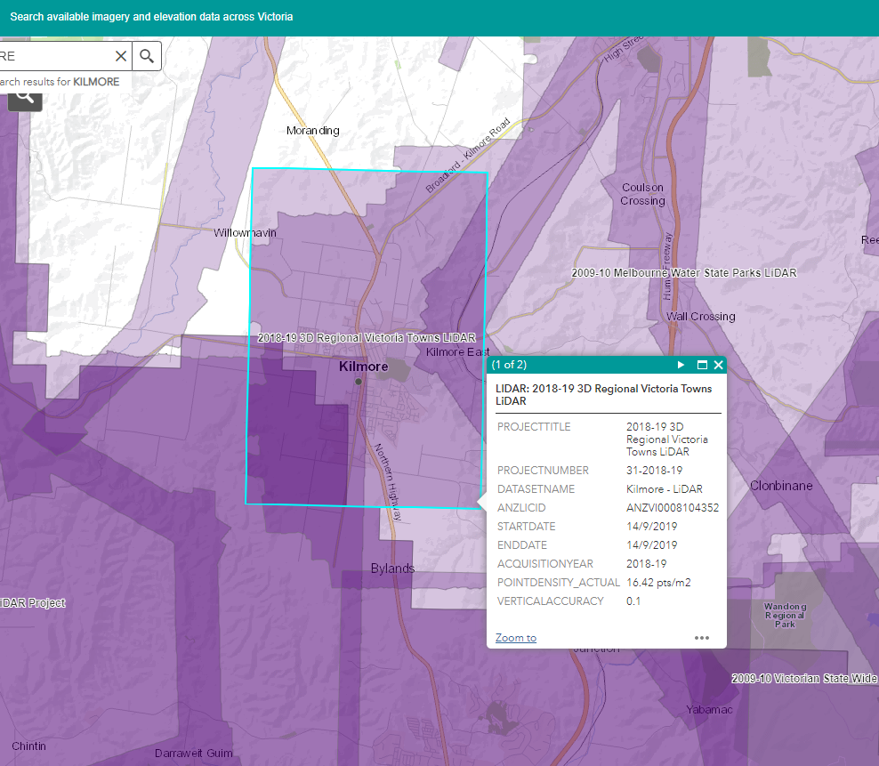

- DEM dataset filename

A standardised data file naming convention has been used to convey key metadata features for each DEM data file.

<name>_<project>_<start date>_<product><resolution>_v<vertical accuracy>_<h-projection>.<extension>

Table 3: Data file names - Kilmore DEM dataset
Single tile data file | e315n5866_kilmore_2019sep14_dem1m_v10cm_epsg7855.tif
Dataset mosaic data file | kilmore_2019sep14_dem1m_v10cm_epsg7855.tif

