November 2024

Guide to creating restrictions in plans

This is a guide to creating restrictions in plans under the *Subdivision Act 1988 (Subdivision Act)*. It incorporates the updated requirements set out in Registrar’s requirements for paper conveyancing transactions version 9 (Registrar’s Requirements).  
  
Note: *examples of the information denoted with * are included in the example plans that follow.*

# Requirements

Requirement 12 of the Registrar’s Requirements came into effect on 14 December 2017 and sets out the requirements for creating restrictions in plans (and restrictive covenants in transfers).

Any plan first signed by the Licensed Surveyor on or after 1 July 2018 must set out the details of a restriction in:

* an MCP(s)
* by reference to a planning permit and/or
* in short form on a single sheet of the plan.

A plan creating a restriction first signed by the Licensed Surveyor on or before 3 March 2024 must comply with Schedule 6 of Version 8 of the Registrar’s Requirements.

A plan creating a restriction first signed by the Licensed Surveyor on or after 4 March 2024 must comply with Schedule 6 of Version 9 (and subsequent versions) of the Registrar’s Requirements.

# 1. Drafting Standards

# Font size must be no smaller than 2.5mm.

# 2. Single sheet

The details of any restriction to be created in a plan must be set out on no more than one sheet of the plan:

1. The single sheet limitation includes the text that outlines the details of the restriction, including any diagrams.
2. The restriction may be set out either in the notations panel on sheet 1 of the plan or on the last sheet of the plan. The restriction cannot be set out in both locations.
3. If a table is used to set out the burdened and benefited land, the table may exceed a single sheet (see Example 5 below).

# 3. Heading*

The heading ‘Creation of Restriction’ must be included before the operative wording and details/description of the

restriction.

# 4. Operative wording*

The formal words by which the restriction is created as set out in Schedule 6 of the [Registrar's Requirements](https://www.land.vic.gov.au/land-registration/publications#:~:text=Business%20Activity%20Reports-,Registrar%27s%20Requirements%20for%20Paper%20Conveyancing%20Transactions,-On%2021%20February) must be included.

When there are multiple covenants in the creation of restriction, the operative wording must be included **once** only

under the heading ‘Creation of Restriction’.

# 5. Multiple covenants within a restriction*

When a restriction created contains two or more covenants, the covenants should be sequentially labelled (for example, ‘Restriction A’, ‘Restriction B’).

If each covenant applies to different lots/parcels in the plan, the land to be burdened and benefited may be set out under each labelled covenant.

The details of any restriction to be created must be set out on a single sheet only, including when there are multiple covenants within a restriction (see point 2 above).

Two or more covenants which can be reduced into a single covenant will be requisitioned.

# 6. Burdened Land*

The land in the plan to be burdened by the restriction must be set out. For example:

*Burdened Land: Lot(s) [ no.] on this plan*   
and/or   
*Common Property [no.] on this plan*

Note: *Common property can only be burdened by a restriction in its own right. Any restriction which appears to relate to or affect a lot owner’s share in the common property will not be recorded on the folio of the Register for the common property.*

It is not acceptable to burden roads and/or reserves in a plan.

# 7. Benefited Land*

The land that benefits from the restriction must be set out. This can be lot(s)/parcel(s) on the plan or land outside the plan. For example:

*Benefited Land: Lot(s) [ no.] on this plan*   
and/or

*Common Property / Road / Reserve [no.] on this plan*

and/or   
*Lot(s) [ no.]/ [parcel identifier] on [Plan number]*

Note: *Any description that requires interpretation such as “relevant abutting lot” or “lots that share a common abuttal with Main Street” is not acceptable.*

# 8. Burdened and Benefited land table*

A table which complies with the form shown in Schedule 6 of the [Registrar's Requirements](https://www.land.vic.gov.au/land-registration/publications#:~:text=Business%20Activity%20Reports-,Registrar%27s%20Requirements%20for%20Paper%20Conveyancing%20Transactions,-On%2021%20February) may be used to set out the burdened and benefited land for the restriction.

A table is recommended when the benefited land differs depending on which land is burdened under the restriction.

# 9. Details of the Restriction*

Details of how the burdened land cannot be used must be set out. For example, the covenant may:

* 1. refer to the Planning Permit
     + The planning permit number must be set out.

[and/or]

* 1. refer to the provisions in a Memorandum of Common Provisions (MCP) that has been lodged and retained by the Registrar of Titles
     + The MCP number must be set out in the details of the restriction.
     + The restriction may refer to specific clause(s) in the MCP that apply to the burdened land.
     + When the MCP number is unknown at the time of certification of the plan, the plan will be requisitioned for the addition of this number. If the plan is requisitioned for this reason, consent of council will be required.
     + To ensure the timely recording of an MCP, the correct MCP form must be used [the forms can be found through [Fees, Guides and Forms](https://www.land.vic.gov.au/land-registration/fees-guides-and-forms) as available on the land.vic.gov.au website]

[and/or]

* 1. describe the restriction
     + Set out the details including all provisions, terms, conditions, clauses, covenants etc. The details must not repeat any requirements set out in a planning permit or an MCP.
     + The details must adhere to the single sheet requirement (see point 2).

# 10. Diagrams

The details of the restriction may include diagrams; however, these must adhere to the single sheet requirement (see point 2 above).

Diagrams related to restrictions are to be separate from the diagrams that define parcel boundaries in the plan.

# 11. Negative covenants only

Restrictions must be **negative** in nature i.e. they must set out how the land cannot be used. Positive covenants are **not acceptable**.

The suggested wording is:

‘*The registered proprietor of the burdened land must not…*’

As a general principle, a restriction is considered negative in nature if the registered proprietor of the burdened land does nothing and the restriction is not breached. Positive covenants require something to be done or money to be expended.

# 12. Restricts use of the burdened land only

A restriction must relate to **use of the burdened land.**

It cannot oblige the registered proprietor of the burdened land to complete, or refrain from completing, activities on land other than the burdened land, including on common property, roads, or reserves.

# 13. Expiry date*

An expiry date must be provided. For example, the expiry date may state:

1. a specified date;
2. not applicable.

When a restriction created contains two or more covenants, and all covenants have a specified expiry date, the latest expiry date will be recorded on the folio of the register.

When a restriction created contains two or more covenants, and one or more of those covenants states the expiry date is ‘not applicable’, no expiry date will be recorded on the folio of the register.   
  
For plans under section 37 of the Subdivision Act, no expiry dates will be recorded on the folio of the Register.

# 14. Plans under sections 32 and 37 of the Subdivision Act

When creating restrictions in plans under sections 32 or 37 of the Subdivision Act, the burdened and benefited land must be clearly identified. ‘Lots on this plan’ will mean the lots created in **the plan** under section 32 or the specific stage under section 37.   
  
When compiling the amended/master plan, any substituted sheets must set out the specific burdened and benefited lot(s)/parcel(s) in the plan under section 32 or specific stage under section 37 (see points 6and 7 above).  
  
Note: Where a staged lot (i.e. lot S2) is burdened or benefited by a restriction, issues can arise in the subsequent stage plan that develops the burdened stage lot. Be mindful when supplying any substituted sheets for the master plan. Refer to [Example 11: Section 37 staged plans](https://www.land.vic.gov.au/land-registration/for-professionals/understanding-plans-of-subdivision-and-consolidation#:~:text=Example%2011%3A%20Section%2037%20staged%20plans), on the Land.vic.gov.au website, for more information on preparing staged plans under section 37 of the Subdivision Act.

# 15. Examples

Examples 1 to 5 illustrate typical ways to drafting creation of restrictions in plans under the Subdivision Act. These examples intend to give context to items outlined above. To assist, each aspect in the examples is indicated by a blue speech bubble with the corresponding item number.

# Example 1: Short form creation of restriction under Notations

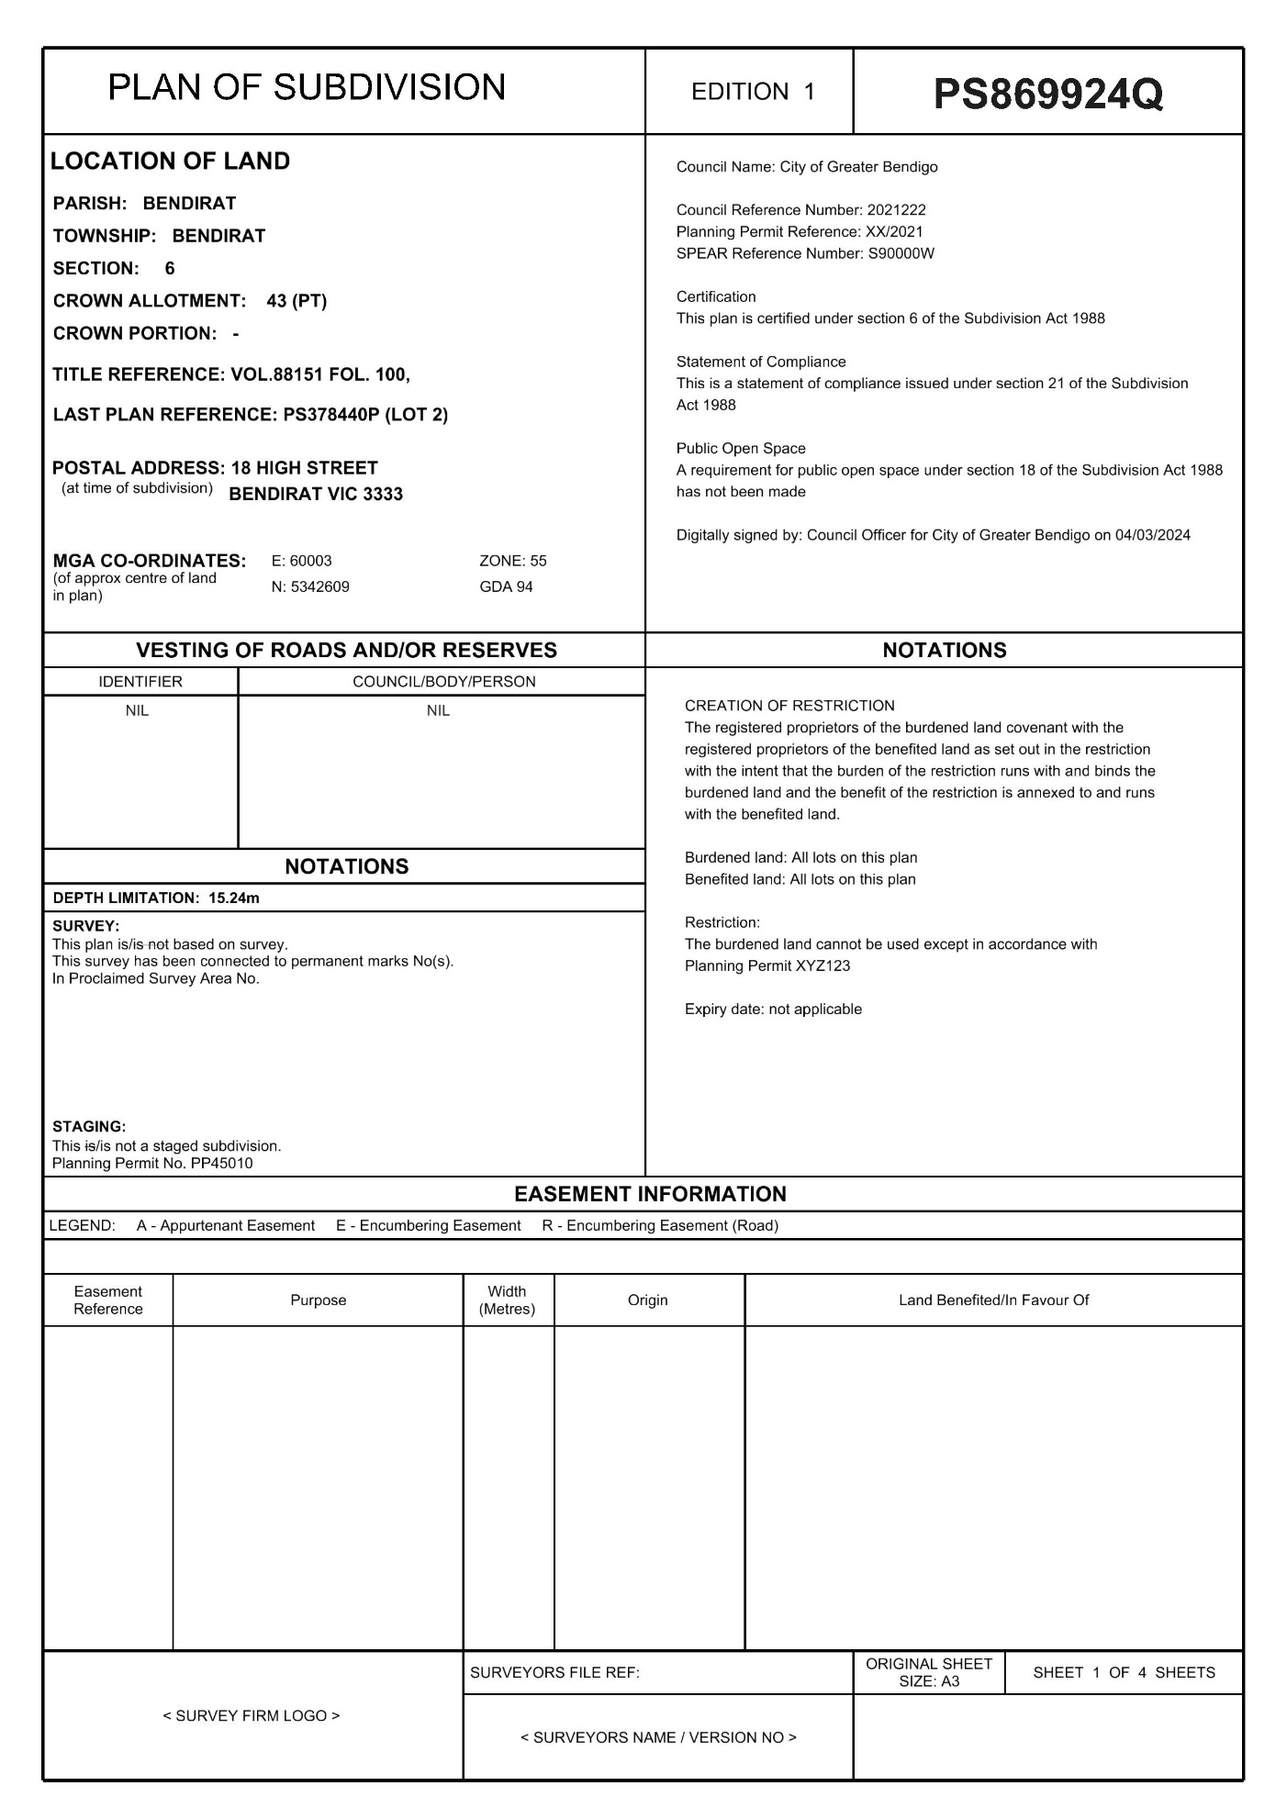

2b

4

3

6&7

9a

13

# Example 2: Creation of more than one covenant on one sheet of the plan including use of a burdened and benefited land in a table

3

4

5

6&7

9a

13

5

9c

6&7

13

5

8

9b

13

12

# Example 3: Creation of restriction including diagram

5

13

9a

5

4

10

3

8

9c

13

# Example 4: Burdened and benefited land set out in a table and benefits land outside the Plan

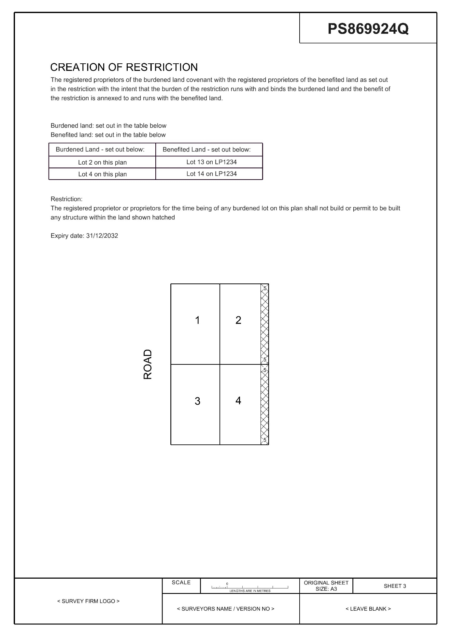

3

4

8

9c

13

# Example 5: Burdened and benefited land set out in a table (exceeding a single sheet)

2c

Need more information?

Find out more about the government’s initiatives at **dtp.vic.gov.au**

