|  |
| --- |
| Guide to a request to waive survey  for an adverse possession application |
|  |

This guide sets out the requirements to lodge a Request to waive survey for an adverse possession application, under sections 15 or 60 of the Transfer of Land Act 1958.

A survey can only be waived in cases in which all the boundaries of the land claimed are previously known to Land Use Victoria i.e., whole transferable parcels, not part(s) of parcels.

If the application is for a whole transferable parcel based on possession, an aerial photograph may be used in place of a survey plan.

Waive Survey (WS) applications are typically only appropriate for rural areas.

Please read this guide in conjunction with the adverse possession guides on the website.

# Documents required by Land Use Victoria

## Request to waive survey for an adverse possession application

The *Request to waive survey for an adverse possession application* form must be fully completed and signed.   
This form is available at [Homepage (land.vic.gov.au)](https://www.land.vic.gov.au/home).

## Certificate(s) of Title

Certificate(s) of Title are not required.

## Acquiring an aerial photograph of the land claimed

The applicant must acquire an aerial photograph of the land being claimed and the surrounding area. Photographs can be purchased through a commercial supplier of aerial photographs. **Photographs taken from Google Maps, Nearmap, or other similar applications and drones are unacceptable.**

The photograph must be taken vertically – oblique photographs are not suitable. The most recent photograph is normally required, and it should disclose that the land subject to the proposed application is occupied to the exclusion of all other parties.

The photograph must:

* be of good quality and at a resolution that enables features to be easily identified
* be from a reliable source – while some councils provide aerial photographs the applicant must ensure they are of a satisfactory quality.
* show the date the photograph was taken. The photograph must be taken less than two years before the lodgement date.
* show a nominal scale.

A further photograph of the land as it was 30 or more years ago may also be a useful exhibit in some cases.

Please supply **two** copies of the aerial photograph. One should be without annotations; mark the occupation on the second. The last page of this guide has an example of each.

## Covering letter

A covering letter must accompany this form and address the following points:

* if other land is included in the enclosure
* the type of occupation (example; fencing) surrounding the enclosure on all sides
* the adjoining property owners of the enclosure on all sides.

# Additional information

## When the Registrar consents to waive survey

If the Registrar consents to waive the survey requirement, the photographs are then used to prepare the adverse possession evidence lodged with the *Adverse possession* form. The applicant makes an application for title based on possession in the usual way.

See below ‘Preparation of evidence’.

## The Registrar may waive the survey subject to the submission of additional information

If the land claimed is not readily identifiable or the enclosing occupation is unclear or obscured, ground photographs clarifying the situation may be helpful. These photographs should be clearly identified and some method of indicating their location should be provided (e.g., sketch plan etc.). In some circumstances the Registrar may require other information such as statutory declarations from abutting parties. See below ‘Preparation of evidence’.

## The request to waive survey is rejected

If the aerial photograph and any additional information is insufficient to support the applicant's application, the Registrar will refuse the request to waive survey. The applicant will then need to obtain a plan and other survey documents prepared by a licensed surveyor to support their application.

## Preparation of evidence

If the waiver is approved the following processes should be followed.

* The aerial photograph marked to show the occupation should be exhibited as part of the statutory declarations, in the same way a plan of survey is exhibited. It should be noted that the photographs should show the total land in the possession of the applicant (as any plan of survey would). That is, the total land in the enclosure, although the applicant may not be claiming all of it.
* The type and apparent age of fences and other forms of boundary demarcation are normally noted on a plan of survey and referred to in the Surveyor's Report. It is important that this information is provided in evidence when there is no survey. It is acceptable to show the type of fences or other demarcation by exhibiting a photograph of it.
* When describing the land in a subsequent adverse possession form or lawyer's certificate, in addition to the Crown description and the title reference, the following statement should also be added: ‘and being the possessory land identified in the request to waive survey WS No ….’
* Evidence the request to waive survey has been granted is usually by the inclusion of a copy of the confirming letter, issued when the waive survey request is approved. It should be provided with the other documents when the *Adverse possession* form is lodged at Land Use Victoria. At that time further documentation will be needed to satisfy all other criteria concerning supporting evidence.

# Fees

Land Use Victoria fees are payable at lodgement.

# How to complete the application form

The *Request to waive survey for an adverse possession application* form should be completed for lodgement.

If the form is being completed manually rather than online:

* the writing must be clear and legible, and in BLOCK LETTERS
* only use black or blue pen
* correction fluid must not be used
* the back of the form must not be used.

# The points below assist in completing the application

## Lodged by

This section is to be completed by the party lodging of the application at Land Use Victoria.

Please insert the following:

* name, telephone number, current email address and postal address for contact details or for the return of any documents
* customer reference and your Land Use Victoria customer code (if applicable).

## Land

Please insert the following:

* Folio reference (e.g., Volume 8756 Folio 123) and the relevant crown description or lot on plan reference; or
* General Law – memorial reference (e.g., Book.456 No.124) and the relevant crown description or lot on plan reference.

Aerial photographs must accompany this form.

## Applicant

Insert the full name(s) and street address(es) of the applicant(s).

Please note that a ‘care of’ or ‘post office box’ is not an acceptable address.

## Date

Insert the date the form is signed by the applicant, e.g., DD/MM/YYYY.

## Signature of applicant

The form must be signed by the applicant(s), a lawyer, or an agent of the applicant.

Signature requirements are:

* applicant signs – no witness required
* signature of an Australian legal practitioner (under the Legal Profession Uniform Law Victoria) – full name and address must be given
* signature of an agent – letter of agency must be supplied.

Note: Section 4(3)(c) of the *Conveyancers Act 2006* excludes a licensed conveyancer from signing an application form for an order under section 60 of the Transfer of Land Act(adverse possession applications).

# How to complete the application when lodged through SPEAR

The following apply specifically to applications lodged through SPEAR.

## Land

The Volume and Folio are mandatory; a waive survey application for General Law land can only be submitted through SPEAR if the land has a provisional folio.

Any additional description is optional.

# Lodging at Land Use Victoria

The applicant should write to the Registrar of Titles using the *Request to waive survey for an adverse possession application*, requesting that the survey be waived, and enclosed aerial photographs be accepted in place of survey documents for an adverse possession application. This should be done before making a formal application for title, since the request to waive survey may not be successful and survey documents may then be required.

Waive Survey (WS) applications should be lodged through an ELN. In PEXA, they are lodged as generic residual documents.

# Further information

Additional information on adverse possession is available at [Homepage (land.vic.gov.au)](https://www.land.vic.gov.au/home)

# Contact us

Click here for [location and contact details](https://www.land.vic.gov.au/contact-us).

# Example 1: Aerial Photograph without annotations

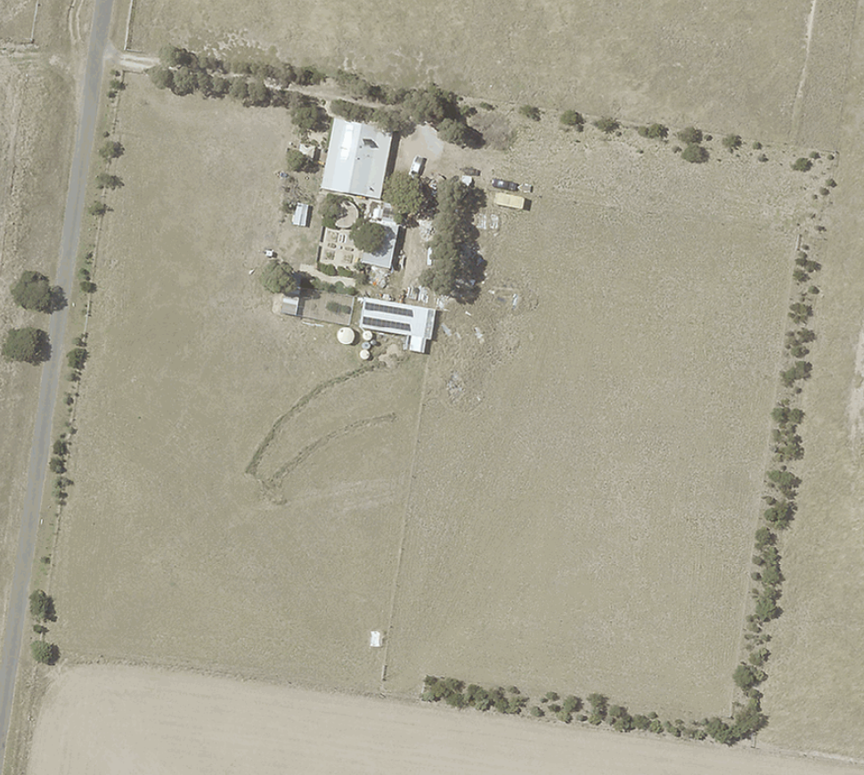

# Example 2: Aerial Photograph with occupation marked

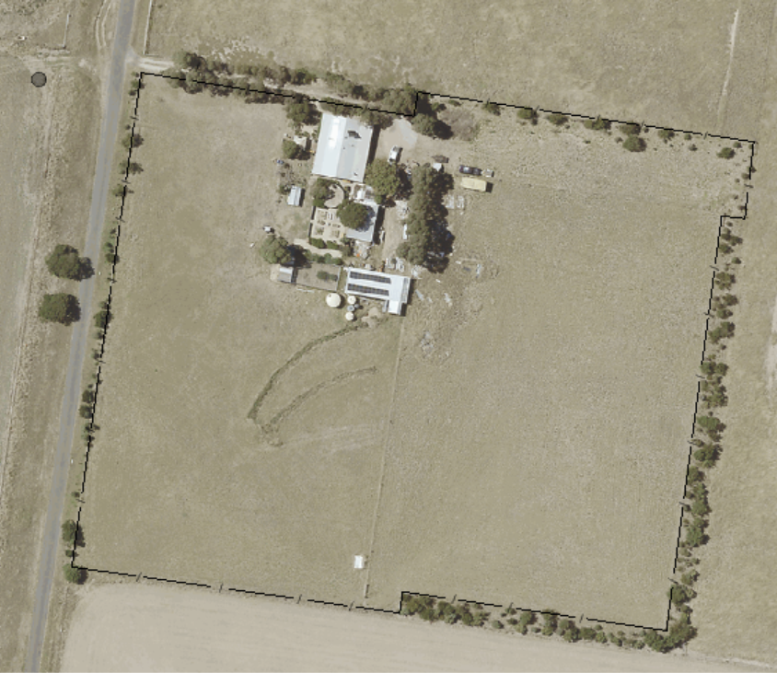

|  |  |
| --- | --- |
| © The State of Victoria Department of Environment, Land, Water and  Planning 2022  byThis work is licensed under a [Creative Commons Attribution 4.0 International licence](http://creativecommons.org/licenses/by/4.0/). You are free to re-use the work under that licence, on the condition that you credit the State of Victoria as author. The licence does not apply to any images, photographs or branding, including the Victorian Coat of Arms, the Victorian Government logo and the Department of Environment, Land, Water and Planning (DELWP) logo. To view a copy of this licence, visit <http://creativecommons.org/licenses/by/4.0/>  **Disclaimer** This publication may be of assistance to you but the State of Victoria and its employees do not guarantee that the publication is without flaw of any kind or is wholly appropriate for your particular purposes and therefore disclaims all liability for any error, loss or other consequence which may arise from you relying on any information in this publication. | **Accessibility**  If you would like to receive this publication in an alternative format, please telephone DELWP Customer Service Centre on 136 186 or email [customer.service@delwp.vic.gov.au](mailto:customer.service@delwp.vic.gov.au). Alternatively, telephone the National Relay Service on 133 677 ([www.relayservice.com.au)](http://www.relayservice.com.au). This document is also available on the internet at [www.delwp.vic.gov.au](http://www.delwp.vic.gov.au). |