|  |
| --- |
| Australian Height Datum revision in Morwell |
| Ongoing subsidence across the Latrobe Valley has led to a revised determination of heights in Morwell |

The Latrobe Valley is subject to ongoing subsidence which has made existing Australian Height Datum (AHD) heights unreliable across the region. Based on new measurements, survey control network (SCN) marks across Morwell and Traralgon are being updated with revised AHD heights in 2017.

# Background

The Australian Height Datum (AHD) is the national vertical datum for Australia. It was defined by assigning zero to mean sea level observations at 30 tide gauges around Australia (1966-68). Traditional spirit levelling observations were used to propagate AHD across the continent. Levelling observations between survey control network (SCN) marks in the Latrobe Valley were collected in 1978-79. These SCN marks are the primary source for realising AHD in the region.

The Latrobe Valley is known to be subject to ongoing subsidence due to natural and anthropogenic effects. Subsidence of land over the last four decades has caused heights in towns such as Morwell to change. Therefore, AHD heights assigned to SCN marks must be updated to ensure that AHD continues to support surveying and engineering applications.

# Updated observations

High precision GNSS observations were collected on AHD levelled SCN marks along the level run from Moe to Traralgon. The GNSS observations identified that the sample AHD SCN marks across Morwell had undergone substantial vertical displacement (up to 0.5 metres) since the original 1978-79 levelling.

To address this subsidence a two-way levelling survey was performed from Hernes Oak to Traralgon. The levelling observations were added to the Victorian Levelling Network (VLN) adjustment and replaced the 1978-79 observations. An additional levelling section along the Strzelecki Highway, 5km south of Morwell, was added to accommodate the extent of vertical displacement on the marks surrounding this area. The levelling was completed in accordance with the Intergovernmental Committee on Surveying and Mapping Special Publication 1 (SP1) Guideline for Control Surveys by Differential Levelling to achieve a maximum allowable misclosure of less than 6mm * √k (km).

1. **Revised AHD heights**

The readjustment of the VLN has quantified the spatial behaviour and extent of subsidence across Morwell from 1978 to 2017. Subsidence varied across marks in the town from 0.2 metres to as much as 0.7 metres.

The adjusted AHD heights and associated uncertainty will be updated in the Survey Marks Enquiry Service (SMES) in October 2017. The vertical positional uncertainty of each AHD height is approximately 0.02 metres.

**Conclusion**

Geodetic Survey in the Office of Surveyor-General Victoria is responsible for providing the most reliable coordinate information for SCN marks in Victoria. The update of AHD height information on SCN marks across Morwell will impact a broad spectrum of spatial data users where height is critical or important. Surveyors and engineers are advised to be cautious when interacting with AHD height information in Morwell and the broader Latrobe Valley.

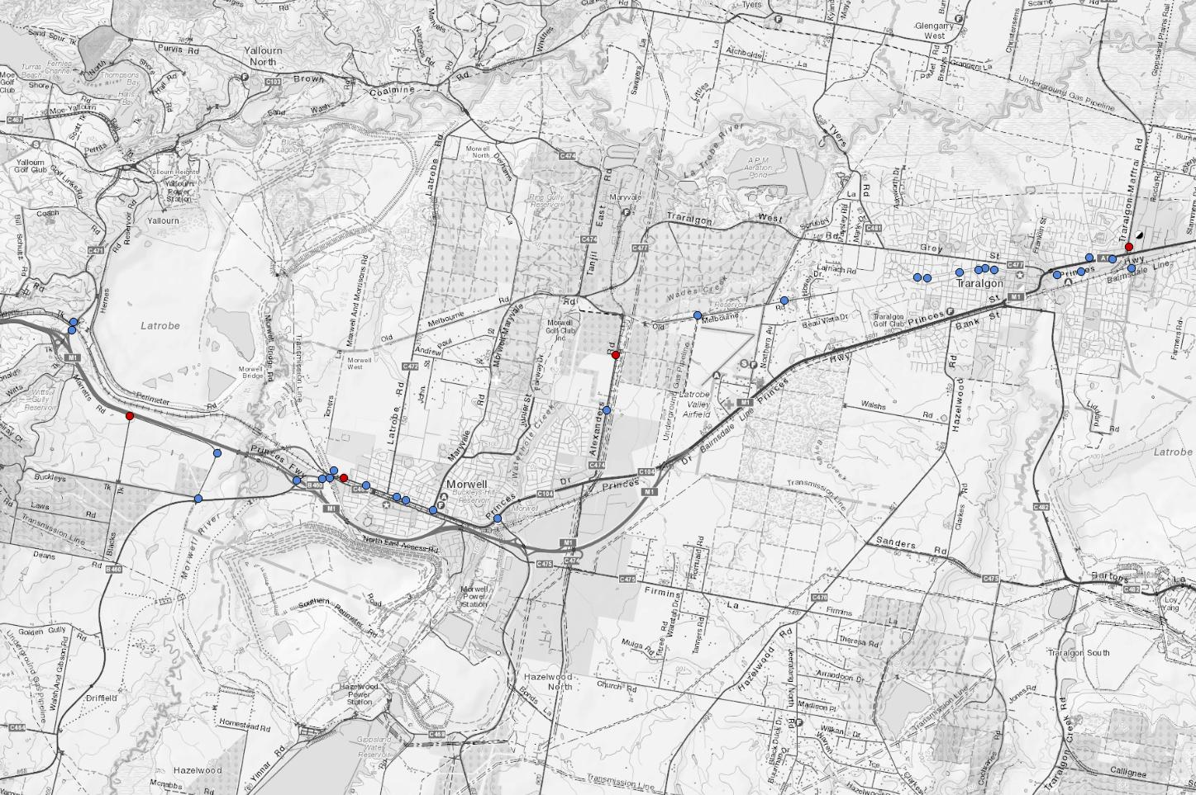



They should consider the legacy of data and allow for potential degradation of data quality with time and ongoing subsidence. Despite the accuracy and precision of levelling work done to derive these revised AHD heights, subsidence will continue to degrade the heights for these SCN marks.

Although there are no current plans to revise AHD, it is hoped that any future national vertical datum will support handling of the earth dynamics.

For the most current AHD height information please visit [maps.land.vic.gov.au/smes](http://maps.land.vic.gov.au/lassi/SmesUI.jsp)

|  |  |
| --- | --- |
| © The State of Victoria Department of Environment, Land, Water and Planning 2020  LogoThis work is licensed under a Creative Commons Attribution 4.0 International licence. You are free to re-use the work under that licence, on the condition that you credit the State of Victoria as author. The licence does not apply to any images, photographs or branding, including the Victorian Coat of Arms, the Victorian Government logo and the Department of Environment, Land, Water and Planning (DELWP) logo. To view a copy of this licence, visit http://creativecommons.org/licenses/by/4.0/  Disclaimer  This publication may be of assistance to you but the State of Victoria and its employees do not guarantee that the publication is without flaw of any kind or is wholly appropriate for your particular purposes and therefore disclaims all liability for any error, loss or other consequence which may arise from you relying on any information in this publication. | Accessibility  If you would like to receive this publication in an alternative format, please telephone the DELWP Customer Service Centre on 136186, email [customer.service@delwp.vic.gov.au](mailto:customer.service@delwp.vic.gov.au), or via the National Relay Service on 133 677 [www.relayservice.com.au](http://www.relayservice.com.au). This document is also available on the internet at [www.delwp.vic.gov.au](http://www.delwp.vic.gov.au). |