SMES
Survey Marks Enquiry Service
The Survey Marks Enquiry Service (SMES) provides free, online access to the survey control mark information managed by the Office of Surveyor-General Victoria. As part of an upgrade of Land Victoria’s web mapping applications, SMES has been modernised with a range of improvements and new features.

What is SMES?
SMES is the online service that provides open access to a database of all survey control mark information in Victoria. SMES supports two-way interaction with the survey control mark database, affording highly flexible searching and download options, as well as the ability to lodge new information or amendments. SMES is also used by the Office of Surveyor-General Victoria to maintain Australia’s geodetic and height datums – the Geocentric Datum of Australia, 1994 (GDA94) and the Australian Height Datum (AHD).

Information in SMES
SMES contains the most up-to-date survey control mark information held at the Office of Surveyor-General Victoria. It includes:
- latest GDA94 coordinate and AHD height values for survey control network (SCN) marks resulting from ongoing network adjustments
- estimates of positional uncertainty – horizontal and vertical
- additional survey mark information and metadata, such as mark status, observation techniques, source and adjustment details
- underlying VicMap data to support interactive map searching
- permanent mark (PM) sketch plans.

New features
SMES has been modernised as part of a consolidation of all Land Victoria’s web mapping applications into an Open Source VicGIS framework (based on GeoServer). New features include:
- a new graphic interface with updated VicMap data
- Google street view incorporated into the user interface
- more flexible search options
- multiple format options for downloading information
- the ability for surveyors and spatial information professionals to submit measurements for inclusion in the Victorian network adjustment
- revised survey control mark categories and symbols
- a new geodetic measurements database
- improvements to the database for the management of information about the survey control mark network
- an efficient and rigorous datum maintenance system for the automated processing of Victoria’s GDA94 coordinates and AHD heights
- Open Web Services to support query of SMES information using location based services applications.
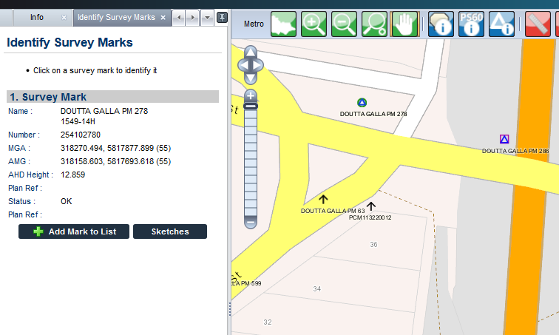

Survey control mark categories
SMES survey control mark categories and symbols provide for simple and convenient access to marks of recognised lineage and quality. The table below summarises the revised symbols.
 | SCN (GDA94) | Non-SCN (GDA94)
SCN (AHD)
Non-SCN (AHD)
No Height
Defective

- SCN (GDA94) – PM or Primary Cadastral Mark (PCM) with rigorously adjusted GDA94 coordinates
- Non-SCN (GDA94) – PM or PCM with estimated (or approximate) GDA94 coordinates
- SCN (AHD) – PM with a spirit levelled AHD height
- Non-SCN (AHD) – PM with estimated (or derived) AHD height

Benefits of SMES
SMES provides a range of benefits to Victoria’s surveying and spatial information community, including:
- easy access to the most up-to-date survey control mark information that supports the alignment of surveys to GDA94 and AHD
- reduced duplication of work effort
- ongoing maintenance of survey control mark information from the user community
- improved validation of information lodged by surveyors and spatial information professionals
- survey control mark information presented in a variety of formats to suit a range of users’ needs.

Contact SMES
T: 03 8636 2546
E: smes.support@delwp.vic.gov.au
W: www.dtpli.vic.gov.au/surveying > Government Surveying Services > Survey Marks Enquiry Service

