|  |
| --- |
| Protection and maintenance of  permanent marks |
| Permanent marks are valuable infrastructure that support surveying of property boundaries, mapping and construction |

Permanent marks are stable reference points in the ground with accurately measured coordinate and height information. It is important that permanent marks are protected and maintained to support surveying and development activities and to ensure minimal inconvenience to the public.

## Importance of permanent marks

Permanent marks are valuable infrastructure that support surveying of property boundaries, development and construction activities, mapping and environmental monitoring. The permanent marks hold accurate coordinate and height information and provide a point of reference for surveying activities. It is important that they remain accessible and stable to ensure the accuracy and reliability of the permanent mark information is preserved. Permanent marks enable surveyors to easily comply with legislation and project requirements, which improves the efficiency of surveying activities, reducing costs for industry and the community.

## Council responsibilities

Local government authorities are responsible for the routine maintenance of permanent mark infrastructure located in road reserves on roads included in their register of public roads. This is in accordance with *Section 15(3)* of the *Survey Co-ordination Act 1958* and council’s obligations as the road authority under the *Road Management Act 2004*. Surveyor-General Victoria (SGV), in the Department of Environment Land Water and Planning (DELWP), can assist councils with occasional maintenance activities. This generally includes minor maintenance tasks, such as lid replacements, that will be performed when completing other work in the area.

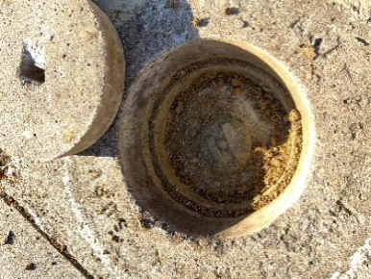 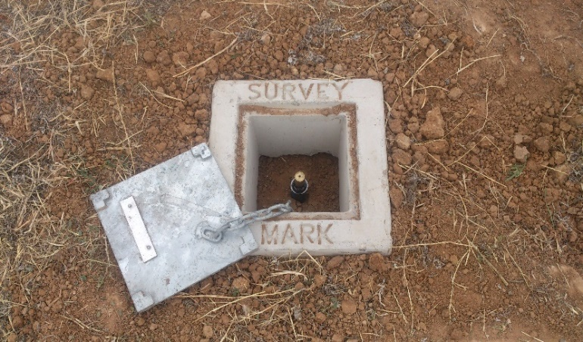

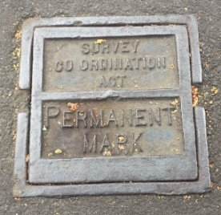 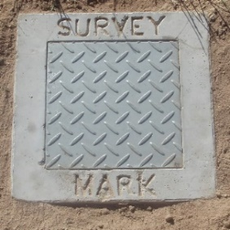

**Common permanent marks and covers**

## Surveyor responsibilities

Surveyors are encouraged to perform basic maintenance of permanent marks and ensure they are left in suitable condition for future use and not a hazard to the public. Surveyors are expected to report damaged and disturbed permanent marks or cases requiring additional maintenance. To support identification, surveyors are also encouraged to submit supplementary sketches and photos of permanent marks via the Survey Marks Enquiry Service (SMES).

## Survey Marks Enquiry Service

Information about all permanent marks in Victoria is available at no cost through the SMES interactive online application at [www.propertyandlandtitles.vic.gov.au](http://www.propertyandlandtitles.vic.gov.au) > Surveying > Survey Marks Enquiry Service.

The permanent marks in an area can be located through this online map service. Coordinate and height information, the mark type and sketch information are also available.

Registered users can also log into SMES and update information about permanent marks.

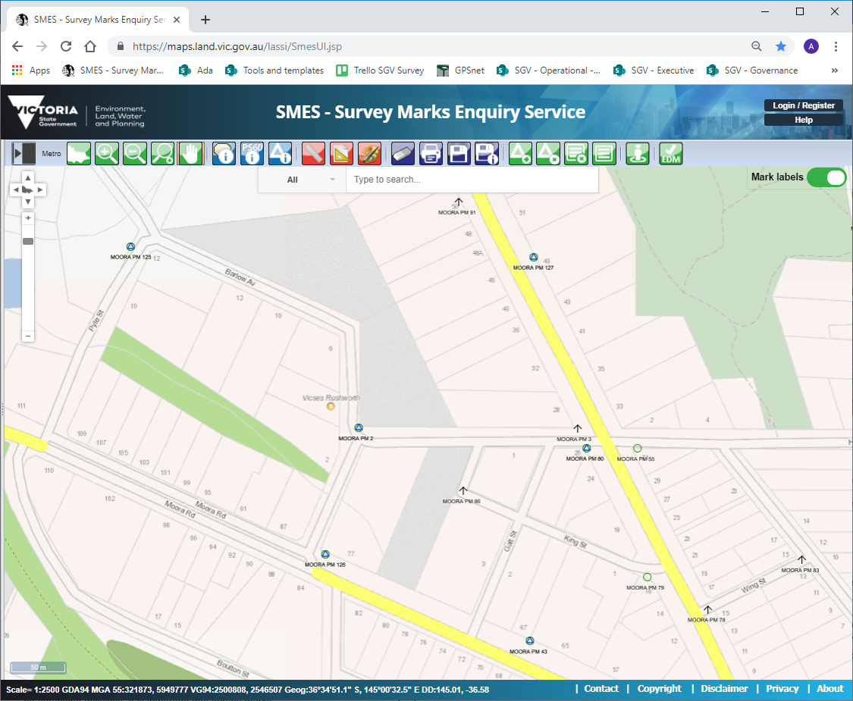

Survey Marks Enquiry Service (SMES)

## Permanent mark materials

For accessibility to users, permanent marks are usually located within road reserves, on footpaths or alongside fences. The most common permanent mark is a brass plaque set in concrete, although they can also be a rod, pipe or other stable monument. Many permanent marks are set below ground level and are enclosed by a protective surround with a cover/lid. Permanent mark materials can be sourced from a range of suppliers. SGV can provide details for local suppliers and in some cases supply small quantities of permanent mark materials for remedial works.

## Reporting issues

It is important that permanent marks are not disturbed and that they remain stable and accessible*.* Councils and construction contractors are encouraged to make every effort to preserve existing permanent marks. It is acknowledged that sometimes interference with these marks is unavoidable due to development and other works. In these instances, it is important to notify SMES Support:

Phone: 03 9194 0770

Email: smes.support@delwp.vic.gov.au

Potential damage or destruction of permanent marks may require them to be removed or replaced. SMES Support will advise the appropriate course of action and update the SMES database as required.

## Your assistance is appreciated

SGV appreciates any assistance in the ongoing maintenance and enhancement of the Victorian permanent mark network. The collaborative approach by the surveying industry, local government and SGV will ensure the protection of this important and valuable infrastructure in Victoria.

|  |  |
| --- | --- |
| © The State of Victoria Department of Environment, Land, Water and Planning 2021  LogoThis work is licensed under a Creative Commons Attribution 4.0 International licence. You are free to re-use the work under that licence, on the condition that you credit the State of Victoria as author. The licence does not apply to any images, photographs or branding, including the Victorian Coat of Arms, the Victorian Government logo and the Department of Environment, Land, Water and Planning (DELWP) logo. To view a copy of this licence, visit http://creativecommons.org/licenses/by/4.0/  Disclaimer  This publication may be of assistance to you but the State of Victoria and its employees do not guarantee that the publication is without flaw of any kind or is wholly appropriate for your particular purposes and therefore disclaims all liability for any error, loss or other consequence which may arise from you relying on any information in this publication. | Accessibility  If you would like to receive this publication in an alternative format, please telephone the DELWP Customer Service Centre on 136186, email [customer.service@delwp.vic.gov.au](mailto:customer.service@delwp.vic.gov.au), or via the National Relay Service on 133 677 [www.relayservice.com.au](http://www.relayservice.com.au). This document is also available on the internet at [www.delwp.vic.gov.au](http://www.delwp.vic.gov.au). |