

Guide to Not In Common Ownership (NICO)

Plans under the Subdivision Act 1988
Version 1

Contents
Introduction 2
Example 2
Plan of subdivision process 3
Effects of registration 4
New folio for Lot 1 on Plan of Subdivision 4
New folio for Lot 2 on Plan of Subdivision 5
When land is affected by owners corporation(s) 6
Supporting NICO/encumbrance overlay diagram 6
Overlay diagram for the above example 6
Transactions to resolve NICO proprietorship 7
Completing the Transfer of Land 7
Subsequent transactions 8
Subdividing folios that have existing NICO proprietorship 8
Example 9
Effects of Registration 9

This is a guide to plans of subdivision and consolidation under the Subdivision Act 1988 (Subdivision Act) that result in folios issuing Not In Common Ownership (NICO). It incorporates the Subdivision (Registrar’s Requirements) Regulations 2021 (the Regulations) and the Registrar’s Requirements for Conveyancing Transactions. It references items covered in other published examples (Plans of subdivision and consolidation).
Upon registration, the plan becomes the title diagram and forms the land description for the new folios of the Register (folios). For consistency and the interpretation of folios, Land Use Victoria (LUV) has included an example to assist with preparing and lodging the associated transactions to resolve NICO proprietorship and encumbrances ‘as to part’.

Introduction
Plans of subdivision and consolidation change title boundaries, however, the ownership and encumbrances affecting land do not change without lodgment of subsequent transactions.
When a plan is registered, the existing folios (referred to as parent folios after registration) are cancelled and new folio(s) created. New folio(s) that issue upon registration of a plan carries forward the proprietorship and encumbrances from the relevant parent folio(s).
Not In Common Ownership (NICO) is the term used to describe the resultant proprietorship recorded on the folio when a registered plan of subdivision or consolidation has altered boundaries between two or more folios held in different ownership.
The new folio for a plan of consolidation of two or more folios held in diverse ownership will always issue in NICO proprietorship with encumbrances recorded as to whole or part of the land depending on the parent folios affected.
For plans of subdivision of two or more folios held in diverse ownership, depending on the new boundaries, there may or may not be folios that issue NICO. Whether encumbrances carry forward as to whole or part on the new folios also depends on the land subject to the encumbrance when it was registered.
Typically, but not necessarily, a plan of subdivision can be used to adjust title boundaries to match the occupation on the ground or if a landowner decides to sell a portion of their land to an adjoining owner.
In the example that follows, two neighbours have agreed to realign their shared title boundary to match the position of the occupation as determined by survey.


Example
Figure 1 – Existing folios
ORANGE STREET
APPLE STREET
VOLUME 11234
FOLIO 567
MORTGAGE
AZ444024A

eCT Control
THE BANK PTY LTD
VOLUME 10874
FOLIO 563
Arthur Albert of 10 Orange Street, Melbourne VIC 3000 is the registered proprietor of the land contained in Certificate of Title Volume 11234 Folio 567.
The folio is subject to mortgage instrument no. AZ444024A.
The eCT Control is held by THE BANK PTY LTD.

Bill Brown of 12 Orange Street, Melbourne VIC 3000 is the registered proprietor of the land contained in Certificate of Title Volume 10874 Folio 563.
The folio is not subject to a mortgage.
Bill holds control of the ‘duplicate’ paper Certificate of Title.

Plan of subdivision process
Arthur and Bill engaged a licensed surveyor to conduct a survey of their properties (Figure 1), which uncovered that the fence between their properties was significantly out of title position. They have agreed to realign their common title boundary by a plan of subdivision.
- The plan of subdivision certified by council is now ready for lodgment at Land Use Victoria.
- Arthur and Bill engaged a legal practitioner to lodge the plan on their behalf.
- Plans of subdivision are mandated for electronic lodgment through SPEAR.

The title boundary between the properties will be altered to the new position on the plan of subdivision (Figure 2).
ORANGE STREET
APPLE STREET

1

2
Figure 2 – Plan of Subdivision
The registered proprietors of both Certificates of Title will jointly apply to Land Use Victoria (Land Registry Services) to subdivide their titles and create new folios for lots 1 and 2 on the Plan of Subdivision (PS).
The Certificates of Title Volume 11234 Folio 567 and Volume 10874 Folio 563 are both required for the lodgment submission.
In this example, as Bill holds a paper Certificate of Title, the
lodging party must first apply to convert the paper title into an electronic Certificate of Title (eCT) using an Administrative Notice.
Arthur’s Certificate of Title is in the eCT Control of THE BANK PTY LTD. The lodging party must request the controlling party to undertake an Administrative Notice ‘Nominate to paper instrument’.
See Guide to Certificates of Title and Administrative Notices for more information.
The lodging party will perform a ‘submit pre-lodgment check’ in SPEAR. Once accepted, and the lodging party ‘pay and lodge’, the plan of subdivision is lodged at Land Use Victoria.
An examination of the plan of subdivision will be undertaken by LUV before the plan is registered and new folios created.

Effects of registration
ORANGE STREET
APPLE STREET

1

2
Original title boundary
New title boundary
Figure 3 – Original vs new title boundaries
Upon registration of the plan of subdivision, new folios are created for the parcels shown on the plan.
The plan of subdivision has altered the boundaries of the land, however, the proprietorship and encumbrances affecting the land are carried forward onto the new folios in accordance with the parent folio(s) contained within the new title boundaries (Figure 3).


New folio for Lot 1 on Plan of Subdivision
LAND DESCRIPTION
----------------
Lot 1 on Plan of Subdivision PS999000A.
PARENT TITLE Volume 11234 Folio 567 Volume 10874 Folio 563
Created by instrument PS999000A 1/08/2025
REGISTERED PROPRIETOR
---------------------
Estate Fee Simple
As to the land formerly contained in Volume 10874 Folio 563
Sole Proprietor
BILL BROWN of 12 ORANGE STREET MELBOURNE VIC 3000
As to the land formerly contained in Volume 11234 Folio 567
Sole Proprietor
ARTHUR ALBERT of 10 ORANGE STREET MELBOURNE VIC 3000
PS999000A 1/08/2025
ENCUMBRANCES, CAVEATS AND NOTICES
---------------------------------
MORTGAGE as to part AZ444024A 1/01/2001
THE BANK PTY LTD

Figure 5 – Resultant new folio
Original title boundary
ORANGE STREET
APPLE STREET

1
Part of the land contained in Volume 10874 Folio 563
Part of the land contained in
Volume 11234
Folio 567
New title boundary
Figure 4 – Parent folio composition of lot 1

As shown in Figure 4 above, the new folio for lot 1 consists of part of the land formerly contained in Volume 10874 Folio 563 and part of the land formerly contained in Volume 11234 Folio 567 therefore, the proprietorship issues NICO (Figure 5).
The mortgage AZ444024A encumbering the land formerly contained in Volume 11234 Folio 567, carries forward ‘as to part’ because it does not affect the land formerly contained in Volume 10874 Folio 563.
The new Certificate of Title (eCT) issues in accordance with the business rules for determining eCT Control after a transaction. As the land is subject to a mortgage, the eCT Control will be ‘The Bank Pty Ltd’ being the controlling party who nominated the parent folio (Volume 11234 Folio 567).
Note: In the instance that there are multiple mortgages which carry forward on a new folio, eCT Control will issue to the mortgagee that is first in priority (generally the mortgage that is first in time) if they are capable of holding eCT Control. For more information see Guide to Certificate of Title and Administrative Notices.


New folio for Lot 2 on Plan of Subdivision
ORANGE STREET
APPLE STREET

2
Part of the land contained in Volume 10874 Folio 563
Original title boundary
Part of the land contained in
Volume 11234
Folio 567
New title boundary
Figure 6 – Parent folio composition of lot 2
LAND DESCRIPTION
----------------
Lot 2 on Plan of Subdivision PS999000A.
PARENT TITLE Volume 11234 Folio 567 Volume 10874 Folio 563
Created by instrument PS999000A 1/08/2025
REGISTERED PROPRIETOR
---------------------
Estate Fee Simple
As to the land formerly contained in Volume 10874 Folio 563
Sole Proprietor
BILL BROWN of 12 ORANGE STREET MELBOURNE VIC 3000
As to the land formerly contained in Volume 11234 Folio 567
Sole Proprietor
ARTHUR ALBERT of 10 ORANGE STREET MELBOURNE VIC 3000
PS999000A 1/08/2025
ENCUMBRANCES, CAVEATS AND NOTICES
---------------------------------
MORTGAGE as to part AZ444024A 1/01/2001
THE BANK PTY LTD

Figure 7 – Resultant new folio

As shown in Figure 6 above, the new folio for lot 2 consists of part of the land formerly contained in Volume 10874 Folio 563 and part of the land formerly contained in Volume 11234 Folio 567 therefore, the proprietorship issues NICO (Figure 7).
The mortgage AZ444024A encumbering the land formerly contained in Volume 11234 Folio 567, carries forward ‘as to part’ because it does not affect the land formerly contained in Volume 10874 Folio 563.
The new Certificate of Title (eCT) issues in accordance with the business rules for determining eCT Control after a transaction. As the land is subject to a mortgage, the eCT Control will be ‘The Bank Pty Ltd’ being the controlling party who nominated the parent folio (Volume 11234 Folio 567).
Note: In the instance that there are multiple mortgages which carry forward on a new folio, eCT Control will issue to the mortgagee that is first in priority (generally the mortgage that is first in time) if they are capable of holding eCT Control. For more information see Guide to Certificate of Title and Administrative Notices.

When land is affected by owners corporation(s)
If a proposed plan affects land that is a member of an owners corporation, the plan must be prepared pursuant to section 32 of the Subdivision Act (unless all the land affected by an owners corporation is proceeding in a plan under section 32A of the Subdivision Act).
While plans under section 32 require unanimous resolution of the owners corporation, the registered proprietor(s) of lots affected by an owners corporation can proceed under section 32 without the need for unanimous resolution of the owners corporation only when the plan satisfies section 32AI of the Subdivision Act.
In most circumstances, if the plan of subdivision resulting in NICO proprietorship includes both land affected by an owners corporation and land that is not, unanimous resolution of the owners corporation is required when proceeding under section 32.
For more information in preparing plans under section 32, see examples 6 and 7 (Plans of subdivision and consolidation).

Supporting NICO/encumbrance overlay diagram
As advised in Customer Information Bulletin 217, overlay diagrams are a mandatory lodging requirement for plans of subdivision where new folio(s) will issue in NICO proprietorship (Figure 8). This has also been extended to an overlay diagram that shows encumbrances ‘as to part’. One overlay depicting both proprietorship and encumbrances may be sufficient. However, for complex existing encumbrances that are ‘as to part’ prior to the NICO proprietorship, a separate encumbrance overlay diagram may be required.
Surveyors must upload a NICO/encumbrance overlay diagram under ‘Add NICO/Encumbrance Overlay Diagram’ in SPEAR. Any accompanying spreadsheets for complex proprietorship and encumbrances can also be uploaded under this document type in SPEAR.

Overlay diagram for the above example
ORANGE STREET
APPLE STREET
Land contained in Volume 10874 Folio 563
Land contained in
Volume 11234 Folio 567

1

2
Figure 8 – NICO overlay diagram (proprietorship & encumbrances)

Transactions to resolve proprietorship and encumbrances ‘as to part’
For further information about lodging transactions across the Electronic Lodgment Networks (ELNs), please refer to the guide to leader / follower dealings.

Transactions to resolve NICO proprietorship
Transfers to resolve NICO proprietorship have not been mandated for electronic lodgment in an ELN and instead, a paper instrument must be submitted through Generic Residual Document (GRD) Transfer of Land Act - Section 104.
It is recommended NICO proprietorship be resolved at the same time the plan is registered. The guide to leader / follower dealings outlines the specific steps for lodging these transactions across the ELNs to resolve NICO proprietorship and encumbrances.

Completing the Transfer of Land
Figure 9 – Land/s panel

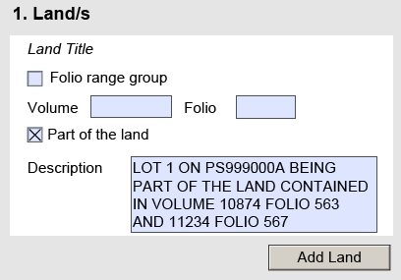
As the new Volume and Folio references for lot(s) being created on the plan of subdivision are unknown until the plan is registered, the Land Title panel must reference the parent folios and the new land description to be transferred (Figure 9).
Use the checkbox ‘Part of the land’ and enter the new land description to be transferred. For example,
‘Lot 1 on PS999000A being part of the land contained in Certificates of Title Volume 10874 Folio 563 and Volume 11234 Folio 567’.
Figure 10 – Transferor/s panel

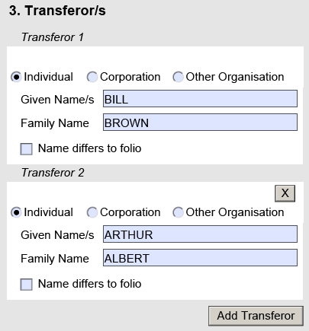
The Transferor/s panel must specify all resultant registered proprietors of the folio issuing NICO (Figure 10).

Figure 11 – Transferee/s panel
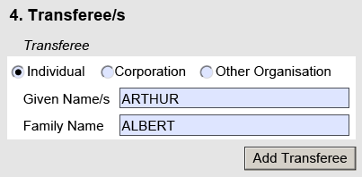
The Transferee/s panel specifies the desired registered proprietor for the new lot on the plan of subdivision (Figure 11).

Subsequent transactions
Once the new folios have issued from the plan of subdivision and the transfer instruments resolving the NICO proprietorship are registered, any subsequent dealings (e.g. discharge of mortgage and mortgage to resolve encumbrances ‘as to part’) can be lodged electronically over the new folios in the appropriate ELN.

Subdividing folios that have existing NICO proprietorship
From 3 May 2021, LUV accepts lodgment of plans that subdivide folios that have existing NICO proprietorship. The plan overlay diagram must depict the title boundaries of ‘the land formerly contained in’ the Certificates of Title specified under the ‘Registered Proprietor’ panel of the existing NICO folio. This may or may not be the parent folios and rather earlier folios.
The overlay diagram assists in the creation of new folios and whether the existing NICO proprietorship is resolved or carries forward onto new folio(s).
Surveyors must upload a NICO/encumbrance overlay diagram under ‘Add NICO/Encumbrance Overlay Diagram’ in SPEAR. Any accompanying spreadsheets for complex proprietorship and encumbrances can also be uploaded under this document type in SPEAR.
Please refer to the following example where the existing folio being subdivided is NICO.

Example
Figure 12 – Existing folio being subdivided
The following is an example of a plan of subdivision lodged at Land Use Victoria that subdivides Certificate of Title Volume 22200 Folio 123 with existing NICO proprietorship (Figure 12).
Volume 22200 Folio 123

LAND DESCRIPTION
----------------
Land in Plan of Consolidation PC800100B.
PARENT TITLE Volume 12345 Folio 678 Volume 98765 Folio 321
Created by instrument PC800100B 1/01/2000
REGISTERED PROPRIETOR
---------------------
Estate Fee Simple
As to the land formerly contained in Volume 12345 Folio 678
Sole Proprietor
JANE DOE of 2 BOURKE STREET MELBOURNE VIC 3000
As to the land formerly contained in Volume 98765 Folio 321
Sole Proprietor
JOHN SMITH of 1 BOURKE STREET MELBOURNE VIC 3000
PC800100B 1/01/2000
ENCUMBRANCES, CAVEATS AND NOTICES
---------------------------------
MORTGAGE as to part AX110011A 1/10/1998
BANKING CORP LTD

The mortgage affects the folio ‘as to part’ which encumbered the land formerly contained in Volume 12345 Folio 678.
The registered proprietors agreed to proceed with a further subdivision of the land without resolving the NICO proprietorship that resulted from the registration of Plan of Consolidation PC800100B.
In these circumstances the required overlay diagram must show the title boundaries which created the NICO proprietorship (in this example, Volume 12345 Folio 678 and Volume 98765 Folio 321) and any encumbrances (in this example, Mortgage as to part AX110011A).
As shown in the overlay diagram in Figure 13, not all parcels resulting from registration of the plan of subdivision will issue NICO and instead some new folios will have the original proprietorship and encumbrances reinstated.
The overlay diagram provides a clear expectant outcome for the proprietorship and encumbrances of new folios to issue from the plan of subdivision, which assists the lodging party in determining what (if any) subsequent transactions are required and assists LUV examiners in the issuing of new folios.

Effects of Registration
Figure 13 – NICO overlay diagram of former folios
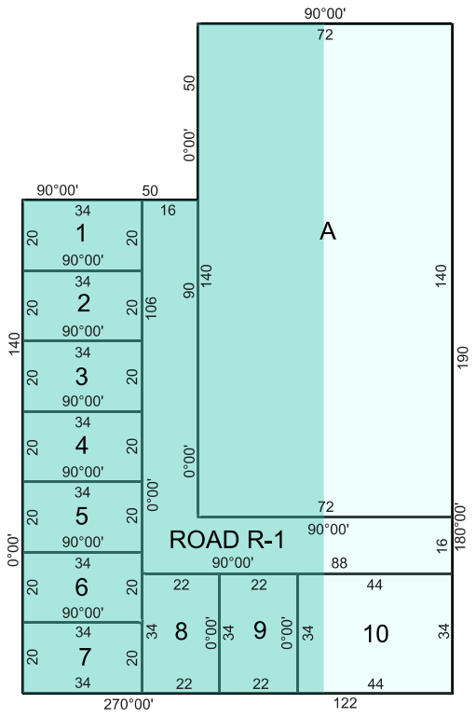
As shown in Figure 13, lots 1 to 9 are fully contained within the former boundaries of Volume 98765 Folio 321 and therefore issue with John Smith as the Sole Registered Proprietor.
Part of the land contained in
Volume 12345
Folio 678
Part of the land contained in
Volume 98765
Folio 321
Lots 10 and A are comprised of part of the land formerly contained in Volume 12345 Folio 678 and Volume 98765 Folio 321 and therefore the NICO proprietorship is carried forward onto these new folios.
The mortgage only affects the land formerly contained in Volume 12345 Folio 678 and therefore only carries forward ‘as to part’ on the new folios for lots 10 and A. Lots 1 to 9 are issued not subject to the mortgage.
Road R-1 vests upon registration of the plan in the authority as shown on the vesting table of the plan, freed from the mortgage.

