2022-2023 Financial Year
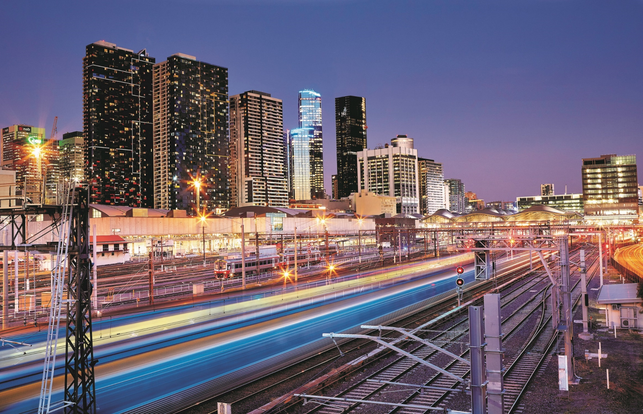
Land Registry Services
Business Activity
Report
Contents
Land Registry Services 2
Business activity report 2022-2023 financial year 2
1 Lodgments 2
1.1 Number of dealings lodged 2
1.2 Yearly lodgments (1945-2023) 2
1.3 Monthly lodgments 3
1.4 Average daily lodgments (with trend line) 3
1.5 Financial year lodgments from 2013-2014 to 2022-2023 (by month) 5
2 Search 6
2.1 Title searches 6
2.2 Financial year title searches (by month) 6
2.3 Planning certificates 7
2.4 Instrument searches 7
2.5 Property certificates 8
2.6 Land Index searches 8
3 Lodgment and Support Services 1 (LSS1) 9
3.1 Landata statistics with trend lines 9
4 Water Register 10
4.1 Water share transactions 11
5 Lodgment by specific dealing types 12
5.1 Discharges of mortgage 12
5.2 Transfers of land 12
5.3 Mortgages 13
5.4 Differences in lodging levels and percentages of discharges, transfers, and mortgages 13
5.5 Plans of subdivisions 15
5.6 Number of plans of subdivision lodged 15
5.7 Number of new parcels created from plans of subdivision 16
5.8 General law conversion 16
5.9 Top 40 dealing types, by number lodged 17
6 Other measures of Land Registry Services activity 18
6.1 Number of dealings registered 18
6.2 Percentage of dealings registered within 5 days 18
6.3 Number of plans registered 18
6.4 Number of dealings refused 18
6.5 Number of dealings waiting to be processed 18
7 Electronic transactions processing 18
7.1 Electronic Conveyancing 18
7.2 Percentage of transactions lodged electronically 19

Land Registry Services

Business activity report 2022-2023 financial year
This report provides statistics for land registration and property information services conducted at Land Use Victoria. Figures for the 2022-2023 financial year and previous years are provided.

1 Lodgments

1.1 Number of dealings lodged
The number of dealings lodged for the financial year was 951,576. This is a 6.94 per cent decrease on the 2021-22 financial year but is the second highest lodgment level on record for the Registry. Past financial years’ lodgments have been:
Year | Total | Year | Total
2003-2004 | 797,231 | 2013-2014 | 747,598
2004-2005 | 780,329 | 2014-2015 | 792,335
2005-2006 | 748,647 | 2015-2016 | 857,497
2006-2007 | 727,464 | 2016-2017 | 876,482
2007-2008 | 777,542 | 2017-2018 | 917,385
2008-2009 | 675,640 | 2018-2019 | 885,058
2009-2010 | 743,389 | 2019-2020 | 853,227
2010-2011 | 720,649 | 2020-2021 | 896,843
2011-2012 | 677,708 | 2021-2022 | 1,022,585
2012-2013 | 669,214 | 2022-2023 | 951,576
Table 1: Number of Dealings Lodged by Financial Year

1.2 Yearly lodgments (1945-2023)
This graph represents the yearly lodgments for each year since 1945. Since 1945, there has been average growth of 3.04 per cent increase per year.
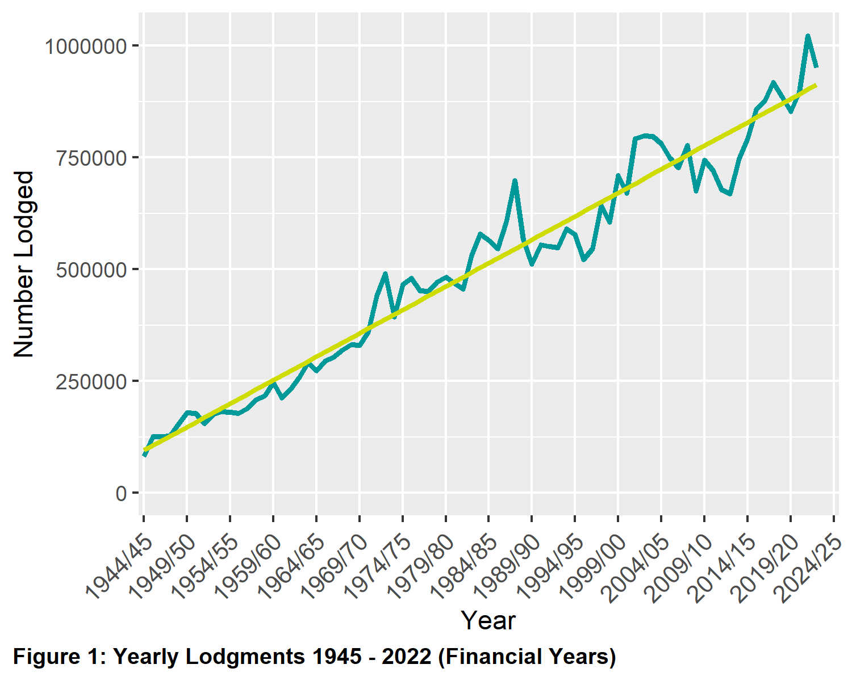

1.3 Monthly lodgments
This graph shows the number of lodgments received for each month of the financial year. In the 2022-2023 financial year, the average number of lodgments was 79,298 per month.
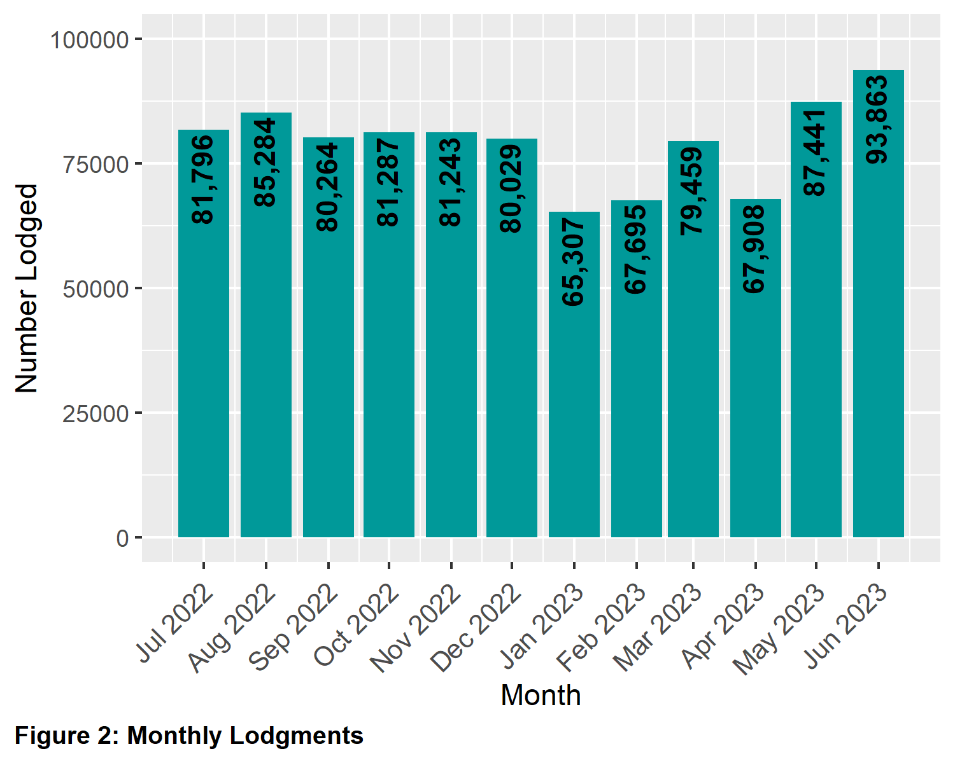

1.4 Average daily lodgments (with trend line)
This graph shows the daily average lodgments for each week of the 2022-2023 financial year. The average daily lodgment throughout the financial year was 3,806 per day. The average daily lodgment is monitored on a daily basis (along with moving averages).
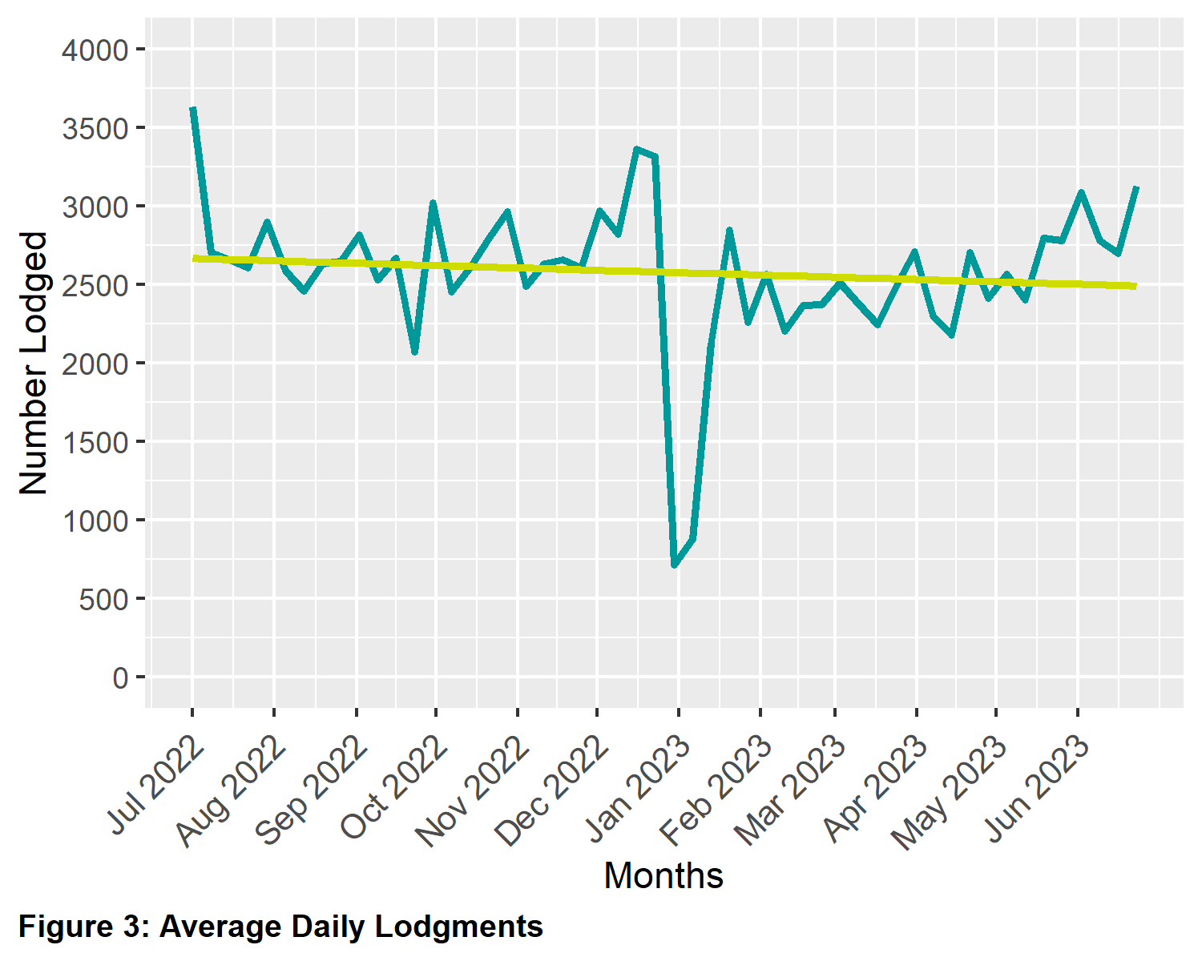

1.5 Financial year lodgments from 2013-2014 to 2022-2023 (by month)
This graph compares monthly lodgments since the 2013-2014 financial year.
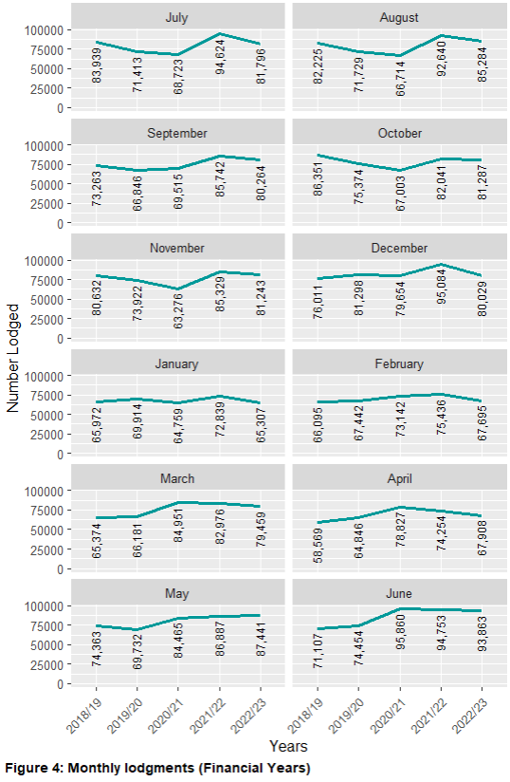
Figure 4: Monthly Lodgements (Financial years)

2 Search
Search categories are listed below with historical trend information.

2.1 Title searches
The number of title searches supplied in the financial year was 2,717,540. This is an 8.73 per cent decrease on the 2021-22 financial year.
Year | Quantity | Year | Quantity
2004-2005 | 1,731,553 | 2014-2015 | 2,242,562
2005-2006 | 1,906,169 | 2015-2016 | 2,232,051
2006-2007 | 2,050,786 | 2016-2017 | 2,463,249
2007-2008 | 2,169,427 | 2017-2018 | 2,866,297
2008-2009 | 2,023,852 | 2018-2019 | 2,483,433
2009-2010 | 2,200,297 | 2019-2020 | 2,540,297
2010-2011 | 2,218,043 | 2020-2021 | 2,797,895
2011-2012 | 2,192,819 | 2021-2022 | 2,977,311
2012-2013 | 2,169,973 | 2022-2023 | 2,717,540
2013-2014 | 2,205,947
Table 2: Number of Title Searches by Financial Year

2.2 Financial year title searches (by month)
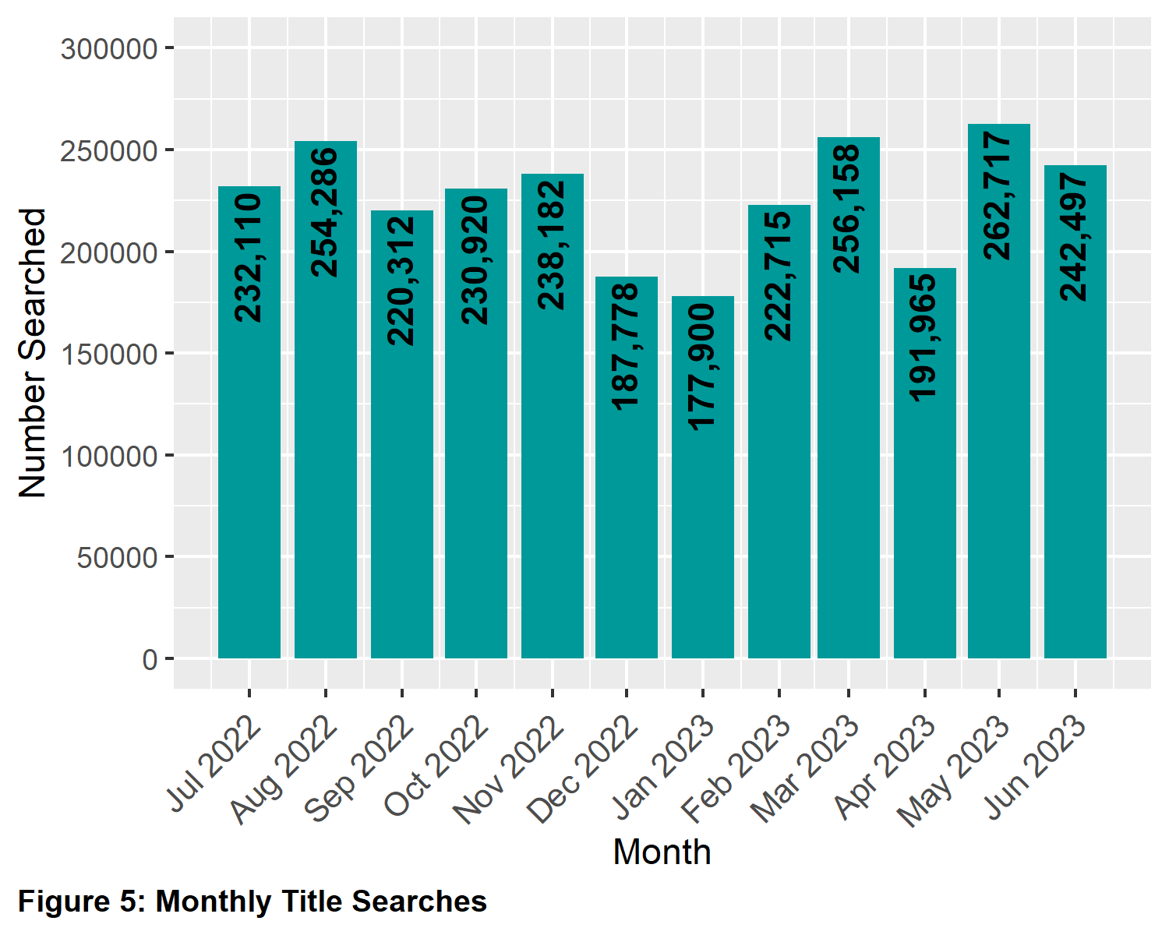

2.3 Planning certificates
Planning certificates decreased by 11.88 per cent in the 2022-2023 financial year.
Year | Quantity | Year | Quantity
2005-2006 | 37,301 | 2014-2015 | 55,461
2006-2007 | 33,259 | 2015-2016 | 57,078
2007-2008 | 40,716 | 2016-2017 | 63,161
2008-2009 | 32,893 | 2017-2018 | 71,771
2009-2010 | 37,695 | 2018-2019 | 67,658
2010-2011 | 37,131 | 2019-2020 | 75,695
2011-2012 | 38,196 | 2020-2021 | 90,139
2012-2013 | 42,018 | 2021-2022 | 98,092
2013-2014 | 50,090 | 2022-2023 | 86,441
Table 3: Number of Planning Certificates by Financial Year

2.4 Instrument searches
Instrument searches decreased by 11.54 per cent in the 2022-2023 financial year.
Year | Quantity | Year | Quantity
2006-2007 | 587,682 | 2015-2016 | 667,018
2007-2008 | 613,296 | 2016-2017 | 673,628
2008-2009 | 618,854 | 2017-2018 | 677,407
2009-2010 | 757,195 | 2018-2019 | 582,125
2010-2011 | 721,380 | 2019-2020 | 466,912
2011-2012 | 668,858 | 2020-2021 | 604,336
2012-2013 | 683,604 | 2021-2022 | 545,272
2013-2014 | 682,478 | 2022-2023 | 482,361
2014-2015 | 667,648
Table 4: Number of Instrument Searches by Financial Year

2.5 Property certificates
Property certificates decreased by 12.44 per cent in the 2022-2023 financial year.
Year | Quantity | Year | Quantity
2006-2007 | 109,355 | 2015-2016 | 541,176
2007-2008 | 134,288 | 2016-2017 | 619,212
2008-2009 | 126,380 | 2017-2018 | 630,885
2009-2010 | 188,155 | 2018-2019 | 622,465
2010-2011 | 243,917 | 2019-2020 | 663,119
2011-2012 | 213,692 | 2020-2021 | 815,614
2012-2013 | 271,449 | 2021-2022 | 938,347
2013-2014 | 367,172 | 2022-2023 | 821,604
2014-2015 | 521,891
Table 5: Number of Property Certificates by Financial Year

2.6 Land Index searches
Land Index searches increased by 5.27 per cent in the 2022-2023 financial year.
Year | Quantity | Year | Quantity
2006-2007 | 1,466,544 | 2015-2016 | 1,153,439
2007-2008 | 1,488,230 | 2016-2017 | 1,345,345
2008-2009 | 1,278,727 | 2017-2018 | 1,374,961
2009-2010 | 1,137,876 | 2018-2019 | 1,319,785
2010-2011 | 1,103,887 | 2019-2020 | 1,352,415
2011-2012 | 1,053,140 | 2020-2021 | 1,440,211
2012-2013 | 1,056,131 | 2021-2022 | 1,618,908
2013-2014 | 998,803 | 2022-2023 | 1,704,251
2014-2015 | 1,070,323
Table 6: Number of Land Index Searches by Financial Year

3 Lodgment and Support Services 1 (LSS1)
This statistic refers to services provided to Electronic Lodgment Networks (ELN) on the creation of a workspace. The service, known as LSS1 provides pre-population of title data, title activity checks and lodgment verification. The statistic below shows the number of LSS1s which is directly related to the number of workspaces created.
Year | Quantity
2022-2023 | 553,606
2021-2022 | 570,488
2020-2021 | 528,675
2019-2020 | 476,167
Table 7: Number of Lodgment and Support Services 1 (LSS1)
by Financial Year

3.1 Landata statistics with trend lines
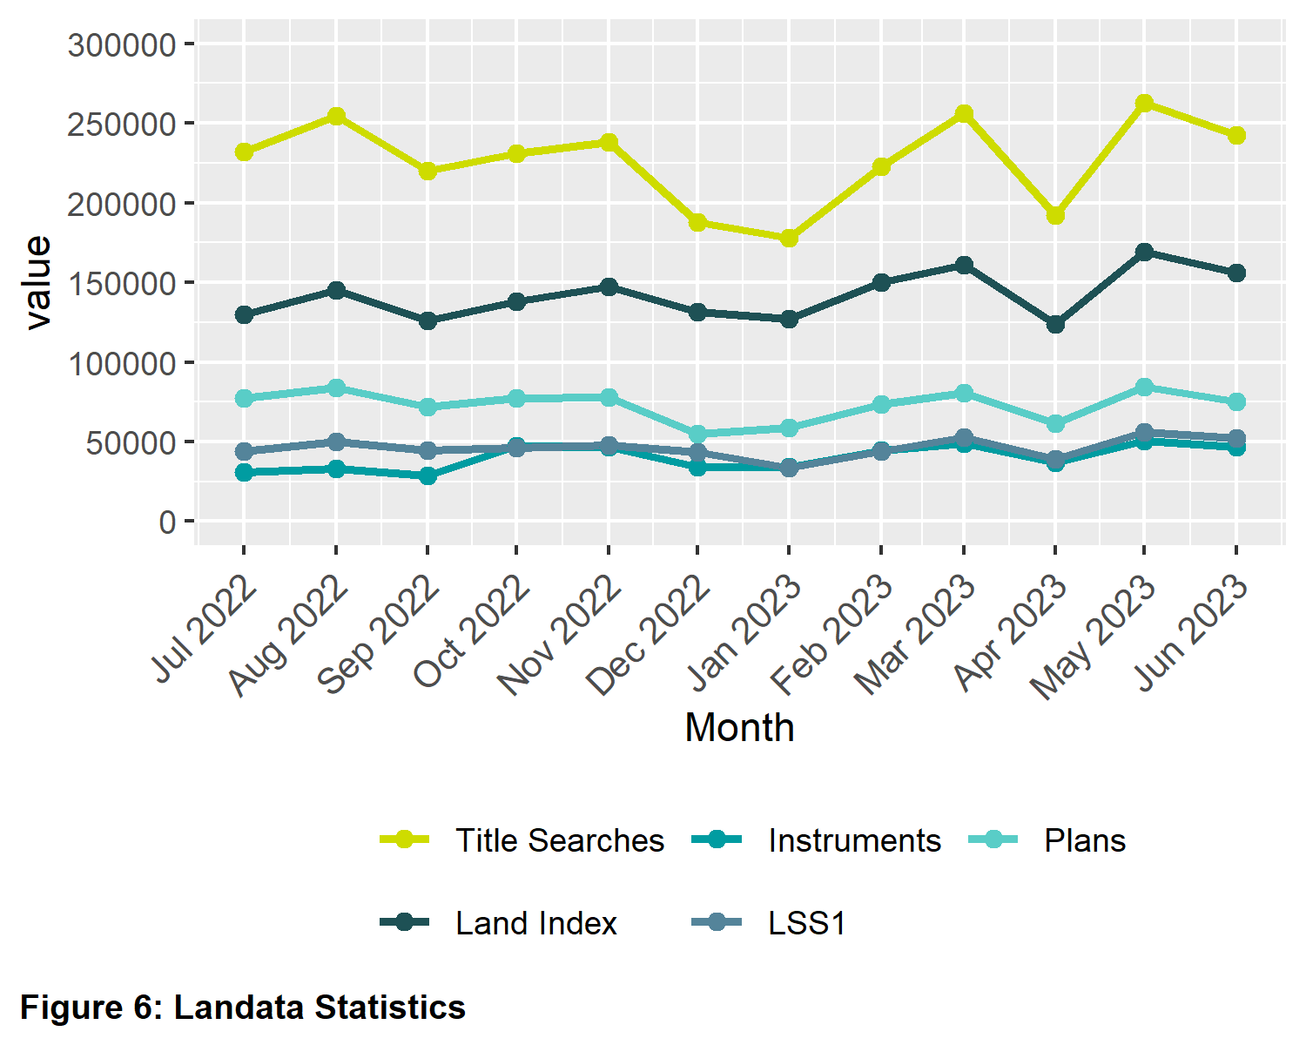

4 Water Register
Water share records searches increased by 14.31 per cent in the 2022-2023 financial year. This significant increase was a result of the Irrigator’s Share Distribution Scheme which created 14,000 new water shares.

Year | Quantity | Year | Quantity
2007-2008 | 5,259 | 2015-2016 | 7,013
2008-2009 | 13,391 | 2016-2017 | 6,162
2009-2010 | 10,983 | 2017-2018 | 9,648
2010-2011 | 9,990 | 2018-2019 | 11,876
2011-2012 | 9,871 | 2019-2020 | 7,491
2012-2013 | 8,800 | 2020-2021 | 7,083
2013-2014 | 7,529 | 2021-2022 | 8,195
2014-2015 | 7,670 | 2022-2023 | 9,368
Table 8: Number of Water Share Records Searches
by Financial Year

4.1 Water share transactions
The Water Registrar is responsible for the recording of transactions with water shares under the Water Act 2007. For the 2022-2023 financial year there was a significant increase in the volume of transactions generated by the creation of new water shares under the Irrigator’s Share Distribution Scheme.
Transfers
Transfer within authority (including limited term transfers) | 2,472
Transfer between authority (including limited term transfers) | 167
Total Transfers | 2,639
Party amendments
Address amendment | 4,085
Name and address amendment | 1,240
Party merge | 0
Total Party Amendments | 5,325
Mortgages
Mortgage create | 318
Mortgage discharge | 764
Mortgage variation | 0
Mortgage amendment | 11
Mortgage priority | 0
Create MCP | 3
Total Mortgages | 1,096
Survivorships
Recording of LPR | 175
Recording of survivorship | 128
Recording of trustee in Bankruptcy | 1
Total Survivorships | 304
Registrar notification on water share
Create notification 0 | 0
Remove notification 5 | 5
Total Notifications | 5
Table 9: Number of Water Share Transactions Recorded (Financial Year 2022-2023)

5 Lodgment by specific dealing types

5.1 Discharges of mortgage
For the 2022-2023 financial year, discharges of mortgage were 34.37 per cent of all dealings lodged.
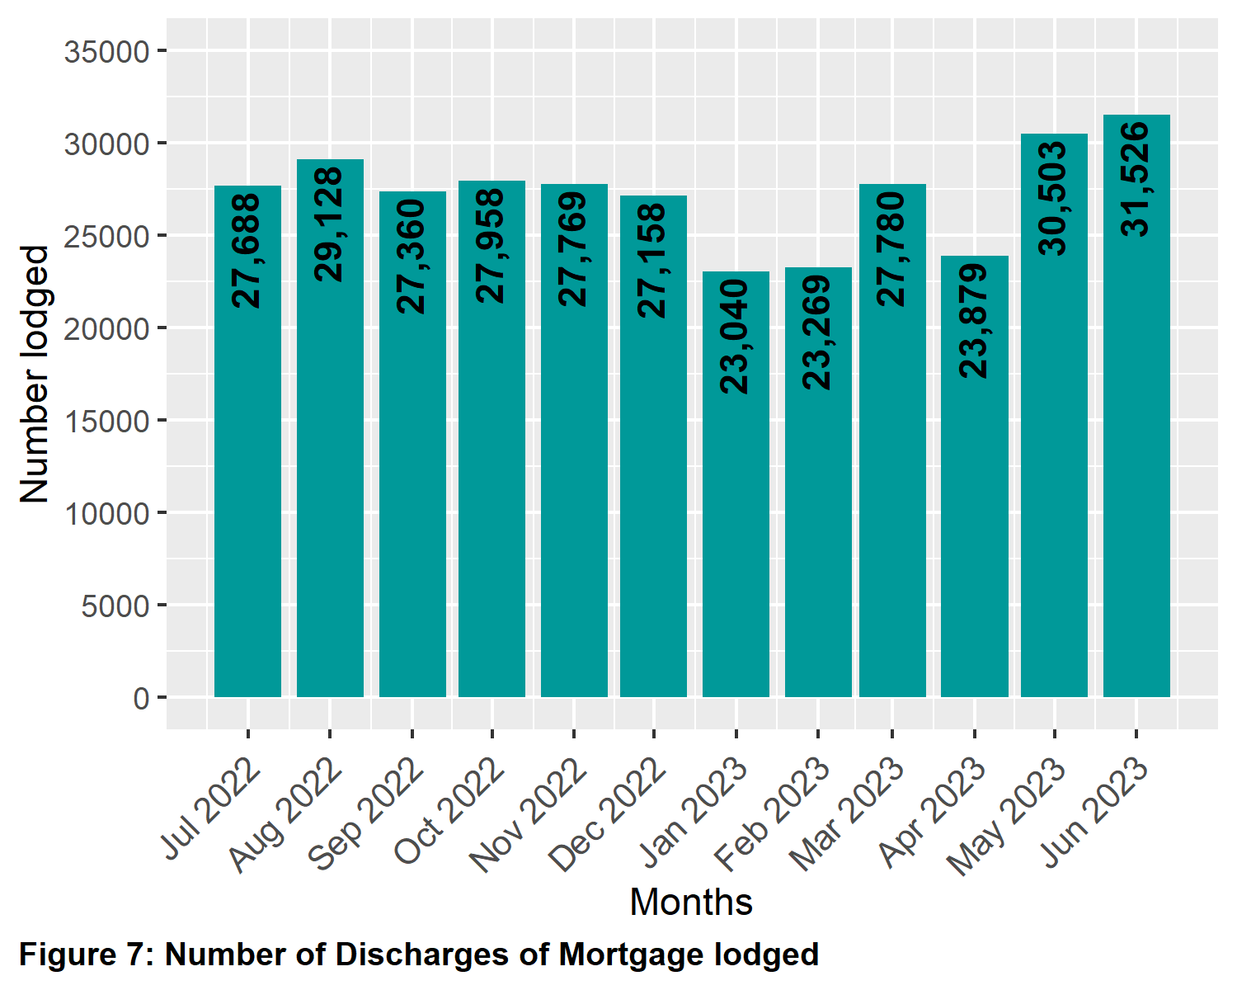

5.2 Transfers of land
For the 2022-2023 financial year, transfers for both monetary and non-monetary consideration were 21.02 per cent of all dealings lodged.
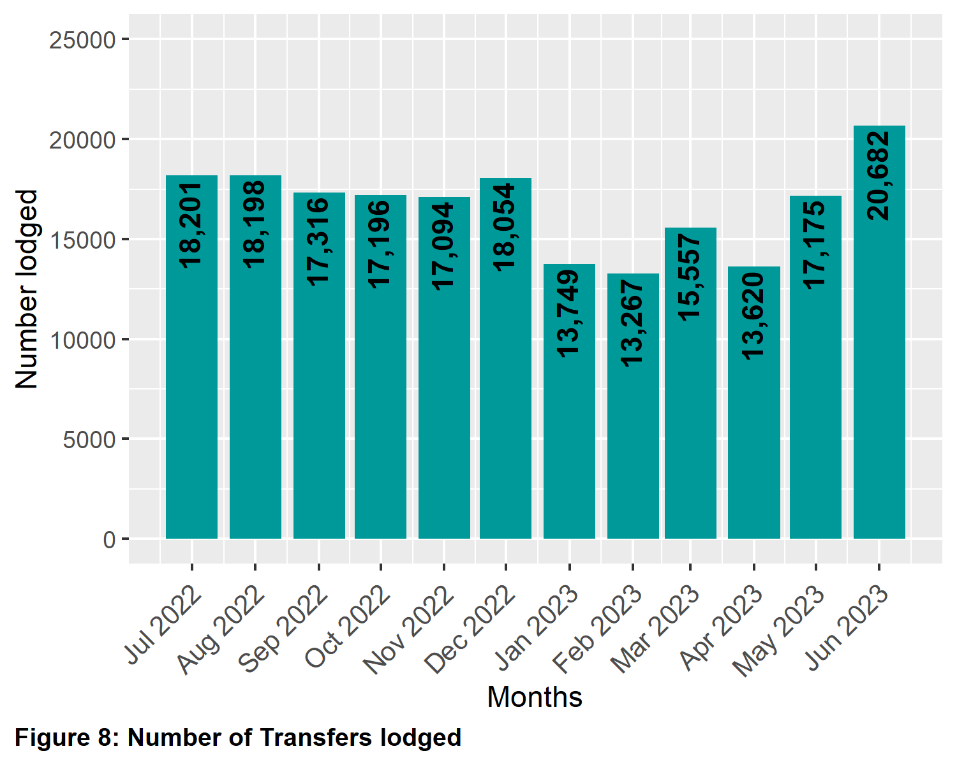

5.3 Mortgages
For the 2022-2023 financial year, mortgages and charges were 32.98 per cent of all dealings lodged.
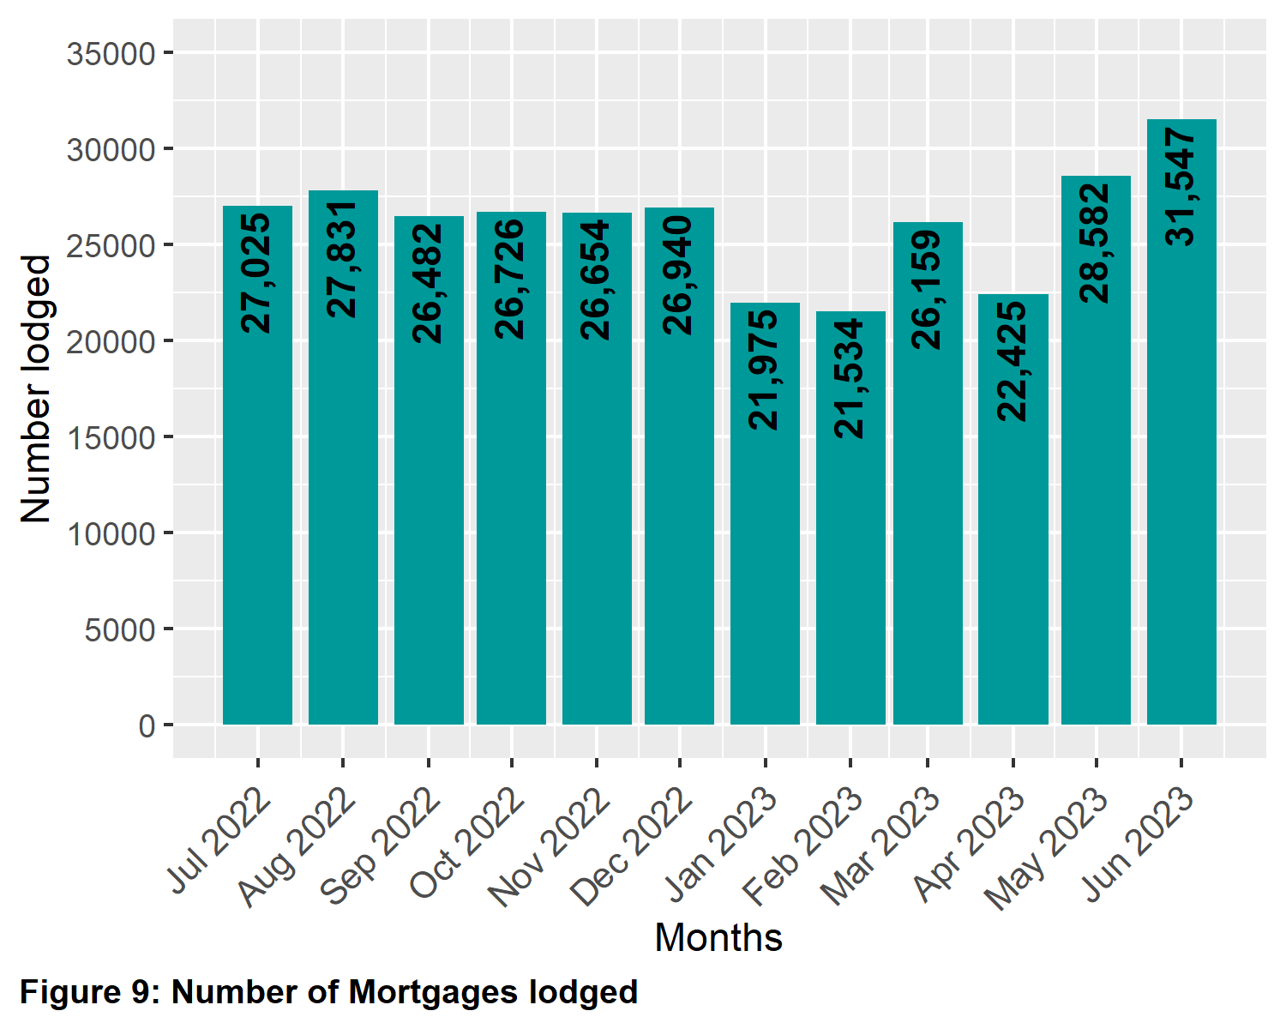

5.4 Differences in lodging levels and percentages of discharges, transfers, and mortgages
Over time, the number and relative percentages in the lodgment levels of the three most common transactions vary. These variations are shown below. The average for each of the dealing types for this financial year is as follows:
Dealing type | Percentage
Transfers | 21.02
Discharges | 34.37
Mortgages | 32.98
Table 10: Percent of Dealing Types Lodged
(Financial Year 2022-2023)

The three main dealing types as a percentage of all dealings lodged since 2003-2004 is shown below.
Year | Transfers (%) | Discharges (%) | Mortgages (%)
2022-2023 | 21.02 | 34.37 | 32.98
2021-2022 | 25.24 | 32.65 | 32.44
2020-2021 | 25.75 | 33.35 | 33.25
2019-2020 | 23.72 | 31.98 | 30.80
2018-2019 | 23.03 | 29.22 | 27.72
2017-2018 | 25.90 | 30.57 | 28.66
2016-2017 | 28.05 | 30.60 | 28.69
2015-2016 | 23.90 | 29.90 | 29.20
2014-2015 | 25.44 | 29.15 | 28.25
2013-2014 | 25.76 | 28.54 | 27.74
2012-2013 | 25.04 | 28.15 | 27.80
2011-2012 | 25.24 | 28.28 | 28.05
2010-2011 | 26.22 | 27.20 | 27.68
2009-2010 | 26.87 | 27.16 | 28.62
2008-2009 | 25.95 | 27.21 | 28.42
2007-2008 | 26.27 | 27.59 | 29.19
2006-2007 | 25.87 | 28.13 | 29.85
2005-2006 | 25.49 | 28.36 | 30.51
2004-2005 | 25.05 | 29.53 | 26.75
2003-2004 | 27.15 | 30.63 | 27.79
Table 11: Percent of Dealing Types Lodged by Financial Year

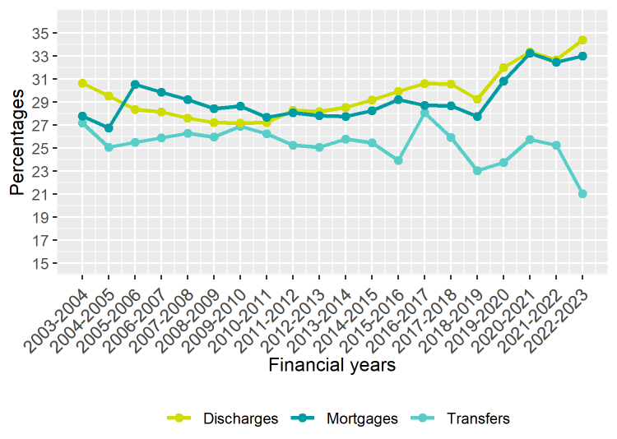
Figure 10: Differences in percentages of lodging for specific dealing types

5.5 Plans of subdivisions
There were 6,657 plans of subdivision lodged in the 2022-2023 financial year, representing 0.7 per cent of all dealings lodged. There are range of other plan types that are lodged under the Subdivision Act 1988 that are not included here including acquisition plans and redevelopment plans. In the 2022-2023 financial year there were 120 of acquisition plans lodged and 203 redevelopment plans.
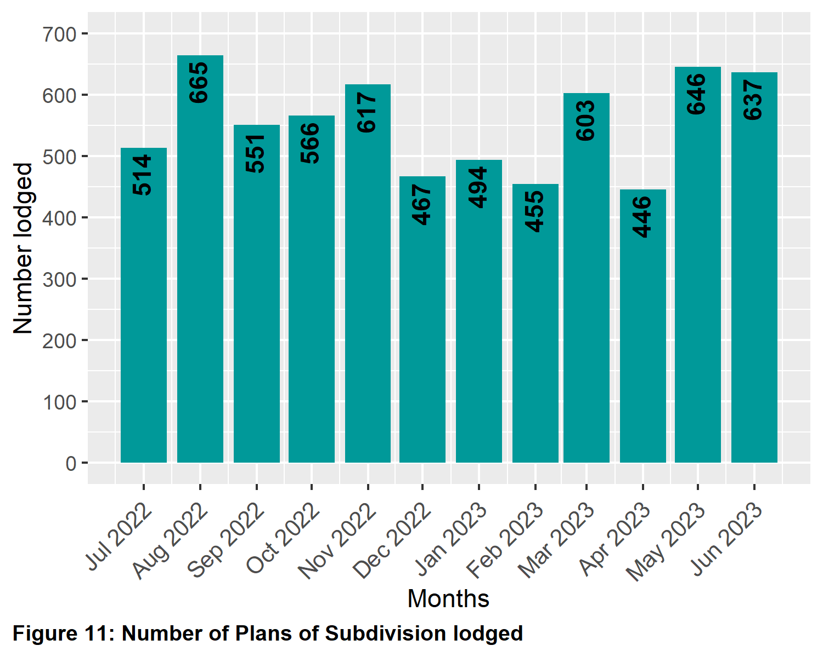

5.6 Number of plans of subdivision lodged
The number of plans under the Subdivision Act 1988 lodged for the 2022-2023 financial year was 7,064. Recent financial year’s lodgings have been:
Year | Quantity | Year | Quantity
2003-2004 | 8,052 | 2013-2014 | 8,001
2004-2005 | 8,349 | 2014-2015 | 8,252
2005-2006 | 8,547 | 2015-2016 | 8,970
2006-2007 | 8,304 | 2016-2017 | 8,376
2007-2008 | 8,048 | 2017-2018 | 8,340
2008-2009 | 7,719 | 2018-2019 | 8,249
2009-2010 | 7,988 | 2019-2020 | 8,541
2010-2011 | 7,699 | 2020-2021 | 8,220
2011-2012 | 8,088 | 2021-2022 | 7,536
2012-2013 | 7,896 | 2022-2023 | 7064
Table 12: Number of Plans of Subdivision Lodged
by Financial Year

5.7 Number of new parcels created from plans of subdivision
The number of parcels created from plans of subdivision under the Subdivision Act 1988 for the 2022-2023 financial year was 68,414. This compares to previous financial years as follows:
Year | Quantity | Year | Quantity
2014-2015 | 61,669 | 2019-2020 | 82,898
2015-2016 | 75,351 | 2020-2021 | 74,352
2016-2017 | 79,034 | 2021-2022 | 60,803
2017-2018 | 77,014 | 2022-2023 | 68,414
2018-2019 | 77,602
Table 13: Number of New Parcels Created from Plans of Subdivision
by Financial Year

5.8 General law conversion
The number of parcels created from General law conversions for the 2022-2023 financial year was 409. This compares to previous financial years as follows:
Year | Quantity | Year | Quantity
2003-2004 | 1,996 | 2013-2014 | 3,774
2004-2005 | 1,750 | 2014-2015 | 2,018
2005-2006 | 1,490 | 2015-2016 | 2,868
2006-2007 | 1,309 | 2016-2017 | 3,228
2007-2008 | 1,238 | 2017-2018 | 1,922
2008-2009 | 1,023 | 2018-2019 | 1,575
2009-2010 | 1,559 | 2019-2020 | 1,468
2010-2011 | 2,559 | 2020-2021 | 482
2011-2012 | 1,303 | 2021-2022 | 378
2012-2013 | 1,997 | 2022-2023 | 409
Table 14: Number of Parcels Created from General Law Conversions
by Financial Year

5.9 Top 40 dealing types, by number lodged
Shown below are the top 40 dealing types lodged in Land Registry Services for the financial year.
Dealing type | Description | Lodged
84M | Discharge of mortgage | 327,058
74 | Mortgage | 303,763
45 | Transfer | 177,775
89 | Caveat | 31,008
45NM | Transfer without monetary consideration | 22,242
89W | Withdrawal of Caveat | 17,581
49 | Transmission Application | 15,443
50 | Survivorship Application | 11,635
74D | Mortgage with name change | 10,090
PS | Plan of Subdivision | 6,657
31 | Application to replace lost Certificate of Title | 3,029
OCAI | Owners Corporation additional information | 2,924
173 | Planning Agreement | 2,378
PN | Priority Notice | 1,205
27A | Change of proprietor name | 1,110
89A | Removal of caveat | 927
MCP | Memorandum of Common Provisions | 842
PC | Plan of consolidation | 697
LTD | Discharge of land tax charge | 609
77 | Transfer by Mortgagee | 574
LACA | Notice | 475
113A | Amendment of address on folio | 463
45E | Creation of easement | 456
32-2 | Application for a new folio of the Register | 419
45N | Transfer with new title | 404
106C | Removal of encumbrance | 399
LTC | Land tax charge | 386
47MSA | Removal of encumbrance | 383
52-2 | Warrant | 332
183W | Removal of Planning Agreement | 263
32-1 | Application for a new folio of the Register | 247
OCR | Owners Corporation rules | 221
RVC | Statutory charge | 205
SA32PS | Plan of Subdivision X32 | 203
45M | Transfer of Mortgage | 196
60 | Adverse Possession | 190
14 | Non-survey conversion | 184
SACA | Change of address of owners corporation | 183
23 | Application TLA | 170
MTPFA | Major Transport Projects Facilitation Act Acquisition | 169
Table 15: Top 40 Dealing Types Lodged (Financial Year 2022-2023)

6 Other measures of Land Registry Services activity

6.1 Number of dealings registered
The number of transactions registered in the 2022-2023 financial year was 947,364.

6.2 Percentage of dealings registered within 5 days
The average percentages achieved were greater than 99 per cent for the whole of the financial year.

6.3 Number of plans registered
The number of plans under the Subdivision Act 1988 registered for the financial year was 7,274. The average percentage of plans registered within 15 days was 83.65 per cent for the whole of the financial year.

6.4 Number of dealings refused
The number of dealings refused for this financial year was 6,217. This represents 0.65 per cent of total dealings presented for acceptance at Land Registry Services for the financial year. In the 2021-22 financial year the figure was 7,069. This represents 0.69 per cent of total dealings presented for acceptance at Land Registry Services.

6.5 Number of dealings waiting to be processed
The number of dealings waiting to be processed in this financial year has stabilised. The ‘holding level’ at the commencement of the financial year was 3,225. For the majority of this year that figure has been less than 3,370. The majority, if not all of these dealings, will be in a processing state that requires attention from customers, or cannot be processed until a statutory period has elapsed. As at 1 July 2023 the figure was 3,051.

7 Electronic transactions processing

7.1 Electronic Conveyancing
The number of transactions lodged electronically in the 2022-2023 financial year was 924,889, down from 993,196 in 2021-22. Transactions lodged electronically in 2022-2023 financial year accounted for 97.2 per cent of all lodgments compared with 97.13 per cent in the previous financial year. For 2022-2023, this was made up of the following:

Transaction Type | Quantity
Discharge of Mortgage | 325,466
Mortgage | 312,932
Transfer | 197,787
Caveat | 30,675
Withdrawal of Caveat | 17,373
Transmission Application | 15,196
Survivorship Application | 11,339
Application Lost Title | 2,882
Agreement | 2,280
Priority Notice | 1,205
Removal of Caveat | 896
Discharges of Land Tax Charges | 609
Transfer by Mortgagee | 548
Application for New Folio | 483
Warrant | 398
Land Tax Charges | 386
Statutory Charge | 234
Transfer of Mortgage | 185
Withdraw Priority Notice | 104
Discharge of Charge | 20
Miscellaneous | 3,891
Table 16: Number of Transactions Lodged Electronically by Type (Financial Year 2022-2023)

7.2 Percentage of transactions lodged electronically
