Image Web server
ArcGIS Pro

Introduction
The Image Web Server (IWS) is a central source for DEECA's aerial photography and satellite imagery.
Only authorised users can access the IWS.
To register as an authorised user of the IWS please refer to the User Registration section.

Adding a WMS Server Connection
- From the ArcGIS Pro start screen open any project or “Start without a template” and then open a New Map
- Click the Insert menu then click Connections
- Select Server, then New WMS Server
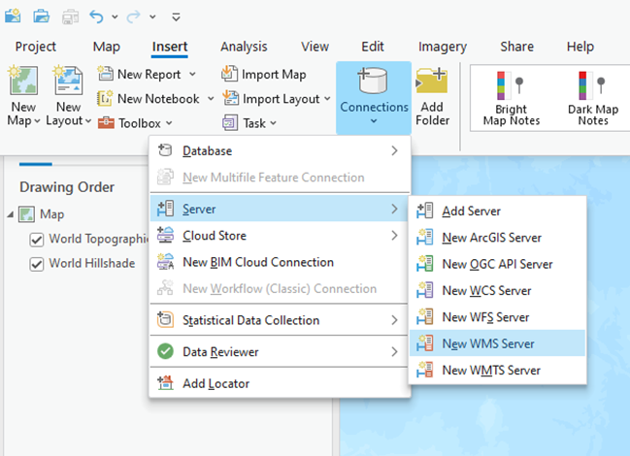
- Copy and paste the following into the URL text window of the Add WMS Server menu
https://iws.maps.vic.gov.au/erdas-iws/ogc/wms/RDP?SERVICE
- DO NOT Enter your username and password
- Select the “Save Username / Password to Windows Credential manager” option
- Click the OK button.

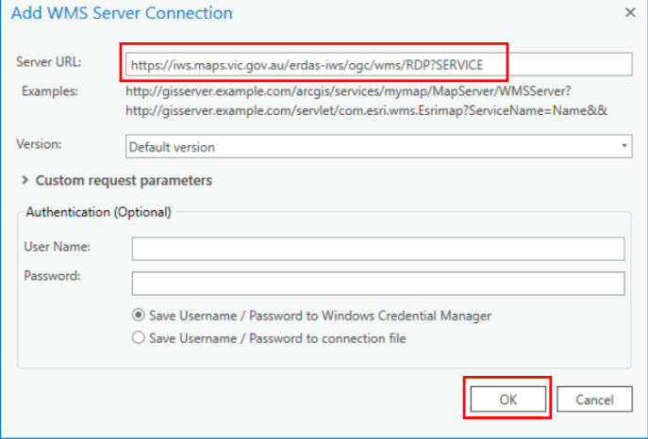
Right-click on the connection and select Add To New Projects. This will ensure the IWS is available from the Catalog in the future.
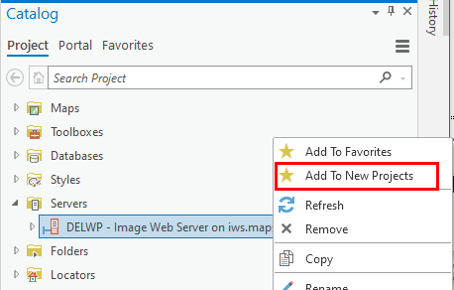

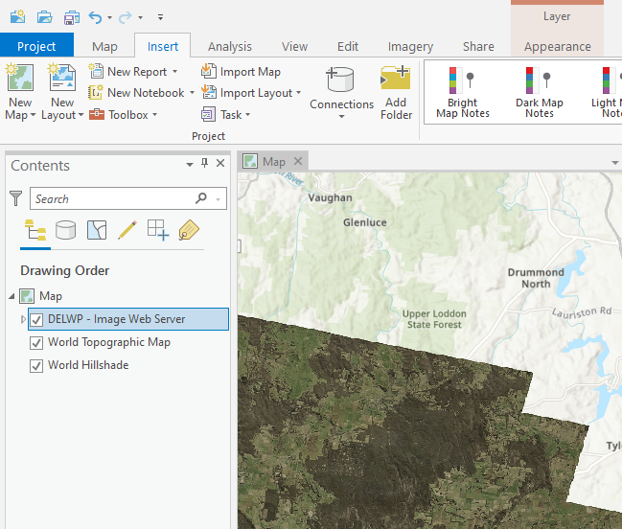
Loading an Image into ArcGIS Pro
- From the Catalog window, expand the Servers folder
- Double click on the DELWP - Image Web Server option and browse to the required directory
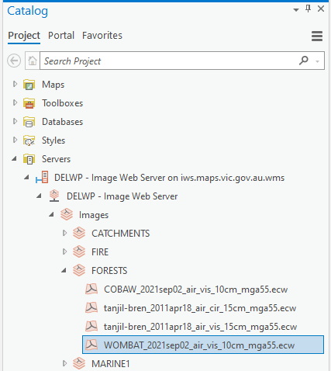
- To add the image to your map drag and drop the image name, or right-click “Add to Current Map”
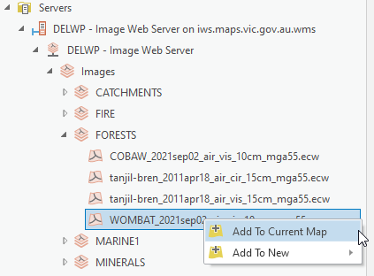
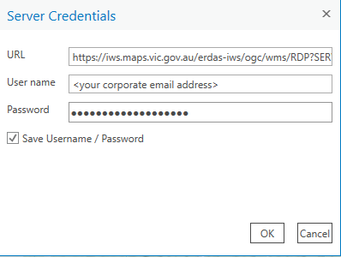
- When prompted enter your “corporate email address” and password and check “Save Username / Password”, then click OK.
- The image should then be loaded into your map. If it does not appear, ensure it is not hidden behind other layers in the Drawing Order

Trouble shooting: Windows 10 users
If you are a Windows 10 user and you are experiencing problems with displaying an image, you can try removing the iws.maps.vic.gov.au entry from your windows credentials. You should confirm that you are a registered IWS user and you have permissions to display the image (you are interested in) before you perform these steps.
- Type credential into Cortana and select Credential manager
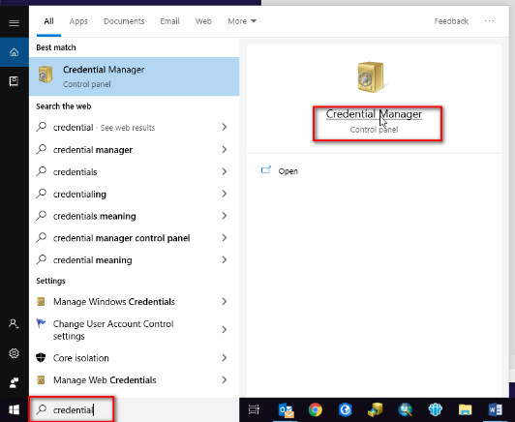
- Select Windows Credentials
- Expand the iws.maps.vic.gov.au entry
- Select remove
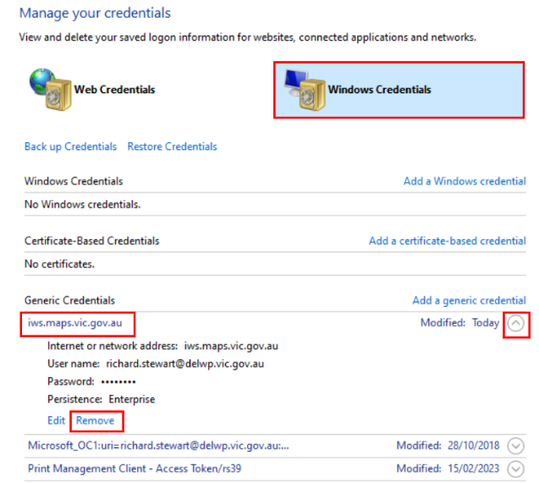
- Now repeat the steps outlined under the heading “Adding a WMS Server Connection”

Image Footprints layer
The image footprints layer is a spatial index of all georeferenced images stored on the Image Web Server. The layer contains information about the image file which will support basic searching for appropriate images.
Internal users can access the footprints layer via ArcGIS Pro as an ESRI file geodatabase via the VSDL on:
J:\Gis_Public\CSDL\CORPORATE.gdb\IWSFOOTPRINT
Approved external users can order and download the footprints layer via DataShare, which supports MapInfo tab and mid/mif as well as ESRI shp formats.

User Registration
Only authorised users can access the IWS.
Approved customers need an account in the identity management system (idam), to access the IWS.

DEECA staff
If you have previously created a DataShare account then you will already have an account in the identity management system. You will be able to log into the Image Web Server using your “corporate email address” and your single sign on password.
DEECA staff without an account in the identity management system (eg you don’t have an existing DataShare account (https://datashare.maps.vic.gov.au/)) need to create one via the DataShare login option
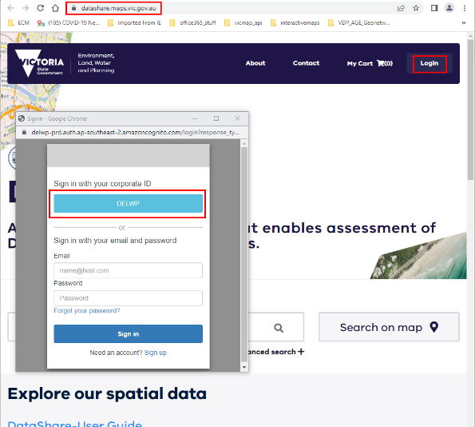
NOTE: once complete you can log out of DataShare
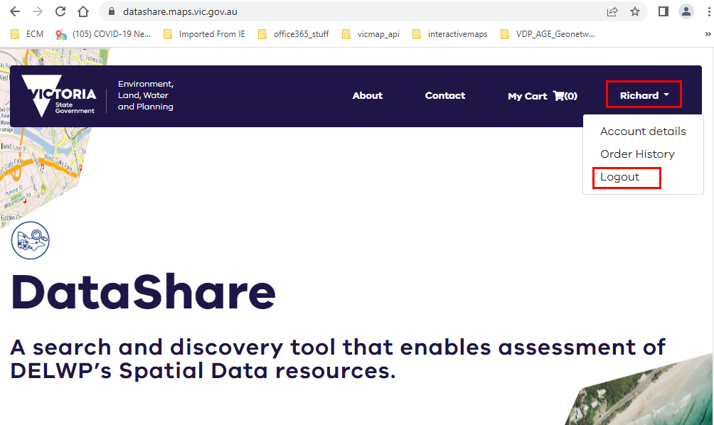
You can now log into the Image Web Server using your “corporate email address” and your single sign on password.

Non DEECA staff
If your organisation has permission to access the IWS and you have previously created a DataShare account (created using your corporate email address) then you will already have an account in the identity management system. You will be able to log into the Image Web Server using your “corporate email address” and your Datashare password.
Non DEECA staff without an account in the identity management system (eg you don’t have an existing DataShare account (https://datashare.maps.vic.gov.au/)) need to create one via the DataShare login option. Use your corporate email address.
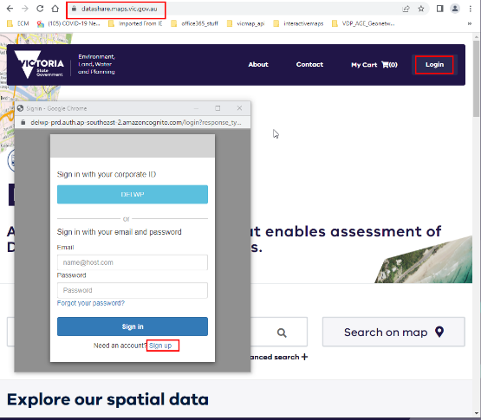
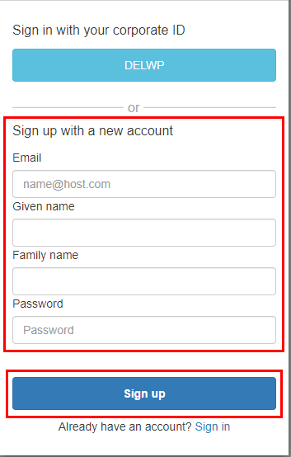

NOTE: once complete you can log out of DataShare
You can now log into the Image Web Server using your “corporate email address” and your DataShare password.

Coming Soon
The ability to view and save a list of Image Web Server imagery, so that you can differentiate between all the imagery on the image web server and those that you have access to is currently being developed and will be available soon.

Image Web Server Contact Details
The Information Services Division (DEECA) manages the IWS. Please address any feedback or queries to GIS.Helpdesk@deeca.vic.gov.au
© The State of Victoria Department of Energy, Environment and Climate Action 2025  This work is licensed under a Creative Commons Attribution 4.0 International licence. You are free to re-use the work under that licence, on the condition that you credit the State of Victoria as author. The licence does not apply to any images, photographs or branding, including the Victorian Coat of Arms, the Victorian Government logo and the Department of Energy, Environment and Climate Change (DEECA) logo. To view a copy of this licence, visit http://creativecommons.org/licenses/by/4.0/  Disclaimer  This publication may be of assistance to you, but the State of Victoria and its employees do not guarantee that the publication is without flaw of any kind or is wholly appropriate for your particular purposes and therefore disclaims all liability for any error, loss or other consequence which may arise from you relying on any information in this publication. | Accessibility  If you would like to receive this publication in an alternative format, please telephone the DEECA Customer Service Centre on 136186, email customer.service@delwp.vic.gov.au or via the National Relay Service on 133 677 www.relayservice.com.au. This document is also available on the internet at www.deeca.vic.gov.au.
.

