Guide to adverse possession applications under section 60 of the Transfer of Land 1958

Contents
1. Claiming land by adverse possession 2
1.1 Who may lodge 2
1.2 Land 2
1.3 Survey requirements – survey-based applications 3
1.4 Survey requirements – non-survey-based applications 3
2. Documents required by Land Use Victoria 3
2.1 Adverse possession application form 3
2.1.1 Land description 3
2.1.2 Applicant 4
2.1.3 Encumbrances 4
2.1.4 Electronic forms 4
2.2 Adverse possession Checklist 6
2.3 Evidence from the ALP acting for the applicant(s) 6
2.4 Evidence from the applicant(s) 6
2.5 Assignment of possessory interest 6
2.6 Evidence from prior possessor(s) 6
2.6.1 Unequivocal evidence required 6
2.7 Encumbrances 7
3. Contact Us 7

This guide sets out the requirements to lodge an application under section 60 of the Transfer of Land Act 1958 (TLA).
- Claiming land by adverse possession
An adverse possession application is used when the applicant has acquired title by possession over land that is under the operation of the TLA. To establish that the applicant has acquired possessory title, the re-entry of the registered proprietor must be time barred under section 8 of the Limitation of Actions Act 1958 (LAA). If the applicant (and any prior possessors through which they claim) has been in continuous, uninterrupted and exclusive possession of the land the subject of the application for 15 years, an application may be lodged with the Registrar of Titles (Registrar).
Even though the applicant may satisfy the formal requirements of the application, if the evidence provided by the applicant does not satisfy the Registrar that title by adverse possession has been acquired, the application will not be granted. The applicant may instead wish to consider seeking an appropriate declaration of a court of competent jurisdiction which could be the Supreme, County or Magistrates Court of Victoria.
To be able to grant an adverse possession application the Registrar must be satisfied that the registered proprietor’s rights and those of any other interested party have been extinguished and that the applicant is entitled to become registered proprietor.
Land Use Victoria will not process applications:
- where the applicant has not acquired title by possession; and/or
- that are not accompanied by evidence sufficient to support a case.
Failure to disclose sufficient evidence or provide the necessary documentation will result in the application being refused at lodgment, or after examination, rejected and fees forfeited under to section 105 of the TLA.
An applicant’s identity must be verified in accordance with the Registrar’s verification of identity requirements.

1.1 Who may lodge
The Registrar strongly recommends that an Australian legal practitioner (ALP) lodge on behalf of the applicant due to the complexity of the applications Even if an applicant chooses to lodge by themselves, a statutory declaration in support of their application must be provided by an ALP. The Law Institute of Victoria (LIV) has a referral service to legal practitioners experienced in this type of work. The LIV is located at Level 13, 140 William Street, Melbourne and can be contacted on (03) 9607 9311.

Note: section 4(3)(c) of the Conveyancers Act 2006 prevents licensed conveyancers from acting, and therefore executing, an application under section 60 of the TLA.

1.2 Land
For claims over General law land please see section 15 of the TLA.

If the applicant’s folio is affected by a ‘Warning as to dimensions’ and the applicant intends to acquire additional land by possession please see section 26P of the TLA.

For all other land, section 60 of the TLA may be used except when the exceptions under 7, 7A, 7B, 7AB and 7C of the LAA and relevant case law apply. Land that cannot be claimed by adverse possession includes:
- Crown land including government roads
- land in the right, title or interest of the Public Transport Corporation or Victorian Rail Track
- land in the right, title or interest of a water authority (defined by the Water Act 1989)
- land in the right, title or interest of the Head, Transport for Victoria or any predecessors (including Roads Corporation (VicRoads))
- land of which a council (as defined in the Local Government Act 1989) is the registered proprietor
- any part of common property affected by an owners corporation where the applicant is an owner of a lot affected by that owners corporation
- land that the applicant is otherwise entitled to, for example, as registered proprietor or beneficiary under a will, intestacy, or trust.

1.3 Survey requirements – survey-based applications
If the claimed land comprises or includes part of a separately transferable lot or Crown allotment the following is required:
- a plan of survey prepared and certified in accordance with Regulations 12(3) and 14 of the Surveying (Cadastral Surveys) Regulations 2015.
- an abstract of field records prepared and certified in accordance with Regulations 12(2) and 13 of the Surveying (Cadastral Surveys) Regulations 2015 and in accordance with the currency conditions outlined in the Victorian Cadastral Survey Practice Directives [DOCX 4.1MB]
- a licensed surveyor’s report prepared and signed in accordance with Regulation 15 of the Surveying (Cadastral Surveys) Regulations 2015.
These documents must be submitted electronically by the licensed surveyor through SPEAR.

1.4 Survey requirements – non-survey-based applications
Survey documents are not required for an application that does not amend title boundaries. The land over which adverse possession is claimed (Subject Land) must be a separately transferable parcel and be wholly enclosed by land that cannot form part of an application for adverse possession.

Aerial photos showing occupation surrounding the whole of the parcel claimed are required if the Subject Land does not meet the above enclosure requirements. In addition, if the Subject Land abuts the land in the proprietorship of a third-party, aerial photos will be required. If aerial photos are not sufficiently clear, a survey may be required. Drone photography is not acceptable. Any aerial photos supplied must include the date the aerial photo was taken and the scale.

The Guide: Request a waive survey for an adverse possession application [DOCX 2.4MB] provides further information about the waiving of survey requirements.

2. Documents required by Land Use Victoria
Freedom of Information (FOI) requests for supporting material, including statutory declarations, in support of these applications, will be provided if deemed relevant by the FOI unit in accordance with section 33 of the Freedom of Information Act 1982. See CIB 210 for further information.

2.1 Adverse possession application form

2.1.1 Land description
The application must set out the Subject Land, that is the land over which adverse possession is claimed.
If a whole folio(s) of the Register, include volume and folio references.
If part of a folio(s) of the Register, the part being claimed must be clearly described in the application form preferably with reference to a plan or diagram.
Applications based on survey must refer to the survey plan and then by reference to the affected folio(s) of the Register, for example:
The land marked [insert identifier] on the plan of survey signed by [surveyor name] dated [date survey plan was signed by surveyor] being part of the land in folio of the Register [volume and folio reference].
Applications not based on survey over part of a title should also use the land description to clearly indicate the Subject Land, for example:
Lot [insert identifier] on the plan [insert plan number eg. TP………] being part of the land in folio of the Register [volume and folio reference].
Crown Allotment [insert identifier] [Crown Description details eg. Section number, Parish/Township] being part of the land in folio of the Register [volume and folio reference].

2.1.2 Applicant
Insert the full name(s) and address(es) of the applicant(s). This information will appear on the new folio if the application is successful. The address(es) will be where notices are mailed in the future.
Please note: a ‘care of’ or ‘post office box’ is not an acceptable address.
Applications can also be made by:
- a legal personal representative
- a mortgagee in possession
- one or more co-proprietors against the other co-proprietor(s).

2.1.3 Encumbrances
The encumbrances to be removed from the Subject Land must be set out in the application form.
If no encumbrances are to be removed from the Subject Land the application form should state ‘Subject to existing encumbrances.’
If all encumbrances are to be removed from the Subject Land the application form should state ‘Free of encumbrances.’
The applicant(s) may choose not to remove some existing encumbrances with the statement ‘Free of encumbrances save and except the [encumbrance reference which is not being removed]’.

2.1.4 Electronic forms
An example of an electronic application form for an adverse possession application lodged in SPEAR has been provided on the following page. This example should be used as guide when completing the application form.
Common issues with these application forms identified at lodgment are:
- An incorrect Land Title Reference (title reference must be for the affected folio(s))
- Part Land Affected section must state ‘Y’ when only part of the affected folio(s) is being claimed
- Land Description section incorrectly completed. If referring to a parcel on a plan of survey, the land description must identify the land being claimed with reference to that plan of survey.
- Encumbrances section incorrectly completed.
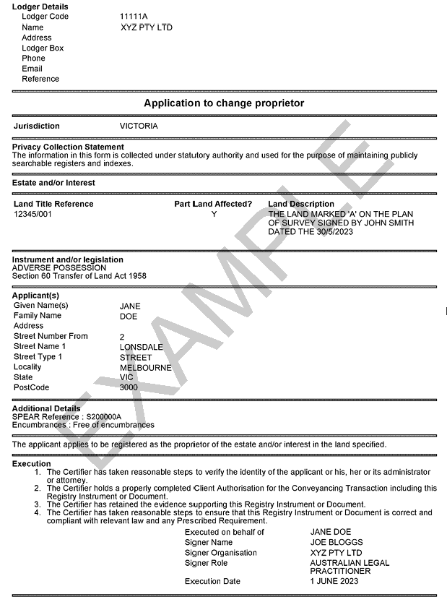

2.2 Adverse possession Checklist
The Adverse possession checklist [DOCX 232KB] must be fully completed, signed and produced at lodgment.
If the preliminary lodgment examination process reveals incomplete checklists, incorrectly completed checklists or deficiencies in the application and evidence, the application will be rejected, and fees forfeited. The checklist is available on the Fees, guides and forms page.

2.3 Evidence from the ALP acting for the applicant(s)
A statutory declaration is required from the applicant’s ALP using the approved proforma statutory declaration from the applicant’s Australian Legal Practitioner (ALP) [DOCX 49.5KB].

2.4 Evidence from the applicant(s)
A statutory declaration is required from the applicant(s) using the approved proforma statutory declaration from the applicant [DOCX 47.1KB]. Each applicant must provide a statutory declaration, either their own or a joint one with other applicants.
Note: a copy of the applicant’s statutory declaration may be sent to the State Revenue Office (SRO) for duty assessment after the application is registered.

2.5 Assignment of possessory interest
If the applicant has not been in possession for at least 15 years, the applicant must produce an assignment or chain of assignments of the possessory rights of the person or people through whom the applicant claims. Each assignment should be by deed, which is no longer required to be stamped or denoted by the SRO because the duty will be assessed by the SRO if the application is to be granted.
A contract of sale does not satisfy this requirement unless the subject land is specifically described in the document. Equally, a transfer of land instrument cannot be inferred to include possessory land.
A sample of a deed of assignment of possessory interest [DOCX 43.6KB] is available on the Fees, guides and forms page.

2.6 Evidence from prior possessor(s)
If the applicant(s) has not been in possession for at least 15 years, a statutory declaration is required from the prior possessor(s) using the approved proforma statutory declaration from prior possessor(s) [DOCX 42.7KB]. Each prior possessor must provide a statutory declaration, either their own or a joint one with others they possessed with.

2.6.1 Unequivocal evidence required
There are situations where the applicant holds a deed of assignment but cannot produce a statutory declaration from the prior possessor(s) at the time of lodgment, because the prior possessor(s) is dead or cannot be traced. In these circumstances there will need to be unequivocal evidence that the title of the registered proprietor has been extinguished.
A statutory declaration from a disinterested witness may be required if the witness has sufficient knowledge. The evidence of a neighbour who has known the land for the entire statutory period is preferred. Witnesses must use the approved proforma statutory declaration from disinterested witness [DOCX 35.0KB]

2.7 Encumbrances
Encumbrances over the Subject Land can be removed if it is proved unequivocally that the applicant has been in continuous, uninterrupted, and exclusive possession of the encumbrance.
The applicant must provide evidence in the form of a statutory declaration using the [approved proforma] that the relevant encumbrances have been extinguished by the applicant’s possession.
If the encumbrance is an easement (e.g. rights of carriageway, drainage, etc.), adverse possession of the easement is required for at least 30 years. The evidence requirements for applications under section 73 and 73A of the TLA apply.
Other encumbrances that may be dealt with are:
- reserves created under the TLA or the Subdivision Act 1988 (but not Crown reservations)
- agreements under section 173 of the Planning and Environment Act 1987
- caveats
- statutory charges.
Encumbrances that cannot be removed include (but are not limited to):
- rights saved by section 207D of the Local Government Act 1989
- notices of acquisition under section 57 of the TLA
- some easements and rights created under section 12(2) Subdivision Act 1988 and section 98 of the TLA
- conditions or reservations in Crown Grants.
Note: Mortgages extinguished under the LAA may be removed under section 84(2) of the TLA.

3. Contact Us
For contact details visit land.vic.gov.au/contact-us

