Land Victoria
Customer Information Bulletin No. 138/2012

New Forms

Land Victoria has developed three new interactive PDF forms:

- Discharge of Mortgage or Charge
- Transfer of Land
- Mortgage.

The new forms contain defined panels, online help and system messages to guide customers in completing the forms. Customers can also save the form either partially or fully completed on their own computer for future reference.

The new forms are available on Land Victoria’s webpage at: www.dse.vic.gov.au > Property, Titles & Maps > Land Titles > Forms, guides and fees.

A sample form is included on the following page.

Customers are encouraged to use the new forms. Old style forms will continue to be accepted.

The new forms do not contain provision for an 'Order to Register'. This is because early next year Land Victoria intends to revise the process for the production of Certificates of Title for dealings lodged by another party.

The present requirement for an Order to Register will not be part of the new process. Until the new process is introduced, any Order to Register required to support a lodgement using one of the new forms should be prepared on a separate page and submitted with the lodgement.

For examples of Orders to Register, see the Land Victoria Lodging Book (Version 4.1), page 1.7.

Discharge of Mortgage or Charge

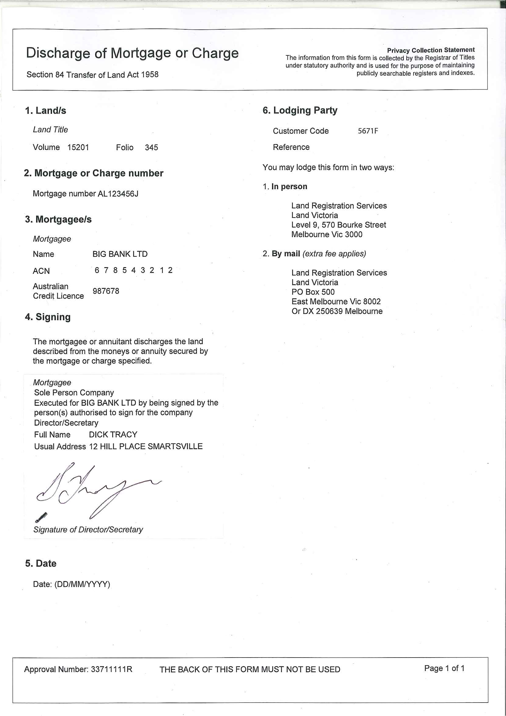

How to subscribe to the Customer Information Bulletin
To receive the CIB online, send an email with your name and email address to lv.cib@dse.vic.gov.au with SUBSCRIBE in the subject line.

Subscribers receive an email including a link to each new issue available for download from the Department of Sustainability and Environment website.

Unsubscribe by sending an email with UNSUBSCRIBE in the subject heading.

For further information:
Land Registration Services
Land Victoria
Level 9, 570 Bourke Street
Melbourne VIC 3000
PO Box 500
East Melbourne VIC 8002
DX 250639
Telephone (03) 8636 2010
Fax (03) 8636 2299

Published by the Victorian Government Department of Sustainability and Environment Melbourne November, 2012
© The State of Victoria Department of Sustainability and Environment 2012
This publication is copyright. No part may be reproduced by any process except in accordance with the provisions of the Copyright Act 1968.

Authorised by the Victorian Government, 570 Bourke Street, Melbourne.
ISSN 1441-1504 PP 349181/01650

For more information contact the DSE Customer Service Centre 136 186

Disclaimer
This publication may be of assistance to you but the State of Victoria and its employees do not guarantee that the publication is without flaw of any kind or is wholly appropriate for your particular purposes and therefore disclaims all liability for any error, loss or other consequence which may arise from you relying on any information in this publication.

Accessibility
If you would like to receive this publication in an accessible format, such as large print or audio, please telephone 136 186, or email customer.service@dse.vic.gov.au

Deaf, hearing impaired or speech impaired? Call us via the National Relay Service on 133 677 or visit www.relayservice.com.au

