|  |
| --- |
| Land Use Victoria  Customer Information Bulletin 180  August 2018 |
|  |

# 

# Registrar’s requirements for paper conveyancing transactions

Version 5 of the *Registrar’s Requirements for Paper Conveyancing Transactions* has been published at [www.propertyandlandtitles.vic.gov.au/publications](http://www.propertyandlandtitles.vic.gov.au/publications).

Version 5 incorporates updates to section 6 ‘Electronic Instruments’ and clarifies the Registrar’s transition to 100% electronic lodgment. In short, electronic lodgment is the use of an Electronic Lodgment Network (ELN) to lodge conveyancing transactions with Land Use Victoria. Under Registrar’s Requirement 6.5(e), on 1 October 2018 a major milestone in the transition to 100% electronic lodgment will become effective and is described below.

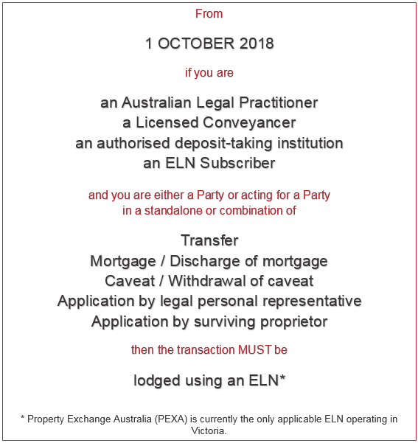

## Exceptions

The following are the current exceptions to the Registrar’s Requirement to lodge Instruments using an ELN:

* the SPEAR ELN
* there is an existing paper Instrument that has been signed prior to the date when electronic lodgment of that particular class of Instrument or transaction is required
* if in a combination of Instruments a Party in one or more Instruments is not an ELN Subscriber or represented by a conveyancer or lawyer.

**Example:** where a combination of discharge of mortgage, transfer and mortgage includes a transferor that is not an ELN Subscriber or is not represented by a conveyancer or lawyer, all Instruments may be lodged as a combination in paper.

* a folio of the Register cannot be dealt with in an ELN
* an instrument affecting more than 20 folios
* a transfer is of a type that is not available electronically, such as:
  + transfers creating an easement
  + transfers of an interest (e.g. a lease)
  + transfers of part of land in a folio of the Register
  + transfers of a tenant in common’s share
  + transfers that cannot be assessed for duty using the State Revenue Office [Duties Online](http://www.sro.vic.gov.au/dutiesonline) System – details of the transaction types able to be processed in Duties Online are in the tables of transactions and combinations of transactions available on the [SRO website](http://www.sro.vic.gov.au/duties-online-transaction-types)
* a survivorship or transmission application that is not available electronically, such as a survivorship application by an interest holder.

From 1 October 2018, the Registrar will refuse to accept for lodgment any paper instrument that, under the Registrar’s Requirements, is required to be lodged using an ELN.

The Registrar will continue to notify industry when new functionality becomes available in an ELN. More ELN functionality will result in fewer exceptions to lodging using an ELN.

# Progression towards 100% electronic lodgment

There have been significant increases in electronic lodgment at Land Use Victoria (LUV) over the last 12 months. In July 2018, electronic lodgments equalled 58 per cent of all instruments lodged. LUV expects the total number of instruments lodged electronically in August 2018 to exceed 50,000.

### Total lodgments at LUV

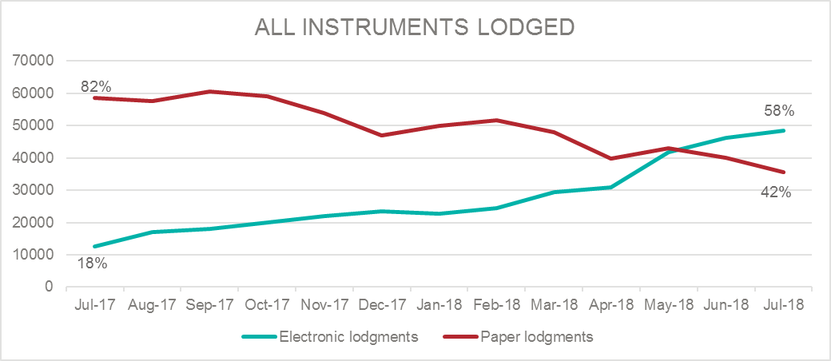

Discharge of mortgage, transfer and mortgage account for approximately 85 per cent of instruments lodged at LUV. Collectively in July 2018, electronic lodgments for discharge of mortgage, transfer and mortgage averaged 60 per cent.

### Instruments lodged in July 2018

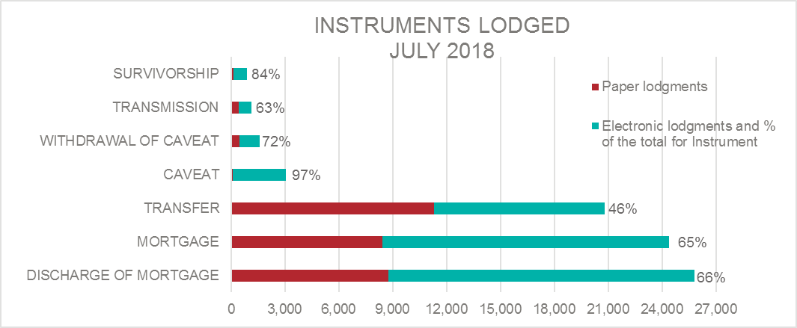

Refinances comprising a discharge of mortgage and mortgage were close to achieving 100 per cent electronic lodgment in July 2018. Settlement matters comprising a discharge of mortgage, transfer and mortgage (DTM) have steadily increased throughout 2018 and, in July 2018, electronic lodgments of DTMs accounted for 41 per cent of lodgments. Leading up to the 1 October 2018 milestone, electronic lodgment for DTMs is expected to increase significantly.

### Instrument combinations lodged in July 2018

# Subscribe

To receive notification when a *Customer Information Bulletin* is published, please send an email to lv.cib@delwp.vic.gov.au with SUBSCRIBE in the subject line – include your name and email address in the body of the email.

# Contact us

For [location and contact details](http://www.dtpli.vic.gov.au/property-and-land-titles/contact-us), go to [www.propertyandlandtitles.vic.gov.au/contact-us](http://www.propertyandlandtitles.vic.gov.au/contact-us).

|  |  |
| --- | --- |
| © The State of Victoria Department of Environment, Land, Water and Planning 2018  LogoThis work is licensed under a Creative Commons Attribution 4.0 International licence. You are free to re-use the work under that licence, on the condition that you credit the State of Victoria as author. The licence does not apply to any images, photographs or branding, including the Victorian Coat of Arms, the Victorian Government logo and the Department of Environment, Land, Water and Planning (DELWP) logo. To view a copy of this licence, visit http://creativecommons.org/licenses/by/4.0/  Disclaimer  This publication may be of assistance to you but the State of Victoria and its employees do not guarantee that the publication is without flaw of any kind or is wholly appropriate for your particular purposes and therefore disclaims all liability for any error, loss or other consequence which may arise from you relying on any information in this publication. | Accessibility  If you would like to receive this publication in an alternative format, please telephone the DELWP Customer Service Centre on 136186, email [customer.service@delwp.vic.gov.au](mailto:customer.service@delwp.vic.gov.au), or via the National Relay Service on 133 677 [www.relayservice.com.au](http://www.relayservice.com.au). This document is also available on the internet at [www.delwp.vic.gov.au](http://www.delwp.vic.gov.au). |