Data product description
Vicmap Index
Document version 4.1 – July 2014
Applies to delivered data model version 1.0

Published by the Victorian Government Department of Environment and Primary Industries Melbourne,
July 2013
© The State of Victoria Department of Environment and Primary Industries 2014
This publication is copyright. No part may be reproduced by any process except in accordance with the
provisions of the Copyright Act 1968.
Authorised by the Victorian Government, 8 Nicholson Street, East Melbourne.
Print managed by Finsbury Green. Printed on recycled paper.
ISBN 978-174287-815-7
For more information contact the DEPI Customer Service Centre 136 186
Standard
This document is based on the AS/NZS ISO 19131:2008 Geographic information
Acknowledgments
The Department of Environment and Primary Industries acknowledge the assistance of PSMA Australia in the preparation of this guide.
Disclaimer
This publication may be of assistance to you but the State of Victoria and its employees do not guarantee that the
publication is without flaw of any kind or is wholly appropriate for your particular purposes and therefore disclaims all
liability for any error, loss or other consequence which may arise from you relying on any information in this publication.
Information Services Branch does not warrant that this Product Description and the data are free from errors or omissions. Also, Information Services Branch shall not be in any way liable for any loss, damage or injury suffered by the licensed user of the data of this Product Description or any other person or organisation consequent upon or incidental to the existence of errors or omissions in the data or this Product Description.
Accessibility
If you would like to receive this publication in an accessible format, such as large print or audio, please telephone
136 186, or email customer.service@dse.vic.gov.au
Deaf, hearing impaired or speech impaired? Call us via the National Relay Service on 133 677 or visit
www.relayservice.com.au
This document is also available in PDF format on the internet at www.dse.vic.gov.au/vicmap/vicmap
Information Services Branch
Department of Environment and Primary Industries

Contents
Overview 5
Vicmap Products 5
Data product specification title 5
Reference date 5
Responsible party 5
Language 5
Topic category 5
Distribution format 5
Terms and definitions 6
Abbreviations and acronyms 8
Informal description of the data product 9
Specification Scope 10
Scope identification 10
Data Product Identification 11
Title 11
Alternate titles 11
Abstract 11
Purpose 11
Topic category 11
Geographic description 11
Data content and structure 12
Feature-based data 12
Feature-based application schema (data model) 12
Data dictionary 12
Data structure 12
Reference system 15
Spatial reference system 15
Temporal reference system 15
Reference system scope 15
Reference systems 15
Data quality 16
Accuracy 16
Feature and attribute accuracy (Thematic accuracy) 16
Completeness 17
Logical consistency 17
Data capture 17
Data capture scope 17
Data maintenance 17
Vicmap maintenance 17
Maintenance and update frequency 18
Data product delivery 19
Access 19
Licencing and pricing 19
Metadata 20
Appendix A- data model 21
Appendix B data dictionary 22
Overview of index tables 22
Index to fields (attributes) 23
Reference tables 30

Overview

Vicmap Products
Vicmap Digital is the foundation that that underlies most spatial information in Victoria. This set of spatial related data products, made from individual datasets, is developed by Information Services Victoria, DEPI.
VSIS framework information datasets have been delivered into the following Vicmap Products, identified below.

Vicmap Address  Vicmap Admin  Vicmap Crown Land Tenure  Vicmap Elevation  Vicmap Features of Interest  Vicmap Hydro  Vicmap Imagery-Aerial Photography  Vicmap Imagery- Satellite | Vicmap Lite  Vicmap Planning  Vicmap Position  Vicmap Property  Vicmap Topographic  Vicmap Transport  Vicmap Vegetation

Further information at http://www.dse.vic.gov.au/vicmap

Data product specification title
Vicmap Index Product Description.

Reference date
July 2013.

Responsible party
Information Services Branch
Department of Environment and Primary Industries
PO Box 500, East Melbourne VIC 3002 Australia
T: 03 8636 2333 | F: 03 8636 2813 | E: vicmap.info@depi.vic.gov.au
http://www.depi.vic.gov.au/vicmap
http://www.depi.vic.gov.au/maps-imagery-data
http://www.depi.vic.gov.au/spatial

Language
English

Topic category
Spatial data and metadata for the index dataset for Victoria.

Distribution format
PDF.

Terms and definitions
This section includes the standard terms and conditions.
.

Term | Definition
Area feature | A feature which is portrayed as a region or surface. An area feature is bounded by one or more polygons.
AS2482 | Australian Standard 2482 defines Geographic information systems – Geographic data – Interchange of feature-coded digital mapping data.
AS/NZS 19131:2008 | Geographic Information – Data Product Specifications  This standard was used as a source for developing the Vicmap Data Product Description template. See also PSMA Data Product Description.
Attribute | A particular characteristic or property of an entity. Attributes can be spatial (or locational) and aspatial (or non-locational).
Attribute Object | The addition of non-locational information about a feature instance. These data identify the feature class and the aspatial attributes of a specific instance of the feature type. The attribute object is composed of one or more attributes.
Attribute Value | The value assigned to an attribute for a specific feature instance.
Chain | A line composed of a sequence of non-intersecting line segments bounded by nodes. Chains reference the polygons to the left and right of the chain.
Data | The base level of information stored in electronic databases. Generally, “raw” data has not been value-added. Source- AUSISB at http://www.ausISB.gov.au
Entity | A real world phenomenon not divided into phenomena of the same kind.
Feature Instance | An abstraction of an entity. The description of a feature instance encompasses only selected properties of that entity. Feature instances can also be referred to as features.
Feature Type | A class of real world phenomena with common properties.  A group of feature instances defined by a set of rules and having common attributes and relationships that are properties of the corresponding real world phenomena. Within the Oracle tables that comprise Vicmap Digital Property, classes may refer to “link” tables, which establish direct relationships between the point and/or line and/or polygon structures that may be used as spatial objects.  The feature structure of the feature based data model can be summarised as:  feature instance = [spatial object + attribute object]
GeoCASE | The modeling tool is a proprietary computer-aided software engineering product called GeoCASE. It is based on the entity–relationship (E–R) model extended to suit an object-oriented approach to representing the real world. (See Ross Honeyman)
Information Services Branch | A body within Department of Environment and Primary Industries, responsible for spatial policy for the State and for providing and maintaining a statewide spatial infrastructure, including the Victorian Geodetic Framework and Vicmap Digital.
Layer | Subdivision of a theme into one or more layers of data on the basis of topological relationships. Linear networks, polygons and point/line features are placed in separate layers.
Linear Network | A theme layer consisting of linear features which are connected forming a pathway along which movement is possible.
Metadata | Metadata, defined as ‘information about information’, provides fundamental information management tools at three levels:  • Discovery: enabling users to locate and evaluate information.  • Management: enabling custodians to better manage their spatial information.  • Utilisation: enabling users to access and manipulate information by means of automated / distributed systems.
Node | A point that is a junction of two or more chains or which is the end point of a chain.
Node/Chain Structure | The structuring of linear features in a theme layer so that they consist of chains broken by nodes at intersections or at the point where an attribute of the feature changes.
Notification for Editing Service | The Notification for Editing Service (NES) is an initiative that is crucial to supporting government delivering outcomes by aiding in the provision of authoritative location based services across business for users of all levels of expertise. The objectives of NES are to:  • Improve spatial data quality  • Provide simple, efficient, effective, low cost maintenance processes  • Create a fully transparent maintenance process for all participants  • Enable maintenance process availability to any potential maintainer  Access to NES application is restricted to selected customers. Enquiries can be directed to vicmap.help@dse.vic.gov.au
Persistent Feature identifier (PFI) | Unique Feature Identification (each feature is uniquely identified for change management) is managed through the use of two identifier attributes; namely the Persistent Feature identifier (PFI) and the Unique Feature Identifier (UFI).  See also Unique Feature Identifier(UFI)
Polygon | A set of chains used to define the boundaries of an area. There is one external polygon and there may be one or more internal, non-nested polygons.
Positional Accuracy | Statistical estimate of the degree to which planimetric coordinates and elevations of features agree with their real world values.
PSMA Data Product Description | PSMA Australia Limited, PSMA Transport & Topography Data Product Description, V3.4, November 2012.  This Data Product Description was used as the template for developing the Vicmap Data Product Description template.  See also AS/NZS 19131:2008 Geographic Information – Data Product Specifications.
Segment | A direct line between a pair of points, or a point and a node.
Sliver | Long, thin triangle or polygon of very small area formed by overlaying of almost-coincident lines. Often a result of twice-digitising the same linear feature.
Spatial Object | The addition of all of the locational attributes of the feature instance and may comprise geometrical objects such as points, lines and polygons. Spatial objects carry a spatial address that consists of one or more couplets (x, y) or triplets (x, y, z) of co-ordinates. In the feature based data model topological relationships will be carried as part of the spatial object whenever the transfer formats support them.
Theme | The information contained in the map production material can be divided into themes which contain logically-related geographic information, each theme capable of being used as a data set in its own right.  Custodial Officers- Place in a product specific items here.
Unique Feature identifier (UFI) | Unique Feature Identification (each feature is uniquely identified for change management) is managed through the use of two identifier attributes; namely the Persistent Feature identifier (PFI) and the Unique Feature Identifier (UFI).  See also Persistent Feature Identifier (PFI)
Vicmap | Vicmap is a set of spatially related data products made up from individual datasets. They are the underlying foundation to Victoria's primary mapping and geographic information systems.  Vicmap products are produced and managed by Information Services Branch, Department of Environment and Primary Industries. Further Information- http://www.dse.vic.gov.au/vicmap

Abbreviations and acronyms
This section includes the standard abbreviations and acronyms.
Add abbreviations and acronyms unique to your Product.

Term | Definition
ABS | Australian Bureau of Statistics
ASGC | Australian Standard Geographical Classification.
ASGS | Australian Statistical Geography Standard
CAD | Computer-Aided Design is the production of drawings, specifications, parts lists, and other design-related elements using special graphics- and calculations-intensive computer programs. CAD systems originally merely automated drafting but now often include three-dimensional modeling and computer-simulated operation of the model.
GDA94 | The Geocentric Datum of Australia (GDA) is the latest Australian coordinate system, replacing the Australian Geodetic Datum (AGD).  The GDA is a part of a global coordinate reference frame and is directly compatible with the Global Navigation Satellite Systems (GNSS).  It is the result of more than a decade of anticipation and work by the Intergovernmental Committee on Surveying and Mapping (ICSM) and its predecessor, the National Mapping Council (NMC).  When the NMC adopted the Australian Geodetic Datum (AGD84) coordinate set in 1984, it recognised the need for Australia to eventually adopt a geocentric datum. This was further recognised in 1988 when the ICSM recommended the adoption of an appropriate geocentric datum by 1 January 2000. This resulted in the adoption of the GDA94.
GIS | Geographic Information System. A spatial database which is manipulated with a set of spatial operators or commands.
ICSM | Intergovernmental Committee on Survey and Mapping. ICSM's role is to provide leadership through coordination and cooperation in surveying, mapping and charting. ICSM's core function is to coordinate and promote the development and maintenance of key national spatial data including geodetic, topographic, cadastral, street addressing, tides & sea level, and geographical names. See http://www.icsm.gov.au/
IUF | Incremental Update Format  A system whereby maintenance updates are provided as change only, add/modify/delete incremental update files, between nominated dates/times.
MGA94 | Map Grid Australia. A cartesian coordinate system based on the Universal Transverse Mercator projection on the Geocentric Datum of Australia 1994. The unit of measure is the metre.
SDE | Spatial Data Engine – an ESRI product  Software used by Information Services Branch to manage the spatial component of it’s Unified Data Store, which includes copies of the whole of the Vicmap Digital product suite.
SDTS | The United States Spatial Data Transfer Standard. This standard is to be the basis of the new Australian Standard for the transfer of spatial digital data.
VSIS 2011-14 | In 2008, the Victorian Spatial Council’s Victorian Spatial Information Strategy 2008-101 introduced the strategic goal of creating a ‘spatially enabled Victoria’.  The role of the Strategy is to create the frameworks that enable all sectors of the spatial information community2 to be highly engaged and their efforts integrated towards delivering a spatially enabled Victoria.  Development of this 2011-14 Strategy has allowed the Council to review the landscape it painted in 2008 and set out the requirements for continuing to respond to the challenges associated with meeting this goal.  VSIS 2011-2014 incorporates four integrated strategic directions:  • Creating a framework in which the use of spatial information can flourish.  • Adopting an inclusive approach to the management of spatial information  • Developing the spatial information community through collaboration and partnerships  • Maintaining the foundations for spatial information management.  Further information http://victorianspatialcouncil.org/

Informal description of the data product
Vicmap Index comprises several individual datasets depicting the extents of a number of Government and industry map series products as well as the State boundary, zero contour, coastline and the extent of information of Vicmap framework data.
Data is sourced from authoritative sources, identified by the name of the dataset.
This dataset will assist users in spatial location, map production, web based search, dispatch, delivery, and GIS analysis

Specification Scope

Scope identification

Level
Theme

Level Names
Vicmap Index

Extent
State of Victoria.

Vicmap Products effected by the Cross border data agreements
Cross border data for select Vicmap Products is provided to DEPI under agreements with NSW and SA.
For these select Vicmap Products, coverage extends across the whole of Victoria as well as up to 100 kilometers into New South Wales and an 1 x 1:100 000 tile into South Australia.
For further information, the list of effected products and a coverage diagram go to http://www.dse.vic.gov.au/crossborderdata.

Data available under the Data.Vic policy http://www.data.vic.gov.au/ – Victoria Only
Many DEPI datasets, and most Vicmap products (covering Victoria only) are freely available through the Data.vic Policy.
See this website for details including:
- Timetable for release
- Usage and availability restrictions
- Licence restrictions and conditions
- Access constraints
- Exclusion of liability
- Supply and media formats
- Projections.

NOTE: Any Vicmap Products or datasets, not currently implemented by the Data.vic Policy, still retain the same pricing, licencing, restrictions, conditions, liability, constraints as indicated at http://www.dse.vic.gov.au/vicmap webpage.

Data Product Identification
See Section 11. VICMAP PRODUCTS, for more information on Vicmap.

Title
Vicmap Index

Alternate titles
NOT APPLICABLE,

Abstract
This product contains line, & polygon features delineating various current government and industry indices. It is a combination of a number of data sets that are a part of the Vicmap Index suite of products. The Vicmap Index product records map series and map book indices as defined by the Custodian. These include Vicmap Topographic Maps, Vicmap Mapbooks, and VicRoads , as well as the spatial boundary and extent of Vicmap framework data .

Purpose
This dataset will assist users in spatial location, map production, web based search, dispatch, delivery, and GIS analysis

Topic category
Vicmap Index contains lines and polygons defined by coordinate spatial data (latitude and longitude) with associated textual metadata.

Geographic description
The Vicmap product covers the indices within the State of Victoria as well as framework boundaries – including state boundaries of south east Australia
The bounding box for this product is as follows:
-
North bounding latitude 32d
South bounding latitude 44d
East bounding longitude 153d
West bounding longitude 138d

Diagram 1. Vicmap Index- Framework
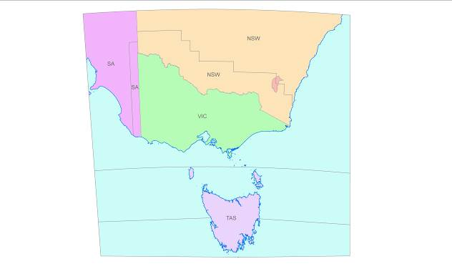

Data content and structure
The Vicmap Index spatial dataset consists of a line and polygon features depicting indices of a number of Government and industry map series products as well as the State boundary, zero contour, coastline and the data extent for Vicmap Framework data. Point data is not included in Vicmap Index
More information on Structure is detailed in the data description of each dataset

Feature-based data
Vicmap Index is a feature-based product. A data model (See Appendix A) is included with an associated data dictionary (See Appendix B).

Feature-based application schema (data model)
The Vicmap Index data model diagram, current to the listed Reference Date, is set out at Appendix A.
NOTE- The most current Data Models are published at http://www.depi.vic.gov.au/vicmap Select Vicmap Products > this product.

Data dictionary
The Vicmap Index feature based feature catalogue in support to the application schema, current to the listed Reference Date, is set out at Appendix 2.

Data structure
Vector file represented as lines and polygons.
Data is stored and maintained in relational databases under the control and direction of Information Services Branch, using Oracle and ESRI’s Spatial Data Engine (SDE).

The four products that make up the Vicmap Index database are:
- VICMAP_INDEX
- Contains all current datasets excluding Melway
- VICMAP_INDEX_RESTRICTED
- Contains current restricted datasets including Melway dataset ( licensed to WoVG users only)
- VICMAP_INDEX_SUPERSEDED
- Contains all superseded datasets excluding Melway
- VICMAP_INDEX_SUPERSEDED_RESTRICTED
- Contains all superseded restricted datasets including Melway datsets (licensed to WoVG users only)

VICMAP_INDEX and VICMAP_INDEX_SUPERSEDED contain the following themes:
- Framework
- Vicmap Topographic Index
- Spatial Visions Vicmap Mapbook Index
- VicRoads Index

VICMAP_RESTRICTED and VICMAP_SUPERSEDED_RESTRICTED contain the following theme
- Melway Index

The datasets that make up these themes are:
- Framework
  - FR_FRAMEWORK_AREA_POLYGON
  - FR_FRAMEWORK_AREA_LINE
- Vicmap Topographic Index
  - VICMAP_MAPINDEX_SPECIAL
  - VICMAP_MAPINDEX_100D
  - VICMAP_MAPINDEX_50D
  - VICMAP_MAPINDEX_50S
  - VICMAP_MAPINDEX_30DA3
  - VICMAP_MAPINDEX_30SA4
  - VICMAP_MAPINDEX_25D
  - VICMAP_MAPINDEX_25S

- Spatial Visions Vicmap Mapbook Index
  - MAPBOOK_MAPINDEX_150_EDXX
  - MAPBOOK_MAPINDEX_100_EDXX
  - MAPBOOK_MAPINDEX_50_EDXX
  - MAPBOOK_MAPINDEX_20_EDXX
  - MAPBOOK_MAPINDEX_15_EDXX
  - MAPBOOK_PAGEGRID_100_EDXX
  - MAPBOOK_PAGEGRID_50_EDXX
  - MAPBOOK_PAGEGRID_150_EDXX
  - MAPBOOK_PAGEGRID_20_EDXX
  - MAPBOOK_PAGEGRID_15_EDXX

- Vicroads Index
  - VICROADS_MAPINDEX_250_EDXX
  - VICROADS_MAPINDEX_100_EDXX
  - VICROADS_MAPINDEX_25_EDXX
  - VICROADS_PAGEGRID_250_EDXX
  - VICROADS_PAGEGRID_100_EDXX
  - VICROADS_PAGEGRID_25_EDXX

- Melway Index
  - MELWAY_MAPINDEX_60_EDXX
  - MELWAY_MAPINDEX_25_EDXX
  - MELWAY_MAPINDEX_20_EDXX
  - MELWAY_MAPINDEX_15_EDXX
  - MELWAY_MAPINDEX_10_EDXX
  - MELWAY_MAPINDEX_5_EDXX
  - MELWAY_PAGEGRID_60_EDXX
  - MELWAY_PAGEGRID_25_EDXX
  - MELWAY_PAGEGRID_20_EDXX
  - MELWAY_PAGEGRID_15_EDXX
  - MELWAY_PAGEGRID_10_EDXX
  - MELWAY_PAGEGRID_5_EDXX

All of the above are polygon databases except for FR_FRAMEWORK_AREA_LINE which is a line and polygon database

Note that:
- ED refers to the current edition of the hardcopy map series publication (Mapbook, Vicroads & Melway) from which these datasets are derived.
- Once a new edition becomes available the preceding one will be placed in the SUPERCEDED product.
- The XX_PAGEGRID_XX dataset holds map reference grids for the corresponding XX_MAPINDEX_XX datasets.

Reference system

Spatial reference system
GDA 94.

Temporal reference system
Gregorian calendar.

Reference system scope
The spatial objects and temporal collection periods for the Vicmap datasets.

Reference systems
The datum used in the construction and maintenance of Vicmap data is the Geocentric Datum of Australia. Data is held in geographicals (latitude/longitude) computed in terms of the GDA at 01 January 1994 (GDA94).

Data quality

Accuracy
The Vicmap Index product is a new product that will rely heavily on Custodianship Agreements for authoritative sources.
It should be noted that the purpose of this dataset is, in most cases, to mirror the data of the authoritative source.
These datasets will have a high level of completeness in terms of feature, attribute and classification with their real world instances.
Please check with the custodial officer for specific information regarding any particular feature type.

For Vicmap Index: Vicmap Topographic Index and Vicmap Index: Framework the following spatial accuracy will apply:
Standard of accuracy conforms to specifications and classification AA1 of the Survey Co-ordination (Surveys) Regulations 1992.
HORIZONTAL: +/- 12.5 metres of true position at map scale.

New updates of Vicroads, Melway and Mapbook indices will be incorporated into Vicmap Index as the equivalent relevant hardcopy product is updated, ensuring consistency between the hardcopy and the digital versions of the product.

Dataset | Dataset creator and custodian | Dataset maintainer
Vicmap Index: Vicmap Topographic Index | Information Services Division, Department of Environment & Primary Industries | Information Services Division, Department of Environment & Primary Industries
Vicmap Index: Framework | Information Services Division, Department of Environment & Primary Industries | Information Services Division, Department of Environment & Primary Industries
Vicmap Index: Spatial Vision’s Vicmap Mapbook Index | Spatial Vision Innovation Pty Ltd | Information Services Division, Department of Environment & Primary Industries
Vicmap Index: VicRoads Index | Vicroads | Information Services Division, Department of Environment & Primary Industries
Vicmap Index: Melways Index | Ausway Publishing | I Information Services Division, Department of Environment & Primary Industries

Feature and attribute accuracy (Thematic accuracy)
Attribute accuracy is an assessment of the reliability of values assigned to features in the dataset in
relation to their true ‘real world’ values. Key attributes (MAP_NAME, MAP_NO, MGA_ZONE and SCALE) have a high degree of accuracy in the order of 99%. Other attributes may have a lower degree of accuracy but less than previously released data.

All attribute accuracies for Vicmap Index, except for Framework and Vicmap Topographic Index, are dependent on the data accuracy supplied to DEPI. For this product, feature and attribute accuracy is a measure of the degree to which the features and attribute values of spatial objects agree with the information on the source material. The allowable error in attribute accuracy was previously up to 5%. A precise attribute accuracy assessment may not always be possible. In these cases an intuitive estimate of the expected attribute accuracy or the likely maximum error based on previous experience is acceptable

Completeness
The Vicmap Index product is a new product that will rely heavily on Custodianship Agreements for authoritative sources.
It should be noted that the purpose of this dataset is, in most cases, to mirror the data of the authoritative source.
These datasets will have a high level of completeness in terms of feature, attribute and classification with their real world instances.
Please check with the custodial officer for specific information regarding any particular feature type

Logical consistency
Logical consistency is a measure of the degree to which data complies with the technical specification.
The allowable error in logical consistency previously ranged from 3% to 5%. The test procedures are a
mixture of software scripts and onscreen, visual checks.
The data structure has been tested for conformance with the data model

Data capture
- Vicmap Index holds data from authoritative sources that maintain that data for their own purpose.
- Each sub product of Vicmap Index has a unique history
- Datasets in Vicmap Index were formerly in Vicmap Shared, except for the Melway and Vicroad Index.
- The Melway and Vicroad index have not previously been held in a Vicmap dataset.
- Information on each sub product will be contained in the individual metadata record.
- All products in Vicmap Index were derived from hardcopy map series products
- The town extents in Vicroads Index is edited by Information Services Branch in order to remove any ambiguity in the page grid reference.

Data capture scope
Local Government property addresses now form the nucleus of VICMAP ADDRESS, with Local Government by default assuming the mantle of address custodian, in the absence of any legislative requirements.

Data maintenance

Vicmap maintenance
Maintenance activities are triggered by DEPI / ISB receiving updated index data from the data custodians according to a pre agreed schedule for the data delivery.

Maintenance and update frequency
Dataset | Update Frequency | Update trigger
Vicmap Index: Vicmap Topographic Index | Ad-hoc | Validated errors in the dataset
Vicmap Index: Framework | Ad-hoc | Validated errors in the dataset
Vicmap Index: Spatial Vision’s Vicmap Mapbook Index | Every two to four years | New edition of VicMap Mapbook
Vicmap Index: VicRoads Index | Every two to four years | New edition of Vicroads
Vicmap Index: Melways Index | Every one to four years | New edition of Melway

Data product delivery

Access
Data and assistance
Vicmap Digital data is available directly from DEPI’s network of official data service providers listed at: http://www.dse.vic.gov.au/vicmapdsp
Supply and media format can be negotiated with the Data Service Provider.

Small packets of data
Selected Vicmap Products can be bought online through DEPI web located at: http://www.dse.vic.gov.au/vicmapdata

Vicmap Position – GPSnet location correction files
Connect to GPSnet™ at http://gnss.vicpos.com.au

Topographic maps available online
Selected Vicmap Topographic products can be bought online through DEPI web at www.dse.vic.gov.au/vicmap. Select from the Maps section Property, Titles and Maps tab.

Topographic hard copy maps
The new series of available Vicmap Topographic – Hardcopy Maps can be accessed through wholesalers or selected retailers listed on DEPI web at www.dse.vic.gov.au/vicmap. Select from the Hardcopy Maps section.

Imagery is now available
Vicmap Imagery – Aerial Photography is available directly from DEPI’s suppliers listed at www.dse.vic.gov.au/vicmap Select from the Vicmap Products section.

Licencing and pricing
See http://www.dse.vic.gov.au/vicmap webpage for information on pricing, licencing, restrictions, conditions, liability and constraints.

Data available under the Data.Vic policy http://www.data.vic.gov.au/ – Victoria Only
Many DEPI datasets, and most Vicmap products (covering Victoria only) are freely available through the Data.vic Policy.
See this website for details including:
- Timetable for release
- Usage and availability restrictions
- Licence restrictions and conditions
- Access constraints
- Exclusion of liability
- Supply and media formats
- Projections.

NOTE: Any Vicmap Products or datasets, not currently implemented by the Data.vic Policy, still retain the same pricing, licencing, restrictions, conditions, liability, constraints as indicated at http://www.dse.vic.gov.au/vicmap webpage.

Metadata
Metadata entries for each product can be viewed from either Datasearch Victoria located at Error! Hyperlink reference not valid. or via the Australian Spatial Data Directory site at http://www.asdd.gov.au/net/asdd/.

Datasearch Victoria
Search for a Victorian dataset by type of data required, area type, dataset name, theme, or you can view all 1,250+ datasets. This will provide access to abstract, metadata, a preview, and the provider.
Further information at http://www.dse.vic.gov.au/datasearch

Appendix A- data model
The latest data model for each product is located at http://www.dse.vic.gov.au/vicmap. Select the Product’s data model from the Vicmap Products section.

Vicmap Index Data Model, Version 1.0, 17th Feb 2012
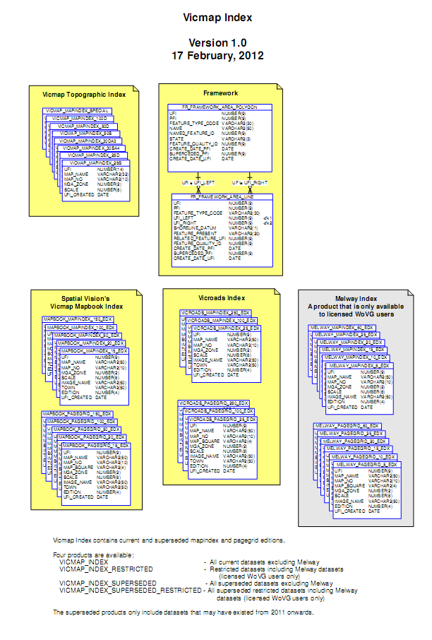
I

Appendix B data dictionary
The core attributes of Vicmap Index are currently derived from external custodians or data maintained under contract to Information Services Branch by Logica Pty. Ltd. The data set is held in Oracle® data base tables, the spatial component of which is managed by Spatial Data Manager (SDM)®.

Overview of index tables
The following procedures are undertaken as normal update/maintenance routines, to ensure conformity of the data to specification:
- Customised menus for data editing which provide on the fly logical consistency attribute checking as data is edited.
- Automated data QA processes to validate topogical integrity, completeness and logical consistency
- Independent review of data upon loading including aspatial attributes, spatial extents and successful data load.
- Validation of entity PFI/UFI tags (where they exist) for uniqueness.

Index to fields (attributes)
TABLE: FR_FRAMEWORK_AREA_LINE
COLUMN | DESCRIPTION | TYPE | LENGTH
UFI | Unique Feature Identifier | Number | 9
PFI | Persistent Feature Identifier | Number | 9
FEATURE_TYPE_CODE | Feature Code | Varchar2 | 30
UFI_LEFT | UFI of polygon object to the left side of the segment | Number | 9
UFI_RIGHT | UFI of polygon object to the right side of the segment | Number | 9
SHORELINE_DATUM | Datum used for shoreline height | Varchar2 | 1
FEATURE_PRESENT |  | Varchar2 | 20
RELATED_FEATURE_ID | UFI of related feature | Number | 9
CREATE_DATE_PFI | Date of original creation of feature | Date | na
SUPERCEDED_PFI | PFI of feature prior to merge or split operation | Number | 9
CREATE_DATE_UFI | Date of creation of feature | Date | na

TABLE: FR_FRAMEWORK_AREA_POLY
COLUMN | DESCRIPTION | TYPE | LENGTH
UFI | Unique Feature Identifier | Number | 9
PFI | Persistent Feature Identifier | Number | 9
FEATUE_TYPE_CODE | Feature Code | Varchar2 | 30
NAME | Name of Feature | Varchar2 | 50
NAME_FEATURE_ID | Unique identifier of feature name | Number | 9
STATE | Name of Australian state | Varchar2 | 3
FEATURE_QUALITY_ID | Identifier for the feature quality record | Number | 9
CREATE_DATE_PFI | Date of original creation of feature | Date | na
SUPERCEDED_PFI | PFI of feature prior to merge or split operation | Number | 9
CREATE_DATE_UFI | Date of creation of feature | Date | na

TABLE: VICMAP_MAPINDEX_SPECIAL VICMAP_MAPINDEX_100D VICMAP_MAPINDEX_50D VICMAP_MAPINDEX_50S VICMAP_MAPINDEX_30DA3 VICMAP_MAPINDEX_30SA4 VICMAP_MAPINDEX_25D VICMAP_MAPINDEX_25S

COLUMN | DESCRIPTION | TYPE | LENGTH
UFI | Unique Feature Identifier | Number | 14
MAP_NAME | Name of map or page. Maybe number or character | Varchar2 | 32
MAP_NO | Number of map or page | Varchar2 | 10
MGA_ZONE | Map Grid of Australia Zone | Number | 2
SCALE | Scale of map | Number | 8
UFI_CREATED | Creation date of feature | Date | na

TABLE: MAPBOOK_MAPINDEX_XX_EDX
VICROADS_MAPINDEX_XX_EDX

COLUMN | DESCRIPTION | TYPE | LENGTH
UFI | Unique Feature Identifier | Number | 9
MAP_NAME | Name of map or page. Maybe number or character | Varchar2 | 50
MAP_NO | Number of map or page | Varchar2 | 10
MGA_ZONE | Map Grid of Australia Zone | Number | 2
SCALE | Scale of map | Number | 8
IMAGE_NAME | Name of corresponding image. Same as Map_Name | Varchar2 | 50
TOWN | Name of town if applicable. Same as Map Name & Image Name | Varchar2 | 50
EDITION | Current edition of source publication | Number | 4
UFI_CREATED | Creation date of feature | Date | na

TABLE: MELWAY_MAPINDEX_XX_EDX
COLUMN | DESCRIPTION | TYPE | LENGTH
UFI | Unique Feature Identifier | Number | 9
MAP_NAME | Name of map or page. Maybe number or character | Varchar2 | 50
MAP_NO | Number of map or page | Varchar2 | 10
MGA_ZONE | Map Grid of Australia Zone | Number | 2
SCALE | Scale of map | Number | 8
IMAGE_NAME | Name of corresponding image. Same as Map_Name | Varchar2 | 50
EDITION | Current edition of source publication | Number | 4
UFI_CREATED | Creation date of feature | Date | na

TABLE: MAPBOOK_PAGEGRID_XX_EDX
VICROADS_PAGEGRID_XX_EDX
COLUMN | DESCRIPTION | TYPE | LENGTH
UFI | Unique Feature Identifier | Number | 9
MAP_NAME | Name of map or page. Maybe number or character | Varchar2 | 50
MAP_NO | Number of map or page | Varchar2 | 10
MAP_SQUARE | Map or page grid reference | Varchar2 | 4
MGA_ZONE | Map Grid of Australia Zone | Number | 2
SCALE | Scale of map | Number | 8
IMAGE_NAME | Name of corresponding image. Same as Map_Name | Varchar2 | 50
TOWN | Name of town if applicable. Same as Map Name & Image Name | Varchar2 | 50
EDITION | Current edition of source publication | Number | 4
UFI_CREATED | Creation date of feature | Date | na

TABLE: MELWAY_PAGEGRID_XX_EDX
COLUMN | DESCRIPTION | TYPE | LENGTH
UFI | Unique Feature Identifier | Number | 9
MAP_NAME | Name of map or page. Maybe number or character | Varchar2 | 50
MAP_NO | Number of map or page | Varchar2 | 10
MAP_SQUARE | Map or page grid reference | Varchar2 | 4
MGA_ZONE | Map Grid of Australia Zone | Number | 2
SCALE | Scale of map | Number | 8
IMAGE_NAME | Name of corresponding image. Same as Map_Name | Varchar2 | 50
EDITION | Current edition of source publication | Number | 4
UFI_CREATED | Creation date of feature | Date | na

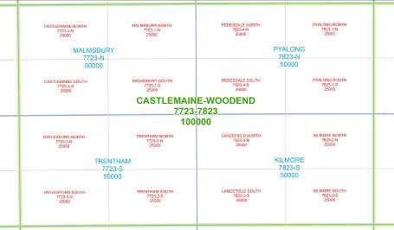

Diagram 2. Vicmap Index - Vicmap Topographic Index

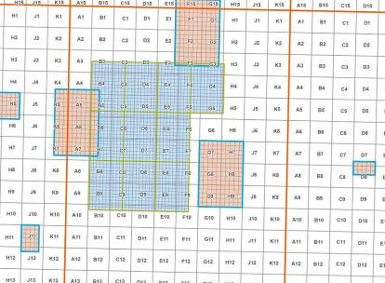

Diagram 3. Vicmap Index – Spatial Vision’s Vicmap Mapbook Index; Mapindex

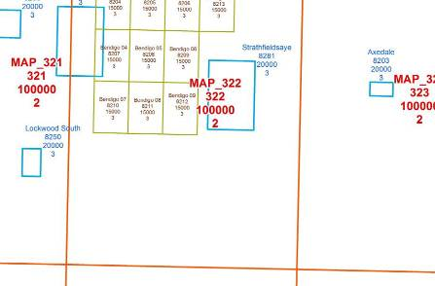

Diagram 4. Vicmap Index – Spatial Vision’s Vicmap Mapbook Index; Pageggrid

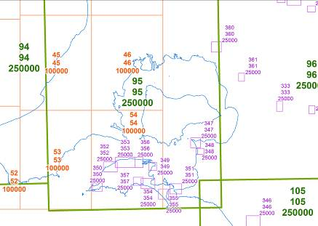

Diagram 5. Vicmap Index – VicRoads Index; MapIndex

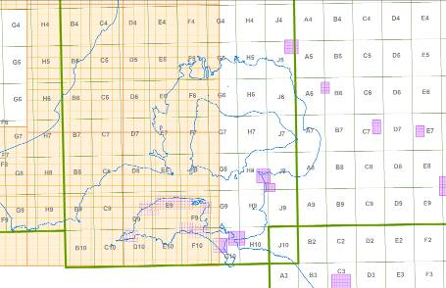

Diagram 6. Vicmap Index – VicRoads Index; PageGrid

Reference tables
NOT APPLICABLE

