|  |
| --- |
| Vicmap Product Development |
| Change Notice # 260 |

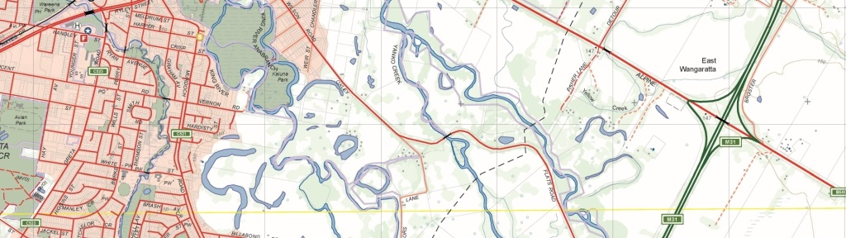

Vicmap Admin – Fire Rescue Victoria (FRV) Boundaries

## What is happening

From 7 September 2020, FRV_DISTRICT and FRV_REGION are being added to Vicmap Admin.

From 1 December 2020, MFB_DISTRICT and MFB_REGION boundaries will be removed from Vicmap Admin.

## Why this change is occurring

Fire Rescue Victoria (FRV) was established on 1 July 2020 as part Victoria’s Fire Services Reforms. It was established to take on the Metropolitan Fire Brigade’s (MFB) functions. The MFB was abolished on 30 June 2020. CFA Career Operational Staff transferred to FRV on 1 July 2020.

The FRV response area consists of 10 districts and 2 regions. The districts are a sub group of the regions. It includes 47 fire stations in metropolitan Melbourne and 38 regional stations.

## Who it will affect

This change will affect all users of Vicmap Admin. Incremental Update Format (IUF) customers will not be affected as part of this change.

## When the change will occur

FRV_DISTRICT and FRV_REGION will be added to Vicmap Admin on 7 September 2020.

MFB_DISTRICT and MFB_REGION boundaries will be removed from Vicmap Admin on 1 December 2020.

## Background

Fire Rescue Victoria (FRV) was established on 1 July 2020 as part Victoria’s Fire Services Reforms. It was established to take on the Metropolitan Fire Brigade’s (MFB) functions. The MFB was abolished on 30 June 2020. CFA Career Operational Staff transferred to FRV on 1 July 2020.

## General Notes

MFB_DISTRICT and MFB_REGION will be removed from the product but will be accessible as individual datasets from DataSearch Victoria.

## How to provide feedback

For Vicmap Product change notices and bulletins, go to the [News and Bulletins](http://www.delwp.vic.gov.au/parks-forests-and-crown-land/spatial-data-and-resources/news-and-bulletins) page.

For further information & feedback please email [vicmap.help@delwp.vic.gov.au](mailto:vicmap.help@delwp.vic.gov.au)

|  |  |
| --- | --- |
| © The State of Victoria Department of Environment, Land, Water and Planning 2020  LogoThis work is licensed under a Creative Commons Attribution 4.0 International licence. You are free to re-use the work under that licence, on the condition that you credit the State of Victoria as author. The licence does not apply to any images, photographs or branding, including the Victorian Coat of Arms, the Victorian Government logo and the Department of Environment, Land, Water and Planning (DELWP) logo. To view a copy of this licence, visit http://creativecommons.org/licenses/by/4.0/  Disclaimer  This publication may be of assistance to you but the State of Victoria and its employees do not guarantee that the publication is without flaw of any kind or is wholly appropriate for your particular purposes and therefore disclaims all liability for any error, loss or other consequence which may arise from you relying on any information in this publication. | Accessibility  If you would like to receive this publication in an alternative format, please telephone the DELWP Customer Service Centre on 136186, email [customer.service@delwp.vic.gov.au](mailto:customer.service@delwp.vic.gov.au), or via the National Relay Service on 133 677 [www.relayservice.com.au](http://www.relayservice.com.au). This document is also available on the internet at [www.delwp.vic.gov.au](http://www.delwp.vic.gov.au). |

Keep all content above this instruction text line. Delete only when document formatting is complete.