|  |
| --- |
| Vicmap™ Product Development |
| Change Notice # 251 Advisory Notice |

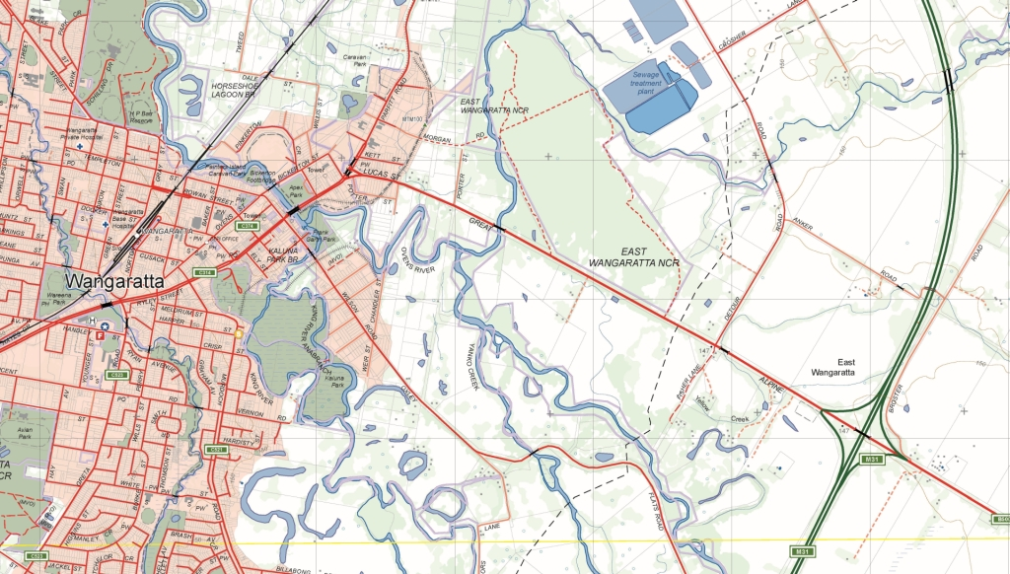

Vicmap Position

## What is happening

Vicmap Position currently includes the GPSnet™ infrastructure & services managed and maintained by the Survey General Victoria.

This change broadens Vicmap Position to include Survey Control as a foundational dataset.

A table SMES_FULL has been added to Vicmap Position. The table holds point data depicting the State’s database of permanent and cadastral survey marks, which may also be referred to as survey monuments, survey benchmarks or geodetic marks.

## Why this change is occurring

To enable the search and discovery of survey mark data maintained by the Surveyor General Victoria and made available in compliance with the DataVic Access policy.

## Who will it affect

This change positively affects all users of Vicmap by broadening and increasing the accessibility of survey mark data for Victoria.

This data is used by the Land and Survey Spatial Information (LASSI) spatial platform that the Survey Mark Enquiry Service (SMES) depends and remains unchanged.

## When the change will occur

The change has been implemented and the data is now available.

## How to provide feedback

For Vicmap Product change notices and bulletins, go to the [News and Bulletins](http://www.delwp.vic.gov.au/parks-forests-and-crown-land/spatial-data-and-resources/news-and-bulletins) page.

For further information & feedback please email [vicmap.help@delwp.vic.gov.au](mailto:vicmap.help@delwp.vic.gov.au) or [smes.support@delwp.vic.gov.au](mailto:smes.support@delwp.vic.gov.au)

|  |  |
| --- | --- |
| © The State of Victoria Department of Environment, Land, Water and Planning 2020  LogoThis work is licensed under a Creative Commons Attribution 4.0 International licence. You are free to re-use the work under that licence, on the condition that you credit the State of Victoria as author. The licence does not apply to any images, photographs or branding, including the Victorian Coat of Arms, the Victorian Government logo and the Department of Environment, Land, Water and Planning (DELWP) logo. To view a copy of this licence, visit http://creativecommons.org/licenses/by/4.0/  Disclaimer  This publication may be of assistance to you but the State of Victoria and its employees do not guarantee that the publication is without flaw of any kind or is wholly appropriate for your particular purposes and therefore disclaims all liability for any error, loss or other consequence which may arise from you relying on any information in this publication. | Accessibility  If you would like to receive this publication in an alternative format, please telephone the DELWP Customer Service Centre on 136186, email [customer.service@delwp.vic.gov.au](mailto:customer.service@delwp.vic.gov.au), or via the National Relay Service on 133 677 [www.relayservice.com.au](http://www.relayservice.com.au). This document is also available on the internet at [www.delwp.vic.gov.au](http://www.delwp.vic.gov.au). |

Keep all content above this instruction text line. Delete only when document formatting is complete.