|  |
| --- |
|  |
| Change Notice #271 |

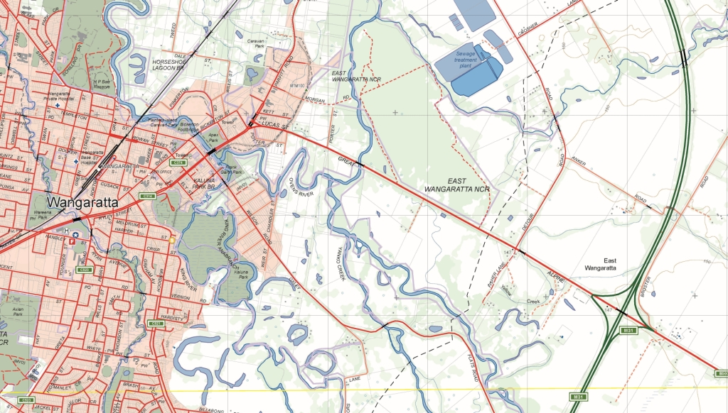

Vicmap Property

## What is happening

Vicmap Property currently captures parcel cad area boundaries (CAD_AREA_BDY)as line strings that contain two end nodes and many intermediate points (refer to Diagram 1 below, The Green points are the end nodes whilst the Blue points are the intermediate points).

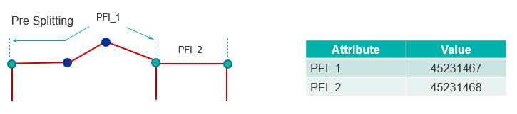

**Diagram 1: Current Vicmap Property representation of CAD_AREA_BDY**

We are changing this practice to now break the lines at parcel boundary intersections, which will result in a significant increase in the number of CAD_AREA_BDY lines in Vicmap Property. Following this process, the above line (PFI_1) will be represented in Vicmap Property as three separate lines. (See Diagram 2 below)

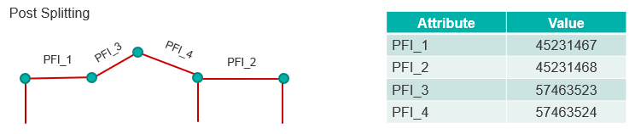

**Diagram 2: New Vicmap Property representation of CAD_AREA_BDY**

Note: This change will not cause the Vicmap Property or IUF data models to change but will increase the number of CAD_AREA_BDYs linework by about 10%.

## Why this change is occurring

This change is occurring in preparation for creating a points table that will incorporate outputs from the Digital Cadastral Modernisation (DCM) project into Vicmap Property. This will allow the full implementation of a points layer to enable landXML manipulation.

## Who will it affect

This change will affect all users of Vicmap Property and Incremental Update Format (IUF) customers.

## When the change will occur

The change will progressively occur over 4 weeks, commencing on the 21/06/2021. The whole state of Victoria will be completed by **19/07/2021.**

## How to provide feedback

This is a data processing activity and this notice has been provided to customers to make them aware of the impending changes.

For Vicmap Product change notices and updates, visit [Vicmap change notices](https://www.land.vic.gov.au/maps-and-spatial/spatial-data/updates-to-vicmap/vicmap-change-notices%0d).

For further information & feedback please email [vicmap.help@delwp.vic.gov.au](mailto:vicmap.help@delwp.vic.gov.au)

If you would like to subscribe to change notices ongoing please forward your contact details including your email to [vicmap@delwp.vic.gov.au](mailto:vicmap@delwp.vic.gov.au)

|  |  |
| --- | --- |
| © The State of Victoria Department of Environment, Land, Water and Planning 2021  LogoThis work is licensed under a Creative Commons Attribution 4.0 International licence. You are free to re-use the work under that licence, on the condition that you credit the State of Victoria as author. The licence does not apply to any images, photographs or branding, including the Victorian Coat of Arms, the Victorian Government logo and the Department of Environment, Land, Water and Planning (DELWP) logo. To view a copy of this licence, visit http://creativecommons.org/licenses/by/4.0/  Disclaimer  This publication may be of assistance to you but the State of Victoria and its employees do not guarantee that the publication is without flaw of any kind or is wholly appropriate for your particular purposes and therefore disclaims all liability for any error, loss or other consequence which may arise from you relying on any information in this publication.  **DELWP spatial disclaimer**  The State of Victoria:   1. does not give any representation or warranty as to the accuracy or completeness of DELWP spatial data, Vicmap data (including metadata) or Vicmap product specifications or the fitness of such data or products for any particular purpose; 2. disclaims all responsibility and liability whatsoever for any errors, faults, defects or omissions in such data or products.   Any person using or relying upon such data or products must make an independent assessment of them and their fitness for particular purposes and requirements. | Accessibility  If you would like to receive this publication in an alternative format, please telephone the DELWP Customer Service Centre on 136186, email [customer.service@delwp.vic.gov.au](mailto:customer.service@delwp.vic.gov.au), or via the National Relay Service on 133 677 [www.relayservice.com.au](http://www.relayservice.com.au). This document is also available on the internet at [www.delwp.vic.gov.au](http://www.delwp.vic.gov.au). |