Information for residents

Naming rules for places in Victoria

Council has contacted you regarding a naming proposal.

Your local council (naming authority) has contacted you to seek your input on a naming proposal. The proposal may directly affect you, e.g. your address number, road name or locality might be changing. Alternatively, the proposal may indirectly affect you, e.g. a new road is being named or renamed, or a bridge or park is being named or renamed.
Naming rules for places in Victoria – Statutory requirements for naming roads, features and localities (the naming rules) sets out step-by-step information on naming, renaming or changing the boundaries of roads, features and localities in Victoria. This fact sheet will assist you in responding appropriately and understanding what role you can play in the process.
The full version of the naming rules can be found at www.land.vic.gov.au/thenamingrules

What can be named or renamed using the naming rules?
Any public or private road, feature or locality within Victoria can be named, renamed or have its boundary changed using the principles, requirements and procedures in the naming rules.
There are many different roads and feature types in Victoria. Responsibility for preparing naming proposals and submitting them to the Registrar of Geographic Names can vary. Please refer to the relevant sections and appendixes in the naming rules.

Who can name or rename roads, features and localities in Victoria and who oversees the process?
Members of the public are encouraged to participate in the naming process by proposing a name, initiating a proposal or responding to a relevant naming authority regarding a naming proposal.
Other stakeholders include emergency service organisations, Australia Post, owners corporations, private institutions, Traditional Owners, historical societies and utility or other service providers. They can be involved in the naming process in three ways:
- propose to the responsible naming authority a name for a road, feature or locality or locality boundary.
- alert a naming authority and the Registrar to an issue with an existing name or boundary for a road, feature or locality and request that the matter be investigated.
- comment on whether a naming, renaming or boundary change proposal conforms to the naming rules.

The proposal needs to be submitted to the naming authority responsible for the area in/across which the road, feature or locality is situated – it is important to note that the council(s) or relevant naming authority(ies) should be contacted for advice because some naming authorities have their own naming policies or guidelines that augment the naming rules.

Who should be consulted?
There are several community groups to consult regarding a naming, renaming or boundary change proposal:
- the immediate community, which broadly includes people who live and work within the area and owners of properties or businesses; in particular, residents, ratepayers and businesses within the immediate area directly affected by the proposal.
- the extended community, which includes residents, ratepayers and businesses surrounding the area directly affected by the proposal; in particular, any visitor groups to the area such as shoppers, tourists, recreational or dining visitors; government (neighbouring councils) or non-government organisations with an interest in or who service the area.
- Traditional Owner group(s), local historical societies and eminent individual historians; service clubs such as Lions and Rotary Clubs, Country Women’s Associations, farmers groups, school parents associations, Probus clubs, senior citizens centres, ethnic associations; 000 Tripple Zero Victoria and emergency service organisations (ESOs).

How do I show support for the proposal?
You can respond to the naming authority using the method outlined in the notification about the change. This might involve writing a letter or email of support.

I support the proposal, but do not support the proposed name or boundaries, what can I do?
You can respond to the naming authority using the method outlined in the notification about the change. This might involve writing a letter or email of support, while indicating your objection to the name and/or providing alternative names or boundaries.
The naming authority may not be asking for submissions of names; you need to check the notification.

I do not support the proposal, what can I do?
The naming rules provide the opportunity to object directly to the naming authority and appeal to the Registrar of Geographic Names if the naming authority decides to proceed.
It should be noted that if the proposal is based on a risk to public safety, it might proceed anyway in order to protect people.

What is an objection?
An objection is a way for members of the community to inform the naming authority that one or more people disagree with a naming or renaming proposal. An objection must explain the opposition to the proposal. Simply lodging opposition without an explanation does not help the naming authority understand the underlying issues.

Lodging objections
Any person or organisation can lodge an objection to a naming, renaming or boundary change proposal during the public consultation period administered by the relevant naming authority. Objections must be lodged directly with the naming authority within the minimum 30 days allocated for feedback. Naming authorities can, if necessary, provide for a longer feedback period.

Considering objections
- Any objections received during the public consultation period must be considered by the naming authority. The naming authority is responsible for weighing up competing objections, having regard to the naming rules and any other relevant matters it identifies.
- All objections must be included in an assessment report stating the objection, indicating relevance to the naming rules and the naming authority’s consideration/response to the objection.
- The naming authority need not consider objections that don’t explain reasons for the objection.
- The decision about whether or not to proceed with a naming proposal resides with the naming authority.

What can I do if the naming authority continues with a proposal I do not support?
The only recourse at this stage is to appeal to the Registrar of Geographic Names about the naming authority’s decision.

Appeals
When the naming authority accepts the proposal, the letter to objectors needs to include details of how an appeal can be made to the Registrar. An appeal can only be made if the objector can demonstrate that either:
- the naming authority did not consider the objections during its deliberations
- the proposal does not reasonably conform to the principles and statutory requirements of the naming rules.
The letter to objectors needs to indicate that an appeal to the Registrar must be lodged within 30 days of the naming authority accepting the proposal and/or sending the letter to the objector (whichever is later).
All appeals must be made in writing and sent to:
Registrar of Geographic Names
Geographic Names Victoria,
PO BOX 500,
East Melbourne, Victoria 3002

or via email to geo.names@delwp.vic.gov.au

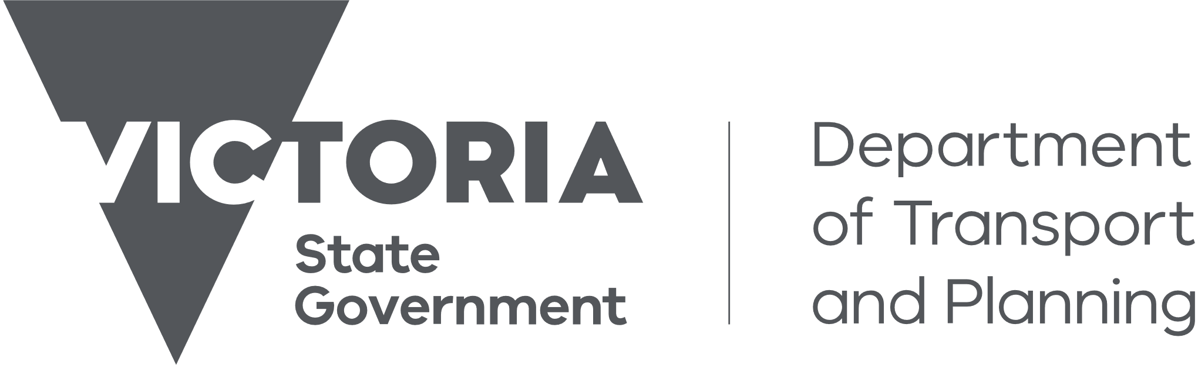
Need more information?
Find out more about the government’s initiatives at dtp.vic.gov.au

ESOs encompass agencies that include Country Fire Authority (CFA), State Emergency Services (SES), Fire Rescue Victoria (FRV), Victoria Police (VicPol), Ambulance Victoria (AV). If consulting Emergency Service agencies, consider contacting both local and administrative management (headquarters) as well as 000 Triple Zero Victoria.

