

Land Registry Services Business Activity Report

2024-2025 Financial Year
Version 1.0

Contents
Land Registry Services 3
Business activity report 2024-2025 financial year 3
1 Lodgments 3
1.1 Number of dealings lodged 3
1.2 Yearly lodgments (1945-2025) 4
1.3 Monthly lodgments 4
1.4 Average daily lodgments (with trend line) 5
1.5 Financial year lodgments from 2020-2021 to 2024-2025 (by month) 6
2 Search 7
2.1 Title searches 7
2.2 Financial year title searches (by month) 7
2.3 Planning certificates 8
2.4 Instrument searches 8
2.5 Property certificates 9
2.6 Land Index searches 9
3 Lodgment and Support Services 1 (LSS1) 10
3.1 LANDATA® statistics with trend lines 10
4 Water Register 11
4.1 Water share transactions 12
5 Lodgment by specific dealing types 13
5.1 Discharges of mortgage or charge 13
5.2 Transfers of land 13
5.3 Mortgages 14
5.4 Differences in lodgment levels and percentages of discharges, transfers, and mortgages 15
5.5 Plans of subdivision 16
5.6 All Plans lodged under the Subdivision Act 1988 17
5.7 Number of new parcels created from plans of subdivision 17
5.8 General law conversion 18
5.9 Crown Land Dealings 18
5.10 Top 40 dealing types, by number lodged 19
6 Other measures of Land Registry Services activity 20
6.1 Number of dealings registered 20
6.2 Percentage of dealings registered within 5 days 20
6.3 Number of plans of subdivision registered 20
6.4 Number of dealings refused 20
6.5 Number of dealings waiting to be processed 20
7 Electronic transactions processing 21
7.1 Electronic Conveyancing 21
7.2 Percentage of transactions lodged electronically 22

Land Registry Services

Business activity report 2024-2025 financial year
This report provides statistics for land registration and property information services delivered by Land Use Victoria. Figures for the 2024-2025 financial year and previous years are provided.

1 Lodgments

1.1 Number of dealings lodged
The number of dealings lodged for the financial year was 932,188. This is a 0.97 per cent increase from the 2023-24 financial year but is the third highest lodgment volume on record for the Land Registry. Past financial years’ lodgments have been:
Table 1: Number of Dealings Lodged by Financial Year
Year | Total | Year | Total
2005-2006 | 748,647 | 2015-2016 | 857,497
2006-2007 | 727,464 | 2016-2017 | 876,482
2007-2008 | 777,542 | 2017-2018 | 917,385
2008-2009 | 675,640 | 2018-2019 | 885,058
2009-2010 | 743,389 | 2019-2020 | 853,227
2010-2011 | 720,649 | 2020-2021 | 896,843
2011-2012 | 677,708 | 2021-2022 | 1,022,585
2012-2013 | 669,214 | 2022-2023 | 951,576
2013-2014 | 747,598 | 2023-2024 | 923,235
2014-2015 | 792,335 | 2024-2025 | 932,188

1.2 Yearly lodgments (1945-2025)
This graph represents the yearly lodgments for each year since 1945. Since 1945, there has been an average growth of 2.93 per cent increase per year.
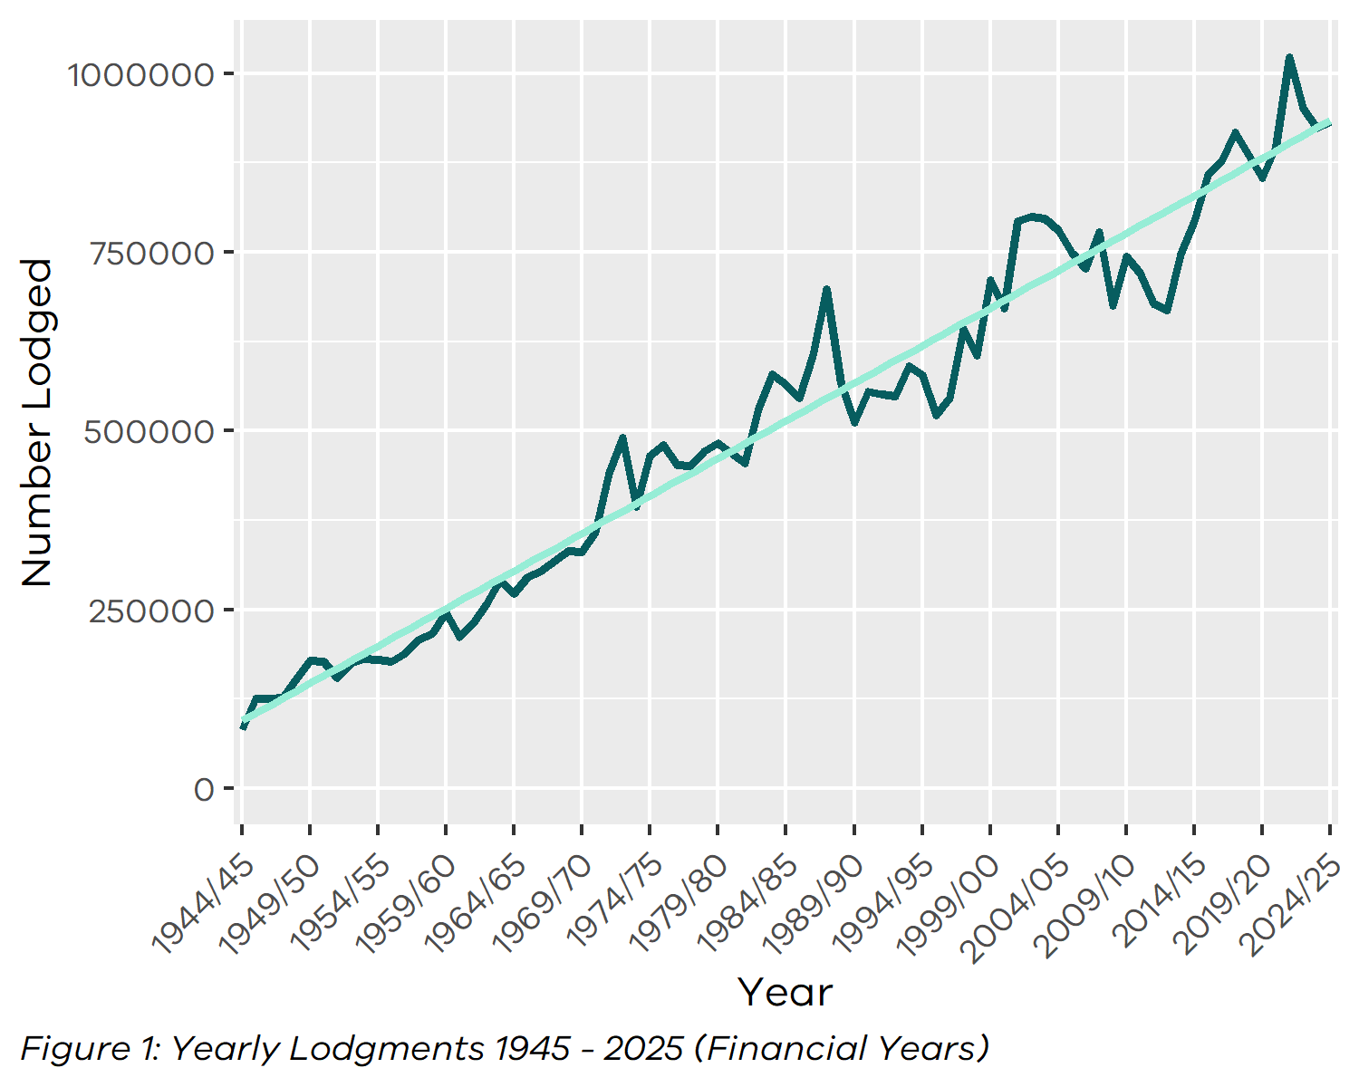

1.3 Monthly lodgments
This graph shows the number of lodgments received for each month of the financial year. In the 2024-2025 financial year, the average number of lodgments was 77,682 per month.
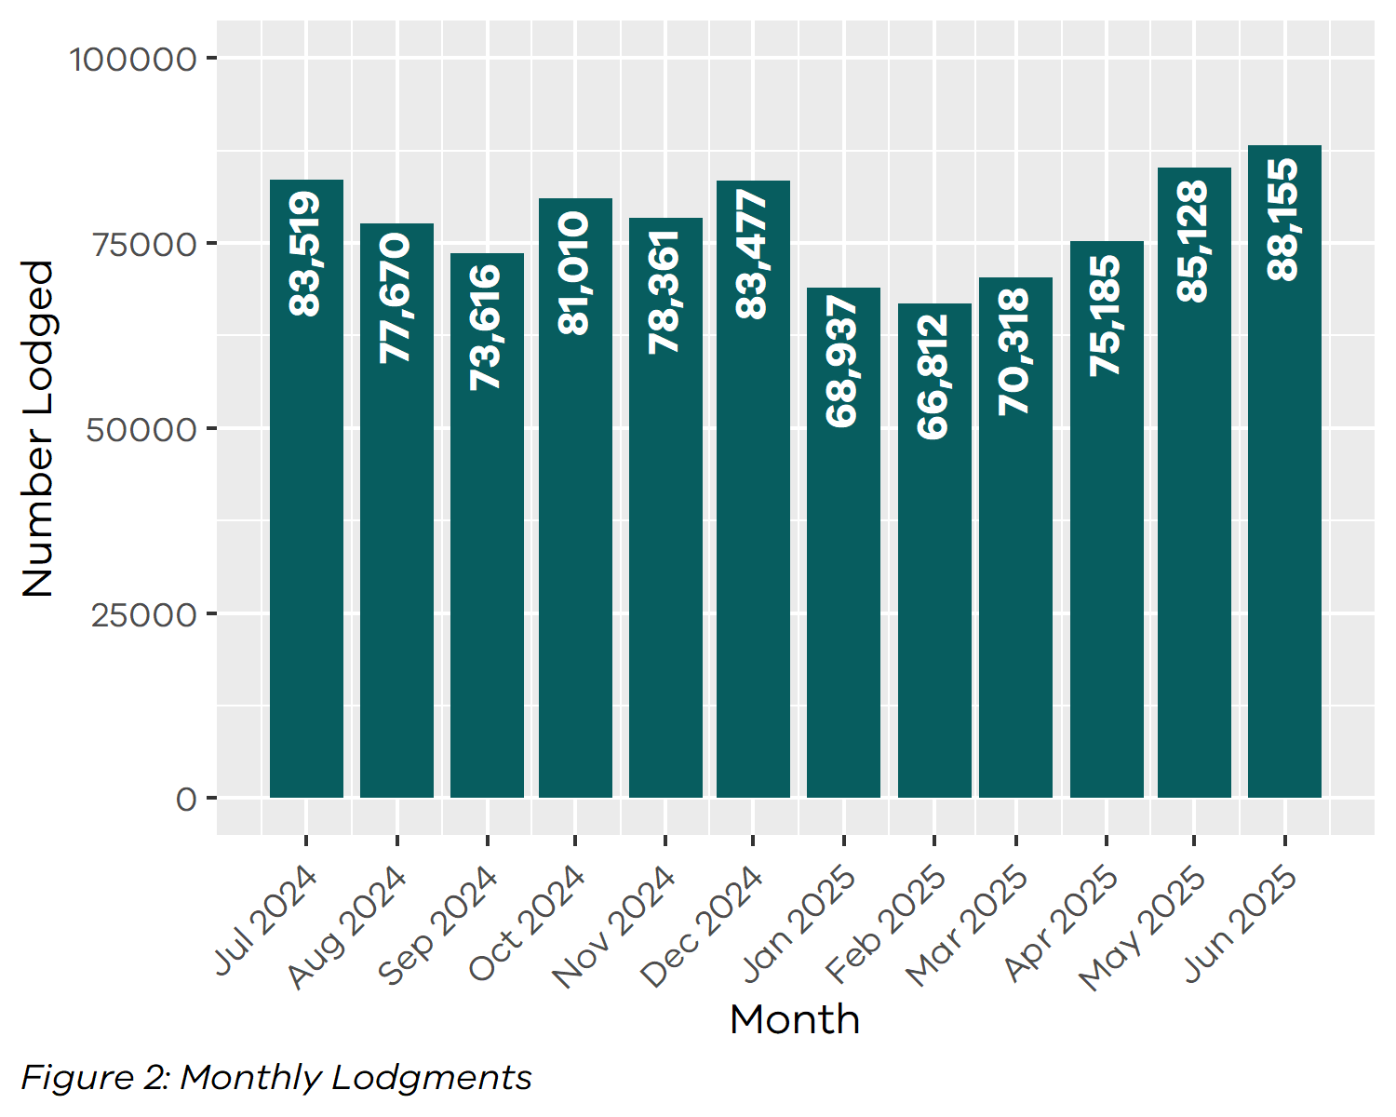

1.4 Average daily lodgments (with trend line)
This graph shows the average daily lodgments for each week of the 2024-2025 financial year. The overall average for the financial year was 3,729 lodgments per day. The daily lodgment activity is continuously monitored, including short term trends using moving averages.
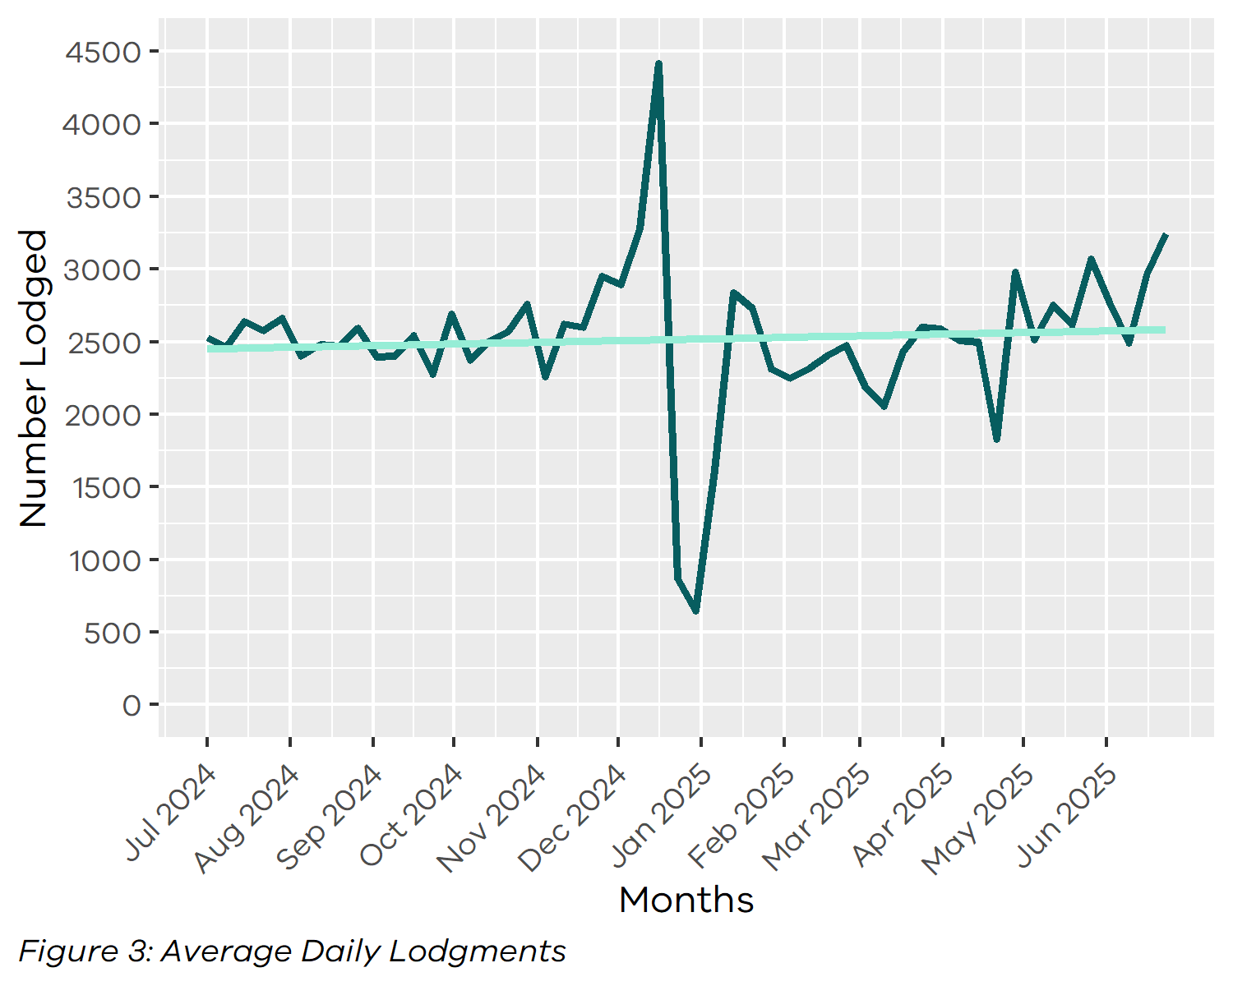

1.5 Financial year lodgments from 2020-2021 to 2024-2025 (by month)
This graph compares monthly lodgments since the 2020-2021 financial year.
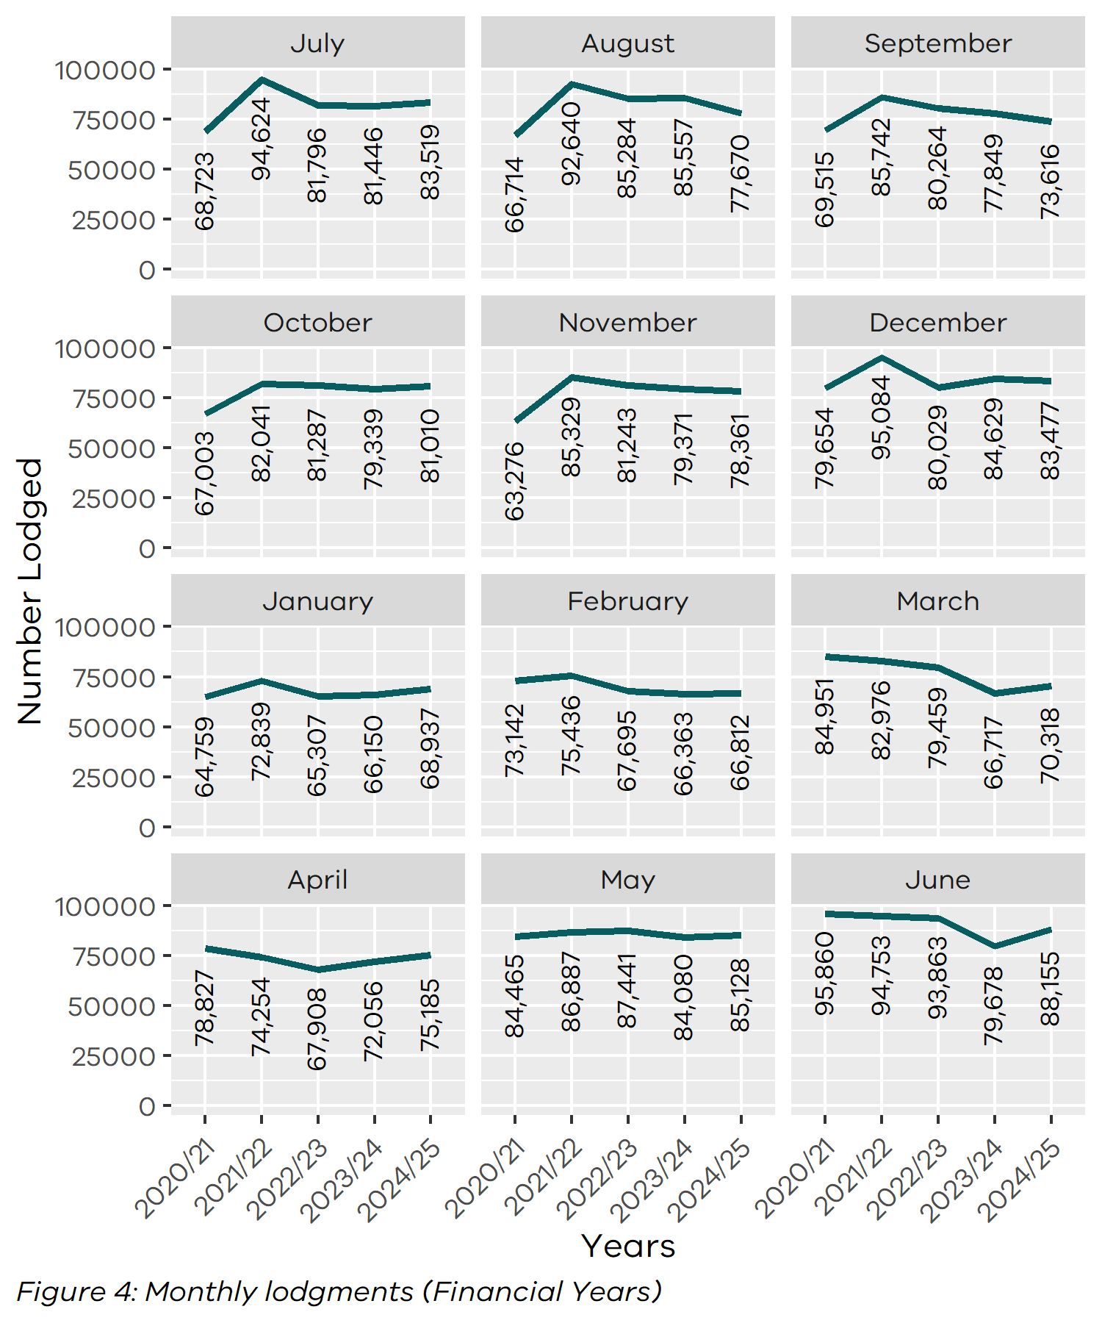

2 Search
Search categories are listed below with historical trend information.

2.1 Title searches
The number of title searches supplied during the 2024-2025 financial year was 3,022,764. This is a 10.82 per cent increase from the 2023-24 financial year.
Table 2: Number of Title Searches by Financial Year
Year | Quantity | Year | Quantity
2005-2006 | 1,906,169 | 2015-2016 | 2,232,051
2006-2007 | 2,050,786 | 2016-2017 | 2,463,249
2007-2008 | 2,169,427 | 2017-2018 | 2,866,297
2008-2009 | 2,023,852 | 2018-2019 | 2,483,433
2009-2010 | 2,200,297 | 2019-2020 | 2,540,297
2010-2011 | 2,218,043 | 2020-2021 | 2,797,895
2011-2012 | 2,192,819 | 2021-2022 | 2,977,311
2012-2013 | 2,169,973 | 2022-2023 | 2,717,540
2013-2014 | 2,205,947 | 2023-2024 | 2,727,641
2014-2015 | 2,242,562 | 2024-2025 | 3,022,764

2.2 Financial year title searches (by month)
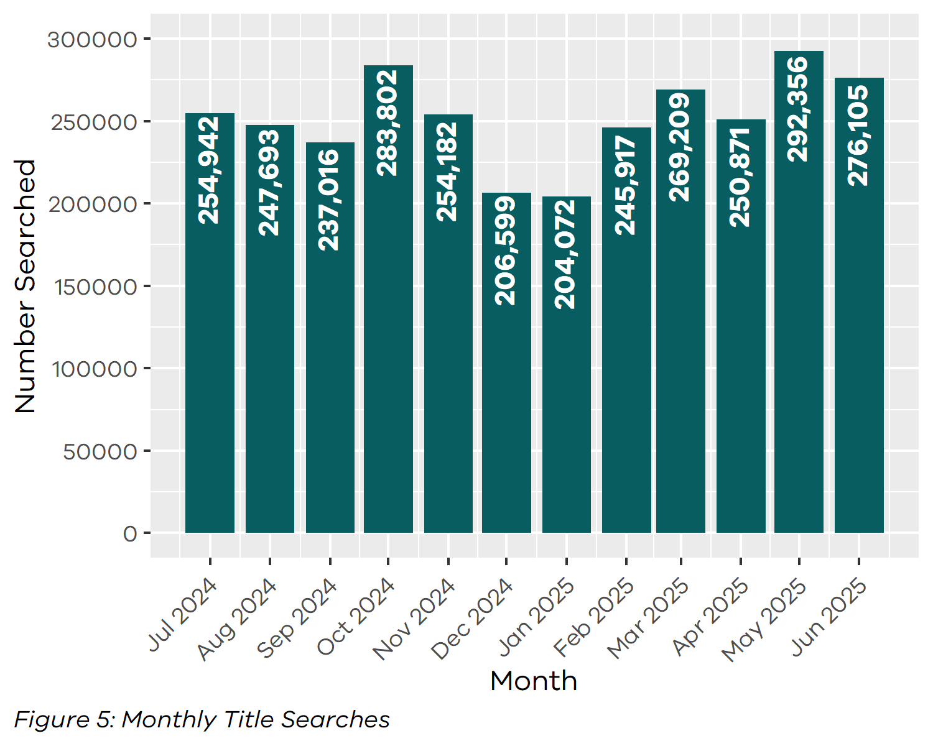

2.3 Planning certificates
Planning certificates increased by 5.42 per cent in the 2024-2025 financial year to 107546.
Table 3: Number of Planning Certificates by Financial Year
Year | Quantity | Year | Quantity
2005-2006 | 37,301 | 2015-2016 | 57,078
2006-2007 | 33,259 | 2016-2017 | 63,161
2007-2008 | 40,716 | 2017-2018 | 71,771
2008-2009 | 32,893 | 2018-2019 | 67,658
2009-2010 | 37,695 | 2019-2020 | 75,695
2010-2011 | 37,131 | 2020-2021 | 90,139
2011-2012 | 38,196 | 2021-2022 | 98,092
2012-2013 | 42,018 | 2022-2023 | 86,441
2013-2014 | 50,090 | 2023-2024 | 102,018
2014-2015 | 55,461 | 2024-2025 | 107,546

2.4 Instrument searches
Instrument searches decreased by 0.83 per cent in the 2024-2025 financial year to 520693.
Table 4: Number of Instrument Searches by Financial Year
Year | Quantity | Year | Quantity
2006-2007 | 587,682 | 2016-2017 | 673,628
2007-2008 | 613,296 | 2017-2018 | 677,407
2008-2009 | 618,854 | 2018-2019 | 582,125
2009-2010 | 757,195 | 2019-2020 | 466,912
2010-2011 | 721,380 | 2020-2021 | 604,336
2011-2012 | 668,858 | 2021-2022 | 545,272
2012-2013 | 683,604 | 2022-2023 | 482,361
2013-2014 | 682,478 | 2023-2024 | 525,057
2014-2015 | 667,648 | 2024-2025 | 520,693
2015-2016 | 667,018

2.5 Property certificates
Property certificates increased by 8.32 per cent in the 2024-2025 financial year to 1048844.
Table 5: Number of Property Certificates by Financial Year
Year | Quantity | Year | Quantity
2006-2007 | 109,355 | 2016-2017 | 619,212
2007-2008 | 134,288 | 2017-2018 | 630,885
2008-2009 | 126,380 | 2018-2019 | 622,465
2009-2010 | 188,155 | 2019-2020 | 663,119
2010-2011 | 243,917 | 2020-2021 | 815,614
2011-2012 | 213,692 | 2021-2022 | 938,347
2012-2013 | 271,449 | 2022-2023 | 821,604
2013-2014 | 367,172 | 2023-2024 | 968,283
2014-2015 | 521,891 | 2024-2025 | 1,048,844
2015-2016 | 541,176

2.6 Land Index searches
Land index searches increased by 5.49 per cent in the 2024-2025 financial year to 1820652.
Table 6: Number of Land Index Searches by Financial Year
Year | Quantity | Year | Quantity
2006-2007 | 1,466,544 | 2016-2017 | 1,345,345
2007-2008 | 1,488,230 | 2017-2018 | 1,374,961
2008-2009 | 1,278,727 | 2018-2019 | 1,319,785
2009-2010 | 1,137,876 | 2019-2020 | 1,352,415
2010-2011 | 1,103,887 | 2020-2021 | 1,440,211
2011-2012 | 1,053,140 | 2021-2022 | 1,618,908
2012-2013 | 1,056,131 | 2022-2023 | 1,704,251
2013-2014 | 998,803 | 2023-2024 | 1,725,930
2014-2015 | 1,070,323 | 2024-2025 | 1,820,652
2015-2016 | 1,153,439

3 Lodgment and Support Services 1 (LSS1)
This statistic refers to services provided to Electronic Lodgment Networks (ELN) on the creation of a workspace. The service, known as LSS1 provides pre-population of title data, title activity checks and lodgment verification. The statistic below shows the number of LSS1s which is directly related to the number of workspaces created.
Table 7: Number of Lodgment and Support Services 1 (LSS1)
by Financial Year
Year | Quantity
2019-2020 | 476,167
2020-2021 | 528,675
2021-2022 | 570,488
2022-2023 | 553,606
2023-2024 | 536,442
2024-2025 | 543,381

3.1 LANDATA® statistics with trend lines
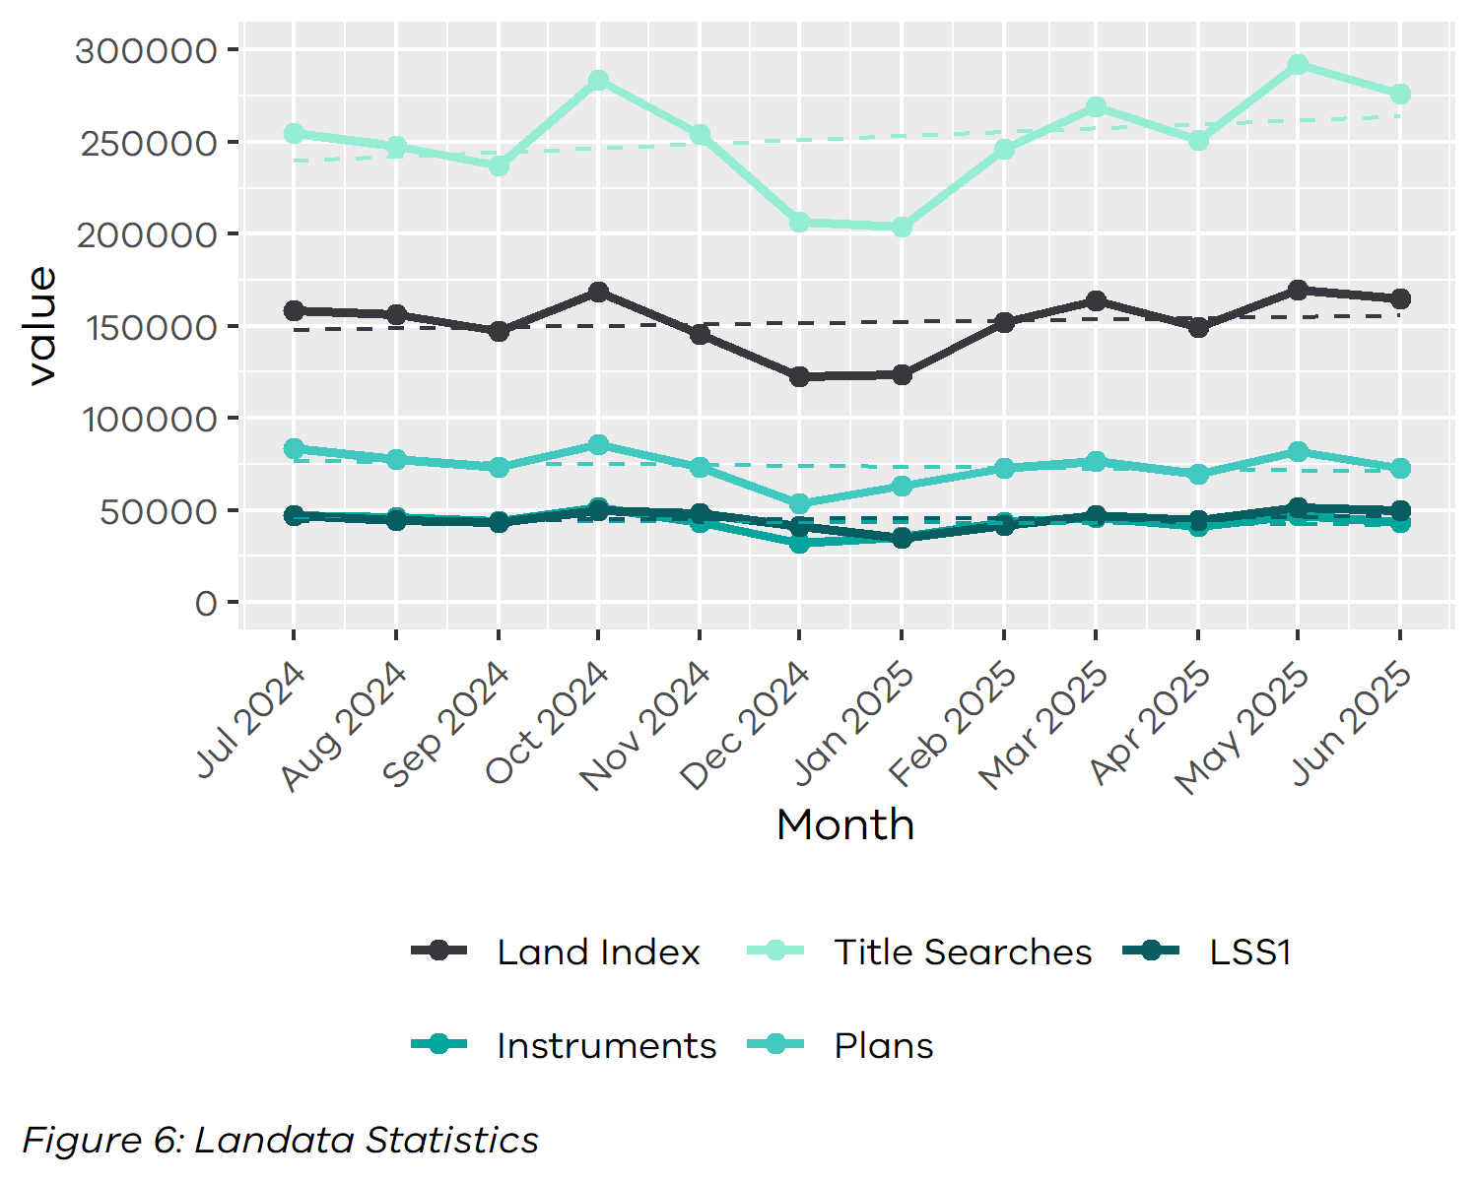

4 Water Register
The number of water share transactions decreased by 1.87 per cent in the 2024-2025 financial year. This compares to previous years as follows:
Table 8: Number of Water Share Transactions by Financial Year
Year | Quantity | Year | Quantity
2007-2008 | 5,259 | 2016-2017 | 6,162
2008-2009 | 13,391 | 2017-2018 | 9,648
2009-2010 | 10,983 | 2018-2019 | 11,876
2010-2011 | 9,990 | 2019-2020 | 7,491
2011-2012 | 9,871 | 2020-2021 | 7,083
2012-2013 | 8,800 | 2021-2022 | 8,195
2013-2014 | 7,529 | 2022-2023 | 9,368
2014-2015 | 7,670 | 2023-2024 | 7,328
2015-2016 | 7,013 | 2024-2025 | 7,191

4.1 Water share transactions
The Water Registrar is responsible for the recording of transactions on water shares under the Water Act 2007. The table below shows the breakdown of the water share transactions.
Table 9: Water Share Transactions Recorded (Financial Year 2024-2025)
Transfers
Transfer of a water share (including limited term transfer) | 2,521
Total Transfers | 2,521
Party amendments
Name and address amendment and party merge | 3,391
Total Party Amendments | 3,391
Mortgages
Mortgage create | 271
Mortgage discharge | 690
Mortgage variation | 1
Mortgage amendment | 9
Mortgage priority | 0
Create MCP | 2
Total Mortgages | 973
Survivorships
Recording of LPR | 171
Recording of survivorship | 130
Recording of trustee in Bankruptcy | 0
Total Survivorships | 301
Registrar notification on water share
Create notification | 0
Remove notification | 5
Total Notifications | 5

5 Lodgment by specific dealing types

5.1 Discharges of mortgage or charge
In the 2024-2025 financial year, discharges of mortgage or charge accounted for 32.38 per cent of all dealings lodged.
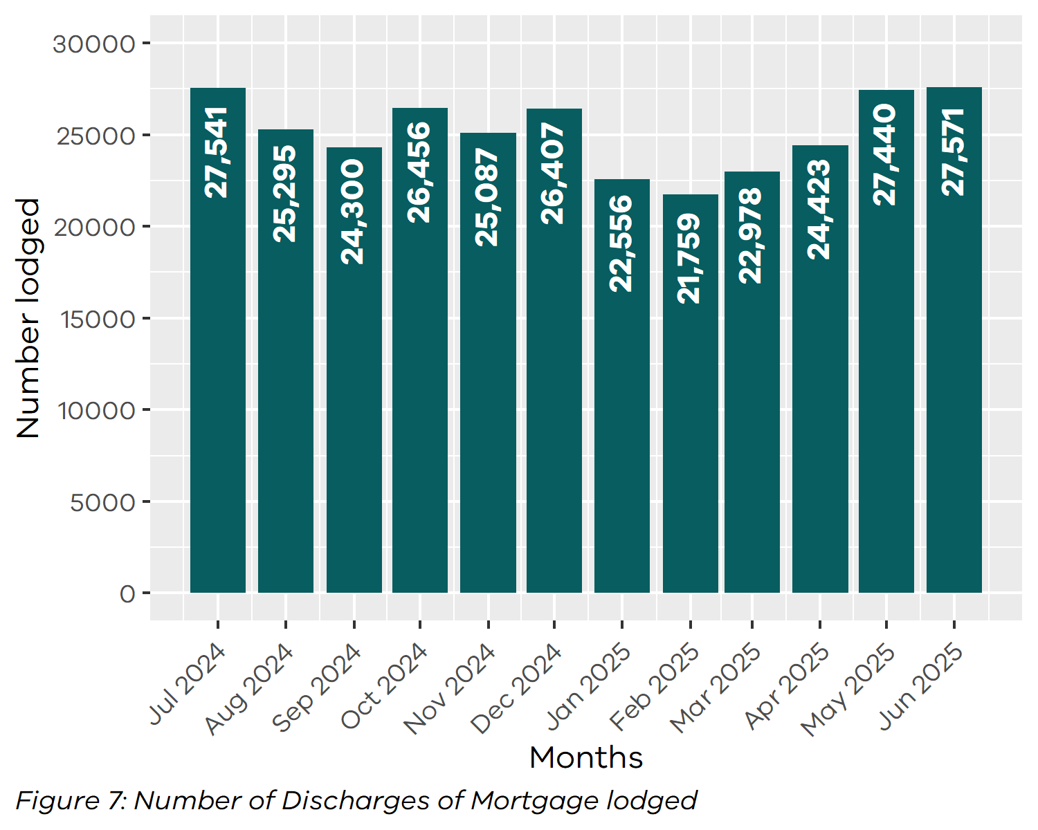

5.2 Transfers of land
In the 2024-2025 financial year, transfers for both monetary and non-monetary consideration made up 23.16 per cent of all dealings lodged.
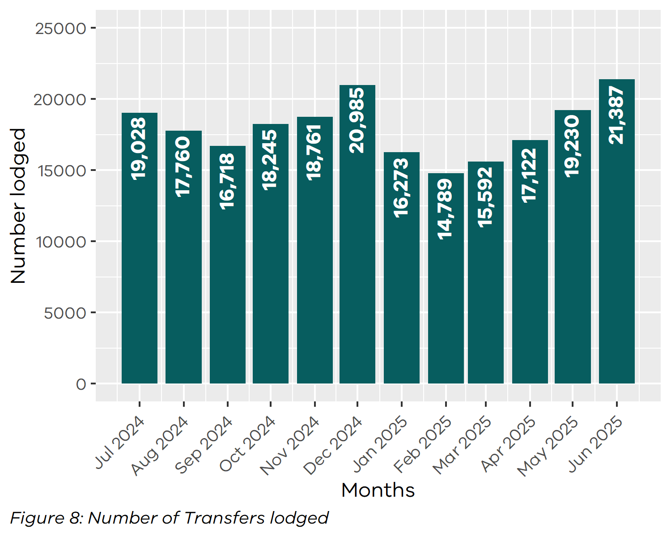

5.3 Mortgages
In the 2024-2025 financial year, mortgages and charges accounted for 32.07 per cent of all dealings lodged.
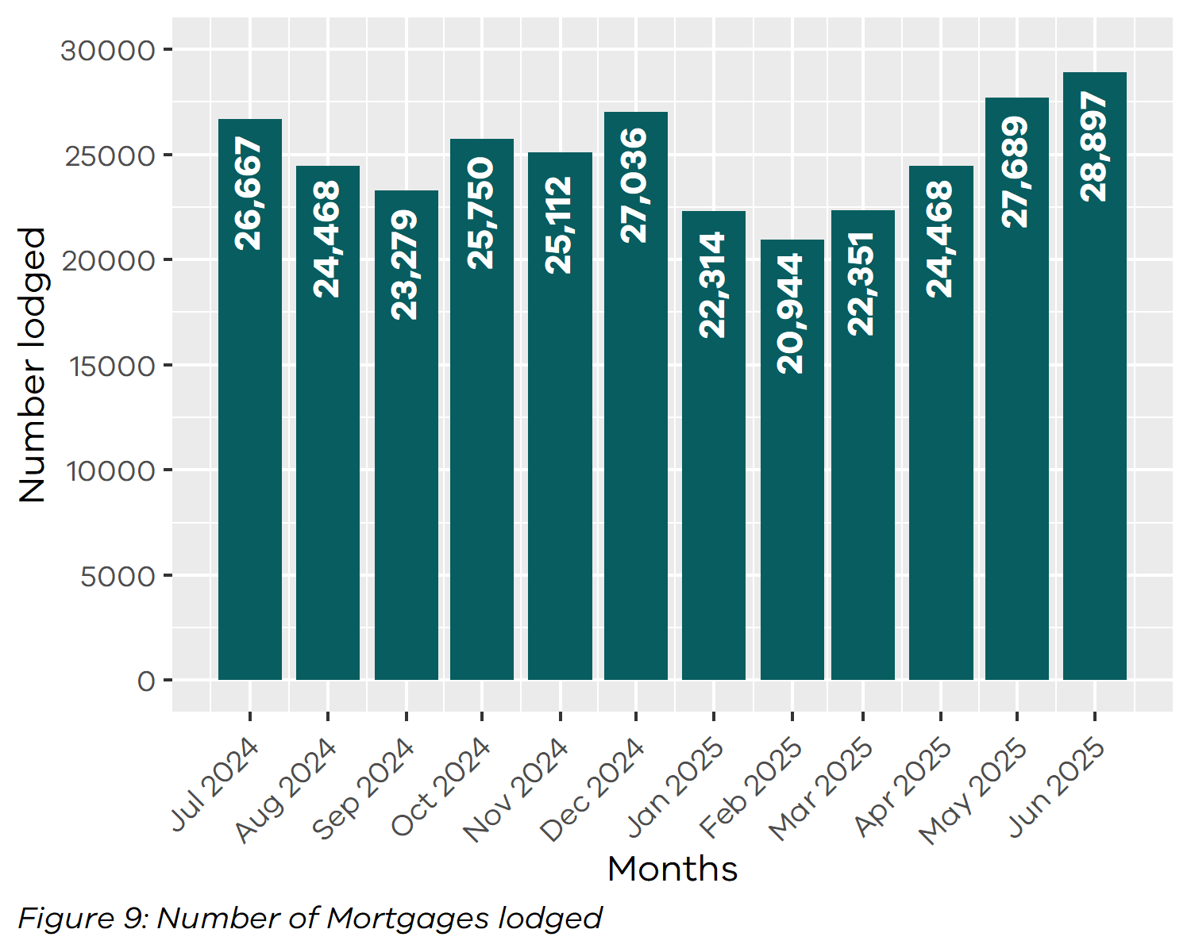

5.4 Differences in lodgment levels and percentages of discharges, transfers, and mortgages
Over time, the number and proportion of the three most common transaction types have varied. The chart below shows how these have changed across financial years. For 2024-2025 financial year, the percentage for each dealing type is as follows:
Table 10: Percentage of Dealing Types Lodged
(Financial Year 2024-2025)
Dealing type | Percentage
Transfers | 23.16
Discharges | 32.38
Mortgages | 32.07
The three main dealing types as a percentage of all dealings lodged since 2005-2006 is shown below.
Table 11: Percentage of Dealing Types Lodged by Financial Year
Year | Transfers (%) | Discharges (%) | Mortgages (%)
2005-2006 | 25.49 | 28.36 | 30.51
2006-2007 | 25.87 | 28.13 | 29.85
2007-2008 | 26.27 | 27.59 | 29.19
2008-2009 | 25.95 | 27.21 | 28.42
2009-2010 | 26.87 | 27.16 | 28.62
2010-2011 | 26.22 | 27.20 | 27.68
2011-2012 | 25.24 | 28.28 | 28.05
2012-2013 | 25.04 | 28.15 | 27.80
2013-2014 | 25.76 | 28.54 | 27.74
2014-2015 | 25.44 | 29.15 | 28.25
2015-2016 | 23.90 | 29.90 | 29.20
2016-2017 | 28.05 | 30.60 | 28.69
2017-2018 | 25.90 | 30.57 | 28.66
2018-2019 | 23.03 | 29.22 | 27.72
2019-2020 | 23.72 | 31.98 | 30.80
2020-2021 | 25.75 | 33.35 | 33.25
2021-2022 | 25.24 | 32.65 | 32.44
2022-2023 | 21.02 | 34.37 | 32.98
2023-2024 | 22.40 | 33.18 | 32.26
2024-2025 | 23.16 | 32.38 | 32.07
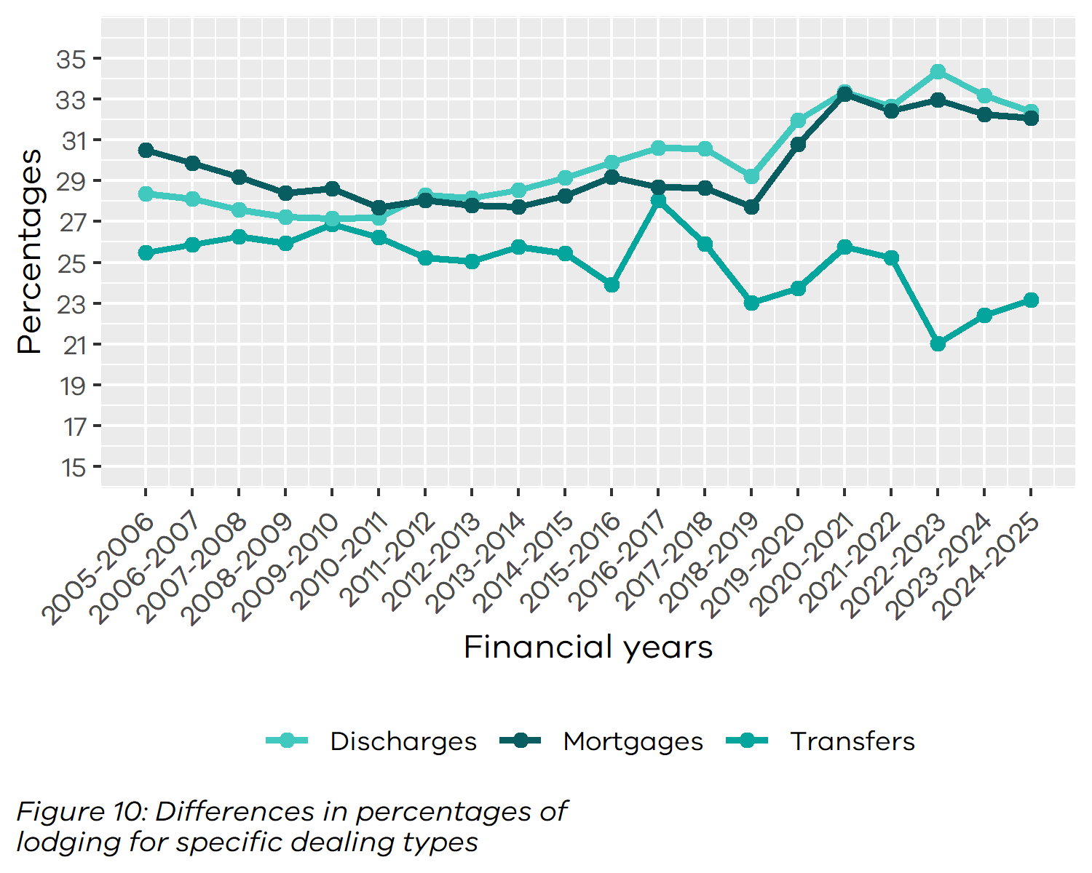

5.5 Plans of subdivision
There were 6,530 plans of subdivision lodged in the 2024-2025 financial year, representing 0.7 per cent of all dealings lodged. This figure does not include other plan types lodged under the Subdivision Act 1988 such as acquisition plans and redevelopment plans. During the same period, 141 acquisition plans and 209 redevelopment plans were lodged.
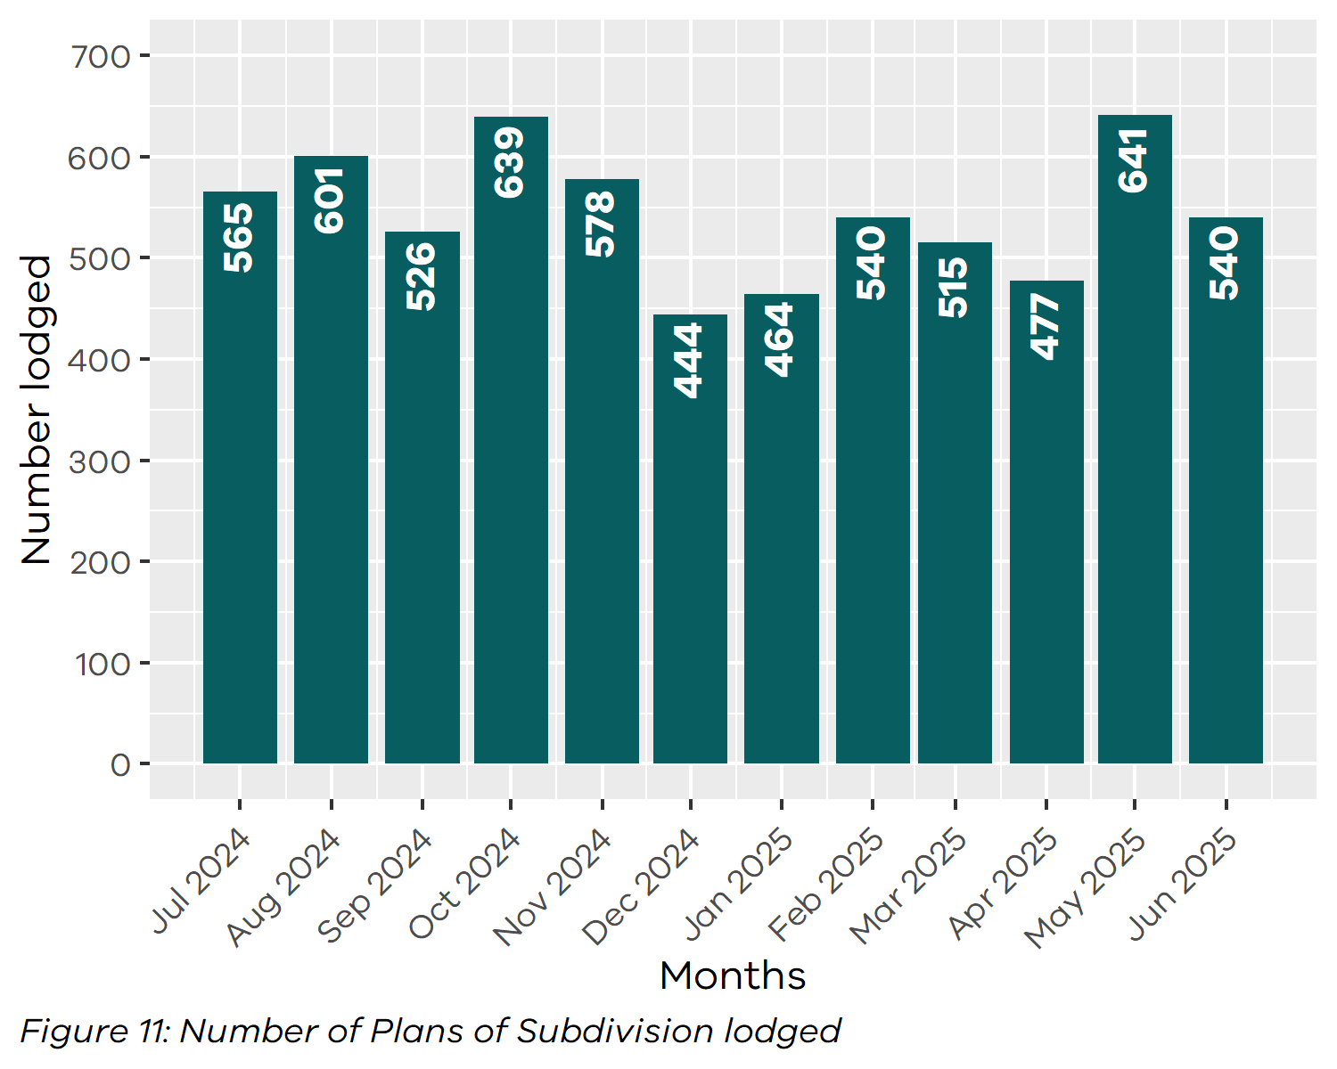

5.6 All Plans lodged under the Subdivision Act 1988
The total number of plans under the Subdivision Act 1988 lodged in the 2024-2025 financial year were 6,981. Lodgment volume for recent financial years are as follows:
Table 12: Total Number of Plans Lodged by Financial Year
Year | Quantity | Year | Quantity
2005-2006 | 8,547 | 2015-2016 | 8,970
2006-2007 | 8,304 | 2016-2017 | 8,376
2007-2008 | 8,048 | 2017-2018 | 8,340
2008-2009 | 7,719 | 2018-2019 | 8,249
2009-2010 | 7,988 | 2019-2020 | 8,541
2010-2011 | 7,699 | 2020-2021 | 8,220
2011-2012 | 8,088 | 2021-2022 | 7,536
2012-2013 | 7,896 | 2022-2023 | 7,064
2013-2014 | 8,001 | 2023-2024 | 7,019
2014-2015 | 8,252 | 2024-2025 | 6,981

5.7 Number of new parcels created from plans of subdivision
In the 2024-2025 financial year, 52,094 parcels were created from plans of subdivision lodged under the Subdivision Act 1988. The comparison below focuses on parcels created from plans lodged under section 22 of the Act, excluding those related to acquisition, redevelopment, or consolidation, across recent financial years:
Table 13: Number of New Parcels Created from Section 22 Subdivisions
by Financial Year
Year | Quantity | Year | Quantity
2014-2015 | 61,669 | 2020-2021 | 74,352
2015-2016 | 75,351 | 2021-2022 | 60,803
2016-2017 | 79,034 | 2022-2023 | 67,021
2017-2018 | 77,014 | 2023-2024 | 61,695
2018-2019 | 77,602 | 2024-2025 | 50,873
2019-2020 | 82,898

Note: this figure was incorrectly reported as 59,959 in the table in FY 2023-24 report. The correct figure was 61,695.

5.8 General law conversion
The number of parcels created from General law conversions during the 2024-2025 financial year was 398. This compares to previous financial years as follows:
Table 14: Number of Parcels Created from General Law Conversions
by Financial Year
Year | Quantity | Year | Quantity
2005-2006 | 1,490 | 2015-2016 | 2,868
2006-2007 | 1,309 | 2016-2017 | 3,228
2007-2008 | 1,238 | 2017-2018 | 1,922
2008-2009 | 1,023 | 2018-2019 | 1,575
2009-2010 | 1,559 | 2019-2020 | 1,468
2010-2011 | 2,559 | 2020-2021 | 482
2011-2012 | 1,303 | 2021-2022 | 378
2012-2013 | 1,997 | 2022-2023 | 409
2013-2014 | 3,774 | 2023-2024 | 373
2014-2015 | 2,018 | 2024-2025 | 398

5.9 Crown Land Dealings
The number of Crown land dealings registered during the 2024-2025 financial year was 2,894. Transactions are typically related to boundary changes and changes to status of Crown land. This compares to previous years as follows:
Table 15: Number of Crown Land Dealings Registered
by Financial Year
Year | Quantity
2019-2020 | 1,707
2020-2021 | 1,346
2021-2022 | 1,337
2022-2023 | 1,736
2023-2024 | 1,550
2024-2025 | 2,894

5.10 Top 40 dealing types, by number lodged
Below is the list of the top 40 dealing types lodged with Land Registry Services during the financial year.
Table 16: Top 40 Dealing Types Lodged (Financial Year 2024-2025)
Dealing type | Description | Lodged
84M | Discharge of mortgage | 301,813
74 | Mortgage | 291,666
45 | Transfer | 192,757
89 | Caveat | 36,579
45NM | Transfer without monetary consideration | 23,133
89W | Withdrawal of Caveat | 17,903
49 | Transmission Application | 15,403
50 | Survivorship Application | 11,364
74D | Mortgage with name change | 7,309
PS | Plan of Subdivision | 6,530
31 | Application to replace lost Certificate of Title | 3,494
173 | Planning Agreement | 2,146
LTC | Land tax charge | 1,604
LTD | Discharge of land tax charge | 1,571
PN | Priority Notice | 1,478
27A | Change of proprietor name | 1,195
77 | Transfer by Mortgagee | 825
89A | Removal of caveat | 817
MCP | Memorandum of Common Provisions | 718
PC | Plan of consolidation | 718
113A | Amendment of address on folio | 513
45E | Creation of easement | 474
32-2 | Application for a new folio of the Register | 368
45N | Transfer with new title | 343
47MSA | Removal of encumbrance | 341
60 | Adverse Possession | 341
106C | Removal of encumbrance | 325
52-2 | Warrant | 325
45M | Transfer of Mortgage | 299
183W | Removal of Planning Agreement | 296
106AR | Registrar’s caveat | 269
RGCAV | Action - Registrar's Caveat | 246
NARF | Notice of action in respect of a folio | 217
RVC | Statutory charge | 215
32-1 | Application for a new folio of the Register | 212
SA32PS | Plan of Subdivision X32 | 209
23 | Application TLA | 195
75A | Variation of Mortgage | 195
SACA | Change of address of owners corporation | 193
MTPFA | Major Transport Projects Facilitation Act Acquisition | 179

6 Other measures of Land Registry Services activity

6.1 Number of dealings registered
The number of transactions registered in the 2024-2025 financial year was 928,276.

6.2 Percentage of dealings registered within 5 days
The average percentages achieved were greater than 99 per cent for the entire financial year.

6.3 Number of plans of subdivision registered
The number of plans of subdivision registered under the Subdivision Act 1988 in the financial year was 6,940. The average percentage of plans registered within 15 days was 97.35 per cent for the financial year.

6.4 Number of dealings refused
The number of dealings refused during this financial year was 3,639 representing 0.39 per cent of all dealings presented for acceptance at Land Registry Services. In comparison, the 2023-24 financial year saw 4,831 refusals representing 0.52 per cent of all dealings presented.

6.5 Number of dealings waiting to be processed
The number of dealings waiting to be processed has stabilised. At the start of the financial year, the holding level was 2,768. For most of the year, this figure remained below 2,556. The majority of these dealings are either awaiting customer action or are on hold until a statutory period has elapsed. As of 1 July 2025 the number stood at 2,399.

7 Electronic transactions processing

7.1 Electronic Conveyancing
The number of transactions lodged electronically in the 2024-2025 financial year was 912,240, up from 901,838 in 2023-24. Electronic lodgments accounted for 97.86 per cent of all lodgments in 2024-2025, compared to 97.68 per cent in the previous year. This figure for 2024-2025, includes the following transaction types:
Table 17: Number of Transactions Lodged Electronically
by Type (Financial Year 2024-2025)
Transaction Type | Quantity
Discharge of Mortgage | 300,944
Mortgage | 298,534
Transfer | 214,343
Caveat | 36,228
Withdrawal of Caveat | 17,735
Transmission Application | 15,238
Survivorship Application | 11,122
Application Lost Title | 3,398
Agreement | 2,131
Land Tax Charges | 1,604
Discharges of Land Tax Charges | 1,571
Priority Notice | 1,478
Transfer by Mortgagee | 820
Removal of Caveat | 801
Application for New Folio | 434
Warrant | 394
Transfer of Mortgage | 290
Statutory Charge | 253
Withdraw Priority Notice | 138
Discharge of Charge | 25
Miscellaneous | 4,759

7.2 Percentage of transactions lodged electronically
