|  |
| --- |
| Land Use Victoria  Customer Information Bulletin 182  September 2018 |
|  |

# 

# Mandatory electronic lodgment – 1 October 2018

Requirement 6.5(e) of the Registrar’s Requirements for Paper Conveyancing Transactions stipulates that from 1 October 2018 certain Instruments must be lodged using an Electronic Lodgment Network (ELN). The requirement is summarised below.

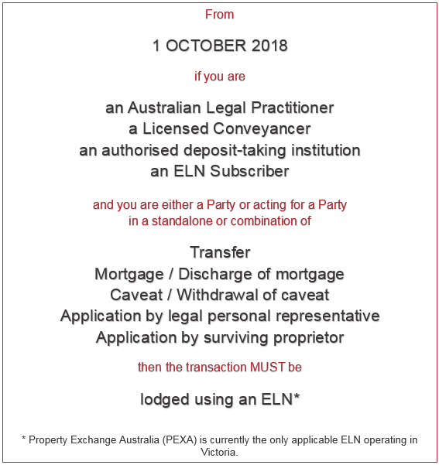

From 1 October 2018, the Registrar will not accept paper lodgment of any of the above Instruments. However, the Registrar will accept paper lodgment if the Instrument(s) cannot be lodged using an ELN for any of the reason(s) set out in the *Request to accept paper lodgment* form available at www.propertyandlandtitles.vic.gov.au/forms-guides-and-fees/title-management.

## Request to accept paper lodgment

The [*Request to accept paper lodgment*](http://www.propertyandlandtitles.vic.gov.au/forms-guides-and-fees/title-management) form should be used when requesting paper lodgment of a transaction/transactions that, on face value, should be completed using an ELN.

All parties to the transaction must determine when a transaction cannot be lodged using an ELN. However, it is the lodging party who must present the request form at lodgment. When presented, Land Registry staff will accept the transaction(s) and proceed to examination.

The request form is only required for the following Instruments:

* Transfer
* Mortgage/Discharge of mortgage
* Caveat/Withdrawal of caveat
* Application by legal personal representative
* Application by surviving proprietor.

The form is not required for Instruments that are currently not required to be lodged using an ELN, such as:

* Application for lost title 31TLA
* Application to record an agreement 181PEA.

The Registrar will monitor use of the request form to ensure customers are using it appropriately.

The [request form](http://www.propertyandlandtitles.vic.gov.au/forms-guides-and-fees/title-management) is located online at www.propertyandlandtitles.vic.gov.au/forms-guides-and-fees/title-management. It can also be found at Land Registry Services, Level 1, 2 Lonsdale St, Melbourne.

# Subscribe

To receive notification when a *Customer Information Bulletin* is published, please send an email to lv.cib@delwp.vic.gov.au with SUBSCRIBE in the subject line – include your name and email address in the body of the email.

# Contact us

For [location and contact details](http://www.dtpli.vic.gov.au/property-and-land-titles/contact-us), go to [www.propertyandlandtitles.vic.gov.au/contact-us](http://www.propertyandlandtitles.vic.gov.au/contact-us).

|  |  |
| --- | --- |
| © The State of Victoria Department of Environment, Land, Water and Planning 2018  LogoThis work is licensed under a Creative Commons Attribution 4.0 International licence. You are free to re-use the work under that licence, on the condition that you credit the State of Victoria as author. The licence does not apply to any images, photographs or branding, including the Victorian Coat of Arms, the Victorian Government logo and the Department of Environment, Land, Water and Planning (DELWP) logo. To view a copy of this licence, visit http://creativecommons.org/licenses/by/4.0/  Disclaimer  This publication may be of assistance to you but the State of Victoria and its employees do not guarantee that the publication is without flaw of any kind or is wholly appropriate for your particular purposes and therefore disclaims all liability for any error, loss or other consequence which may arise from you relying on any information in this publication. | Accessibility  If you would like to receive this publication in an alternative format, please telephone the DELWP Customer Service Centre on 136186, email [customer.service@delwp.vic.gov.au](mailto:customer.service@delwp.vic.gov.au), or via the National Relay Service on 133 677 [www.relayservice.com.au](http://www.relayservice.com.au). This document is also available on the internet at [www.delwp.vic.gov.au](http://www.delwp.vic.gov.au). |