|  |
| --- |
| Vicmap™ Product Development |
| Change Notice 241 Advisory Notice |

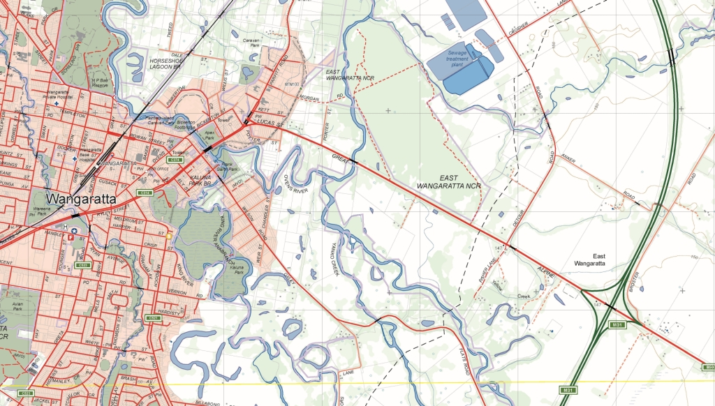**+**

Vicmap Index 13 November, 2018

## What is happening

The book name associated with each Spatial Vision’ map index and page grid is being added.

The column BOOK_NAME VACHAR2(50) will be added to:

* MAPBOOK_MAPINDEX_150_EDXX
* MAPBOOK_MAPINDEX_100_EDXX
* MAPBOOK_MAPINDEX_50_EDXX
* MAPBOOK_MAPINDEX_20_EDXX
* MAPBOOK_MAPINDEX_15_EDXX
* MAPBOOK_MAPINDEX_150_EDXX
* MAPBOOK_MAPINDEX_100_EDXX
* MAPBOOK_MAPINDEX_50_EDXX
* MAPBOOK_MAPINDEX_20_EDXX
* MAPBOOK_MAPINDEX_15_EDXX

## Why this change is occurring

This change is responding to customers who want to identify the Spatial Vision map book associated with a specified map index or page grid.

## Who will it affect

This change will affect all users of Vicmap Index

The change will be implemented **after 13 November, 2018.**

For Vicmap Product change notices and bulletins, go to the [News and Bulletins](http://www.delwp.vic.gov.au/parks-forests-and-crown-land/spatial-data-and-resources/news-and-bulletins) page.

For further information & feedback please email [Vicmap.help@delwp.vic.gov.au](mailto:Vicmap.help@delwp.vic.gov.au)

|  |  |
| --- | --- |
| © The State of Victoria Department of Environment, Land, Water and Planning 2018  LogoThis work is licensed under a Creative Commons Attribution 4.0 International licence. You are free to re-use the work under that licence, on the condition that you credit the State of Victoria as author. The licence does not apply to any images, photographs or branding, including the Victorian Coat of Arms, the Victorian Government logo and the Department of Environment, Land, Water and Planning (DELWP) logo. To view a copy of this licence, visit http://creativecommons.org/licenses/by/4.0/  Disclaimer  This publication may be of assistance to you but the State of Victoria and its employees do not guarantee that the publication is without flaw of any kind or is wholly appropriate for your particular purposes and therefore disclaims all liability for any error, loss or other consequence which may arise from you relying on any information in this publication. | Accessibility  If you would like to receive this publication in an alternative format, please telephone the DELWP Customer Service Centre on 136186, email [customer.service@delwp.vic.gov.au](mailto:customer.service@delwp.vic.gov.au), or via the National Relay Service on 133 677 [www.relayservice.com.au](http://www.relayservice.com.au). This document is also available on the internet at [www.delwp.vic.gov.au](http://www.delwp.vic.gov.au). |

Keep all content above this instruction text line. Delete only when document formatting is complete.