|  |
| --- |
| Vicmap™ Product Development |
| Change Notice #259 Advisory Notice |

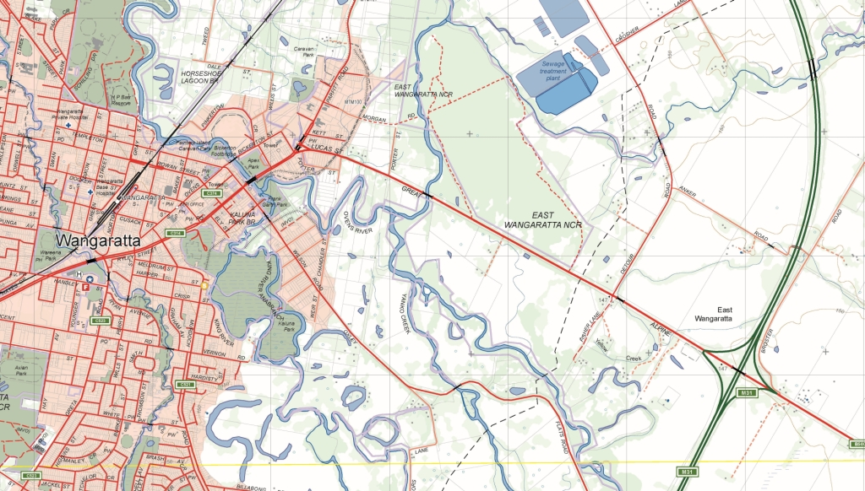

Vicmap Position - Survey Control

## What is happening

The SCN_AHD attribute in Vicmap Position – Survey Control product is renamed to ADJ_AHD. Details are as follows:

|  |  |  |  |  |  |
| --- | --- | --- | --- | --- | --- |
| **Change** | **VMPOSITION Attribute** | **Definition** | **Explanation** | **Field type/size** | **Examples** |
| OLD ATTRIBUTE | SCN_AHD | Survey Control Network (AHD) status | Determines whether the survey mark is a level-adjusted AHD or levelled AHD mark | VARCHAR2(3) | SCN_AHD options:-  Y = Yes, survey mark is a SCN mark  N = No, survey mark is a Non-SCN AHD mark |
| NEW ATTRIBUTE | ADJ_AHD | Level-Adjusted AHD status | Determines whether the survey mark is a level-adjusted AHD. Attribute/ field previously labelled as SCN_AHD | VARCHAR2(3) | SCN_AHD options:-  Y = Yes, survey mark is a level-adjusted AHD mark  N = No, survey mark is estimated AHD mark |
|  |  |  |  |  |  |

## Why this change is occurring

The Survey Control Network (AHD) status was replaced by Level-Adjusted AHD status during the LASSI 2.16 release. This change was necessary to maintain the naming convention between VMPOSITION and LASSI-SMES.

Where:

* AHD means Australian Height Datum.
* LASSI means Land and Survey Spatial Information, a free online web mapping application that can be used to find a parcel of land or property. URL: [maps.land.vic.gov.au/lassi](http://maps.land.vic.gov.au/lassi/LassiUI.jsp)
* SCN means Survey Control Network.

## Who will it affect

This change will affect all users of Vicmap Position - Survey Control.

## When the change will occur | How to provide feedback |

The change took place **on the 13/09/2020.**

For Vicmap Product change notices and bulletins, go to the [News and Bulletins](http://www.delwp.vic.gov.au/parks-forests-and-crown-land/spatial-data-and-resources/news-and-bulletins) page.

For further information & feedback please email [Vicmap.help@delwp.vic.gov.au](mailto:Vicmap.help@delwp.vic.gov.au)

|  |  |
| --- | --- |
| © The State of Victoria Department of Environment, Land, Water and Planning 2020  LogoThis work is licensed under a Creative Commons Attribution 4.0 International licence. You are free to re-use the work under that licence, on the condition that you credit the State of Victoria as author. The licence does not apply to any images, photographs or branding, including the Victorian Coat of Arms, the Victorian Government logo and the Department of Environment, Land, Water and Planning (DELWP) logo. To view a copy of this licence, visit http://creativecommons.org/licenses/by/4.0/  Disclaimer  This publication may be of assistance to you but the State of Victoria and its employees do not guarantee that the publication is without flaw of any kind or is wholly appropriate for your particular purposes and therefore disclaims all liability for any error, loss or other consequence which may arise from you relying on any information in this publication. | Accessibility  If you would like to receive this publication in an alternative format, please telephone the DELWP Customer Service Centre on 136186, email [customer.service@delwp.vic.gov.au](mailto:customer.service@delwp.vic.gov.au), or via the National Relay Service on 133 677 [www.relayservice.com.au](http://www.relayservice.com.au). This document is also available on the internet at [www.delwp.vic.gov.au](http://www.delwp.vic.gov.au). |